PO Box 123
Halifax, NS B3K 5X5

20 March 1999

Miss Maria Ringwald
Family Farm
2321 Spring Garden Road
Halifax, NS B2J 4E9

Miss Ringwald:

Allow me to submit my candidacy for the position of Assistant Manager for your store in Halifax. My qualifications and experience match the job prerequisites as advertised at the Canada Employment Centre.

Your store's long-standing reputation for excellence and the fine service you offer your loyal clientele are only two of the many reasons I am eager to join your team. I am a dynamic. punctual and well-organized person.

Enclosed please find my resumé. I can also provide you with letters of recommendation and school diplomas if you wish. I am available for an interview at your convenience and will be happy to answer any questions you may have. You may contact me at the above address, or by phone, at (902) 555-1254.

I sincerely hope you will consider my offer. In the meantime, please accept my kindest regards.

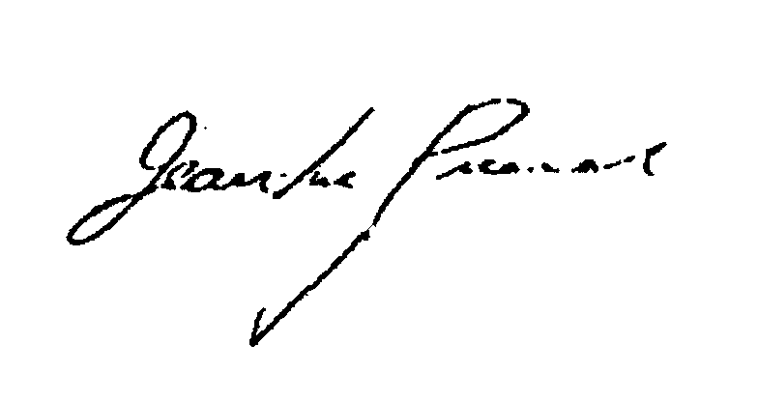
Sincerely.
Jean Luc Picard

Enclosed: Resumé

