A-CR-CCP-270/PT-001

YEAR:

ROYAL CANADIAN AIR CADETS

TRAINING ORGANIZER

YOU ARE A LEADER!

Congratulations, you are now part of the air cadets' elite! Everything you have learned and experienced so far will help you achieve what very few young adults like you have a change to experience: You will be asked to play a greater role in the operations of your squadron and your decisions and actions will more than likely influence the lives of many young air cadets! Do you remember your first drill instructor? How about your first staff-cadet? Someone surely did, at one point in time, create such an impression on you that you chose to remain associated with the air cadet organization. The eyes and ears of a new generation of cadets are now turned toward you.

For the past couple of years your superiors have taken charge of you, made all the decisions, organized several activities and told you exactly what to do and when to do it. Basically, you hardly had anything else to do but show-up end enjoy everything that was prepared for you. This time is now over and you must realize that your subordinates expect the same from YOU! No matter how small your tasks are, they must be performed to a higher standard.

One of the most important skill required by a good leader is the ability to organize time. As you will soon realize, being "in charge" can be lots of fun, but it can also prove to be difficult if you do not learn to keep track of everything said and done.

The success of any superior organizations lies in the facility of its members to manage time better and make sound decisions. The way you organize your time and your subordinates' time, as well as the efficiency by which you manage it, will reflect on the success encountered by both your subordinates and, to a certain extent, your squadron.

Have you noticed that it is easier to trust someone who seems to know what he/she is doing? Successful leaders of all time have one thing in common: THEY KNOW WHAT TO DO AND WHEN TO DO IT! They have developed an ability to take charge more efficiently. Organizing time will help to plan your tasks in such a way that you will always know exactly what to do and when to do it.

This TRAINING ORGANIZER has been created especially for you. It contains several sections aimed at one goal: HELP YOU BECOME A GREAT LEADER. Use it well!

Just to remind you...

The main squadron parade formations are:

Squadron in Line

Squadron in Column of Route

Squadron in Column of Threes

Squadron in Column of Flights
Key to Symbols
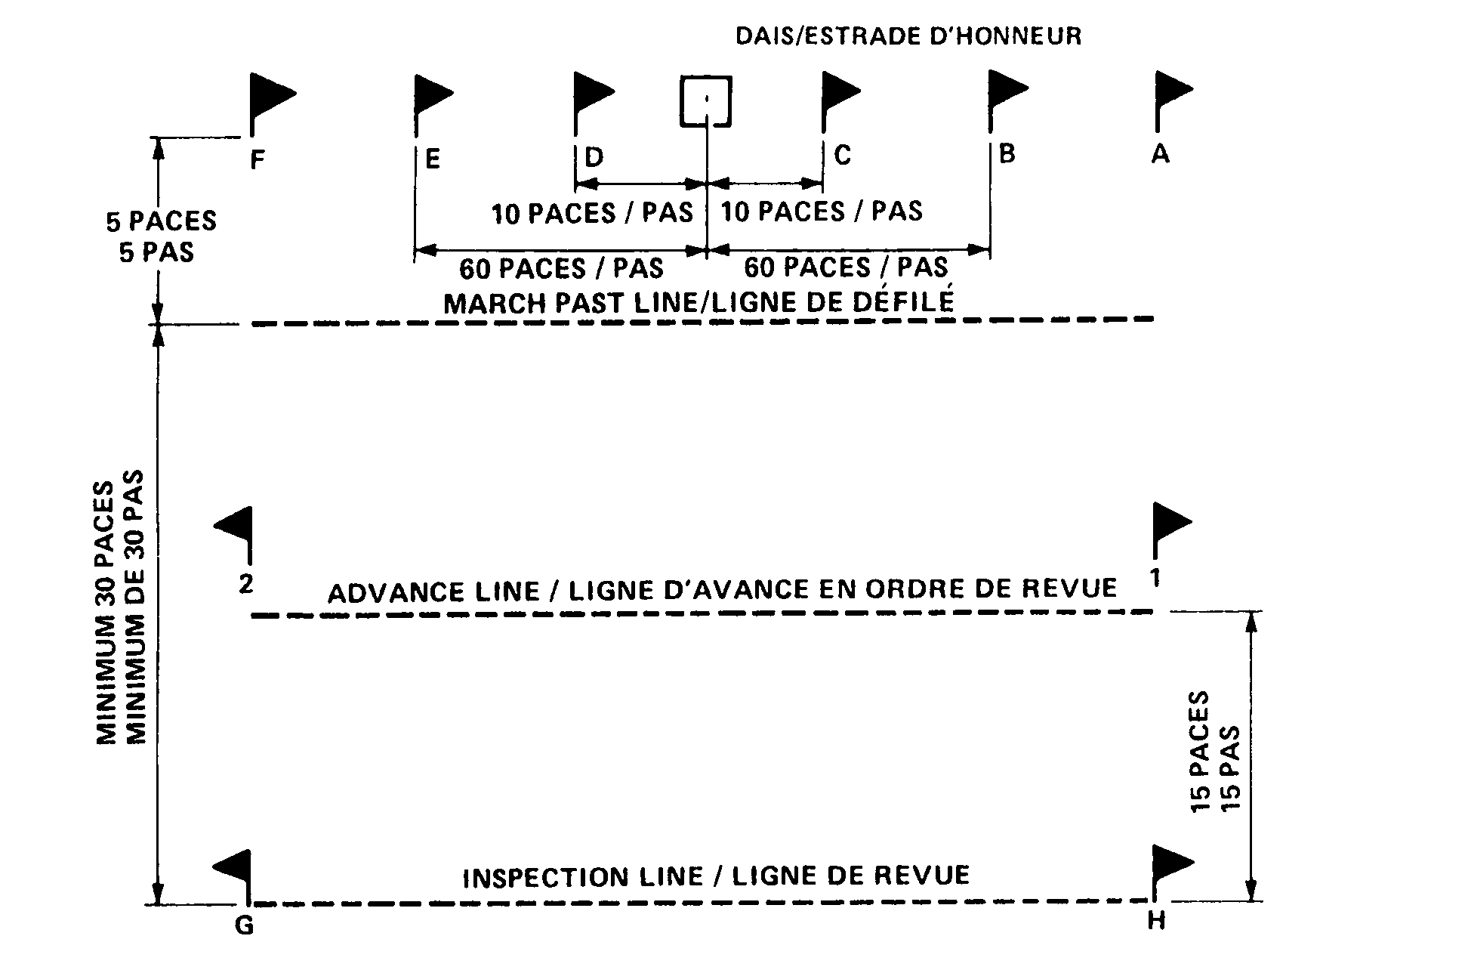
The Review Parade Ground

