A-CR-CCP-269/PT-001

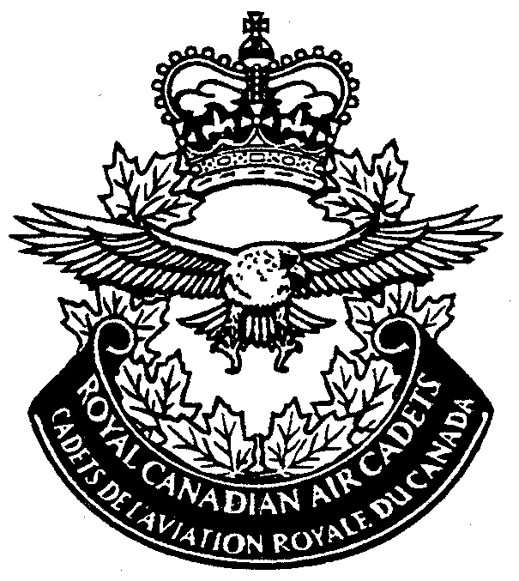
ROYAL CANADIAN AIR CADETS

LEVEL FOUR
HANDBOOK

Issued on Authority of the Chief of the Defence Staff



A-CR-CCP-269/PT-001
DéfenceNational
NationaleDefence

ROYAL CANADIAN AIR CADET MANUAL

PROFICIENCY LEVEL FOUR
HANDBOOK

(Supersedes ACRCCP 269-PT-001 Dated 1993-09-01)

Issued on Authority of the Chief of the Defence Staff

OPI: D Cdts 1998-07-01

LIST OF EFFECTIVE PAGES

Insert latest changed pages; dispose of superseded pages in accordance with applicable orders.

NOTE

The portion of the text affected by the latest change is indicated by a black vertical line in the margin of the page. Changes to illustrations are indicated by miniature pointing hands or black vertical lines.

Dates of issue for original and changed pages are:
Original 0 1993-09-01
Ch 1 1998-07-01
Ch 2
Ch 3
Ch 4
Ch 5

Zero in Change No. Column indicates an original page. The letter E or F indicates that the modification applies exclusively in English or French. Total number of pages in this publication is 216 consisting of the following:

Page No. Change No.

Cover 0
Title Page 0
A, B/C 0
i/ii 0
iii to ix/x 0
1-1-1/1-1-2 0
1-2-1 to 1-2-28 0
1-3-1/1-3-2 0
2-1-1/2-1-2 0
2-2-1 to 2-2-5/2-2-6 0
2-3-1/2-3-2 0
3-1-1 to 3-1-6 0

LIST OF EFFECTIVE PAGES (Cont)

Page No. Change No.

3-2-1 to 3-2-8 0
4-1-1/4-1-2 0
4-2-1/4-2-2 0
4-3-1, 4-3-2 0
4-4-1 to 4-4-5/4-4-6 0
4-5-1 to 4-5-16 0
5-1-1 to 5-1-9/5-1-10 0
5-2-1 to 5-2-3/5-2-4 0
5-3-1 to 5-3-3/5-3-4 0
5-4-1/5-4-2 0
6-1-1/6-1-2 0
6-2-1 to 6-2-6 0
6-3-1 to 6-3-4 0
6-4-1 to 6-4-3/6-4-4 0
6-5-1 to 6-5-11/6-5-12 0
7-1-1/7-1-2 0
7-2-1 to 7-2-4 0
7-3-1 to 7-3-6 0
7-4-1 to 7-4-3/7-4-4 0
7-5-1/7-5-2 0
8-1-1/8-1-2 0
8-2-1 to 8-2-4 0
8-3-1 to 8-3-4 0
8-4-1 to 8-4-3/8-4-4 0
8-5-1 to 8-5-3/8-5-4 0
8-6-1, 8-6-2 0
9-1-1/9-1-2 0
9-2-1 to 9-2-5/9-2-6 0
9-3-1 to 9-3-7/9-3-8 0
9-4-1 to 9-4-6 0
9-5-1 to 9-5-7/9-5-8 0
9-6-1/9-6-2 0
10-1 to 10-6 0
11-1 to 11-10 0

Contact Officer: D Cdts

©1998 DND/MDN Canada

PREFACE

1. A-CR-CCP-269/PT-001 is intended to be used as a textbook for study and reference by Royal Canadian air cadets in training at their local squadron.

2. A-CR-CCP-269/PT-001 is based on the Course Training Standard and Course Training Plan for Level Four found in A-CR-CCP-265/PC-001 and A-CR-CCP-269/PH-001 respectively, and is intended for use by air cadets in their fourth training year of the Air Cadet Programme.

CONTENTS

PAGE

CHAPTER 1 – PERFORMANCE OBJECTIVE 401
– DRILL 1-1-1/1-1-2

Section 1 – Introduction 1-1-1/1-1-2

Section – The Squadron 1-2-1

Squadron Formations 1-2-3
The Review Parade Ground 1-2-7
Forming up a Squadron 1-2-8
Dressing a Squadron in Line 1-2-15
Falling in the Flight Commanders 1-2-16
The Squadron Review 1-2-17
Falling Out the Flight Commanders 1-2-19
Sequence of a Squadron Review 1-2-20
The Inspection Party 1-2-21
The March-Past 1-2-23
The Department of the Reviewing Officer 1-2-28

Section 3 – Conclusion 1-3-1/1-3-2

CHAPTER 2 – PERFORMANCE OBJECTIVE 402
– DRILL INSTRUCTION 2-1-1/2-1-2

Section 1 – Instruction 2-1-1/2-1-2

Section 2 – The Drill Lesson 2-2-1

Teaching Drill 2-2-1
Calling out the Time 2-2-2
Type of Formation 2-2-3
The Hollow Square Formation 2-2-3
Instructional Techniques 2-2-4
Mechanical Aids to Drill 2-2-5/2-2-6
As You Were 2-2-5/2-2-6

Section 3 – Conclusion 2-3-1/2-3-2

CONTENTS (Cont)

PAGE

CHAPTER 3 – PERFORMANCE OBJECTIVE 404
– CITIZENSHIP 3-1-1

Section 1 – The Memorandum 3-1-1

Components of a Memorandum 3-1-3

Section 2 – Meetings 3-2-1

The Chairperson 3-2-1
Chairing a Meeting 3-2-1
Quorum 3-2-4
The Secretary 3-2-5
Minutes 3-2-5
Reports 3-2-5
Voting 3-2-5
Just a Few Hints.........................................................................................3-2-6

CHAPTER 4 – PERFORMANCE OBJECTIVE 405
– PHYSICAL FITNESS 4-1-1/4-1-2

Section 1 – General 4-1-1/4-1-2

Section 2 – Minor Team Games 4-2-1/4-2-2

Section 3 – Officials 4-3-1

Section 4 – Components of a Physical Activity Session 4-4-1

Warm up 4-4-1
Activity 4-4-5/4-4-6
Cool Down 4-4-5/4-4-6

Section 5 – Air Cadet Fitness Programme 4-5-1

The Tests 4-5-1
Crests 4-5-1
Preparation 4-5-2

CONTENTS (Cont)

PAGE

CHAPTER 5 – PERFORMANCE OBJECTIVE 406 5-1-1

Section 1 – Sensible Living 5-1-1

Generalities 5-1-1
Curriculum Vitae 5-1-1
Components of a Curriculum Vitae 5-1-2
Personal Identification 5-1-2
Your Education/Work Experience 5-1-2
Personal Information 5-1-3
Your References 5-1-3
Presentation of Your Résumé 5-1-4

Section 2 – Offer of Employment Letter 5-2-1

Section 3 – The Interview 5-3-1

Section 4 – Conclusion 5-4-1/5-4-2

CHAPTER 6 – PERFORMANCE OBJECTIVE 408 6-1-1/6-1-2

Section 1 – Leadership 6-1-1/6-1-2

Introduction 6-1-1/6-1-2

Section 2 – Morale and Esprit de corps 6-2-1

Morale: A Basic Requirement in a Group 6-2-1
Esprit de Corps 6-2-3
Moral and Esprit de Corps 6-2-4

Section 3 – Interviewing and Counselling 6-3-1

Interviewing 6-3-1
Occasions to Interview 6-3-1
Objectives of Counselling 6-3-2
Suggested Counselling Rules 6-3-3
Common Errors 6-3-3

CONTENTS (Cont)

PAGE

Section 4 – Performance Evaluation 6-4-1

Purposes and Application of Evaluation 6-4-1
Performance Interviews 6-4-2

Section 5 – Planning an Activity 6-5-1

BEFORE THE ACTIVITY 6-5-2

Searching for Information 6-5-2
Elaborating a Plan 6-5-2
Assigning Tasks 6-5-4
Holding a Planning Meeting 6-5-4

DURING THE ACTIVITY 6-5-5

Supervising 6-5-5

AFTER THE ACTIVITY 6-5-5

Holding a Post-Activity Meeting 6-5-5

Submitting a Final Report 6-5-6

CHAPTER 7 – PERFORMANCE OBJECTIVE 409
INSTRUCTIONAL TECHNIQUES 7-1-1/7-1-2

Section 1 – Introduction 7-1-1/7-1-2

Section 2 – Problem Trainees 7-2-1

Types of Problem Trainees 7-2-1
Caution on Type-Casting 7-2-4

Section 3 – The Teaching Lecture Method 7-3-1

Preparing the Teaching Lecture 7-3-1
Delivering the Teaching Lecture 7-3-2
Advantages and Limitations of the Lecture Method 7-3-3
Lesson Planning Tips 7-3-4

CONTENTS (Cont)

PAGE

Section 4 – Demonstration – Performance Method 7-4-1

Learn by Doing 7-4-1
Essentials of the Demonstration-Performance Method 7-4-1

Section 5 – Conclusion 7-5-1/7-5-2

CHAPTER 8 – PERFORMANCE OBJECTIVE 413
METEOROLOGY 8-1-1/8-1-2

Section 2 – Introduction 8-1-1/8-1-2

Section 2 – The Atmosphere 8-2-1

Properties 8-2-1
Divisions and Characteristics 8-2-2
Moisture in the Atmosphere 8-2-3

Section 3 – Clouds 8-3-1

Classification of Clouds 8-3-1
High Clouds 8-3-1
Middle Clouds 8-3-2
Low Clouds 8-3-2
Clouds of Vertical Development 8-3-3
Cloud Formation 8-3-3

Section 4 – Fog 8-4-1

Types of Fog 8-4-1
Radiation Fog 8-4-2
Advection Fog 8-4-2
Upslope Fog 8-4-3/8-4-4
Steam Fog 8-4-3/8-4-4
Precipitation-Induced Fog 8-4-3/8-4-4
Ice Fog 8-4-3/8-4-4

CONTENTS (Cont)

PAGE

Section 5 – Precipitation 8-5-1

Forms of Precipitation 8-5-1
Drizzle 8-5-2
Rain 8-5-2
Snow Pellets (Soft Hailstones) 8-5-2
Snow 8-5-3/8-5-4
Ice Prismes 8-5-3/8-5-4
Ice Pellets 8-5-3/8-5-4

Section 6 – Temperature 8-6-1

Solar and Terrestrial Radiation 8-6-1

CHAPTER 9 – PERFORMANCE OBJECTIVE 417
NAVIGATION 9-1-1/9-1-2

Section 1 – Introduction 9-1-1/9-1-2

Section 2 – Aeronautical Charts 9-2-1

The Lambert Conformal Conic Projection 9-2-2
The Mercator Projection 9-2-2
Types of Aeronautical Charts 9-2-5/9-2-6

Section 3 – Basic Chart Information 9-3-1

Section 4 – Navigation Plotting and Plotting Equipment 9-4-1

Instruments 9-4-1
Plotting a Direction 9-4-5
Reading Off a Direction 9-4-5

Section 5 – Navigation Terminology 9-5-1

Units of Distance and Speed 9-5-5
Conversions 9-5-5
Hours and Minutes 9-5-5
Time in Flight 9-5-5

CONTENTS (Cont)

PAGE

Distances 9-5-5
Groundspeed 9-5-6
The One-in-sixty Rule 9-5-6

Section 6 – Conclusion 9-6-1/9-6-2

CHAPTER 10 – PERFORMANCE OBJECTIVE 419
AIRCREW SURVIVAL 10-1

Introduction 10-1
Selection of a Bivouac Site 10-1
Elements of a Bivouac 10-2
Your Contribution to the Survival Exercise 10-5

CHAPTER 11 – PERFORMANCE OBJECTIVE 420
TRAINING SUPPORT 11-1

Introduction 11-1
Evaluation Report 11-2

PO 401

D
R
I
L
L

CHAPTER 1

PERFORMANCE OBJECTIVE 401 – DRILL

SECTION 1

INTRODUCTION

1. Now that you have learned to execute individual and squad drill movements, as taught in the first three levels of training, you are ready to participate in drill exercises as a staff member of your squadron on parade.

2. You will be asked, like every Level 4 cadet, to participate more actively in your squadron parades. You will be asked to proceed to the fall-in and to command the squadron for the march-past. It is important that you carefully read the information contained in this chapter as it will help you accomplish the task. Do not hesitate to ask if you feel you need more information. It will be too late to do it when your cadets are waiting for your next command.

SECTION 2

THE SQUADRON

1. For parade purposes, a squadron consists of two or more flights. It is commanded by a cadet squadron commander, assisted by a deputy squadron commander and a squadron warrant officer (SWO). It is important that you distinguish between the parade appointment cadet squadron commander, held by a cadet and the staff position Squadron Commanding Officer, held by the officer in charge of your squadron. The reason you must make the distinction is that in the Canadian Armed Forces, the officers are responsible for commanding the troops on parade. Air cadets have adopted drill and ceremonial procedures that are similar to those of the Canadian Forces, exception being made, among others, for the officer appointments on parade that are held by senior cadets.

2. Ranks and appointments are not interrelated. This means that you could be appointed SWO on parade even if you are wearing the rank of sergeant. This is why you must also learn to differentiate between the parade appointments squadron warrant officer, warrant officer and the ranks worn by members of the Armed Forces. Air cadets do not use Master Warrant Officer (MWO) and Warrant Officer (WO) as part of their rank structure, but we have adopted the parade appointments used by the Canadian Forces (CF) in order to avoid confusion when air cadets are involved in ceremonies with cadets of other elements or with CF units.

3. Symbols for the appointments normally held by officers on parade are represented by a circle while those held by non-commissioned officers (NCOs) are represented by a square. The following table represents an

example of a parade that could be used by your squadron to indicate squadron parade positions on any given training day:
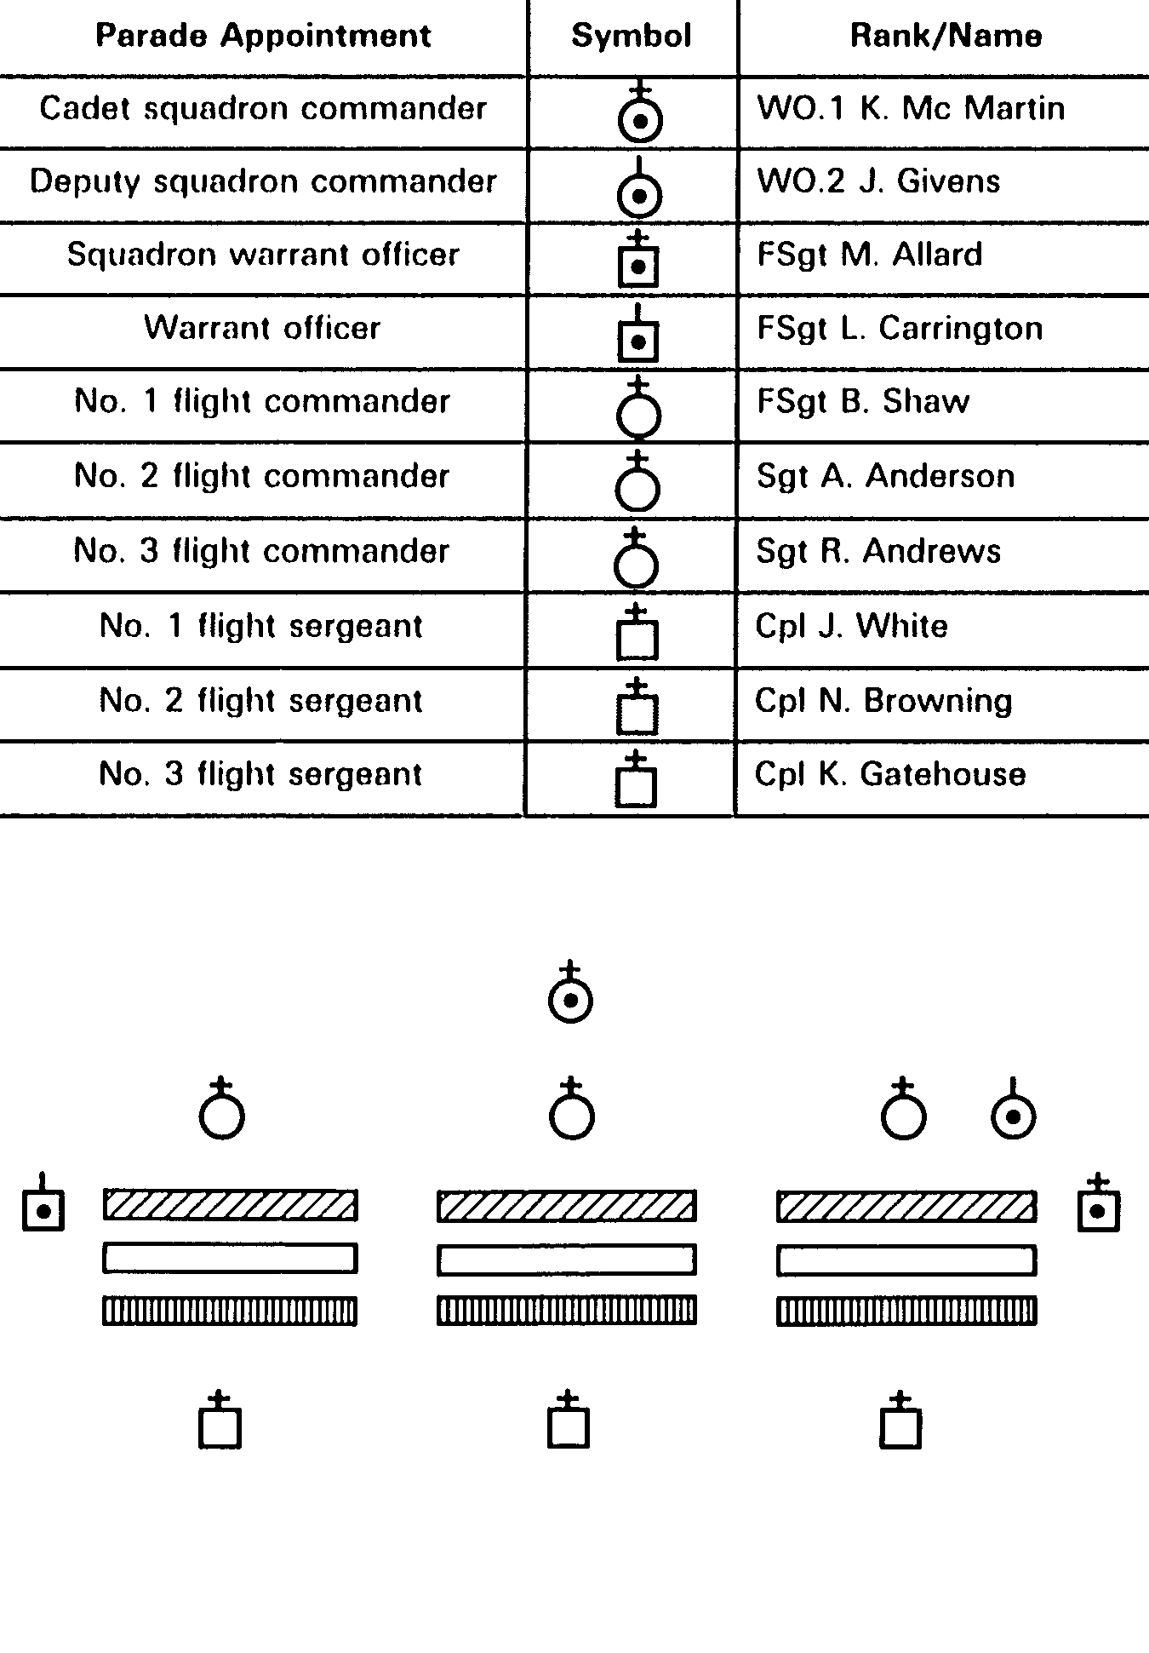

SQUADRON FORMATIONS

4. The squadron formations most commonly used by air cadets squadrons are:

a. in line;

b. in column of threes;

c. in column of route; and

d. in column of flights.

5. The Squadron in Line. When a squadron is formed in line (see Figure 1-1):

a. The flights are side-by-side on the same alignments, with a seven-pace interval between flights.

b. Each flight is formed as in flight drill.

c. The cadet squadron commander is in the centre of the squadron three paces in front of the line of flight commanders (six paces in front of the front rank).

d. The deputy commander is in line with the flight commanders and three paces in front of the second file from the right flank of the aquadron.

e. The SWO (right guide) is one pace to the right of the No. 1 flight marker, in line with the front rank.

f. The WO (left marker) is one pace to the left of the left flank of the squadron, in line with the front rank.

6. Squadron in Columns of Threes. A squadron formed in column of threes is in the same formation as one in line, but faces a flank (see Figure 1-2).

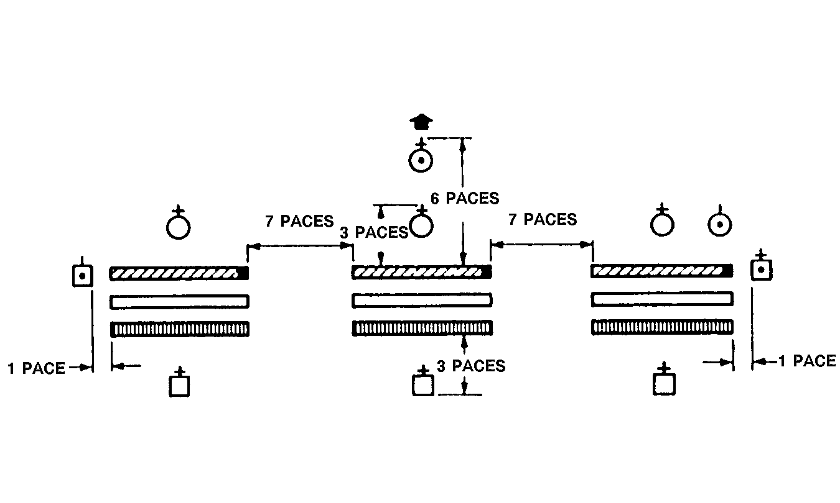
Figure 1-1 Squadron in Line
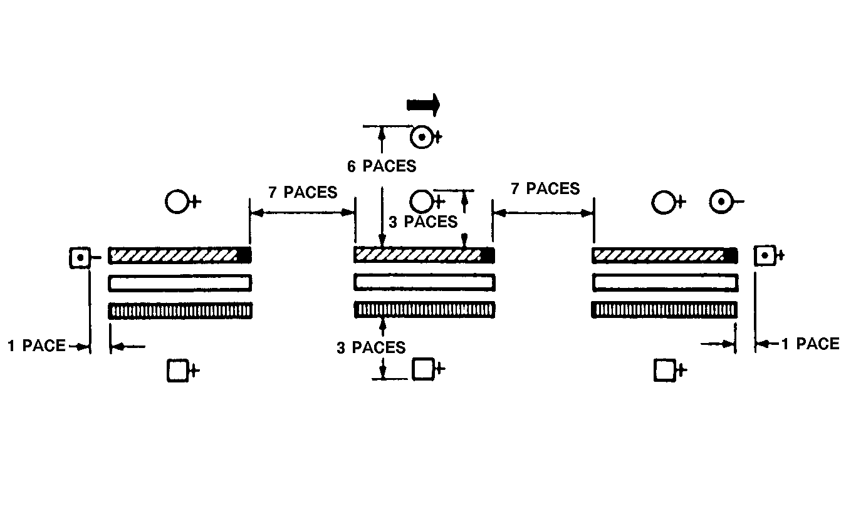

Figure 1-2 Squadron in Column of Threes

7. Squadron in Column of Route. A squadron in column of route (see Figure 1-3) is similar to one in threes, except that:

a. The cadet squadron commander is two paces in front of the leading commander (four paces in front of the centre file of the leading flight).

b. The deputy commander is two paces behind the rear flight WO (four paces in rear of the centre file of the rear flight).

c. The SWO (right guide) is one pace in front of the directing flank of the leading flight.

d. The WO (left guide) is one pace in rear of the directing flank of the last flight.

8. Squadron in Column of Flights. A squadron in column of flights is formed with each flight in line, one behind the other (see Figure 1-4). If the flights are of unequal strength, the leading flight shall be the strongest. The distance between flights is the frontage of the leading flight, plus seven paces; the minimum distance is 12 paces.

a. The cadet squadron commander is three paces in front of the leading flight (six paces in front of the front rank of the leading flight).

b. The squadron deputy commander is three paces in rear of the rear flight WO (six paces in rear of the rear rank of the rear flight).

c. The SWO is one pace to the right and in line with the front rank of the rear leading flight.

d. The WO is one pace to the right and in line with the front rank of the rear flight.

9. When training is conducted in an area offering a limited space, as it is often the case with the facilities used by air cadet squadrons, it is recommended to reduce spacing between the flights.

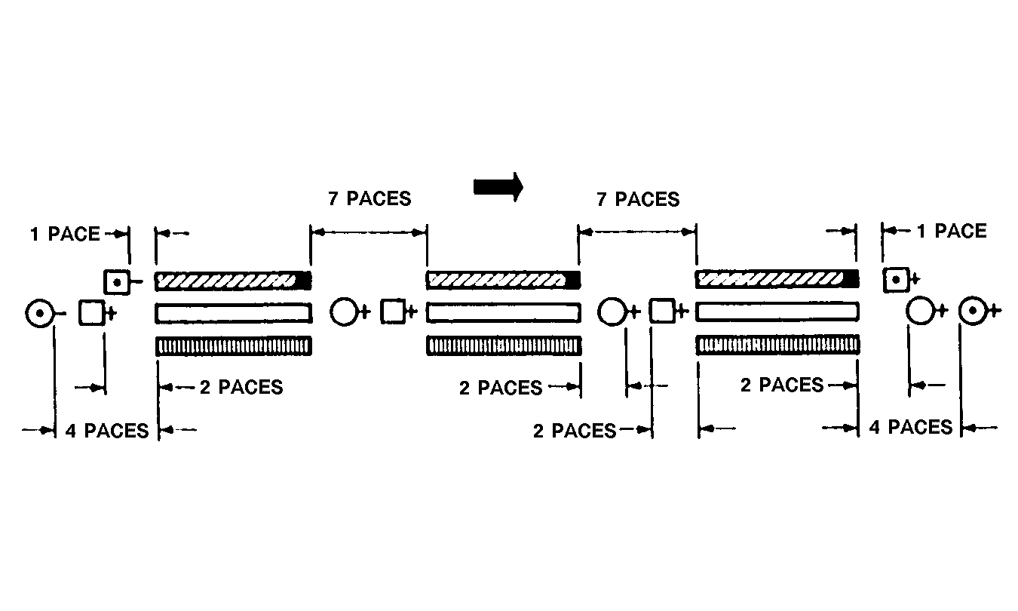
Figure 1-3 Squadron in Column of Route
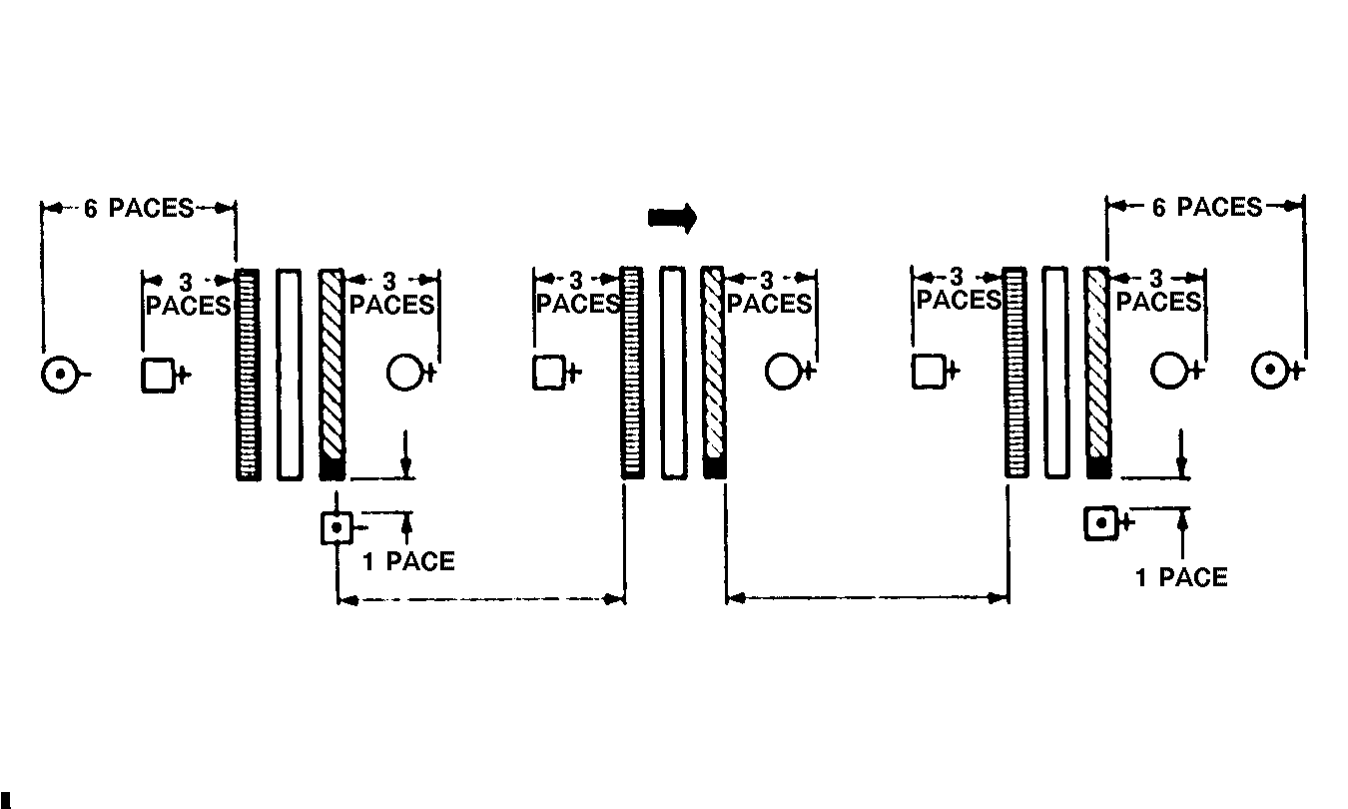
Figure 1-4 Squadron in Column of Flights

THE REVIEW PARADE GROUND

10. The following elements are elements of the review parade ground, no matter which drill formation is used by the squadron:
a. flags and markers;
b. dias;
c. inspection line;
d. march-past line; and
e. saluting base.

11. The review parade ground is marked by flags or markers as illustrated in Figure 1-5. The markers guide the cadets along the march-past line and clearly indicate where they must fall in, where they should start saluting and where they should stop saluting, etc.

12. The inspection line is the line on which the front rank of the squadron is formed for inspection. The march-past line is the line along which the right flank of the squadron marches during the march-past. The advance line is the line at which the front rank of the squadron halts on completion of the advance in review order.
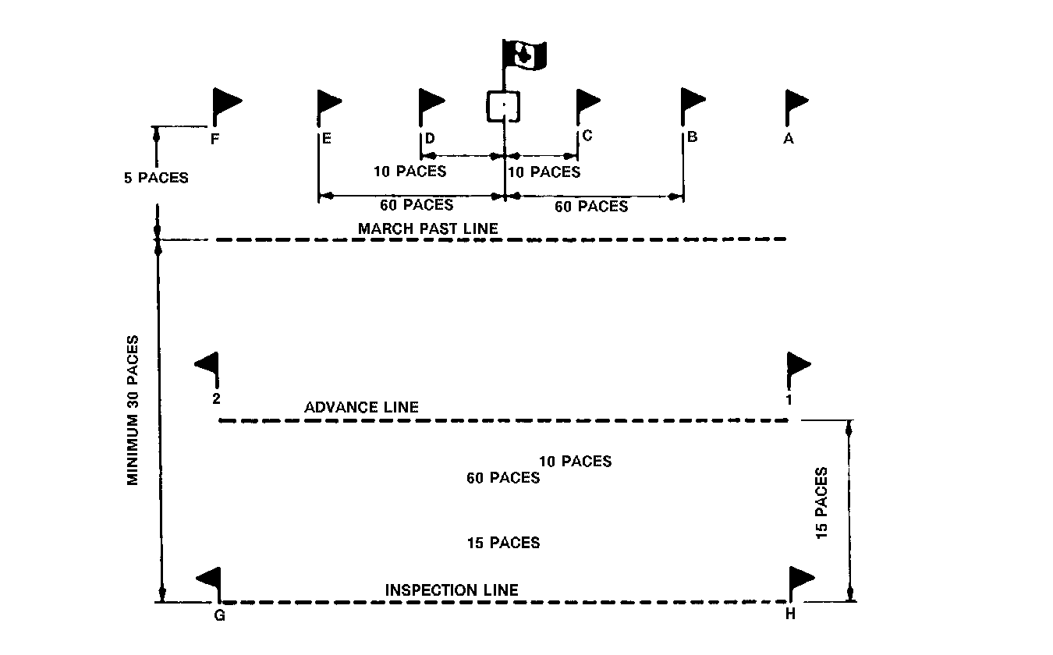
Figure 1-5 Review Parade Ground
13. The length of the inspection line (G-H) depends on the frontage of the troops being inspected. Its distance from the march-past line includes the greatest frontage occupied by the band or the massed bands while playing the units past. Except in unusual circumstances, minimum distance from the march-past line shall be 30 paces.

14. The length of the saluting base (B-E) shall not be less than 120 paces nor greater than 260 paces, depending on local conditions. The march-past begins at Point B and ends at Point E. The reviewing officer is located at the centre of the saluting base. Ten paces on each side of the officer, along the saluting base, are Points C and D, at which the salute begins and finishes respectively. If a march-past is to take place without opening and closing order, ie, in quick time only, Points B and E need not be marked, but points A and F should still be located normally.

15. As a general rule, the march-past line (A-F) is the same length as inspection line and is situated no less than five paces in front of the saluting base.

16. The advance line is the same length as the inspection line and is normally situated 15 paces forward of the inspection line.

17. All points are marked by flags or pennants. Flags may also be set to mark the spot on which the cadets are to form (Points 1 and 2) and the inspection line (Points G and H). These locations may also be marked by other means, eg, chalk or ribbons. Be careful not to use something that could damage the gymnasium floor. Such a floor is really expensive to repair or replace.

FORMING UP A SQUADRON

18. Prior to forming the squadron, the flight sergeants call and inspect their flights. Then they position their flights (sized if so ordered) as directed by the SWO, normally at the edge of the parade ground. They report their flight strengths to the SWO prior to the markers being called.

19. An air cadet squadron is usually formed up in line. The squadron is normally formed up in the centre of the allotted parade ground. Knowing the squadron's strength and frontage, the SWO selects where to fall in the markers by dividing in two the squadron's frontage, including intervals, and marching the appropriate number of paces to the right flank.

20. The following table contains all the commands the actions taken to form up a squadron in line:

No. | Command | By | Action | Remarks
1 |  |  | The SWO marches to and halts in a position to be occupied by the marker of No. 1 flight. | The flights are normally positioned standing easy at the edge of the parade ground. The SWO faces the future position of the front rank if the squadron is to form up in line, and the right flank if the squadron is to form up in column of route.
2 | MARKERS | SWO | The flight markers come to attention and march onto the parade ground. The marker of No. 1 flight halts three paces in front and facing the SWO. The remainder halt on the left of the No. 1 Flight marker and dress to the right at shoulder length. Upon completion of dressing, they look to the front in succession from the right. | Flights formed on the edge of the parade ground adopt the stand-at-ease position. Standard pauses are observed between drill movements.
3 | MARKER, NUMBERS | SWO | Markers number in succession from the right, eg, Nos. 1, 2, etc.
4 | NO. 1 RIGHT, REMAINDER, LEFT TURN | SWO | No. 1 flight marker turns right, the remainder turn left. | The SWO specifies the number of places to be taken by Nos. 2 and 3 flight markers after the completion of the left turn.
5 | NO. 1, STAND FAST, REMAINDER, QUICK MARCH | SWO | No. 1 flight marker stands fast, the remainder quick march the remainder distance and halt.
6 | NO. 1 STAND FAST, REMAINDER ABOUT TURN | SWO | No. 1 flight marker stands fast, the remainder about turn and cover off the No. 1 flight marker. | The SWO, by wheeling, marches out 6 paces in front of No. 1 flight marker and ensures the markers are covered off.
7 | MARKERS, STEADY | SWO | The markers stand fast
8 | MARKERS, LEFT TURN | SWO | The markers turn left. | The order places the markers in line. The SWO then, by wheeling, stands six paces in front of and facing the future centre of the squadron.
9 | SQUADRON, FALL IN | SWO | The flight sergeants come to attention, about turn, facing their respective flight together.
10 | NO. 1 FLIGHT, ATTENTION | NO.1 flight ser-geant | The flight acts as ordered. | Nos. 2 and 3 flight sergeants order their flights to attention in succession, following No. 1 flight.
11 | NO. 1 FLIGHT, QUICK MARCH | NO. 1 flight ser-geant | The flight acts as ordered and marches. | Nos. 2 and 3 flight sergeants similarly order their flights in succession following No. 1 flight.
12 | NO. 1 FLIGHT, HALT | NO. 1 flight ser-geant | The flight halts on its marker.
13 | SQUADRON, OPEN ORDER, MARCH | SWO | The squadron acts as ordered.
14 | SQUADRON, RIGHT DRESS | SWO | The squadron acts as ordered. | The SWO and the flight sergeants dress the squadron as described in paragraph 22, note question 2.
15 | SQUADRON EYES FRONT | SWO | The squadron acts as ordered.
16 | REPORT YOUR FLIGHTS | SWO | Flight sergeants report their flights. | Flight sergeants, when indicating their flights, shall use the procedure for telling off their flights. Meanwhile, the flight commanders position themselves ready to fall in. The deputy squadron commander shall stand two paces behind the SWO.
17 |  |  | The SWO turns about, salutes and reports the squadron to the deputy commander. The deputy commander orders the SWO to fall in. The SWO turns right and marches to the appropriate position on parade. The deputy commander takes two paces forward to assume SWO's former position. | The deputy commander waits until the SWO has adopted the new position before giving any further commands.
18 | FLIGHT COM-MANDERS, FALL IN | D/ COMD | The flight commanders act as ordered. | Flight sergeants report their flights and, after being ordered to fall in, turn right and march to their positions. The squadron is now ready, at the appointed time, to receive its cadet squadron commander. The latter marches onto the parade ground and stands two paces from the deputy commander.
18 | FLIGHT COMMANDERS, FALL IN (CONT) |  |  | turns about and calls the squadron to attention as the cadet squadron commander approaches.
19 | SQUADRON, ATTENTION | D/ COMD | The deputy commander reports the squadron to its commander. The cadet squadron commander orders the deputy commander to fall in. The deputy commander turns right and by a succession of wheels marches to the position on parade. The cadet squadron commander stops forward 2 paces, adopting the formerly occupied by the deputy commander.
20 | SQUADRON STAND-AT-EASE | SQN COMD | The squadron acts as ordered. | The cadet squadron commander carries on by inspecting the flights or having the flight commanders inspect their own flight.  It is common practice for the cadet squadron commander to talk to the cadets while waiting for the reviewing party to arrive. While doing so, the cadet squadron commander ensures the cadets are ready for the march-past.

DRESSING A SQUADRON IN LINE

21. On the command RIGHT: DRESS by the SWO:

a. The cadets dress by the right, the right-handed single file of the squadron looks straight to its front.

b. The flight sergeants of Nos. 2 and 3 flights pace off the proper interval between the flight on their right and their own flight and position their markers accordingly. Upon completion, they return to their normal position in line and dress to their right.

c. The SWO turns left and marches to a position five paces to the right of the squadron and dresses each rank in succession in the following manner:

(1) Facing the front and in line with the front rank, the SWO dresses the front rank and orders FRONT RANK, STEADY.

(2) The SWO turns left, and keeping arms at the side, paces off the interval, halts, turns right, and dresses the centre rank. The SWO then orders CENTRE RANK, STEADY.

(3) The SWO turns left, and, keeping arms at the side again paces off the interval, halts, turns right, and dresses the rear rank. The SWO then orders REAR RANK, STEADY.

d. The command EYES FRONT is ordered by the WO after returning to the front of the squadron.

FALLING IN THE FLIGHT COMMANDERS

22. The flight commanders position themselves five paces in rear of and centred on the deputy commander. Dressing is automatic and flight commanders stand at ease in succession from the right.

23. The deputy commander orders the SWO to fall in, moves to the SWO's former position, turns about and orders the flight commanders to fall in.

24. On the command FLIGHT COMMANDERS FALL IN by the deputy commander, the flight commanders come to attention, turn left and march to their respective flights, approaching their flight sergeant from the right flank (figure 1-6)

25. Following the same procedures as for a flight parading independently, each flight is handed over to its flight commander. Once the flight sergeants are in their new positions, the flights are stood at ease by their commanders in succession from the front (right). When the last flight commander orders the flight to stand at ease, flight commanders turn about and stand at ease together.

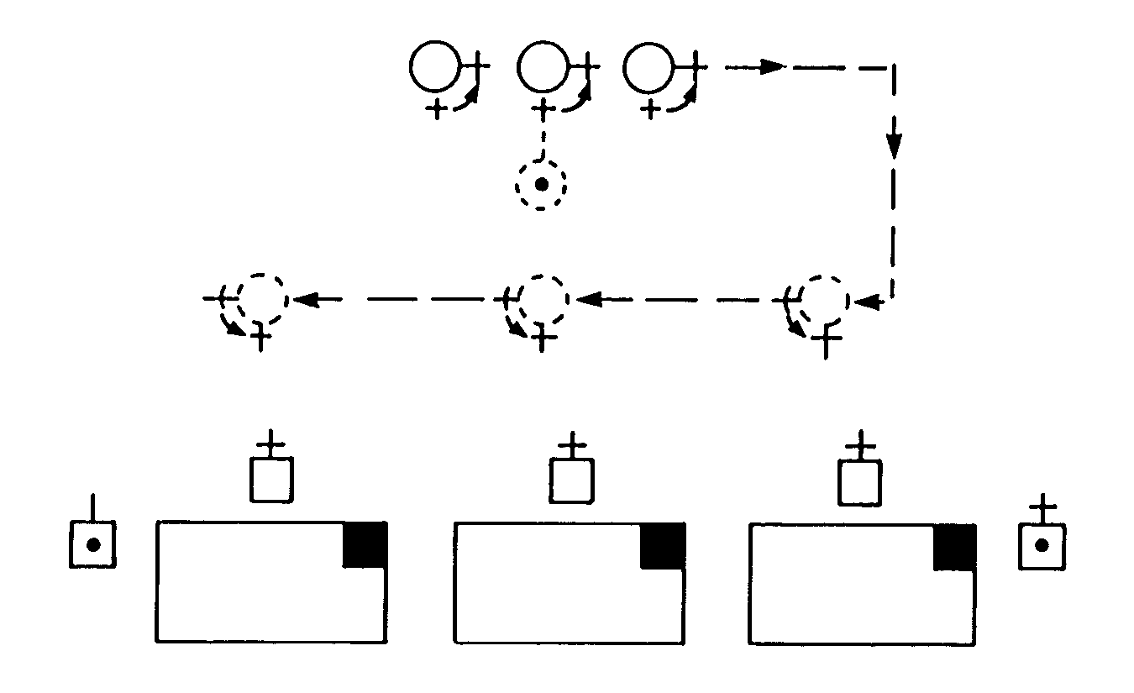
Figure 1-6 Flight Commanders Fall In

THE SQUADRON REVIEW

26. Air cadet squadrons are usually reviewed:
a. once a week by the squadron training officer in collaboration with the cadet squadron commander;
b. once a month by the squadron commanding officer (CO), who inspects the cadets dress and deportment during the march-past. The CO is often joined by civilian and military guests. Commanding officers' parades are the ideal occasion for the squadron cadet commander to proudly present, on parade, the results of the cadet's work; and
c. once a year, during the squadron annual inspection, by a guest reviewing officer, jopined by a representative of the Air Cadet League of Canada and a representative of your regional cadet office. The annual inspection is the equivalent to the school graduation night where everybody graduates from one level of training to another. It is the ideal occasion for the commanding officer to proudly present the cadets on parade.

27. It is possible that your squadron may proceed in a different way, depending on the efficiency of your cadets or your commanding officer. No matter how often the squadron is reviewed, it should always be done in the same manner.

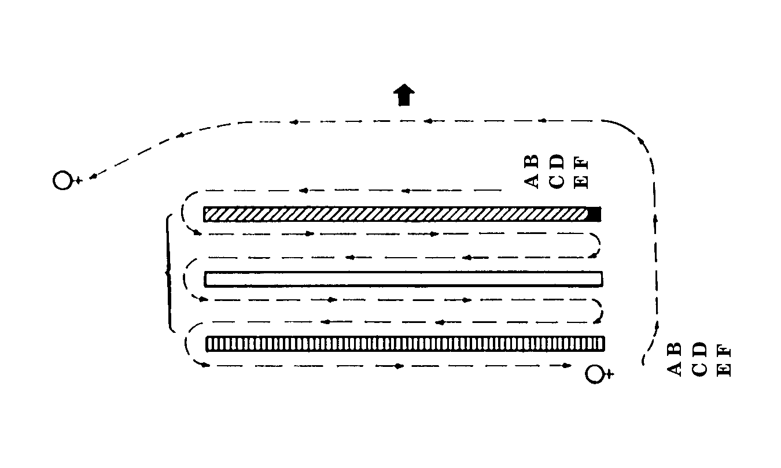
Figure 1-7 Squadron Review

28. The squadron can be reviewed by flight or in line. When the inspection is conducted by flight the reviewing groups do so one flight at a time, normally accompanied by the appropriate flight commander. For the review in line, the reviewing groups do so one rank at a time, starting with the front ranks of all the flights, followed by the centre ranks and then the rear ranks, accompanied by the cadet squadron commander only. The type of review to be performed depends on the number of cadets and the time available, and is chosen by the squadron training officer.

29. Inspections are carried out at the open order.

30. When cadet squadron commanders wish to inspect their squadrons they do so one flight at a time, normally accompanied by the appropriate flight commander, the deputy squadron commander and the SWO. The cadet squadron commander orders NUMBER ONE FLIGHT STAND FAST, REMAINDER STAND AT EASE and then inspects the squadron, commencing with the flight ordered to stand fast. Once the inspection is completed, it is common practice for the cadet squadron commander to address constructive comments to the flight commander.

31. If the commanding officer wishes to inspect the squadron, the CO is accompanied by the cadet squadron commander, the flight commander (inspection by flight) and, if the CO wishes, by one or two guests.

32. As the squadron commander approaches the flight that has been ordered to stand fast, the flight commander turns right and moves to a position three paces in front of the appropriate flight marker, and reports the flight. The remaining flight commanders observe the cadet squadron commander. As the cadet squadron commander commences inspecting the rear rank of the preceding flight, the flight commanders turn about to face their flight, order their flight to attention, turn left, and move to a position three paces in front of their respective markers, where they report their flights.

33. When cadet squadron commanders do not wish to inspect their squadron personal, they may order the flight commanders to carry on with the inspection. Flight commanders then inspect their flights, accompanied by the flight sergeant.

34. When the inspection of a flight is completed, the flight commander returns to the flight's centre front, orders CLOSE ORDER MARCH and STAND AT EASE, following which the flight commander turns about to face the fronts, stands at ease, and awaits further orders from the cadet squadron commander. When the inspection of the squadron is completed, the cadet squadron commander orders ATTENTION, and then:

a. turns the squadron over to the deputy commander;

b. falls out the flight commanders and turns the company over to the SWO;

c. falls out the deputy commander, the SWO and the WO (left guide) and orders flight cammanders to carry on with flight duties; and

d. follows specific directives as ordered by the training officer.

FALLING OUT THE FLIGHT COMMANDERS

35. Prior to giving the order for flight commanders to fall out, the cadet squadron commander takes up a position that allows the flight commanders to halt at the required distance in front of the cadet squadron commander, with sufficient space left for the flight sergeant to occupy the position vacated by the flight commander of the centre flight.

36. The command FLIGHT COMMANDERS FALL OUT is given by the cadet squadron commander when the squadron is at attention.
37. The flight commanders march by the most direct route and form up in line, five paces in front of, centred on and facing, the cadet squadron commander, at arm's length interval, the deputy commander on the right. When all are present and in line, the deputy commander shall take a half pace forward. As the deputy commander's right foot completes the movement, all flight commanders observe a standard pause and salute. When ordered by the cadet squadron commander to DISMISS, the deputy commander steps back one half-pace. All flight commanders observe a standard pause, salute and march straight forward off the parade ground.

38. On the command FLIGHT COMMANDERS FALL OUT, the flight sergeants march around the left flank of their flights and occupy the positions vacated by the flight commanders.

39. When the flight sergeants are in position and the flight commanders have been dismissed, the cadet squadron commander orders the squadron to stand at ease.

40. After the squadron has been stood at ease, the cadet squadron commander calls the SWO forward. On arrival, the SWO receives instructions. The cadet squadron commander then turns and marches off the parade ground. The SWO calls the squadron to attention as the cadet squadron commander departs. The SWO then carries on as instructed.

SEQUENCE OF A SQUADRON REVIEW

41. The sequence of a squadron review combines the following:

a. the reception of the reviewing officer;

b. the inspection;

c. the march-past;

d. presentations, if any;

e. the address ot the reviewing officer;

f. the advance in review order; and

g. the departure of the reviewing officer.

42. At the time ordered for the review, the squadron is formed at the open order, in line, on the inspection line, ready to proceed.
43. When the reviewing officer or the squadron commanding officer has taken up a position on the dais, the cadet squadron commander orders the General Salute. The band plays the appropriate music and all cadets holding officers positions on parade salute, cutting their arms to the side after a standard pause after the last note of music. If a band is not available, the salute is completed with a standard pause between movements.

44. Upon termination of the salute, the cadet squadron commander reports to the reviewing officer that the squadron is ready for inspection.

THE INSPECTION PARTY

45. The members of the reviewing group should position themselves in one of the following manners (see Figure 1-7):

a. review by flight, by the cadet squadron commander:

Position A – the cadet squadron commander, nearest the rank being inspected;

Position B – the flight commander, on the right of the cadet squadron comander; and

Position C – the deputy squadron commander, in the rear of the cadet squadron commander;

b. review in line, by the cadet squadron commander:

Position A – the cadet squadron commander, nearest the rank being inspectedcd; and

Position B – the deputy commander, on the right of the cadet squadron commander;

c. review by flight by the squadron commanding officer:

Position A – the squadron commanding officer, nearest the rank being inspected;

Position B – the flight commander, on the right of the squadron comanding officer;
Position C – a civillian or military guest, in the rear of the squadron commanding officer; and

Position D – the cadet squadron commander, in the rear of the flight commander;

d. review in line by the squadron commanding officer:

Position A – the squadron commanding officer, nearest the rank being inspected;

Position B – the cadet squadron commander, on the right of the squadron commanding officer;

Position C – a civilian or military guest, in the rear of the squadron commanding officer; and

Position D – a civilian or military guest, in the rear of the cadet squadron commander; and

e. review in line by the annual inspection reviewing officer:

Position A – the reviewing officer, nearest the rank being inspected;

Position B – the cadet squadron commander, on the right if the reviewing officer;

Position C – the Air Cadet League representative, in the rear of the reviewing officer;

Position D – the squadron sponsor's president, on the right of the League representative;

Position E – the regional cadet office representative, in the rear of the League representative; and

Position F – the squadron commanding officer, on the right of the regional cadet office representative.

46. The reviewing groups described in paragraph 47 are those most commonly used by air cadet squadrons. It is possible, however, that regional differences may slightly modify the order that everybody occupies
within the reviewing group. Ask your training officer, who will tell you exactly how it should be done in your region.

47. Unless specifically requested, the reviewing officer shall not be preceded by anyone.

48. The reviewing officer normally inspects the squadron by flight, accompanied by each flight commander. On a large parade, or when time is a factor, the reviewing officer may be accompanied by the cadet squadron commander only, with the cadet squadron commander on the reviewing officer's right. In this event the squadron remains at attention, and inspections are conducted across the complete frontage of the squadron.

49. The reviewing officer does not normally visit or inspect the band unless it is an integral part of the squadron being inspected.

50. On completion of the inspection and after the cadet squadron commander accompanied the reviewing officer to the dais, the cadet squadron commander shall order the squadron to attention and request permission to march past in review.

THE MARCH-PAST

51. Air cadet squadrons normally march past in column of route, in quick time, since it is the simplest march-past. The procedures, commands and actions required to march past in column of route are described in the following table:

No. | Command | By | Action | Remarks
1 |  |  | Upon receiving permission to proceed, the cadet squadron commander salutes, turns about and returns to the command position.
2 | MOVE TO THE RIGHT IN COLUMN OF ROUTE, RIGHT TURN | SQUADRON COM-MANDER | Squadron acts as ordered. | Cadet squadron commander, deputy commander, SWO, WO, flight commanders and flight sergeants take up position in column of route.
3 | SQUADRON, BY THE LEFT, QUICK MARCH | SQUADRON COM-MANDER | Squadron acts as ordered.  At the first suitable point past Point H, the cadet squadron commander wheels left and the squadron follows. Upon reaching the march-past line, the cadet squadron commander leads the squadron along the line.
4 | BY THE RIGHT | SQUADRON COM-MANDER | The SWO (right guide) moves to the right flank and leads the rear flank of the squadron along the march-past line. | Given after the cadet squadron commander has completed the wheel.
5 | IN SUCCES-SION BY FLIGHT, EYES RIGHT | SQUADRON COM-MANDER |  | Given at Point B.
6 | NO. 1 FLIGHT, EYES RIGHT | NO. 1 flight commander | Cadet squadron commander and No. 1 flight commander salute, flight turns head and eyes to the right. | SWO maintains head and eyes to the front, guiding No. 1 flight on march-past line. Each succeeding flight commander repeats these commands. Flight act as ordered.
7 | IN SUCCES-SION BY FLIGHT, EYES RIGHT | SQUADRON COM-MANDER |  | Given as squadron commander has reached Point D.
8 | NO. 1 FLIGHT, EYES FRONT | NO. 1 FLIGHT COM-MANDER | Squadron commander and flight commander cease salute, flight turns heads and eyes to the front. | Given as the whole flight has passed Point D. Flight commanders know their flight frontage and the number of paces required.
9 | BY THE LEFT | SQUADRON COM-MANDER | Squadron commander wheels left at Point F, squadron follows. | Given just as wheel started by squadron commander upon reaching Point G. Squadron commander wheels left leading squadron onto the inspection line.
10 | SQUADRON  ( ), MARK TIME | SQUADRON COM-MANDER | Squadron marks time, remainder continues forward until arrival at original position and then marks time.
10a | SQUADRON ( ), HALT |  |  | If the squadron is experienced at maintaining proper distance, only the command HALT needs be given as the squadron arrives at its original position
11 | SQUADRON ADVANCE, LEFT TURN | SQUADRON COM-MANDER | Squadron turns left.

PRESENTATION AND ADDRESS

52. If presentations are to be made, they take place after the march-past.

53. Following any presentation the reviewing officer may address the squadron. Cadets are normally standing at easy unless specified otherwise by the reviewing officer.

THE ADVANCE IN REVIEW ORDER

54. On the command ADVANCE IN REVIEW ORDER, BY THE CENTRE, QUICK MARCH by the cadet squadron commander, the squadron advances 15 paces and halts automatically, completing all forward movement on the last pace, and then bending the right knee and assuming the position of attention.

55. In exceptional circumstances, where space does not permit the minimum 30 paces between the march-past and inspection lines, a lesser advance may be specifically ordered, eg, ADVANCE IN REVIEW ORDER 9 PACES, BY THE CENTRE, QUICK MARCH. The front rank always halts no closer than 15 paces from the march-past line. If fewer than seven paces can be taken, there shall be no advance.

56. The cadet squadron commander then orders The General Salute. The music to be played, at the discretion of the commanding officer, is:

a. The General Salute, or

b. an appropriate excerpt from the official march of the formation or unit being inspected; or

c. an appropriate excerpt from the official march of the military formation or unit of which the dignitary is a member (for example, if the reviewing officer is member of the Cadet Instructor List (CIL), the musical excerpt may come from La feuille d'érable which is the officical march for CIL officers or the coda from RCAF March-Past.

57. The national anthem shall not be played or sung if the dignitary is an officer, regardless the rank.

THE DEPARTURE OF THE REVIEWING OFFICER

58. On completion of the salute, the reviewing officer departs.

59. If the cadet squadron commander is asked to follow the reviewing officer, the cadet squadron commander does so, only after calling forward the deputy commander and formally turning over the command of the squadron.

SECTION 3

CONCLUSION

1. Precision in the execution of drill movements, accuracy in the commands, sharpness demonstrated by the cadets in a command position and the overall deportment of the cadets on parade are often indicative of the quality of training received and the esprit de corps existing within the squadron. The sharpness in your voice as you deliver your commands will likely dictate the energy by which the cadets will react. It is therefore important for you to know all the details pertinent to the position you will hold on parade.

PO 402
D

R
I
L
L

I
N
S
T
R
U
C
T
I
O
N

CHAPTER 2

PERFORMANCE OBJECTIVE 402 – DRILL INSTRUCTION

SECTION 1

INTRODUCTION

1. Drill occupies a very important place in the development of squadron morale, especially with young cadets. Very few things equal the feeling of pride experienced by members of a flight or squadron to the sound of a drum or military band.

2. The level of precision of movements depends greatly on the efforts of the cadets during practice period. The efficiency with which the instructor applies instructional techniques and teaching methodology also contributes to the overall efficiency of the performing flight.

3. You have had the chance to witness several instructors in the heat of the action over the past four years. Some of the many have had impressed you more than others, both by their style and bearing in front of a group. You will now have the occasion to exert the same influence on younger cadets.

4. The present chapter is a repetition of teaching you received last year. Consult this chapter and develop your own style of teaching. Remember that drill does not have to be difficult or strenuous to be interesting. It is up to you to determine the atmosphere in which the cadets will develop. Your cadets will make mistakes. Be sure to be patient, positive and correct all errors immediately.

SECTION 2

THE DRILL LESSON

1. This year, you will learn instruction techniques that will allow you to teach in a classroom. Most of these techniques – PO 409, Chapter 8 – can also be applied to teaching drills. As with the classroom lesson, there are four major headings that must be considered. They are the introduction, the body, the test and the conclusion. The contents of each of these four headings are similar to that of a classroom lesson, although there are some drill differences.

TEACHING DRILL

2. Preliminaries. The following duties should be performed before commencing the lesson:

a. Review the appropriate lesson.

b. Order the squadron into a suitable formation, eg, hollow square.

c. State the movement to be taught and the reason for its teaching.

d. State the requiremnt for the performance check.

3. The Lesson. The lesson should be taught in the following two stages:

a. Stage 1

(1) Demonstrate the complete movement, calling out the time.

(2) Demonstrate the first part of the movement.

(3) Explain how the first part of the movement is done.

(4) Give the squadron the opportunity to ask questions.

(5) Practice the squadron on the first movement (collectively, individually, collectively).

(6) Teach the second and each subsequent movement following the sequence described in 2, 3, 4 and 5.
b. Stage 2

(1) Practice the complete movement, with the instructor calling time.

(2) Practice the complete movement, with the squadron calling the time.

(3) Practice the complete movement, with the squadron judging the time.

4. Performance Check Test. Conduct the test.

5. Conclusion. The lesson should be summarized in the following manner:

a. Restate the movement taught and the reason for teaching.

b. State the level of achievement.

c. State the next lesson.

CALLING OUT THE TIME

6. In the early stages of training, the squadron calls out the time when executing drill movements. After completing a movement on the march, the cadence is called for three paces, eg, on quick march, the squadron calls LEFT RIGHT LEFT.

7. To warn the cadets that the time is to be called out, precede the command for the movement by the cautionary command CALLING OUT THE TIME,

8. As an example, on the command CALLING OUT THE TIME, RIGHT TURN, the squadron :

a. executes the first movement of the turn on the executive order and simultaneously calls ONE;

b. on completing the first movement calls, TWO, THREE while observing the standard pause; and

c. when executing the final movement calls out ONE.

TYPE OF FORMATION

9. As you prepare for the lesson, you must decide what type of formation to use while teaching. The three formations most commonly used are the single file for small groups of 5 cadets or less, the semi-circle (executed without any word of command) for groups of 6 to 9 cadets and finally, the hollow square formation used for groups of 10 cadets or more. Note that these numbers correspond to the number of cadets required to form one, two or three ranks of a squadron.

10. Do not hesitate to split the squadron in two or three groups and ask other instructors to help you if the group is too large.

THE HOLLOW SQUARE FORMATION

11. The hollow square formation (see Figure 2-1) is ideal for drill instruction as it will allow each cadet to see your demonstration and hear comments. It will also allow you to supervise closely.

12. The squadron will be in line three ranks prior to forming the hollow square.

13. One the command FORM HOLLOW SQUARE, CENTRE RANK RIGHT, REAR RANK LEFT TURN, the squadron acts as ordered.
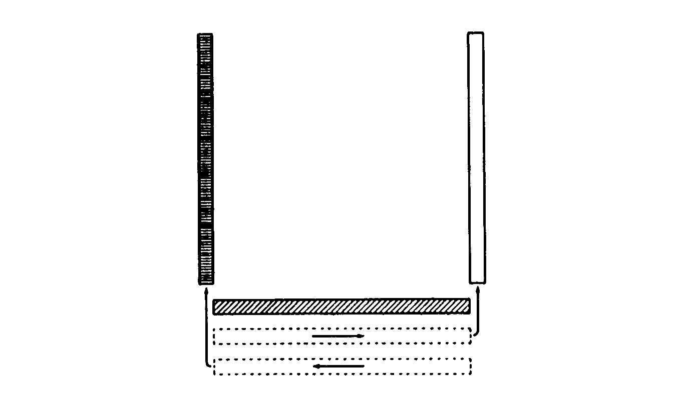
Figure 2-1 The Hollow Square
14. On the command CENTRE RANK LEFT WHEEL, REAR RANK RIGHT WHEEL, QUICK MARCH, the squadron acts as ordered.

15. The command MARK TIME will be given when the rear cadet of the centre and rear ranks are one pace in front of the front rank.

16. On the command SQUAD HALT, the squadron acts as ordered.

17. On the command CENTRE RANK LEFT, REAR RANK RIGHT TURN, the squadron acts as ordered.

18. The reverse procedure is used to reform the squadron into three ranks.

INSTRUCTIONAL TECHNIQUES

19. Instructor's Appearance and Bearing. Since example is imitated, your appearance and bearing must be of the highest standard. When conducting drill instruction, stand at attention unless it is necessary to demonstrate or to correct and individual. Execute all movements correctly and smartly.

20. Demonstrations. Demonstrations must be planned so that the squadron can see the position or movement. Be careful not to demonstrate too often. Excessive demonstration can bore your cadets.

21. Checking. Constant checking and correcting of faults is essential. Faults should be corrected after they occur.

22. Vocabulary. Aim to develop a vocabulary of short, concise words with which you can impress on the squadron the movement must be performed smartly. For example, the words crack, drive, and strike suggest the degree of smartness required in the execution of the movement.

23. Short Rest Periods. Cadets always learn drill movements better if they are given short rest periods during lesson. Command the squadron to stand easy and allow the cadets to bend their knees and stretch out their arms. During the rest periods try telling a short joke or a personal anecdote or focus of the concept of working as a team.

24. Correction of Faults. If you want to correct a cadet's drill position, DO NOT STRIKE OR PUSH the cadet. Just indicate what has to be corrected and give the cadet the time to adjust. Never use physical strength to impress others: you may frighten a cadet.

25. When well executed, drill asks of the cadet a great deal of energy and concentration, which may diminish after a while. Do not hesitate to encourage the cadets, even for small improvements. You will need a great deal of patience to bring everyone to work as a team, remember that all the cadets deserve to be congratulated and commended for their efforts.

MECHANICAL AIDS TO DRILL

26. It can be very difficult to keep the right cadence, especially with young cadets. To help you deal with this problem, use one of the following tools:

a. Drums: Ask a musician in your band to beat the cadence on a drum. Young cadets enjoy the sound of the snare and bass drums.

b. Metronomes: A metronome is a mechanical device that can be adjusted and used to give the exact cadence. There are two types of metronomes. The first one is the pyramid shaped pendulum metronome. It has to be cranked from time to time and is the most commonly available. The electronic (or quartz) metronome is powered by a battery, thus ensuring a long-lasting and constant cadence. The advantage of the electronic metronome is that the beat will not slow down when the battery and the volume weaken, as it is the case with the pendulum.

27. When teaching a more difficult movement, use a cadet as an example. Make sure that this cadet can perform the movement well. If your squadron has a drill team, use the cadets from the specialized team; they already know the movements and this exercise can serve as a good revision.

28. When your cadets have learned drill on the march, but require some minor improvements like height of the arms, the lifting of the head, the alignment during wheeling, etc, you could play a tape of the military marches. This music, specifically written for marching, is very dynamic and offers a constant cadence. As you will notice by doing so, your cadets will soon straighten their shoulders and chin, and they will march with more energy!

AS YOU WERE

29. AS YOU WERE will only be ordered when another word of command cannot be used to have a squadron adopt a previous position or to cancel an incorrect order before it has been completed.

SECTION 3

CONCLUSION

1. Drill instructors are different from other instructions because they have to behave in such a way that cadets have no choice but to respect them constantly on and off the parade square. Very few instructors can say that they have such impact on young cadets.

2. Your uncompromising attention to detail will often be mistaken by some cadets for a form of harrassment. Some of them will be afraid of making mistakes while you are around. You have to make sure that all cadets understand that you insist on excellence to help everybody to work together.

3. The tone of your voice should be firm but never haughty or aggressive. Cadets soon come to understand the difference. DO NOT SHOUT! No matter how many mistakes cadets make, they deserve your respect and your help! Be patient and if needed, ask for another instructor's assistance to take care of cadets having difficulty.

4. Your teaching task should not be limited to the parade square. Never hesitate to stop and correct a cadet's drill outside of a drill class. Your cadets will likely be thankful and appreciate your interest and concern.

PO 404
C
I
T

I
Z
E
N
S
H
I
P

CHAPTER 3

PERFORMANCE OBJECTIVE 404 – CITIZENSHIP

SECTION 1

THE MEMORANDUM

1. Have you ever wondered why your officers always seem to be writing at their desks or scribbling in a pad during exercises? The answer comes in part from their function within the squadron. Officers must plan the work of the squadron and establish policies to help guide the activities of the unit. In order to accomplish these tasks, officers must put pen to paper. They write memoranda (memos), operational orders, course reports, performance evaluation reports, military letters and service papers. They fill in forms, type up standing orders, establish financial budgets, craft the minutes of meetings, file loss reports and conduct summary investigations. The paperwork can seem endless!

2. All of this paper in not without its purpose, however, as it is an essential component of any activity that appears on the calendar of events. In other words, the training of cadets cannot happen without the proper administration of the unit. For example, every weekend exercise that your training officer organizes requires ops orders which will be supplemented by several memoranda requesting outside services. If equipment goes missing, a loss report must be completed. So, as you can see, paperwork is not an end in itself but rather as a means to conduct training.

3. PO 408 – Leadership teaches you to organize activity for your cadets. You will probably be asked to organize quite a few of these in future years with the squadron. One of your responsibilities as an organizer will be to communicate with other people to ensure their presence or request their services. You will also communicate quite often with other people during regular training sessions. You will be constantly put in situations where your ability to communicate will be tested.

4. As you well know, communication may be accomplished in several ways, using verbal and written means. In your everyday life, you must exchange plenty of information verbally for many different reasons. However, in certain situations, it is better to write the message you want to transmit. This is the case when decisions have to be made, when you want actions to be take, or when you want people to remember the content of your message.
5. The memorandum is the common form of written communication for inter-office use within the military. An inter-office memo is one that can be sent to other military members within your immediate area. For example, memos can be sent to anyone within your squadron, another squadron or a representative from the regional cadet office. It is considered an internal form of correspondence (internal to the Department of National Defence).

6. Before looking at the function and format of a memo, it is useful to consider briefly the importance of military writing. The military has many regulations regarding correspondence. Of these, there are three basic rules to keep in mind during your stay in cadets. These rules are known as the A, B, Cs of military writing.

a. A stands for Accuracy. All that you write in a memo must be precise, accurate and thoughtful. Use only facts that you know to be true and write your sentences so that they accurately portray your situation. For example, there is a big difference between a back-pack weighing a few kilograms and one weighing 25 kilograms. Especially if you are carrying it!

b. B stands for Brevity. In writing a memo, it is important to be as brief as possible. No one wants to read your life story or wade through a long winding tale. State your message briefly, while being careful not to leave out any key facts.

c. C stands for Clarity. Not only must your memo be accurate and brief; it must also be clear. Use short concise sentences and plain words to express your ideas. Your readers must be able to fully understand what you want when they get to the bottom of the page!

7. There is a difference between a memorandum and a regular letter. Since you will be asked to communicate mainly with other members of your squadron, it is important that you read the following instructions carefully. Unless specifically asked by one officer from your squadron, you should not write any official letters to authorities outside the squadron. Your officers have the authority to do that and they will be more than happy to collaborate with you if there is a requirement.

8. A memorandum is mainly used to:

a. request equipment;

b. confirm the services of an individual or group;

c. make reservations;

d. call meetings

e. suggest changes/amendments; or

f. confirm a decision.

9. The next three paragraphs cover the format of a memorandum. Here are a few ground rules first, however. A memo can be typewritten but, for the purposes of this course, you will be asked to write all your memos by hand. Do try to make your handwriting as clear as possible, as there is nothing more embarrassing than taking the time to write a memo only to have your reader phone you back later because your handwriting was illegible.

COMPONENTS OF A MEMORANDUM

10. For an example with explanations, see Figure 3-1. A memorandum is composed of the following:

a. The word MEMORANDUM must appear at the top left of the page. This identifies the kind of correspodence your reader received. To add emphasis, you should underline the word MEMORANDUM with a ruler.

b. The FILE NUMBER is lined up with the left-handed side of the page. Although you might have to use a file number on some of your memos, other memos will not require a file number at all. To help you decide whether to use a file number, ask yourself the following question: Will this memo end up in the filling cabinet or thrown in the garbage? If your memo must stay on reference for a long period of time, then you can assume it will go into the filing cabinet and therefore needs a file number. If in two weeks time your memo will no longer be needed, then you can assume it will end up in the garbage and will not need a file number. If you need a file number, consult your administration officer, who will tell you which number to use.
c. Directly underneath the file number comes the DATE. The military writes dates in the following way:

7 Mar 93

d. Lined up on the left-hand side of the page in the ADDRESSEE BLOCK. This is the block that identifies the person to whom you are sending the memo. The person's appointment or title should be used. To avoid confusion, the person's title is used followed by the squadron number, eg, Training Officer Sqn 999.

e. Immediately following the addressee is the SUBJECT of the memo. This part of a memo should be short and provide a broad summary of the contents. As it is an important part of the memo, it must be underlined with a ruler, eg, REQUEST FOR EQUIPMENT IN SUPPORT OF ANNUAL INSPECTION PARADE 94.

f. The next item in a memo is a LIST OF REFERENCES. Not all memos have references, so this part may not be necessary. You might include a reference to a telephone converstaion (Telcon) or to a meeting you had. For example, if your supply officer called you during the week and asked you to write a memo to request the 10 compasses you need for your training weekend, your reference might read as follows:

Ref: Telcon Lt Martin – (your name), 10 Nov 94

If the contents of your memo, or parts of it, refer to another memorandum and to a decision that was taken previously, your references might read as follows:

Refs a. 1085-62-84 (Sqn 999), 1 Nov 94

b. Planning meeting 2Lt Richter, 8 Sept 94

g. Now it is time to write the BODY of your memo. This is where you explain your situation or request the items you require. There are only two things to remember in the body of the memo: follow the ABCs of military writing and number the paragraphs.
h. The next item is located on the bottom left-hand side of the letter. It is the DISTRIBUTION of your memorandum. When you write a memo you usually intend to :

(1) inform someone; or

(2) ask someone to take action.

Your memo may be addressed to more than one person and may serve many purposes. For example, in Figure 3-1, Sgt Boomer asks Lt Phillips to take action on the requests included in the message. Sgt Boomer also provides a copy of his message to WO2 Black and Sgt White, two members of his working team, for information purposes. You may also address the message to a group instead of listing all group members, eg, all Level 2 Instructors. If the message is intended for one person only, there is no need to use the distribution portion of the memo.

j. The last item in a memo is your SIGNATURE BLOCK. This is where you sign your name and tell your reader who you are. The signature block is made up of your signature, your rank, and your appointment or title. It is located in the bottom left-hand side of your memo. An example of signature block is:

G. Davis
Sgt
Level 3 instructor

11. In writing and dealing with memos, you should know what MINUTES are. Minutes are written comments (or replies) that are added by hand to a clear space o the original memo. In this way, an answer to the memo can be given without having to write up a new memorandum. It is a kind of shorthand that saves everybody time. The memo at Figure 3-1 has a minute attached to the bottom of the page that illustrates where minutes should be placed. A minute should be numbered, include the signature, rank, position, and phone number of the person writing the minute, as well as the date. The person receiving your memo should minute a reply or minute appropriate comments.

12. Finally, remember to use the ABCs of military writing and the correct format for hand-written memos. Minute any memos that you might receive to save time. Above all, don't put memos in your filing box and forget about them – someone has taken the time to write them because they thought it was important to do so.

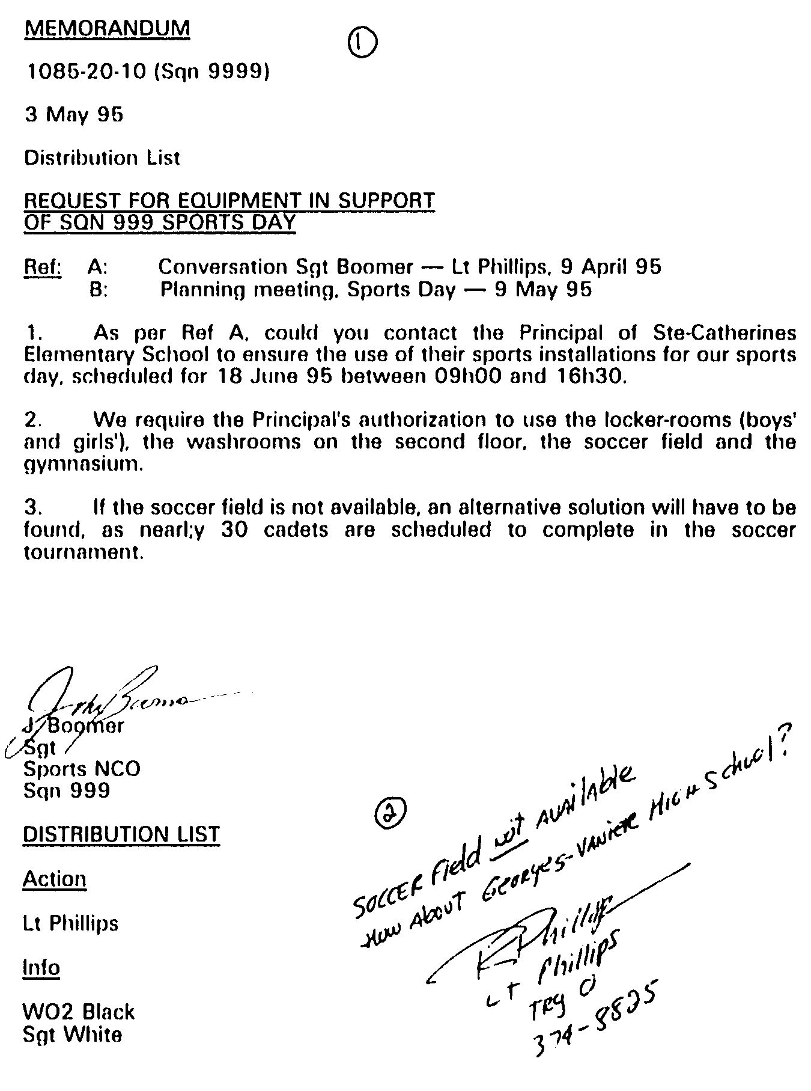
Figure 3-1 Memorandum

SECTION 2

MEETINGS

1. Have you ever been involved in a meeting where everybody was trying to talk at the same time? Where individuals were drowned out by the buzzing of the crowd? Where each participant was trying shout down the next? What a disaster!… You may also have had the unique chance to experience a meeting where everything was done in a very orderly manner and where every participant addressed the group in turn. Although there is a huge difference between these two examples, we may be talking about the same group trying to discuss the same subject… What exactly is it then that makes the group behave in such a way in the first instance, when it may react in an orderly manner on another occasion? What is THE most important factor in determining if a meeting will go well or poorly?

THE CHAIRPERSON

2. When comes the time to keep a good grip over the conduct of a meeting, the CHAIRPERSON is the most important person. It is the chairperson's responsibility to maintain discipline and to ensure that every participant is given a chance to address the group in a methodical and satisfactory way. The chairperson is an integral and necessary part of any meeting.

3. You will have many occasions to preside over meetings in the years to come, whether it is as chairperson or as co-ordinator of an activity. You will even be asked to organize a meeting this coming year! DON'T WORRY! If you stick to the following explanations, you will be able to face any group. As with anything, there is one important principle to remember… PREPARATION IS EVERYTHING.

CHAIRING A MEETING

4. It is just as important for a chairperson to prepare carefully for a meeting as it is for an instructor to prepare a lesson plan and visual aids. If you are asked to chair a meeting, you will have to:

a. Prepare the Agenda. It is your duty to establish the agenda (see Figure 3-2) and to decide precisely what subjects will be discussed. By doing so, you improve your chances of keeping good control over the discussions. It is possible to modify the agenda prior to the meeting as long as all the members are advised.
b. Notify the Members. As soon as your agenda has been written, you must inform the members that a meeting will be held, stating the location, the day and the time. You must also include the draft agenda. This way you ensure that everyone has some time in advance to think about the items opened for discussion, thereby preventing time-consuming explanations. We recommend that you use a memorandum to notify the members and that you add the agenda as an annex.

c. Call the Meeting to Order on Time. Do not wait for everyone to arrive or stop talking to officially open the meeting. Get everyone's attention and announce the opening of the meeting. For example you could say;

It is now seven o'clock. We have a quorum, and if the meeting will come to order we will begin. (pauses for members to arrange themselves and give you their attention). I would like to go over the agenda…

d. Announce the Order of Business as Detailed in the Agenda. It may be a good idea to go through the agenda with the members. If anyone wants to add a new item to the agenda, you may do so, granted the group agrees.

e. Direct the Business and Conduct the Meeting. Your duty is to ensure that the agenda is being respected. Be careful not to let any outside element disrupt the good conduct of the meeting. Take appropriate measures to keep a good grip on the whole process. You must encourage discussion between members and bring them to unanimous decision, if possible. Make people see the two sides of an argument by being the devil's advocate once in a while. Take the time needed to fully analyse every point until everybody, or at least a majority, agrees. If a consensus is impossible due to a tied vote, you have the deciding vote.

Ensure that only one person speaks at a time. It may become very frustrating if many people talk at the same time. Each member must wait for the speaker to finish before replying or answering a question. It is a simple question of politeness! You must determine the order in which those asking to address the group will do so. Cadets usually ask permission to talk by raising their hand.

f. Introduce the Speakers. If the members of the group are not too familiar with one another, you must introduce them. Do this when

the meeting starts or as each speaker addresses the group. Ensure that you know the participants' names, ranks and functions before the meeting starts. If spectators or observers from outside the group want to speak during the meeting, they must receive your permission and wait for you to introduce them. After all, you are the chairperson.

g. Limit the Time Alloted to Speakers. Time in an important factor in a meeting. You must encourage speakers to be clear and concise. Determine, from the start, a time limit for each intervention. By asking everyone to limit their speeches to 5-10 minutes, they will be more inclined to stick to the essentials. If you do not set a time limit, some people may have a tendency to abuse the speaker's privelege and deliver long speeches.

h. Limit Debate to the Question under Discussion. It is really easy to lose control of a group, specially when everybody is having fun! You are responsible for having the group stick to the topic of discussion. A little humour is never a bad thing, and it may even help people relax a little, but once again, keep a good grip on your agenda. You don't want to sleep there either!

j. Maintin Order. No improper behaviour or vulgarity should be tolerated during a meeting. It may happen that someone is tired or frustrated and says something out of order. You have the authority to ask that person to leave the room, if the situation is bad enough to justify such a measure. If this happens, ask to meet with the person after the meeting and refer the case to your superior.

k. Recognize and Secure a Hearing for Those Entitled to Speak. You must decide if the people attending as spectators or observers have the right to speak. If not, ensure they do not take up precious time which should be kept for your members. As for the members themselves, ensure that everybody is given a fair chance to speak out. Do not let a few monopolize the clock and everyone's attention. Bring them back to order. Keep an eye open for members who speak less often or who are too shy to give their opinions.

m. Be Fair, Just and Impartial. As chairperson, you must remain neutral and impartial when the time comes to make a decision. For example, you are not allowed to cut people's speaking time if you do not share their opinions. This is censorship. People are entitled to their own opinions. Be very careful not to censor anyone for personal reasons. However, if someone tends to do things that you
judge unacceptable, you may go as far as limit or suspend that person's access to the discussion.

n. Refrain from Lecturing, being Domineering and Offering Personal Opinions. Being a chairperson does not give you the right to abuse the power steming from the position. Keep your personal opinions for yourself and do not use the hammer as a judge or a…carpenter would!

p. Appoint Committees. If the goal for the meeting is to co-ordinate an activity and you just happen to be the co-ordinator, you should delegate the tasks to different persons or committees. Use the occasion to determine target dates for everyone invloved with a task in the activity.

q. Close the Meeting on Time. Keep an eye on your watch or the clock and spread the workload so that the meeting can finish on time as it was planned. If you need more time ask the group first. It is a simple question of respect. Some members may have made other plans, or someone may be waiting for them, in a car outside.

QUORUM

5. In the conduct of meetings, a quorum is the minimum number of members that must be assembled for the transaction of business. The number is usually set out in the by-laws of the organization. If not so defined, however, a quorum is always the majority of the members present. The purpose of a quorum is to prevent minority groups from dominating the proceedings.

6. When a quorum is not present, the chairperson may either adjourn the meeting forthwith, announcing a new time and place to reconvene, or may, with the consent of the members, proceed with business on the understanding that decisions reached will be subject to ratification at the next meeting.

7. A quorum is usually not a problem with air cadet meetings because attendance is often mandatory or, at least, strongly recommended. A practical way of ensuring a quorum is to ask the members to confirm their presence at the meeting at least 48 hours in advance. Air cadets do not need a quorum to reach a decision, but it would be a good idea for you, the chairperson, to ensure that those absent with a good reason are made aware of any decisions taken during their absence.

THE SECRETARY

8. It is recommended you ask someone to act as your secretary during the meeting. You will need to focus all your attention on doing your job as a chairperson and you won't have time to take notes. Even though it is not mandatory to assign a secretary, if you decide to ask someone, ensure that this person has fairly good handwriting style and can easily condense and summarize the discussions. It would also be advisable to choose someone who is not actively involved in the meeting as a member. The secretary must provide you with a written record (minutes) of everything that has been said and decided on during the meeting.

MINUTES

9. The minutes of a meeting are a record of the actions taken and the decisions reached. You will not be asked to provide minutes for your meetings, but it would be appreciated by everyone if you were to distribute a record of important dates and decisions taken. Use a memorandum to do it and keep it on file. Cadets usually take notes during meetings.

REPORTS

10. If the meeting is conducted to co-ordinate the efforts of cadets or committees, the person responsible for those committees will have to produce reports in which they give the status of their work. These reports do not have to be written. Ensure that the target dates set at the beginning of your project are respected.

VOTING

11. Most civilian organisations must ask their members to vote in order to make any kind of decision. Voting is a democratic process used to ensure that everybody's opinion has the same fair chance of being heard. The military, with its chain of command and its system of delegation, does not allow for much debate. The leaders organize, delegate and supervise the activities. They decide for their subordinates. However, nothing says that you cannot ask your cadets to vote on general items. By doing so, you make them feel they are part of the decision-making process.
Better bend than break.

– Scottish proverb

When you have to make a choice and don't make it,
that in itself is a choice…

– William James

JUST A FEW HINTS…

12. KNOW YOUR FILES THOROUGHLY. If you master the files and subjects which are to be discussed during the meeting, you will enhance your chances of success. Be ready to answer all questions that may be asked by your cadets. If you chair a co-ordination meeting, your subordinates will be looking for supplementary information and answers in order to accomplish their tasks. If you cannot answer their questions on the spot, take notes and get back to them as soon as possible. Your subordinates' efficiency often depends on you own efficiency in helping them.

13. TAKE CONTROL OVER THE MEETING AND KEEP IT. No matter what the rank and status of those sitting in front of you, you are the chairman. It is your responsibility to control the meeting. Politely ask anyone with a tendency to take too much space to let you do your job. It is easier to take and keep control of a group than to try to regain it after you lost it.

14. AVOID DISTRACTIONS. Try to eliminate all sources of distraction before and during the meeting:

a. Shut off the television sets or radios in the room.

b. Hold your meeting around a table, preferably in an auditorium.

c. Ask the cadets to put everything that is not required for the meeting on the floor or elsewhere (binders, purses, books, etc.)

d. Make sure that the room is well ventilated; open the windows if necessary.

e. Keep an eye on those who just can't stop whispering in each other's ears.
15. OBSERVE OTHER CHAIRPERSONS. If possible, ask other chairpersons if you may attend their meetings as a silent observer. Take a good look at them in action. Note their strong points. Ask one of your good friends to watch you in action and recommend constructive changes. Do not try to copy somebody else's style, but work on developing your own instead. Be natural and learn to trust yourself. You may be surprised to find the chairperson's seat more comfortable than you first expected!

Figure 3-2 Example of Meeting Notice/Agenda
MEETING NOTICE

MEETING OF SOCIAL ACTIVITIES COMMITTEE

SQUADRON 999

WILL BE HELD IN THE SQUADRON CONFERENCE ROOM

AT 1830 HR 29 NOV 1994

AGENDA

ITEM SUBJECT SPONSOR

1 Confirmation of Agenda

2 Christmas Party F/Sgt Woodworth

3 United Way Campaign Andrew Baker

4 Lotto-Cadet WO 2 Walker

K. Jones
Flight Sergeant
Chairperson

Distribution List

. . . . . . . .
. . . . . . . .
. . . . . . . .

PO 405
P
H
Y
S
I
C

A
L

F
I
T
N
E
S
S

CHAPTER 4

PERFORMANCE OBJECTIVE 405 – PHYSICAL FITNESS

SECTION 1

GENERAL

1. For the last time this year, you must participate in the Air Cadet Fitness Programme (ACFP) which is an adaptation of the Canada Fitness Award. If you have already attained the excellence level, your participation will be most useful to help motivate the younger cadets. Encourage every member of your group to participate. Tell the cadets what each test is for.

2. Besides participating in the ACFP, you must assist your squadron staff running the sports programme and organizing various sports teams. You will also be required to officiate at various sports meets.

3. The promotion of physical fitness is one of the primary aims of the cadet movement. Team sports, as organized by your squadron, also create and develop teamwork between young and non-commissioned officers (NCOs).

SECTION 2

MINOR TEAM GAMES

1. Minor team games are excellent supplementary conditioning activities that deserve a prominent place in the sustaining stage of physical fitness training. They contribute to the development of circulo-respiratory and muscular endurance and provide stimulating competition, recreation and variety.

2. Minor team games have these main advantages:

a. They provide for maximum participation.

b. They have simple rules and do not require complex skills or team tactics.

c. They do not require sophisticated equipment.

d. They can be played on any easy marked piece of reasonably level ground when regular playing fields or courts are not available.

e. They can used as an effective diversion to maintain the moral of the cadets.

SECTION 3

OFFICIALS

1. The presence of officials is essential to ensure the proper sequence of events at any sports competition. Contrary to popular belief, officials are not used uniquely to ensure the enforcement of rules and discipline. Their function is much broader. It should be noted that an official is an individual whose function within a sports organisation includes the supervision of events (organization, judging and officiating).

2. The number of officials, as well as their type of function, will vary according to the sports and the facilities available. The following list will give you an overview of the variety of tasks performed by officials:

a. co-ordinating the event;

b. acting as umpire;

c. acting as line judge;

d. acting as goal judge;

e. keeping time;

f. keeping score;

g. lead the warm-up;

h. providing technical support and equipment;

j. providing first aid;

k. cleaning up; and

m. other.

3. Your officers and qualified Level 5 cadets should organize a series of meets in which cadets from your squadron will participate. You will be asked to act as an official for one of these competitions. It is therefore important that you take note of the position you will occupy and the tasks assigned to that function as soon as possible. You will probably be advised by the co-ordinator what your functions are at a plannig meeting that will be held a few days prior to the event.
4. It is most important that you be ready to function within your job upon arrival. It will be too late for questions when the whistle blows to indicate the start of play. The efficiency of the officials, while discrete, often makes the difference between an organization that functions proficiently and professionally as opposed to one that generates several complaints.

5. The main role of officials is to ensure that the cadets have fun in an organized and safe manner while respecting all the specified rules. Officials must work in the shadow of the participants; their role is one of support. As soon as an umpire decides to steal the show, the players lose interest and develop a certain amount of frustration. If you are asked to officiate, be sure to be both discrete and fair. You will have to resist the temptation of delegating your responsibilities in order to participate in the game. You have a role to play and you must act it out to the end.

SECTION 4

COMPONENTS OF A PHYSICAL ACTIVITY SESSION

1. Each activity session should consist of three parts:

a. warm up;

b. activity; and

c. cool down.

WARM UP

2. The warm up is an essential part of every session. A warm up routine has a number of benefits:

a. It Prepares the Body for Action. It increases heart rate, warms up the muscles, stretches tight connective tissue at the ends of the muscles, and helps lubricate the joints. All this helps the muscles function more efficiently.

b. It Helps Develop Sports Skills. Done on a regular basis, stretching and strengthening exercises allow the muscles to work through a wider range so you can play sports comfortably and with greater skill.

c. It Helps Prevent Injury. Muscles that are supple and strong are less prone to overstretch and strain.

d. Guidelines. To get these benefits, you must warm up properly. Here are some guidelines that your instructor can use for a group warm up session:

(1) Start with three minutes of brisk walking or easy jogging.

(2) Do your stretching exercises slowly and smoothly, with no bouncing or jerking. Quick, bouncing movements can cause injury.

(3) Stretch only until you feel tightness. If you feel pain, you are stretching too far.
(4) Do strengthening exercises at a controlled speed. If they are done too quickly, poor technique may result and the risk of injury is increased.

(5) Breathe naturally, inhaling and exhaling fully on each repetition. Holding your breath should be avoided. It can cause dizziness or faintness, and it puts greater demands on the heart.

(6) Don't rush. A good warm up takes 10 to 15 minutes.

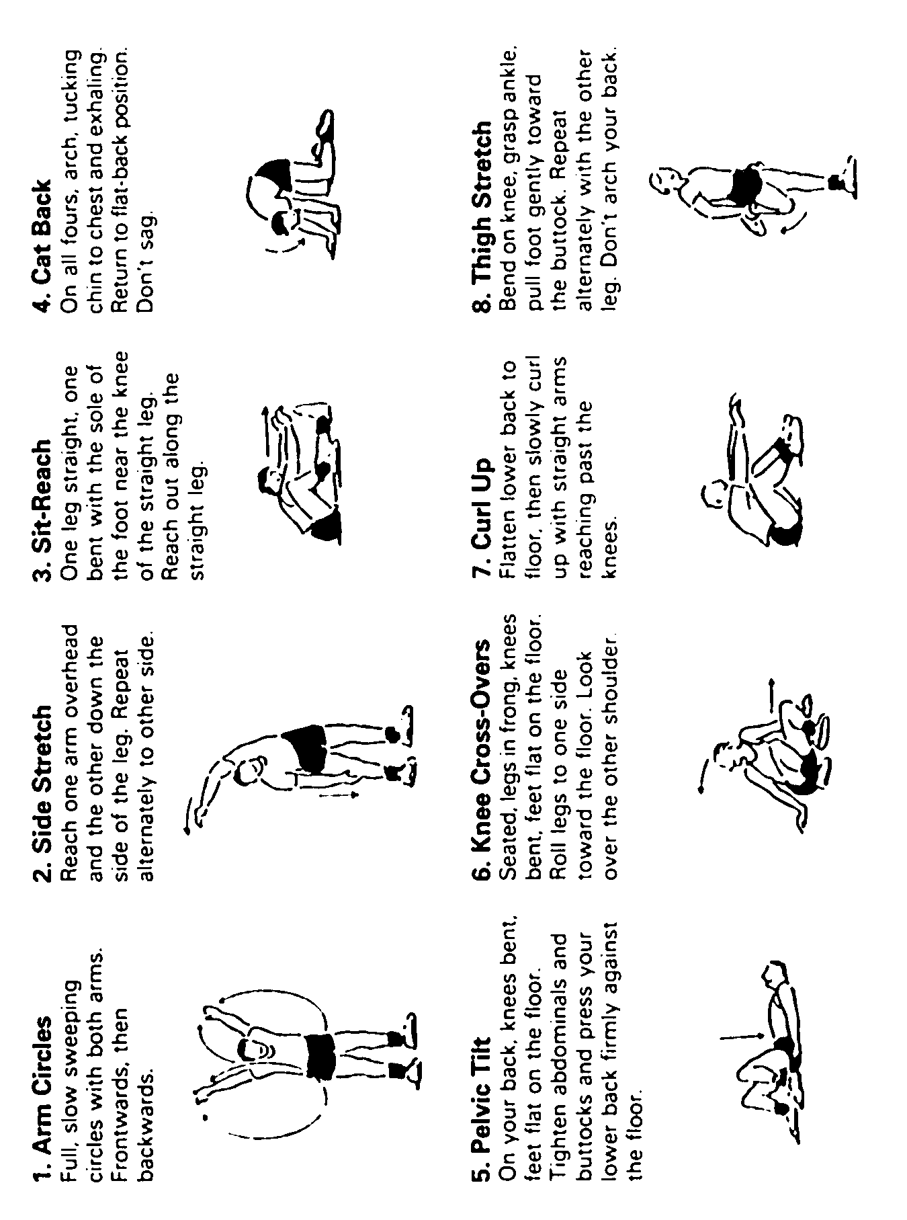
Figure 5-1 (Sheet 1 of 2) Stretching Exercises

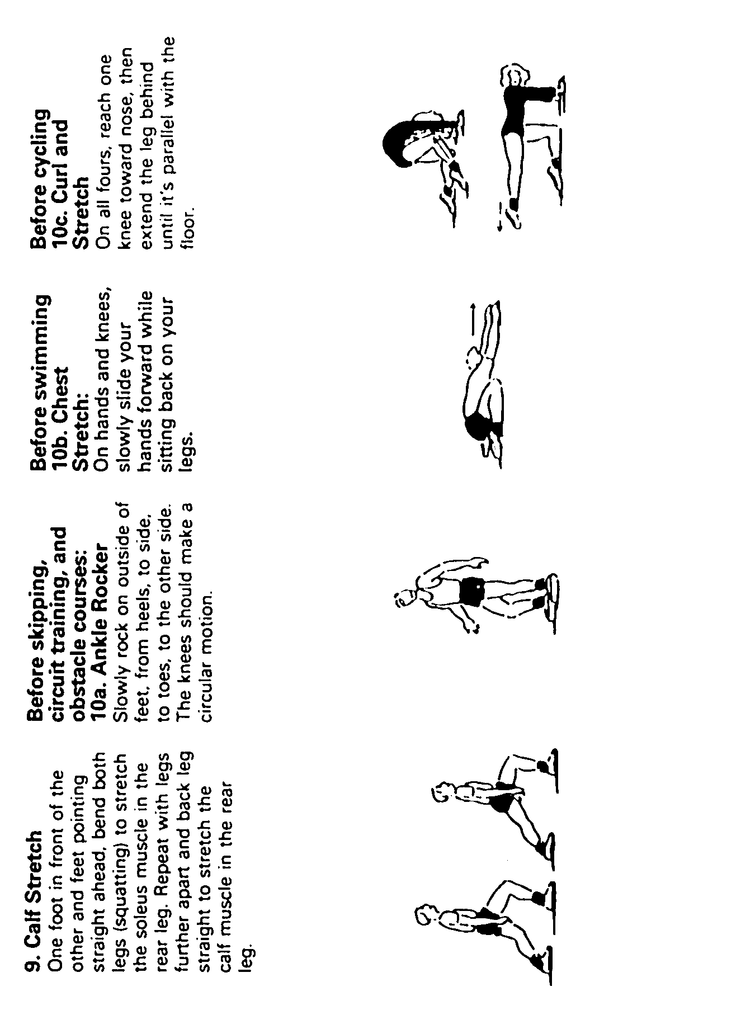
Figure 5-1 (Sheet 2 of 2) Stretching Exercises

ACTIVITY

3. The activity part of your session could be a run, obstacle course, circuit training, physical training, a game or some combination of these. The following guidelines can help you accomplish effective, safe, and enjoyable activities.

a. Progression. Follow the principles of progressive overload: increase the demands of an activity (duration and intensity) gradually over a period of time.

b. Specificity. The effects of activity are specific to the types of training done: running improves aerobic fitness; medicine ball exercises improve co-ordination, agility, and strength; and so on. Do a variety of activities to ensure a balanced programme.

c. Consistency. It is important to exercise regularly. Studies show that for fitness improvement, three times a week is twice as good as two times a week.

d. Flexibility. Inclement weather (heat and humidity or extreme cold), facility conflicts or other factors may cause you to miss or modify sessions. Try to stick to a routine, but be flexible and improvise whenever necessary.

COOL DOWN

4. Stretching exercises play an important role in cool down following an activity session. A cool down brings the rate and body temperature back to normal, and it helps prevent unnecessary stiffness and soreness that can result from vigorous activity. Spend at least five minutes on the cool down. Do the exercises from the sample routine and stretch the muscles which were used most during your activity (8 and 9 for running, 8 and 10 for games like hockey, basketball, etc).

SECTION 5

AIR CADET FITNESS PROGRAMME

THE TESTS

1. The six tests of the ACFP each have a specific purpose. They are:

a. push-ups, for arm and shoulder girdle strength;

b. shuttle run, for speed, power and agility;

c. partial curl-ups, for abdominal muscles;

d. standing long jump, for power and agility;

e. 50 m run, for speed, power and agility;

f. endurance run, for endurance.

CRESTS

2. Uniform crests are awarded on the basis of level of achievement:

a. Award of Excellence. Excellence level in all six test items.

b. Gold. Gold level or higher in five test items, including the endurance run.

c. Silver. Silver level or higher on four test items, including the endurance run.

d. Bronze. Bronze level or higher in four test items, including the endurance run.

3. The crest has its origin in the TRISCELE, which is an ancient symbol for the sun and for the revival of life and of prosperity.

4. The symbol of the triscele is found on monuments that date as far back as 1300 BC. It is interesting to note that the earliest classical trisceles are clearly connected with fitness: for example, shield bearing this symbol appears on a vase designated as a prize in Athenian competitions in the sixth century.

PREPARATION

5. A basic conditioning or training programme of about 3 to 4 weeks may be conducted by your instructors. A similar programme could follow testing to improve results.

6. The six Air Cadet Fitness Programme activities are described in Figures 5-2 to 5-7. The norm charts from which your score is calculated are shown in Figures 5-9 to 5-14. Your instructor will explain the use of these charts. A sample personal progress chart is illustrated at Figure 5-8. You should receive one of these from your instructor.

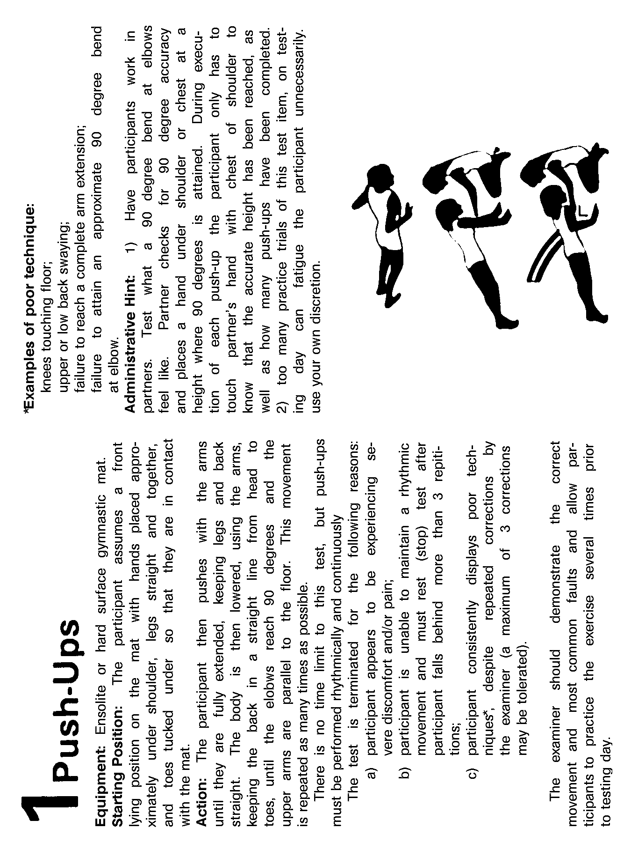
Figure 5-2 Push-ups

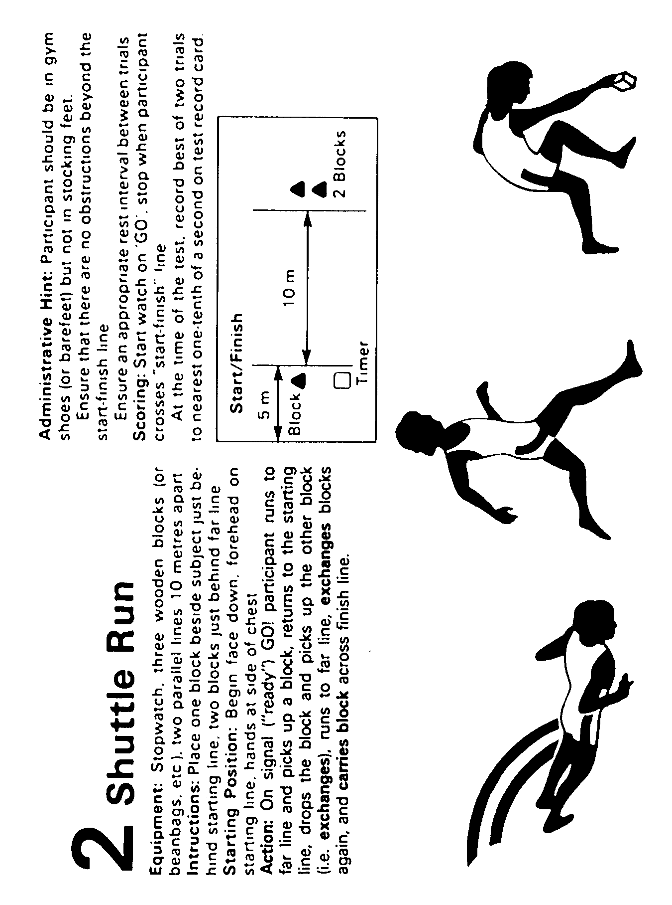
Figure 5-3 Shuttle Run

Figure 5-4 Partial Curl-ups

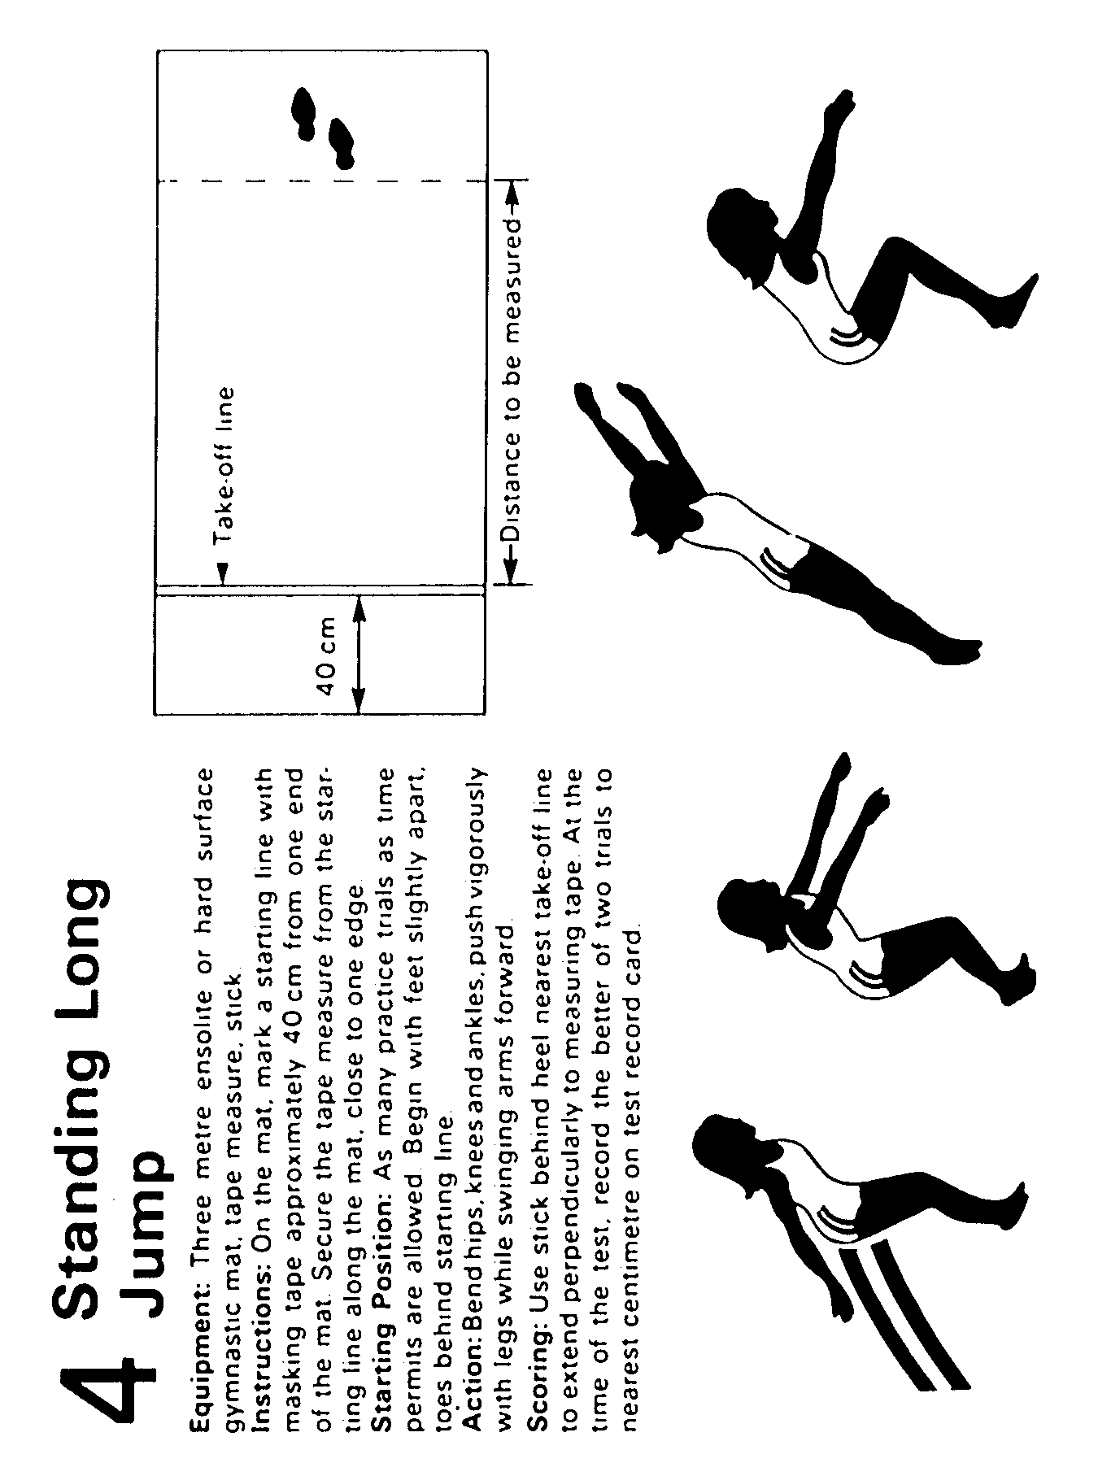
Figure 5-5 Standing Long Jump

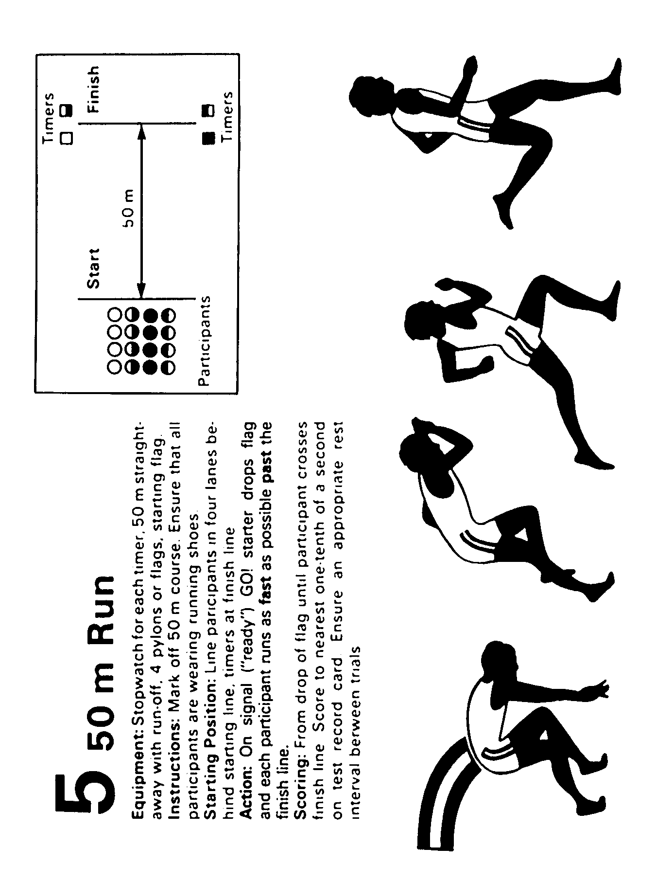
Figure 5-6 50 m Run

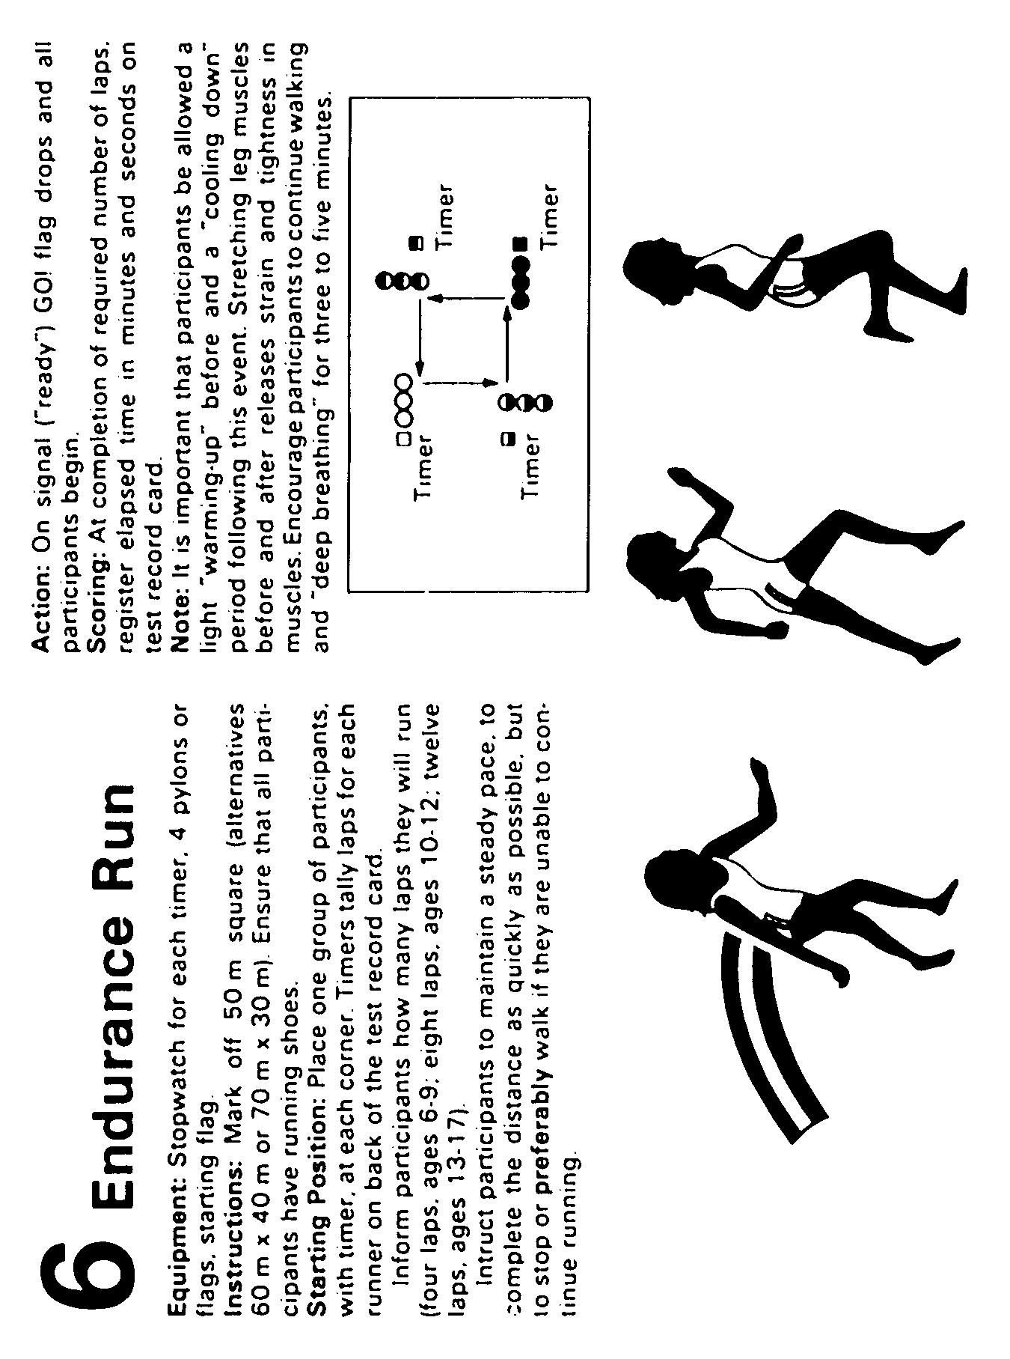
Figure 5-7 Endurance Run

 | Your Personal Progress Chart
 | TESTS | Push-ups | Shuttle  Run | Partial Curl-ups | Standing Long Jump | 50 m Run | Endurance Run
 | GOAL
 | September
 | October
 | November
 | December
 | January
 | February
 | March
 | April
 | May
 | June
 | July
 | August
Figure 5-8 Personal Progress Chart

 | - PUSH-UPS
 | (Total Number)
 |  |  |  |  | Female
 | Standard by Age |  |  |  | 12 |  |  | 13 |  |  | 14 |  | 15 |  |  | 16 |  |  | 17 |  |  | 18
 | Excellence |  |  |  | 20 |  |  | 21 |  |  | 20 |  | 20 |  |  | 24 |  |  | 25 |  |  | 25
 | Gold |  |  |  | 17 |  |  | 17 |  |  | 16 |  | 20 |  |  | 20 |  |  | 20 |  |  | 20
 | Silver |  |  |  | 10 |  |  | 11 |  |  | 16 |  | 15 |  |  | 12 |  |  | 16 |  |  | 16
 | Bronze |  |  |  | 2 |  |  | 4 |  |  | 3 |  | 7 |  |  | 4 |  |  | 7 |  |  | 7
 | (Total Number)
 |  |  |  | Male
 | Standard by Age |  |  | 12 |  |  |  | 13 |  |  | 14 |  | 15 |  |  | 16 |  |  | 17 |  |  | 18
 | Excellence |  |  | 31 |  |  |  | 39 |  |  | 40 |  | 42 |  |  | 44 |  |  | 53 |  |  | 53
 | Gold |  |  | 28 |  |  |  | 35 |  |  | 32 |  | 37 |  |  | 40 |  |  | 46 |  |  | 46
 | Silver |  |  | 18 |  |  |  | 24 |  |  | 24 |  | 30 |  |  | 30 |  |  | 37 |  |  | 37
 | Bronze |  |  | 9 |  |  |  | 11 |  |  | 13 |  | 20 |  |  | 22 |  |  | 23 |  |  | 23
Figure 5-9 Push-Up Standards

 | 2 SHUTTLE RUN
 | (To nearest one-tenth of a second)
 |  |  | Female
 | Standard by Age |  | 12 |  |  | 13 |  |  | 14 |  | 15 |  |  | 16 |  |  | 17 |  | 18
 | Excellence |  | 12.2 |  |  | 11.9 |  |  | 11.5 |  | 11.8 |  |  | 11.7 |  |  | 11.6 |  | 11.6
 | Gold |  | 12.5 |  |  | 12.3 |  |  | 12.0 |  | 12.2 |  |  | 12.0 |  |  | 11.9 |  | 11.9
 | Silver |  | 13.1 |  |  | 19.0 |  |  | 12.7 |  | 12.9 |  |  | 12.6 |  |  | 12.6 |  | 12.6
 | Bronze |  | 14.3 |  |  | 14.1 |  |  | 14.8 |  | 14.0 |  |  | 13.8 |  |  | 13.7 |  | 13.7
 | (To nearest one-tenth of a second)
 |  |  | Male
 | Standard by Age |  | 12 |  |  | 13 |  |  | 14 |  | 15 |  |  | 16 |  |  | 17 |  | 18
 | Excellence |  | 11.7 |  |  | 11.4 |  |  | 10.9 |  | 10.8 |  |  | 10.5 |  |  | 10.4 |  | 10.4
 | Gold |  | 12.0 |  |  | 11.6 |  |  | 11.2 |  | 11.0 |  |  | 10.7 |  |  | 10.6 |  | 10.6
 | Silver |  | 12.5 |  |  | 12.1 |  |  | 11.7 |  | 11.4 |  |  | 11.1 |  |  | 11.1 |  | 11.1
 | Bronze |  | 13.7 |  |  | 13.5 |  |  | 12.7 |  | 12.4 |  |  | 12.1 |  |  | 11.9 |  | 11.9
Figure 5-10 Shuttle Run Standards

 | 3 PARTIAL CURL-UPS
 | (Total Number)
 |  |  |  | Female
 | Standard by Age |  |  | 12 |  |  | 13 |  |  | 14 |  | 15 |  |  | 16 |  |  | 17 |  | 18
 | Excellence |  |  | 50 |  |  | 59 |  |  | 48 |  | 38 |  |  | 49 |  |  | 58 |  | 58
 | Gold |  |  | 43 |  |  | 50 |  |  | 41 |  | 35 |  |  | 35 |  |  | 49 |  | 49
 | Silver |  |  | 38 |  |  | 40 |  |  | 30 |  | 26 |  |  | 26 |  |  | 40 |  | 40
 | Bronze |  |  | 19 |  |  | 22 |  |  | 20 |  | 15 |  |  | 16 |  |  | 26 |  | 26
 | (Total Number)
 |  |  | Male
 | Standard by Age |  | 12 |  |  |  | 13 |  |  | 14 |  | 15 |  |  | 16 |  |  | 17 |  | 18
 | Excellence |  | 64 |  |  |  | 59 |  |  | 62 |  | 75 |  |  | 73 |  |  | 66 |  | 66
 | Gold |  | 54 |  |  |  | 51 |  |  | 54 |  | 87 |  |  | 50 |  |  | 58 |  | 58
 | Silver |  | 32 |  |  |  | 39 |  |  | 40 |  | 45 |  |  | 37 |  |  | 42 |  | 42
 | Bronze |  | 22 |  |  |  | 28 |  |  | 24 |  | 26 |  |  | 24 |  |  | 25 |  | 25
Figure 5-11 Partial Curl-Up Standards

 | 4 STANDING LONG JUMP
 | (centimetres)
 |  |  |  | Female
 | Standard by Age |  | 12 |  |  |  | 13 |  |  | 14 |  | 15 |  |  | 16 |  |  | 17 |  | 18
 | Excellence |  | 179 |  |  |  | 184 |  |  | 189 |  | 188 |  |  | 196 |  |  | 198 |  | 198
 | Gold |  | 171 |  |  |  | 170 |  |  | 181 |  | 181 |  |  | 187 |  |  | 190 |  | 190
 | Silver |  | 158 |  |  |  | 163 |  |  | 162 |  | 185 |  |  | 173 |  |  | 174 |  | 174
 | Bronze |  | 133 |  |  |  | 141 |  |  | 145 |  | 144 |  |  | 147 |  |  | 152 |  | 152
 | (centimetres)
 |  |  |  | Male
 | Standard by Age |  | 12 |  |  |  | 13 |  |  | 14 |  | 15 |  |  | 16 |  |  | 17 |  | 18
 | Excellence |  | 183 |  |  |  | 200 |  |  | 213 |  | 223 |  |  | 232 |  |  | 238 |  | 238
 | Gold |  | 176 |  |  |  | 193 |  |  | 206 |  | 215 |  |  | 224 |  |  | 231 |  | 231
 | Silver |  | 182 |  |  |  | 177 |  |  | 199 |  | 202 |  |  | 211 |  |  | 220 |  | 220
 | Bronze |  | 142 |  |  |  | 151 |  |  | 166 |  | 171 |  |  | 191 |  |  | 195 |  | 195
Figure 5-12 Standing Long Jump Standards

 | 5 50 m RUN
 | (To nearest one-tenth of a second)
 |  | Female
 | Standard by Age | 12 |  |  | 13 |  |  |  | 14 |  |  | 15 |  |  |  | 16 |  |  |  | 17 |  |  | 18
 | Excellence | 8.4 |  |  | 8.0 |  |  |  | 7.9 |  |  | 8.0 |  |  |  | 7.9 |  |  |  | 7.9 |  |  | 7.9
 | Gold | 8.6 |  |  | 6.2 |  |  |  | 8.1 |  |  | 8.2 |  |  |  | 8.1 |  |  |  | 8.0 |  |  | 8.0
 | Silver | 9.2 |  |  | 9.7 |  |  |  | 8.6 |  |  | 8.7 |  |  |  | 8.6 |  |  |  | 8.5 |  |  | 8.5
 | Bronze | 10.2 |  |  | 9.5 |  |  |  | 9.4 |  |  | 9.4 |  |  |  | 9.3 |  |  |  | 9.2 |  |  | 9.2
 | (To nearest one-tenth of a second)
 |  | Male
 | Standard by Age | 12 |  |  |  | 13 |  |  |  | 14 |  |  | 15 |  |  |  | 16 |  |  |  | 17 |  |  | 18
 | Excellence | 8.1 |  |  |  | 7.7 |  |  |  | 7.4 |  |  | 7.2 |  |  |  | 7.0 |  |  |  | 6.9 |  |  | 6.9
 | Gold | 8.4 |  |  |  | 7.9 |  |  |  | 7.6 |  |  | 7.4 |  |  |  | 7.1 |  |  |  | 7.0 |  |  | 7.0
 | Silver | 8.8 |  |  |  | 84 |  |  |  | 8.0 |  |  | 7.7 |  |  |  | 7.4 |  |  |  | 7.3 |  |  | 7.3
 | Bronze | 9.7 |  |  |  | 9.2 |  |  |  | 8.8 |  |  | 8.4 |  |  |  | 8.0 |  |  |  | 8.0 |  |  | 8.0
Figure 5-13 50 m Run Standards

 | 6 ENDURANCE RUN
 | (Minutes and Seconds)
 |  |  |  | Female
 |  |  |  | 1 600 m |  |  |  |  |  | 2 400 m
 | Standard by Age |  |  |  | 12 |  | 13 |  |  | 14 |  | 15 |  |  | 16 |  |  | 17 |  | 18
 | Excellence |  |  |  | 8:41 |  | 13:54 |  |  | 13:28 |  | 13:31 |  |  | 12:38 |  |  | 12:45 |  | 12:45
 | Gold |  |  |  | 9:18 |  | 14:33 |  |  | 14:18 |  | 14:01 |  |  | 13:22 |  |  | 13:31 |  | 13:31
 | Silver |  |  |  | 10:26 |  | 16:12 |  |  | 15:51 |  | 16:02 |  |  | 16:44 |  |  | 15:19 |  | 15:19
 | Bronze |  |  |  | 12:46 |  | 18:59 |  |  | 18:51 |  | 18:58 |  |  | 18:37 |  |  | 18:53 |  | 18:53
 | (Minutes and Seconds)
 |  |  |  | Male
 |  |  |  | 1 600 m |  |  |  |  |  | 2 400 m
 | Standard by Age |  |  |  | 12 |  | 13 |  |  | 14 |  | 15 |  |  | 16 |  |  | 17 |  | 18
 | Excellence |  |  |  | 7:41 |  | 11:31 |  |  | 10:43 |  | 10:23 |  |  | 10:08 |  |  | 10:08 |  | 10:08
 | Gold |  |  |  | 8:04 |  | 11:49 |  |  | 11:09 |  | 10:05 |  |  | 10:42 |  |  | 10:32 |  | 10:32
 | Silver |  |  |  | 8:46 |  | 12:51 |  |  | 12:16 |  | 11:51 |  |  | 11:22 |  |  | 11:10 |  | 11:10
 | Bronze |  |  |  | 10:31 |  | 15:35 |  |  | 14:40 |  | 14:46 |  |  | 14:08 |  |  | 13:33 |  | 13:33
Figure 5-14 Endurance Run Standards

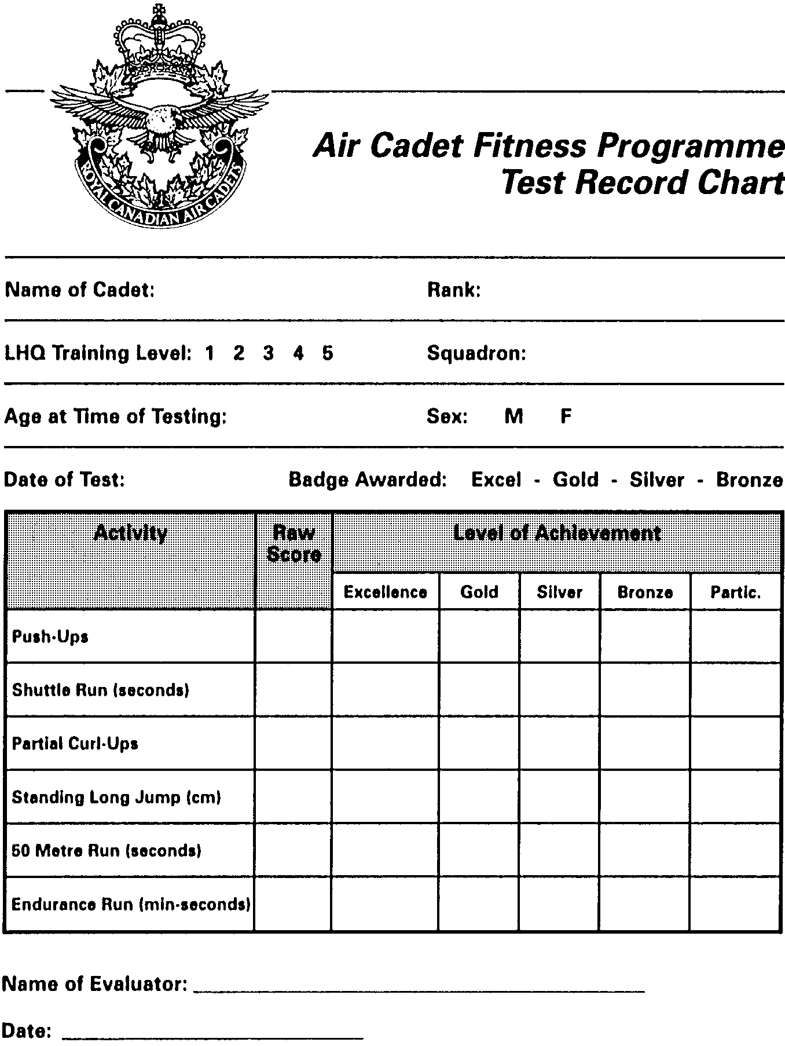
Figure 5-15 ACFP Test Record Chard

PO 406
S
E
N
S
I
B
L
E

L
I
V
I
N
G

CHAPTER 5

PERFORMANCE OBJECTIVE 406

SECTION 1

SENSIBLE LIVING

GENERALITIES

1. You are now at an age where you may be tempted to get a job, be it a summer job, part-time job or a full-time job. You may want money for your personal weekly expenses or for the next school semester. As you well know, jobs are very scarce and the choices available may not be exactly what you were hoping for.

2. Job hunting can be a long and strenuous process, especially if you are not ready to make the effort to prepare well. Putting your name on a job application is not, and will never be, a guarantee of success.

3. Have you ever noticed that it seems rather easy for some people to find a good summer job and that others just keep ending with the… well… not-so-interesting ones? Why is that? Why would an employer dare chose someone else instead of you! Better yet, how could you improve your chances of being selected for that great job you have been looking for?

4. Many factors affect an employer's hiring decisions. The most common factors are: the types of job (specific abilities required), specialized studies (technical knowledge required), your availability, your interest in the job, you experience in that type of job or, simply, the employer's knowledge of you.

5. Your personal presentation may be the single most important element in landing the job. You must ensure that the employer knows you because, above all else, employers always prefer to hire people they feel they can trust.

CURRICULUM VITAE

6. When the time comes to introduce yourself to a potential employer, the curriculum vitae, CV, or résumé, is one of your best tools, excepting direct interviews. A curriculum vitae is not a job application, but a chronological description of your education and experience.
7. The person in charge of hiring will tend to favour your application if the résumé you have submitted is well-prepared and logically organized. In other words, it must be easy to read. A résumé must be impeccable in its presentation, and the facts it includes must be true and precise. Your résumé must be impeccably presented, and the facts it contains must be accurate and complete.

COMPONENTS OF A CURRICULUM VITAE

8. Your curriculum vitae must have four distinct parts:

a. identification;

b. education/work experience;

c. personal information; and

d. references.

PERSONAL INDENTIFICATION

9. This part includes your:

a. name and given name;

b. address;

c. phone number;

d. social insurance number (optional);

e. date of birth (optional);

f. social status (singlel, married) (optional); and

g. nationality.

YOUR EDUCATION/WORK EXPERIENCE

10. Write this part carefully, bearing in mind that this information may be all the prospective employer has to go on to determine if you are qualified for the job.
11. You should describe your education in reverse chronological order, beginning with the last diploma you received. Indicate the title of the diploma and the date it was officially awarded to you. You must also list all the schools you went to in the past few years and the one you are currently attending.

12. You must list and provide short descriptions of all the jobs and positions you have held in the past and are still holding. This part of the résumé will give the employer a good idea of your work experience. Do not hesitate to mention the positions and summer jobs you had with the cadets; most employers recognize the value of training you receive as a cadet. Everything you have done, even the smallest jobs, should be included here. Everything you have done has its value, whether it is washing the dishes in a restaurant or cleaning the stands at the local hockey rink. Let the employer know that you are an active person. After all, most employers started with smaller jobs too, so they know where you are coming from. Remember that there is no such thing as a stupid job. Employers are looking for active and dynamic people. They will therefore tend to avoid hiring someone who sits at home, waiting for a job to fall from the sky!

PERSONAL INFORMATION

13. How do you spend your spare time? Are you involved in any sports, cultural pursuits or social activities? Most employers want to know if you are an active citizen. You do not have to describe everything you do in great detail; just listing the activity is enough (eg, reading (preferences), playing guitar, swimming, collecting coins, engaging in outdoor activities such as biking, hiking, jogging etc).

14. You should also mention every award that you won in school, with the cadets, or elsewhere. Your CV must show you at your best. If you were awarded a trophy, a plaque, a certificate or a medal, don't hesitate to mention it!

YOUR REFERENCES

15. You do not have to include references in your CV. But it will not hurt your chances to take advantage of the support of two or three people who can attest to your qualifications and experience. These people should be willing to provide a letter of reference if needed, or at least, be able to answer a few questions about you. You must include their names, jobs, addresses, and phone numbers.
16. You must ask these people for their permission before using them for references. Then you must ensure that the information you provide about them is exact. It is preferable to chose people from a variety of backgrounds. For example, you could pick one of your officers, a teacher and the director of the social centre in which you are involved. If possible, do not use family members as a references; references should come from unbiased sources.

PRESENTATION OF YOUR RÉSUMÉ

17. Your CV should not exceed three pages. Its structure and presentation should make it easy to read. You must therefore, pay special attention to small details such as margins, page numbering and text structure.

18. Your writing style should be dynamic and precise, and free of lengthy sentences. If your text is too long, the employer may be tempted to skim through it, or skip reading it altogether, especially if many candidates are vying for the same position. Write short and precise sentences using action verbs such as: "I am involved in…" "I supervise the training of…", "I am responsible for 30 cadets", etc.

19. The CV must be produced on 8-1/2 × 11 paper. It must be printed or typed on white or slightly coloured paper (eg, a vary pale shade of grey). Only use one side of the sheets.

20. Make sure your grammar is perfect. It would be a shame to diminish the overall quality of your CV because you failed to correct a few words. You probably know someone, in your family or among your friends, who masters English grammar. Ask that person to review your text. It only takes a few minutes but it could make a huge difference in the employer's mind. Try to avoid abbreviations or acronyms such as SLC (Senior Leaders Course) or TACC (Trenton Air Cadet Camp) as they mean nothing to those not directed involved with the cadet movement. Write the titles and positions in full.

21. The following are two ample CVs. You do not have to use them as guides if you do not want to. Maybe you already know another format that suits your needs or tastes better. However, no matter what format you decide to use, you must ensure that all the elements you have just learned about are included.

CURRICULUM VITAE
EXAMPLE 1

Jean-Luc Picard
719 Enterprise Blvd.
Vulcan, Alta
K1A P1K
(413) 374-9824
Social Insurance Number: 123-456-789

18 years old (date of birth) 13 June 1976
Single
Canadian
Primary Language – English (very well)
Secondary Language – Spanish (well)

EDUCATION

Sept. 1994 I was accepted at the Royal Military College in Kingston, Ontario for next year (Fall 1995)

1993-1994 I graduated from St. Bones College in June 1994. (St. Bones College, 1345 Photon street, Bonesville, K1A P2K).

1990-1993 I successfully completed my elementary studies at St. Joseph's Elementary School.

WORK EXPERIENCE

Currently Assistant Cook – I am responsible for preparing breakfasts, making salads for lunch and cleaning tables at the snack bar Rock'n Roast in Charlesville. I also wash the dishes. I work three nights a week and weekends.

Summer 93 Assistant flight commander for the Junior Instructors' Course at the Penhold Air Cadet Summer Camp. I taught and was also responsible for maintaining the discipline of 35 cadets, 15 to 17 years old. I was awarded the rank of flight sergeant. I taught the following topics: instructional techniques, drill, audio-visual techniques.

Summer 92 Sports instructor for the Penhold Air Cadet Summer Camp. My responsibilities included waking up the cadets, leading the morning aerobic session and supervising the daily recreational activities of nearly 800 cadets.

Summer 91 I picked strawberries at Mr. John Greenfield's farm in Saskatoon.

I also worked for the Air Show in Cold Lake, Alberta. I cleaned up the airport area before and after the Air Show.

ACTIVITIES

1989 - 1993 I joined Squadron XXX of the Royal Canadian Air Cadets, in Calgary, Alberta in 1989. I am currently teaching instructional techniques and effective speaking to younger cadets. I have attained the rank of Master Warrant Officer.

1992 I competed in the Friendship Games. I ran the 1 500 metres race where I finished second, my best result to date.

I was a member of the team representing my school in the provincial portion of Reach for the Top, a cultural game show presented each year on CBC.

Summer 1991 I participated in the six-week Athletic Instructor's Course at the Borden Air Cadet Camp in Ontario.

Summer 1990 I participated in the three-week Junior Instructor's Course at the Penhold Air Cadet Camp. I received the trophy for best overall student.

CURRICULUM VITAE
EXAMPLE 2

IDENTIFICATION

Name: Kim Jones Date of birth: 25 September 1975
Address: 2445 Whittaker Citizenship: Canadian
Frederiction, NB Spoken
E1C 4T5 Languages: English, Spanish (well)
Telephone: (403) 474-9876 Written
Languages: English, French (well)
Marital Status: Single

EDUCATION

Administration – 1993
Second year – Community College

High School Diploma – 1991
Joan of Ark High School (Girls' School)

WORK EXPERIENCE

Squadron XXX Frederiction – Assistant to the Administration
Officer 1992-1993

– Updated the personal files for 130 cadets on a monthly basis.
– Supervised two clerks (corporals).
– Typed outgoing mail for the commanding officer.
– Updated the commanding officer's weekly agenda.
– Filed incoming mail.

Greenwood Air Cadet Summer Camp – Administration Clerk –
Summer 1992

– Updated nominals list on a daily basis.
– Managed 8 telephone lines and liaised with 5 department supervisors.
– Typed performed computer work
– Made photocopies.

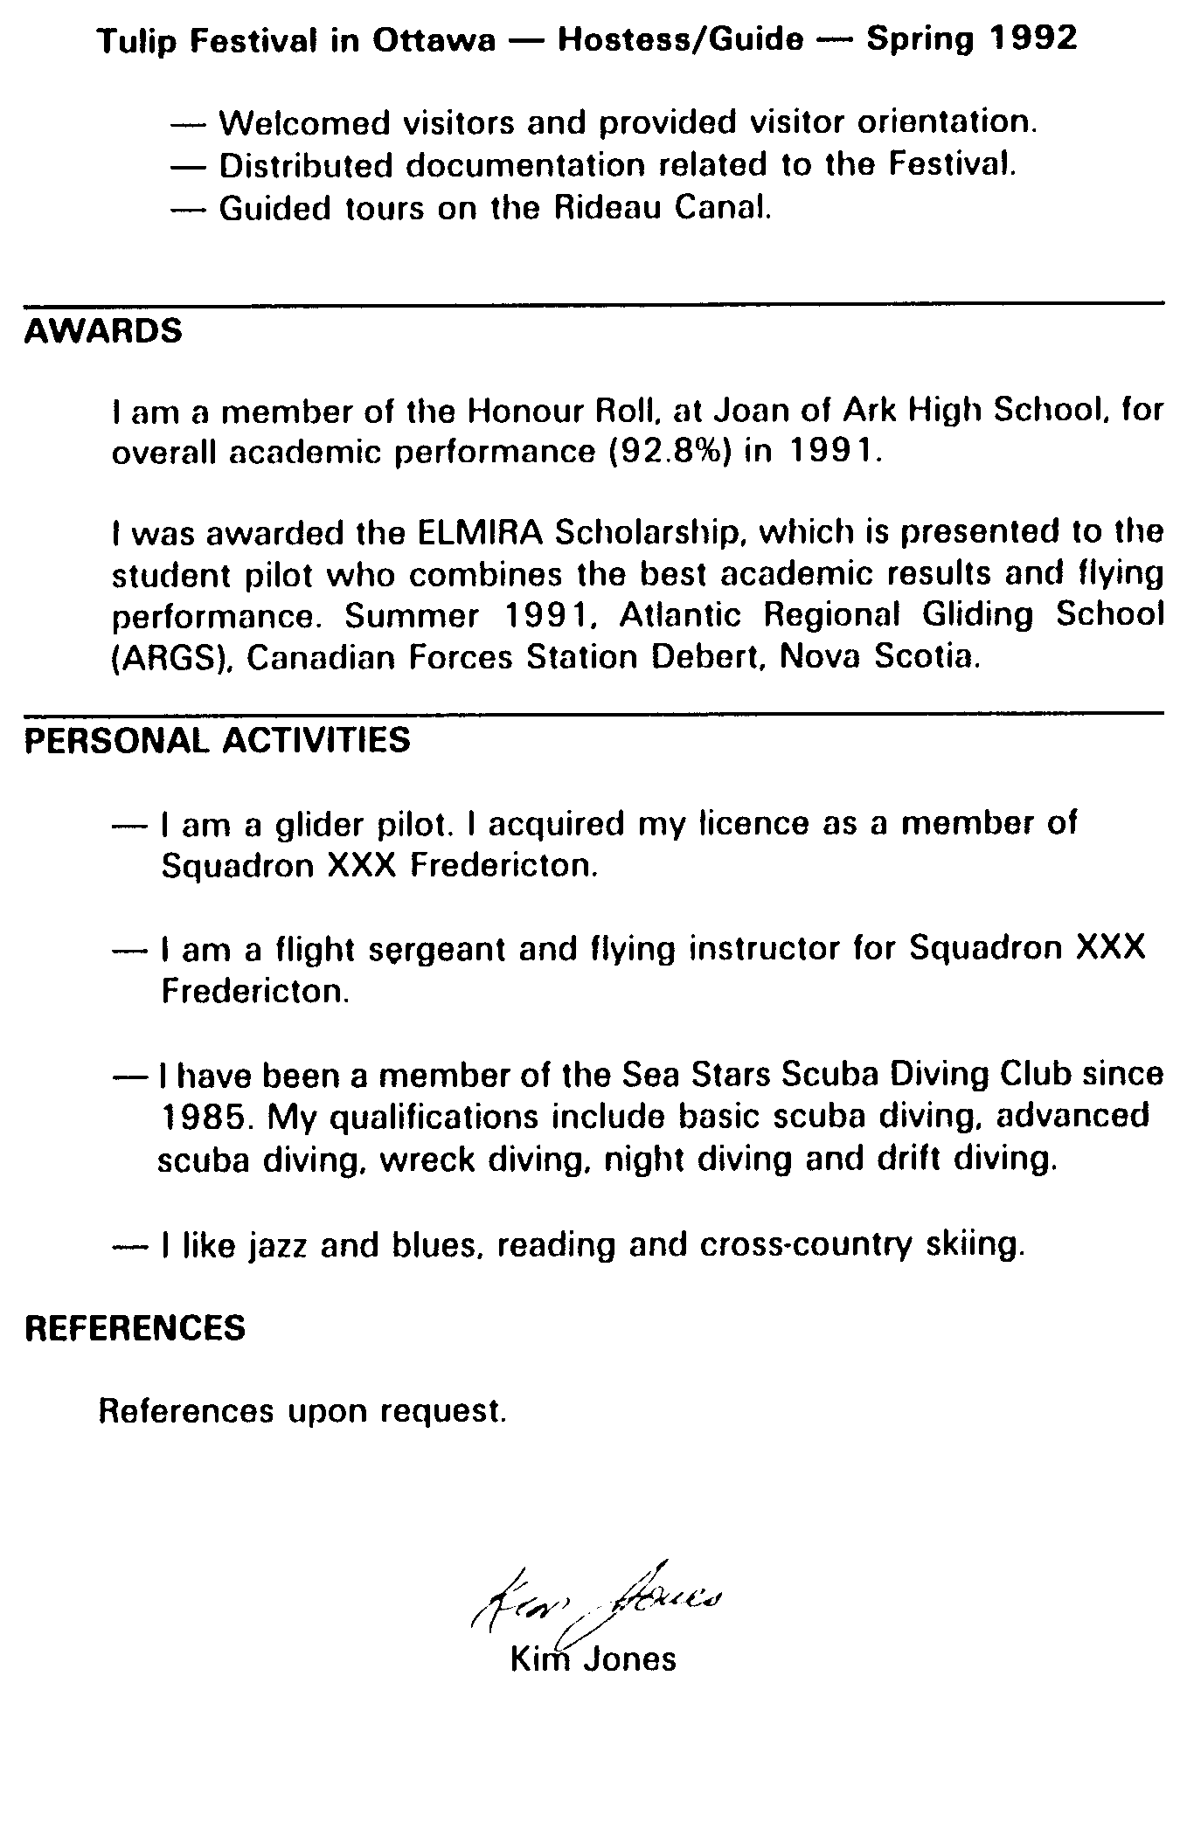

SECTION 2

OFFER OF EMPLOYMENT LETTER

1. Some places to which you apply may not have job application forms. In this case you should write a covering letter. Since you use this letter to officially offer your services, it must be very convincing and well structured.

2. The offer of employment letter is normally composed of:

a. the date;

b. the name and address of the employer;

c. four paragraphs;

d. your signature; and

e. the word enclosed.

3. In the first paragraph you may explain how you have learned about the job opportunity (newspaper, a friend, employment centre, etc) or you may simply offer your services directly.

4. The second paragraph is used to present yourself and describe why you are interested in this specific job opportunity. Remember that an employer pays more attention to candidates who seem genuinely interested. You must also take this time to describe abilities you have that would help you perform if you are chosen.

5. Use the third paragraph to indicate that your curriculum vitae and all other significant documents (diplomas, letters of reference, etc) have been annexed to this letter. It is also recommended to inform the employer that you are available for an interview at the employer's earliest convenience.

6. The fourth paragraph contains your greetings, and if you wish, you may express your wish to meet the person responsible for personnel selections. Give your phone number or a phone number through which you can be reached.

7. Write enclosed in the bottom left corner of your letter to indicate that other documents are annexed to your letter. You will probably only need to add your curriculum vitae to your letter. It may happen, however,
that an employer requires you to add your letters of recommendation or copies of your diplomas.

8. The following is an example of a letter in which you offer your services for a job.

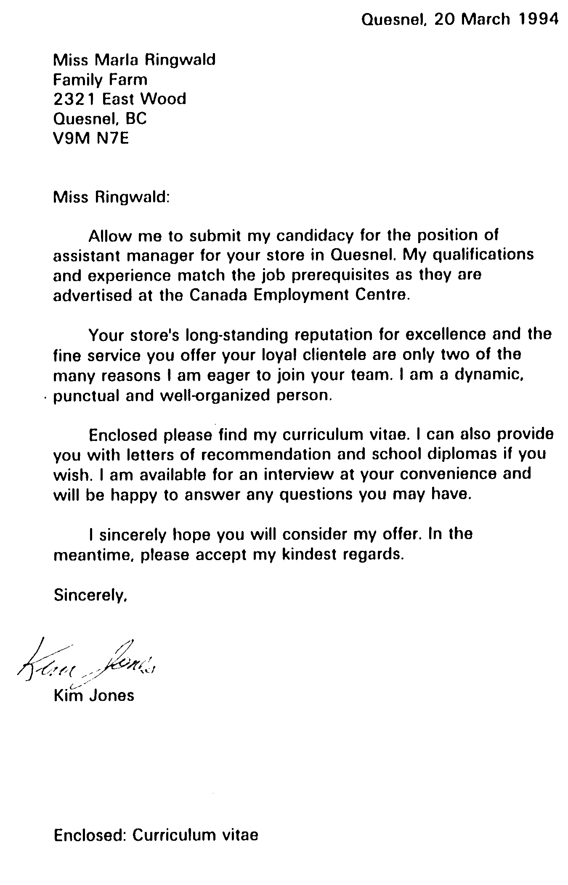

SECTION 3

THE INTERVIEW

1. If an employer asks to meet you for an interview, do not panic! This is good news. If the employer wishes to know more about you, your CV has clearly made a good impression.

2. People often tend to exaggerate the real meaning of a job interview. They think it is a kind of interrogation where the employer tries to find flaws about their past or to know more about their private life. Usually, however, the interview allows the employer to establish direct contact with you and give a chance to promote yourself in person. Grab this opportunity with both hands! Very few employers hire someone without first having had a chance to talk to them directly.

3. A certain preparation is appropriate. Keep in mind that you have only a couple of minutes to make a good impression on the interviewer.

4. When comes the time to prepare yourself for an interview, the main thing to remember is to eliminate every source of stress. Try not to worry too much; everybody is nervous during an interview, even those going through this process for the tenth time! What differs from one person to the other is the ability to control the factors causing stress. Among others, the following require special attention:

a. your dress and general appearance;

b. your physical behaviour; and

c. the way you answer questions.

5. Your dress and general appearance must be impeccable, especially if the job you want requires contact with the public. Brush your jacket, iron your pants or dress and polish your shoes. It is recommended to get a haircut. Remember that you have only one chance to create a good impression. Moreover, if your appearance is flawless, you won't have to worry about it. The first seconds are the most important. Before you even open your mouth, you have the opportunity to make an impact.

6. You must present yourself at your best. Your physical behavior can say more about you than you think. Show some assurance from the very beginning.

a. Take a couple of seconds to breath deeply before entering the room where the interview will be conducted. Get rid of your bubble gum, ensure that your breath is fresh, relax and prepare yourself mentally for the first thirty seconds of the interview.

b. Put a large smile on your face. You are not facing a firing squad!

c. As soon as you enter the room, shake hands firmly with the interviewer. A good handshake demonstrates that you are confident. Make the first move.

d. Express some gratitude for the opportunity given to you with the interviewer. For example, say I am glad to meet you, or Thank you for giving me this opportunity.

e. Do not sit before you are asked to. The interview may take place somewhere else. When you are given the chance, sit down straight on your chair and avoid biting your nails, juggling with your keys, swinging your legs, etc. Remember that there is no need to worry. This is an interview, not a police investigation.

f. Establish eye contact and look at the person doing the interview straight in the eyes without staring.

7. The way you answer to questions tells a lot about your preparation and your true desire to work for that company. You must be honest and direct in your responses.

8. Try to avoid answering by a mere yes or no. Give your honest opinion. Take full advantage of the few minutes available. You must be very careful however not to dominate the interview by talking non-stop. A few seconds are usually enough for your reply. If more information is required, additional questions will be asked.

9. Keep smiling and do not lose your positive attitude. When they want to relax the atmosphere, some people have a tendency to make jokes or denigrate the competition. There is no place for negative remarks or sarcasm during a job interview. You will not gain any points by it, and may well lose the respect of those listening to you.

10. Think before answering any questions. Take a few seconds to formulate a complete and logical response. It is important that you articulate your words so that the interviewer will not have to repeat the question or ask you to repeat the answer.

11. You will probably be given a chance to ask questions too at the end of the interview. You should prepare a couple of questions on the company or the job itself. This way, you clearly demonstrate that you are truly interested.

12. When the interview is over:

a. Stand up.

b. Shake hands with the interviewer.

c. Express your thanks.

d. Ensure that you do not leave anything personal behind you (coat, binder, purse, etc).

e. Walk straight and calmly to the door.

f. Put a large smile on your face as you leave the room. The interview is over!

SECTION 4

CONCLUSION

1. Finding a job may prove to be a difficult adventure, especially if you are young and have not graduated yet. However, nothing is impossible for whoever puts real efforts into it. The jobs available may not be what you are hoping for. They may not pay as much as you want. They probably require a degree of experience you do not have yet. For each job available, there are hundreds of potential candidates. That is why you must put all the changes on your side by preparing thoroughly.

2. Whether you are looking for a summer job, for a full-time or part-time job, you must always present yourself at your best. It is the key to success. No employer will hire someone who seems hesitant or shows a lack of self-confidence.

3. There are no miracle solutions. Nor will you find well paid jobs on every street corner! You must clearly establish that you are THE ideal candidate for the job. You must convince the employer that YOU would be a valuable asset to the staff.

4. Complete your preparation by asking one of your friends to act as the employer. Rehearse the interview. Do not worry… the training you have received until now as a cadet prepares you for that type of situation. The ball is in your court now. Good luck!
Something to think about…

Not failure, but low aim, is crime.

– James Russell Cowell

To avoid criticism do nothing, say nothing… be nothing.

– Elbert Hubbart

They are able because they think they are able.

–Virgil

PO 408
L
E
A
D
E
R
S
H
I
P

CHAPTER 6

PERFORMANCE OBJECTIVE 408

SECTION 1

LEADERSHIP

INTRODUCTION

1. The higher you climb up your squadron's chain of command, the more additional responsibilities you are likely to receive. What you will be asked to accomplish from now on is different and more difficult than anything you have been asked to do in the past. You will have to supervise larger numbers of cadets, plan interesting activities and ensure that your cadets are happy to be part of your group. You will also have to take charge and solve minor problems affecting your subordinates.

2. The efficiency of your flight or squadron largely depends on how members respond to various situations. This is called morale. If morale is good, members will probably react with enthusiasm to your requests. If the morale is low, the same request could be received very differently. You must consider the interaction of attitudes which constitute morale and know how this interaction affects the attitudes of your cadets.

SECTION 2

MORALE AND ESPRIT DE CORPS

MORALE: A BASIC REQUIREMENT IN A GROUP

1. A group enjoys high morale when its individual members have a feeling of well-being. An individual's morale results from the interplay of that individual's attitudes. Group morale, however, is far more than the mere sum of the members' attitudes; rather, it is the product of their collective efforts. The group's relationship with its leader is vital to good morale. Morale is influenced by the following factors:

a. Common Purpose. Awareness of common purpose can best be stimulated at the grassroots level by leader in charge of a small group. The idea of working together in terms to achieve short-range goals provides the group with overall common objectives. If all your cadets work together to achieve the same goal, they will have a tendency to stick closely together and push in the same direction.

b. Leadership. By setting a poor example and neglecting to practice what is taught, you, as the leader, can destroy morale. Nothing succeeds like success. On the contrary, an inept leader always destroys the group's sense of well-being and gives rise to the perception that nothing is going right.

c. Discipline. Discipline is essential for fostering good morale in air cadets. You should ensure that no individual is allowed to affect the good morale of your group. By maintaining good discipline, you show the cadets that you are in full control of the situation. They will tend to trust your leadership more if they feel you are in control.

d. Self-Respect. Before morale can be generated, individual members of the orgaization must have their own feelings of self-respect. It is a normal human need to belong and contribute to a group, and you should encourage and use this need. Work should be assigned commensurate with training and ability, and with regard to the cadet's special talents. Praise should be given promptly and publicly, and criticism should be made intelligently and generally in private.
e. Pride. Once self-respect is achieved, pride in the orgaization should be stimulated. You should arrange sports and competitions with other flights or groups, and always be alert for the opportunuty to engage your flight competitvely with other groups. Encourage suggestions from the group for group activities such as informative and recreational activities. You must take the initiative and provide group participation. By diligent application in these areas, you will provide the climate and the basis for the growth of pride in the group.

f. Comradeship. This is an intangible but is, nevertheless, real. You must encourage group members to develop a sense of loyalty, a sense of family and a sense of humour. This builds a reserve of strength the group can grow upon in difficult times.

g. Mutual Confidence. This is closely linked to comradeship but tends to be a form of mutual respect between cadets based on each other's professional abilities. It must exist at all levels and between all ranks: up, down and across. You must make every effort to be technically proficient and keep abreast of current trends and developments. Confidence can be greatly enhanced if you are able to carry out any task you may require your subordinates to undertake. For example, your cadets will be more inclined to shine their boots if they see you are doing it too. The group must have the confidence that you, their leader, will represent them fairly and accurately to the higher echelons of command. Take their side if required and recommend them if deserved. You must refrain from criticizing seniors if mutual confidence is to be achieved and maintained.

h. Comfort and Welfare. Cadets will work long hours under bad conditions and morale will not be affected, provided that:

(1) you tell them why; and

(2) they are satisfied that you have a sincere interest in their welfare.

4. Material comforts are important and desirable when the situation permits, but they do not take the place of the other factors, and by themselves they mean nothing. Cadets must be confident that you are doing your best for them. If they have this confidence, they are prepared to accept hardships and discomfort with no adverse effects on morale.

3. It is very important that you keep an eye open to detect problems while they are still minor. The state of the cadets' morale at any given time depends upon and is measurable by their attitude to:

a. the squadron;

b. themselves;

c. their companions; and

d. their leader.

ESPRIT DE CORPS

4. Esprit de corps pertains to a group and can be instilled in cadets insofar as they identify themselves with any group, such as a band, drill team, flight, or squadron that possess such an esprit de corps. The essence of high morale in a group, ie, the consciousness of well-being, was discussed earlier in this chapter. The esprit de corps is directly proportional to the success achieved by the leader in meeting these requirements.

5. You can contribute to the development of esprit de corps by exerting your influence and personality in the following areas:

a. Pride in the group. The realization is engendered that the whole
– the squadron – is greater, much greater, than the sum of its individual parts. Cadets have the conviction that their separate skills have been integrated and co-ordinated by their leaders, who are themselves part of the group and not distant figures of authority. From this group-pride springs a desire to create a coherent unity to which all members are intensely loyal.

b. Uniqueness. If a group is unique, such as a squadron that maintains an exceptional standard of performance year after year, or a group that wins an important competition, the cadet's feeling of pride intensifies. If, in addition, all the cadets are involved in the group success, the intensity of esprit de corps that can develop is almost unbelievable. If the squadron is effectively unique in the excellence of its leadership, this also is a factor to be considered.

c. Tradition. In squadrons with a tradition of success and efficiency, valid traditions are passed on and their impact on recent arrivals is immediate and forceful. The tradition is usually passed on from generation to generation by senior cadets. A cadet participating in
a squadron that was named in honour of a famous person will be conscious of a challenge. These valid traditions are manifested by banners, trophies and squadron names. These provide constant reminders that create daily challenges, and inspire cadets to greater efforts that will enhance the efficiency of their particular squadron. Cadets must be convinced that they too can contribute to your squadron's tradition by their good work.

d. Dynamics. Esprit de corps is dynamic. It thrives on the desire to excel, and on the determination that the particular unit shall have no peer in the performance of its specific functions. It is reflected also in a general pride in behaviour and dress, outward signs of harmony, good discipline, and efficiency in other matters. Members of this unit often tend to adopt a condescending attitude towards outsiders and competitors. In most cases they have team cheers and colours. This allows them to be readily recognized as members of an elite team. The squadron has esprit de corps and it is clearly evident.

MORALE AND ESPRIT DE CORPS

6. Esprit de corps and morale are separate entities. Wither can exist independently of the other. What then is the relationship between morale and esprit de corps? It is suggested that they are not necessarily complementary to one another. It is therefore unusual in a newly organized squadron to develop esprit de corps without first achieving morale. It may be inferred, therefore, that good morale provides the necessary climate for the birth of esprit de corps, and the best climate for its somewhat mysterious growth and preservation.

7. You must therefore be extremely sensitive to morale. You must be conscious of its variations as these are similar to changes in the weather. What should be done if the morale of the group dips and continues on a downward trend? This will soon be obvious in a decrease of willful performance on the part of the individuals. Two reliable indicators of a decline in morale are unusually high absenteeism and problems with motivation. The trouble will almost invariably be found in the leadership. Work goals may be achieved, but the manner in which they are achieved might leave much to be desired.
8. If the cause of bad work and performance is difficult to detect, you should:

a. examine the morale of the unit in the light of the requirements stated above;

b. examine the effectiveness of the subordinate leaders against their requirements;

c. identify those whose leadership and supervisory performance are below requirements; and

d. take action to remedy identified weaknesses.

9. The maintenance of esprit de corps will be difficult unless the following problems, which may arise, are overcome:

a. lack of confidence in the leadership;

b. presence within the unit of groups of people in conflict;

c. presence of unwilling members who hamper unit performance;

d. rapid turnover of personnel, especially of the leader; and

e. lack of proper recognition for unit achievement.

10. Have you ever heard the expression the end justifies the means? Well, it is not always true. You must be very careful not to put the realization of your goals ahead of your cadets' well-being. No matter how many cadets you lead and what your mission is, your most important responsibility to ensure your cadets' well-being. Give them a common objective, guide them toward the achievement of that goal, and help them develop pride and comradeship. If your subordinates trust you and are proud to be part of your team, they will demonstrate good morale and esprit de corps.

11. Esprit de corps and morale are two important factors when the time comes to determine why a cadet or a group of cadets performs better than another. These two elements are quite fragile, however, and it takes very little to cause the seeming unity between members of a group to deteriorate to the point where you face real problems.
12. When confidence exists, everything seems to be perfect. As soon as one element decides to step out of line, however, you must react. A cadet's happiness is fragile. Cadets are quite competitive among themselves. They all want promotions, summer camps, trophies at the end of the year, the best position on parade and your attention. You will surely have to deal with cadets who are not happy with their situations. Only a few of them will be selected for camps, promotions, etc. The others may feel rejected or treated unfairly from time to time, whether it is justified or not. It is your responsibility as a leader to solve minor problems as soon as they appear. The whole group should never suffer because one cadet, or a small group of cadets, is not happy.

13. As soon as you determine the nature of a problem, you must take the appropriate course of action to correct the situation. If the problem is of a personal nature, take your time to assess the situation. You might have to interview or counsel the cadet.

Remember…

If you slow down, they stop.

If you weaken, they give in.

If you sit, they lie down.

If you doubt, they lose hope.

If you criticize, they destroy.

But…

If you walk ahead,

they will pass beyond.

If you offer them your hand,

they will give you their life!

Remember…

SECTION 3

INTERVIEWING AND COUNSELLING

1. Interviewing and counselling skills can be used to gain information about cadets and their work, assist them to perform their tasks, and solve their disciplinary or personal problems.

INTERVIEWING

2. Interviewing is a form of communication directed toward guiding, aiding, or understanding another person, usually in a face-to-face personal talk. An interview is influenced by the personalities of the interviewer and the person being interviewed. Thus, no single formula for successful interviews can be given. However, some occasions are outlined below in which the leader should conduct interviews.

OCCASIONS TO INTERVIEW

3. Initial. Welcoming cadets new to your unit is very important to you and them. During the interview you explain what is expected of them and their place among the other cadets of the group. You should then introduce them to those they should know and all the other cadets of their new flight.

4. Performance. After cadets have been members of a group for a period of time, they should be periodically informed of their progress. This will indicate to them how acceptable their work is, and what improvements are necessary. Performance interviews also provide feedback and should motivate cadets to greater efforts.

5. Assignment. To prepare cadets for new tasks, you should tell them exactly what is required. They should be allowed to ask questions to clarify any point.

6. Final. Thanking cadets when they leave the squadron is very important. When particular credit is due, they should receive an appropriate expression of gratitude so that they will leave the squadron with the feeling of a job well done.

OBJECTIVES OF COUNSELLING

7. The objectives of counselling are to improve the morale of cadets, to increase efficiency, to increase loyalty, and to improve acceptance of changes. The following are functions which assist in meeting these aims:

a. Advice. Although counselling may include giving advice, this is but one of several functions. Advice should not be given freely because cadets may not agree or wish to follow it, and, if they try it and failure results, they will blame you. Giving free advice is usually dangerous; a better approach is to guide cadets towards their own solutions.

b. Reassurance. Counselling can provide reassurance to cadets by giving them courage to face their problems. One precaution, however, is that cadets may not accept the notion that their difficulties can be overcome and, even if reassured first, their courage may disappear when they begin to take action.

c. Communication. Counselling can improve both upward and downward communications. In the downward direction, leaders assist subordinates in understanding policies and procedures when emotional problems relate to these maters. Upward communication is improved in that leaders can often obtain feedback regarding the feelings of their subordinates.

d. Emotional Release. Cadets tend to release emotional tensions by telling someone about their problems. As they begin to explain their problems to a sympathetic listener, their tension subsides. This release does not necessarily solve problems, but it does help in removing emotional blocks to the solution.

e. Clarified Thinking. Since problems are usually magnified in the minds of troubled persons, counsellors can act as catalysts in assisting cadets to see the problems in their attitudes, thus bringing about more rational thinking. Clearer thinking enables cadets to make more realistic decisions regarding their emotional problems.

SUGGESTED COUNSELLING RULES

8. To increase the probability of success, you must help the cadet open up rather than to freeze up. Observing the following rules should prevent adverse results:

a. Establish the purpose of the session in advance.

b. Prepare and plan beforehand.

c. Counsel in a private space free of disruptions.

d. Respect the interests and individuality of each cadet.

e. Help the cadet feel at ease by inspiring trust.

f. Keep the conversation going but do not dominate it.

g. Avoid questions which merely a yes or no reply.

h. Avoid why questions as they force a defensive stand.

j. Keep your views and opinions to yourself.

k. Refrain from giving unjustified advice.

m. Refain from passing value judgements.

n. Avoid excessive control.

p. Do not become side-tracked for lengthy periods.

q. End the session positively.

r. Record information, impressions and interpretations.

s. Keep the matter confidential.

t. Follow up unobtrusively.

COMMON ERRORS

9. Perception. Be careful not to observe only what you want to see and hear. It is dangerous to interpret a cadet's words and actions only in
terms of your own opinions and prejudices. Sometimes you have to see more than the obvious. It is possible for a cadet to act in a certain way in order to hide frustration or disappointment. A cadet at fault may give you 10 different reasons, all wrong, for those actions. Do not take all that is said for granted; learn instead to form your own opinions based on known facts.

10. Appearance. Prejudices and impulsive judgements may cause you to judge a cadet on the basis of appearance. Something in the appearance, manner, dress or expression of the cadet may remind you of another person. You would commit an error by assuming that all other characteristics of the two people are consequently the same.

11. Generalization. It is tempting to assume that a cadet who is well-groomed is a neat worker, or that a slow speaker is a slow thinker. Generalization can cause errors, based on the belief that a person's habit are transferred from one situation to another. This, of course, is untrue. For example, it is unsafe to assume that a cadet's behaviour will always be perfect because the cadet is well-behaved during the inspection of the flight.

12. Imitation. Unconscious imitation is another common error. In varying degrees, all people tend to imitate the moods and manners of those with whom they converse. Show a picture of a smiling person to a group and the reaction is to smile. If the picture is of a sour-faced person, the group reacts accordingly. In counselling, the tendency to imitate can lead to adverse results. For example, you should avoid imitating a pessimistic or other undesirable mood. You should, rather, create and transfer to the cadet a mood which will promote a friendly, purposeful atmosphere.

13. Face Value. Taking statements at face value and believing everything said can lead to misunderstanding. For example, a cadet may claim to be the victim of a great injustice that may turn out to be an exaggeration. Verify everything you hear to ensure you know the truth.

14. Generally speaking, counselling is employed to keep smaller problems from becoming larger. Good listening is of utmost importance to you. Listening involves not only hearing what cadets say. It also means observing what they avoid saying, what they are unable to say without help, their intonations, and their physical gestures and expressions. These observations enable you to make more accurate interpretations.

SECTION 4

PERFORMANCE EVALUATION

1. The present and future effectiveness of the Air Cadets movement depends largely upon the most competent cadets reaching the higher levels of command in their squadrons, thus providing leadership for all the other cadets.

2. Promotion to these higher levels of command is directly influenced by personal assessments submitted by officers and senior cadets. Therefore, accurate evaluation of cadets increases the probability of fitting the right cadet to the right position. Moreover, impartial and accurate evaluation is vital to morale, confidence in the system, and proficiency. You will be required to evaluate other cadets, and must know, therefore, how to assess carefully and fairly.

PURPOSES AND APPLICATION OF EVALUATION

3. Evaluation provides the leader and the training staff with the information needed to:

a. identify those cadets best qualified for promotion;

b. assist those capable of improving their performance;

c. eliminate those who;

(1) cannot develop the required abilities; or

(2) are unable or unwilling to assume responsibility; and

d. determine each cadet's effectiveness in performance duties.

4. Nothing brings more pride to a leader's heart than witnessing a subordinate accomplish tasks with distinction. It is your responsibility as a leader to ensure that your cadets improve their capability constantly. As well, you have to recommend your best cadets to your superiors so these cadets can be rewarded for their efforts.

PERFORMANCE INTERVIEWS

5. In the case of a cadet experiencing difficulties at the performance level, the best solution may be an interview. You then have to honestly talk about performance and provide all the support you can to help the cadet correct the situation. Every leader knows this fact, but some fail to do it because it is unpleasant to criticize. But the unpleasantness of fault-finding, even intended constructively, is no excuse for leaders to side-step their responsibilities.

6. You are not doing any favors by soft-pedalling cadets' failures. Sooner or later all cadets must face a reckoning. They will not thank you for letting them muddle along, believing that everything is all right, only to be penalized later for incompetency.

7. If you suppress criticism to spare feelings, you may build up a resentment and become privately overcritical. Some fault, possibly minor, will finally trigger your temper and you will be likely to throw the book at the subordinate. This kind of criticism, given in anger, almost certainly won't help the cadet, and may generate hostility toward you.

8. Only when cadets feel that you are sincerely trying to help, will they be inclined to listen and accept your suggestions. Criticism will not help your credibility as a leader unless it is done with a positive approach in mind. Here are some suggestions for developing subordinates through constructive interviews:

a. Emphasize the Strong Points. Each cadet has skills, talents, abilities, and interests. Refrain from spending all your time correcting faults when it might be better devoted to cultivating strengths.

b. Note Improvements. If a cadet profits from your advice or criticism, say so promptly. Recognition of progress will encourage the cadet to be even better.

c. Be Specific. Vague generalities such as I don't like your attitude, or You must do a better job seldom pay off. Tell cadets where they are falling short and precisely what to do to improve.

d. Watch Habit Patterns. Careless practices such as tardiness, sloppy work, decline in normal proficiency, etc should be corrected before they become big problems.
e. Make Your Criticism Job-Related. Direct your criticism at the way the cadet does the job, not the cadet. If some emotional problem (family, school, personality, etc) is affecting the cadet's work you may have to bring this up. A sympathetic talk may be all
that is needed; but if worries are destroying the cadet's work efficiency, you have to refer to a superior.

f. As Questions. Get the cadet's story. Maybe when you hear it you will agree that some of your criticism is unfair. Perhaps you are censuring the cadet for failures which stem from a lack of proper training.

g. Do not Criticize a Cadet for Involuntary. If a job is simply beyond a cadet's capabilities, criticism will not help. Perhaps the best thing you can do is to indicate that you realize nature of the difficulty and will help the cadet find a way out. A transfer, less responsibility, or even a more suitable job elsewhere may be the answer. Try to cushion the blow with a sincere display of concern.

h. Do Not Try to Be Funny. Do not wisecrack about a cadet's shortcomings. If you don't take the deficiencies seriously, the cadet may not either. Or the cadet may silently but furiously resent your ridicule. Moreover, you will lose the cadet's trust and respect.

j. Do Not Argue. Give cadets a chance to tell their side of the story. If their objections to your opinions have merit, revise your thinking, but never debate. The only way to get a cadet to want to improve is to win agreement on what the cadet's basic shortcomings are.

9. You have to help all your subordinates to improve themselves. You cannot do it for them. You must recognize what they do right. If you are made aware that one of your cadets does something out of the ordinary, whether it is at the squadron level or in school, take it upon yourself to mention it to your superiors. You must do everything in your power to ensure that your subordinates are rewarded for what they do right. Work at making them your allies and, in return, they will give you the best of themselves.
Men are born with two eyes but only one tongue
In order that they should see twice as much as they say…

– Charles Colton

SECTION 5

PLANNING AN ACTIVITY

1. One of the most exciting and rewarding aspect of your job as leader is organizing interesting activities for your subordinates. You have to bring your cadets to work and encourage them to socialize with other cadets; they should take an active part in the squadron social life.

2. Organizing an activity, no matter what its nature or importance, requires a certain degree of planning. You may take the initiative for organizing an activity or wait for your supervisor to order you to do it. In any event, you still have to plan in advance. You must establish everything that has to be accomplished and how you want the work done.

3. The success of an activity mainly depends on the quality of its preparation and organization. The organization should not, however, be limited to the activity itself; it involves a series of different and important steps to be followed such as:

a. Before the Activity:

(1) searching for information;

(2) elaborating a plan;

(3) assigning the task; and

(4) holding a planning meeting;

b. During the Activity:

(1) Supervising; and

c. After the Activity:

(1) holding a debriefing/post-activity meeting; and

(2) submitting a final report.

BEFORE THE ACTIVITY

SEARCHING FOR INFORMATION

4. Every time you are asked to organize an activity, you must answer a number of important questions. When you have answered these questions in your own mind, you are ready to organize your group:

a. WHAT is the nature of the activity?

b. WHEN is it scheduled to happen?

c. WHERE will it take place?

d. WHY is it important to hold this activity?

e. WHO is responsible?

5. Most of the time your superior will provide you with a lot of information in delegating the responsibility to you. Don't be afraid to ask for additional information if you feel it is important to your job. If your superior does not have the information you need, you might have to do some research by yourself.

6. Too many people believe that they can plan and organize everything in their head without putting anything on paper. That's a mistake that could later prove to be costly. When you are in charge of an activity, take notes. These notes could save you later when the times come to plan.

ELABORATING A PLAN

7. As soon as you have information you require to plan the activity, it is time to structure your mission. You may find different methods to do it, one of them being the SMEAC, which stands for Situation, Mission, Execution, Administration and Command.

8. SMEAC will help you plan in detail and to keep an eye on the sequence of events leading to the successful attainment of your goals. Answer the following questions while planning:

a. Situation:

(1) Why do you or your group need this activity?

(2) How will your group benefit from this activity?

(3) Are you in a special situation?

(4) Will this activity bring something new to your situation?

This is not the mission… only the context in which the mission is accomplished

b. Mission:

(1) What do you have to accomplish?

(2) What is the aim of the mission?

(3) How much time do you have?

(4) What are the conditions most likely to influence the mission?

(5) What are the restrictions?

c. Execution:

(1) What are the detailed steps of the mission?

(2) Where does it take place?

(3) What are the timetables, meeting points, gatherings, dispersal/departure, etc?

d. Administration and Logistics:

(1) What are the human resources available and required?

(2) What are the material resources available and required?

(3) What are the transportation needs?

(4) What are the food/ration needs?

(5) What are the accommodation needs?

(6) What is the budget, and what money/outside sponsorship is available and required?
(7) What are dress requirements?

(8) Is safety a factor to be considered? Does this activity require the presence of duty personnel, police, St-John's Ambulance, etc?

e. Command and Communications:

(1) Who is responsible for each step of the activity?

(2) What are the methods of communication available and required?

(3) What are the deadlines/target dates for each step?

(4) Do you have a phone list for the staff involved?

(5) What is the chain of command?

9. It is strongly recommended that an alternative plan be created to be used if initial variables change. This Plan B should provide an adequate solution to the obstacles encountered and should ensure that an alternative is immediately available, providing a safety net that allows you to react and adapt to the new variables.

10. When you know the answers to your specific situation, organize your information on paper and submit a draft copy of your plan to your superior, at least one month in advance. The latter will study your plan and recommend some course of action if required. Some minor adjustments may be needed before you are authorized to go ahead with the activity.

ASSIGNING TASKS

11. As soon as you receive the green light, name an assistant (2IC), who will assist you in your task. Delegate secondary tasks to subordinates. Many young leaders who are eager to impress their superiors tend to do everything and fail to delegate minor tasks that could easily be accomplished by others. Trust your subordinates. If you collaborate closely with them, it should be easy to correct any problems that arise.

HOLDING A PLANNING MEETING

12. When you have determined who your assistants are, meet with them and delegate the different tasks related to the activity. Ensure they

know exactly what they have to accomplish. Keep them informed of all the changes and ask them to keep you informed as well. Plan a series of target dates for each being delegated and ask them to provide you with a periodic report (verbal or written) on the progression of their work. If work progresses too slowly, you may have to intervene.

DURING THE ACTIVITY

SUPERVISING

13. For the duration of the activity, your most important and main task will be to supervise the work of your subordinates. Decide on a meeting point from where you can co-ordinate the efforts of your staff. Once again, young leaders too eager to do well will make the mistake of being involved too deeply in the evolution of the activity. As co-ordinator of the activity, you must keep a certain distance in order to keep an eye on the ensemble.

14. You have a couple of assistants. USE THEM! If you have taken the time to prepare them well, they will be able to do their job. Be available and help them solve any problems they have. Be careful, however, not to do the job for them, but help them whenever the situation requires that you do so. The efficiency and performance of your subordinates could be affected if they feel you do not trust them.

15. The plan you have created to begin with was an ideal scenario for what you wanted to see happen. However, you should expect to modify this plan if circumstances change. THIS IN NORMAL! You must show initiative and adapt to new situations. Problems will occur. The worst thing to do in this situation is to react as if nothing is happening. By acting this way, you avoid facing your responsibility as a leader. Use your experience and competence to face the problems. If you find the problem too difficult, ask for advice or refer immediately to your supervisor.

AFTER THE ACTIVITY

HOLDING A POST-ACTIVITY MEETING

16. As soon as the activity is over you should meet wit your staff and conduct a post-activity meeting in which everyone's role in the activity is thoroughly examined. Ask your assistants to provide you with a written report. The post-activity report, verbal or written, is a precious source of information which will allow you to review the activity and make recommendations for the future.
17. A personal post-activity report usually answers the following questions:

a. What was the nature of my task?

b. What problems did I encounter?

c. What solutions did I apply?

d. What course of action could help improve the situation in the future?

e. What were the weakest points of my mission?

f. What were the strongest points of my mission?

g. What is my personal opinion of the overall success of the activity?

18. You will probably not agree with some comments or suggestions made by your subordinates, but you have to respect their opinion. Stay neutral and listen to your staff: you may learn from what they have to tell you. Do not take their remarks as a personal attack on you or a disapproval of your leadership. Remember that people are entitled to their own opinions. Nobody ever said that everything would always be perfect! You staff has a different angle than you do on the situation. Try to put yourself in their shoes for a couple of minutes. In order for a debriefing to be worthwhile, discussions should be conducted in a climate of trust and honest exchange. For each problem brought to the table a constructive solution must be offered by yourself or, even better, by the whole group. This way, everybody will have the feeling that they were directly involved in the decision-making process. You will be surprised to realize how many good solutions and alternatives can be found during such a meeting.

SUBMITTING A FINAL REPORT

19 Now that you have your assistants' reports in hand and that you have analyzed the shortfalls and strong points of your organization, you must produce a FINAL REPORT (after-action report) for your supervising officer. This written report must, in addition to answering the same question as for the post-activity report, include a precise evaluation of each element of your original plan. For example: Is there a difference between the budget, as it was planned, and the money really spent? If yes, why? Were the target dates complied with? If not, why? Did you receive the full support expected? In essence, your final report must explain the differences existing between what you had planned in the original plan and what really happened in facts.

20. Every leader has for responsibility to ensure that the next generation of leaders benefit from the experience gained today. Keep that in mind while producing your final report. The report must be detailed and include proper an precise recommendations.

The final test of a leader is that he leaves behind him, in other men, the conviction and the will to carry on.

– Walter Lippman

Leadership: The art of getting someone else to do something you want done because he wants to do it.

– Dwight Eisenhower

21. EXAMPLE OF SMEAC

SPORTS MEET PROJECT

SQUADRON XXX

SMEAC

Presented to: Capt MC Carthy, Trg O, Squadron XXX
By: WO.2 Connick, Sports NCO

SITUATION:

Many new cadets have joined the squadron since the initial recruitment period in Sept-Oct. Since only the NCOs directly in charge of them have had the time to sit down and talk to them, integration is taking more time than first expected. Moreover, the squadron timetable did not allow for cadets to participate in activities other than those specifically designated for their flight, thus creating a division between the cadets. The squadron could only benefit from an activity in which the cadets from all the sections could interact and socialize with the NCOs, specially at this time of the year.

MISSION:

The goal of this sports meet is to allow a more personal exchange between the recruits and the other cadets, including the NCOs. By allowing the cadets to have fun together, we can develop the squadron esprit de corps and, who knows, perhaps bring a new wave of recruits to join the squadron.

We have only three weeks to organize this meet because Christmas is around the corner. The most important obstacle we are facing is ensuring that sports facilities are available at Greenbanks High School. We must also consider the fact that a majority of NCOs will only be available to participate in the sports meet during the first weekend of December (07-08 December), due to the end of semester exams.

EDUCATION:

Where: Greenbanks High School
When: Saturday, December 7
Time: 09h00 to 16h00
Arrival: Back door will be open at 08h45

Detailed Timetable:

09h00 – Arrival
09h15 – Setting up teams
09h30 – Warm-up
09h45 – First game – Team A against Team B
10h15 – Warm-up – Team C and Team D
10h45 – Second game – Team C against Team D
11h15 – Third game – Winner A-B against Winner C-D
11h45 – Fourth game – Loser A-B against Loser C-D

12h15 – Lunch

13h30 – Warm-up officers/NCOs
13h45 – Game – officers/NCOs
14h15 – Game – officers against Team A
14h45 – Game – NCOs against Team C
15h15 – Game – NCOs against recruits

15h45 – Speech – Commanding officer
15h50 – Cleaning-up/storage of equipment
16h00 – End of the activity

ADMINISTRATION AND LOGISTICS:

Lunch: Cadets are required to bring their own lunches.

Transportation: Cadets are responsible for getting to the High School by their own means.

Dress: Cadets are responsible for bringing/wearing their own sports
equipment. However, they must ensure that soles of their
runners will not mat the gymnasium floor.

Lockers will be available for those who want to use them. In this
case, each individual is responsible for bringing a lock.

Sports Equipment: – The following equipment will be provided by
Sergeant Brooks from flight No.2:

– two volleyballs; and
– two whistles for the umpires.

– The following equipment must be reserved/borrowed from the
high school:

– one volleyball net;
– two volleyball poles;
– one umpire chair; and
– one set of flags for the line judges.

Human Resources:

– Sergeant Monkman – Umpire
– Sergeant Robbins – Line judge
– Corporal Langston –Line judge

– Flight Sergeant Carpenter – Captain Team A
– WO.2 Alomar – Captain Team B
– Sergeant Wong – Captain Team C
– Sergeant Maloney – Captain Team D
– Lieutenant Andrews – Captain officers' team
– WO.1 Clapton – Captain NCO's team

Duty Personnel: – Sergeant Tracy
– Corporal Taylor

Budget: Donuts and juices will be distributed to all participants during
lunch hour.

Total cost of donuts and juice should not exceed $30.00. Part of
the costs will be absorbed by the NCO's canteen; as for the
rest, it will be taken from the Social Activities Committee's
budget (Lieutenant Muller has been contacted in regards to this
and her answer is expected next week).

COMMAND AND COMMUNICATIONS:

– The following is the list of personnel in charge:

a. WO.2 Connick – Co-ordinator
b. Reservation School/Material – Capt. McCarthy, Training officer
c. Flight Sergeant Bernstein – Lunch
d. Sergeant Davis – Clean-up
e. Sergeant Lewis – Warm-up

– Target dates

03 Nov – SMEAC to Capt. McCarthy
10 Nov – Target date for reservation of gymnasium
25 Nov – Planning meeting (NCOs conference room)

07 Dec – Activity

13 Dec – Retroaction meeting (NCOs conference room)
18 Dec – Final report to Capt. McCarthy

– Phone List

WO.2 Connick – 376-9908
Capt. McCarthy – 374-5587
M.B. Doussett (Director, Greenbacks High School)
– 693-0013
PO 409
I
N
S
T
R
U
C
T
I
O
N
A
L

T
E
C
H
N
I
Q
U
E
S

CHAPTER 7

PERFORMANCE OBJECTIVE 409

INSTRUCTIONAL TECHNIQUES

SECTION 1

INTRODUCTION

1. So, how did you like last year's experience? As you surely noticed, even for only 15 minutes, teaching in not small a task. You must be well organized and have an excellent knowledge of the topic to be taught in order to successfully transmit that knowledge to someone else.

2. Now, that does not mean you necessarily have to be an expert in order to teach a specific subject. If you have access to good references and know how to efficiently prepare each of your lessons, you can teach the most technical subject included in the Air Cadet Training Programme.

3. Although your personal preparation will play an important role in the success of the lesson, it does not mean that a lesson plan and a couple of visual aids are guarantees that your lesson will result in a great success.

4. One factor that is too often overlooked, especially by new instructors, is the human factor. After all, you are not preparing your lesson for a room full of empty chairs! Most cadets sitting in front of you will be more than happy to collaborate in your success as an instructor. Occasionally, however, you will have to deal with a few of cadets who are not too interested in what you are saying. These cadets will keep talking and interrupting your presentation. After a while, they can also have the other cadets doing the same thing, preventing you from reaching your goals.

SECTION 2

PROBLEM TRAINEES

TYPES OF PROBLEM TRAINEES

1. Experience shows that even the best-prepared lesson can end in failure. Nine times out of ten, the reason is the presence of a few problem trainees or, more precisely, the instructor's inability to handle cadets who do not conform to the average cadet for whom the lesson was prepared. There is, therefore, a requirement for the successful instructor to be aware of the problem trainees who could disrupt the class and to know how to handle them so that the objectives of the lesson can be achieved.

2. Now, you must not believe that all cadets will cause you discipline problems. We have identified eight types of problems cadets and different various ways of handling each of them. They are:

a. the fast learner;

b. the slow learner;

c. the silent cadet;

d. the talker;

e. the fault-finder;

f. the know-it-all;

g. the apple-polisher; and

h. the sidetracker.

3. The Fast Learner. Fast learners are the ones who, whether learning skills or theory, are the first to be finished. Such cadets might be considered an asset and a cause for self-congratulation rather than for concern. Yet, as any experienced instructor knows, these cadets may come to find the work unchallenging and therefore boring. If this occurs, the cadets soon develop a lack of motivation and purpose. First, determine that a cadet is a high-achiever. If so, give the cadet more advanced work. If personally suited for the work, the cadet could also coach slower learners, or help in setting up
equipment or carrying out demonstrations. Whatever action is indicated, always take two precautions:

a. Give the cadet extra work which is genuinely beneficial, not make-work projects. As the instructor, you must ensure constant progress.

b. Avoid setting the cadet in a bad light with fellow cadets by any suggestion of favouritism. No matter how good, this cadet is still first and foremost a cadet like the others. If the other cadets think, even for one moment, that you are giving their colleague a special treatment, you may end up with an additional problem to be solved.

4. The Slow Learner. The slow learner is always the last one to finish. Some of these may appear to be always one day behind; they are in a fog or inept one day, but the next day they have mastered the theory or the skill. These learners present no real problem. The ones to watch are the ones who steadily drop behind the rest of the class. To aid such cadets, the first step is to determine the cause of their slowness. Is there, in spite of pre-tests and screening, a lack aptitude for this field? Is vocabulary limited? Is the necessary background of skill or knowledge lacking? You may well find that for such cadets, extra tuition or coaching may be the answer. The precaution here is that cadets must recognize and accept help as a privilege and not a punishment.

5. The Silent Cadet. Silent cadets sit by choice at the back of the class; if asked to say anything, they redden, stammer, and trail off into an incoherent mumble. If such cadets are satisfactory learners, the temptation to leave them alone is strong. But if you do not attempt to help them get used to expressing themselves and taking part in group activities you are not doing all you could and should for them. So long as they remain shy, retiring, and uncommunicative, many opportunities for advancement are being lost to them. In encouraging them, begin easily by asking them only a few questions and those few requiring short answers. Find out areas in which they are keenly interested or particularly well-informed; this may ease self-consciousness. All this procedure requires care. It must not become obvious, and if forced, such cadets may be only driven further into their shell.

6. The Talker. Talkers are long-winded and tedious. They are always ready to express their views and, if unchecked, will seize on any oral questions as an opportunity to deliver a speech. This type is relatively harmless, yet takes up an unfair proportion of the class time and is

developing a habit which will be harmful in the long run. Condition talkers by asking them questions which call only for terse and pointed answers and by encouraging them to express themselves concisely.

7. The Fault-Finder. Fault-finders are anti-everything. They are professional complainers who find fault with the course material, the methods of instruction and the whole environment. Such a cadet is a genuine challenge to the patience and ingenuity of the instructor. Only three general courses of conduct can be suggested for dealing with fault-finders:

a. Settle their grievances or satisfy them if possible.

b. These cadets expect a verbal confrontation or a negative reaction from you. Admit their grievance. This often cuts the ground from under their feet.

c. Never get involved in a personal, heated argument with them. Such personal arguments always waste class time; in addition you will always come out an undignified second best.

8. The Know-It-All. The know-it-all is closely related to the fault-finder and the talker and is equally obnoxious to fellow cadets and to the instructor. Such types consider themselves authorities on any topic that turns up, and freely and offensively express their views on it. As quickly as possible, determine whether this cadet is really knowledgeable or merely a pretender. Frauds will probably collapse under the pressure of steady questioning or other testing. If a genuine know-it-all, bear with the cadet until graduation. It is, however, well worthwhile to consider counselling this type of cadet, especially young ones. Like silent cadets these are developing a habit and attitude that will be a barrier to further advancement.

9. The Apple-Polisher. The apple-polisher is a well-known type. In class these cadets nod appreciatively whenever a point is made. Out of class they are always over-ready to oblige. Normally they are trying to curry favour. Let them clearly understand therefore, that only merit counts in determining a passing or failing grade. The cadet may, of course, have the personality of a friendly, tail-wagging puppy and act that way because of a helpful, generous temperament. Even so, it will be useful to the cadet to understand that helpfulness may often be misunderstood, especially by other cadets.

10. The Sidetracker. Sidetrackers can practice their art with a high degree of craft. Before long the sidetracker has led the whole class and the

instructor off the main road of the lesson down a side ally. The time spent may be enjoyable or even in a general way profitable, but does little for the objectives of the lesson. Some sidetrackers have not completed their assignments and are therefore stalling to avoid exposure. Others, however, regard it as a game of skill and engage in it with enthusiasm. To deal with this situation demands eternal vigilance. Be particularly wary of their questions. Although the questions may seem related to the subject of the lessons, answering them will take you and the class miles away from the objectives of the lesson. Sidetrackers rely on the natural desire of any instructor to impress trainees by showing off knowledge and experience. It is easy to succumb to this temptation. Never let your guard down.

CAUTION ON TYPE-CASTING

11. You must beware of classifying cadets into types as if classifying them by rank or age group. More often than not problem cadets are mixed types. A silent cadet may be shy at all; but may rather be a know-it-all who cannot bear to discuss things with the peasants (including you!) who surround him. You must consider every cadet with a problem as an individual.

12. You must also know the cadets in front of you. It is quite possible that a cadet may decide not to answer your questions, participate in group activities or collaborate, even if this student is usually more active and co-operative. That may be a way to show displeasure for a promotion denied; there may be school or family problems, or the cadet may just be in a bad mood. This type of cadet will not cause you any additional problem if you do not try to apply pressure. There is a fair chance that the situation will soon return to normal. Time may be the best remedy in this case.

13. You may, however, have more problems with the little clique of cadets sitting at the back of the classroom if you fail to immediately take control over them. That clique is mostly composed of a bunch of friends sitting together, constantly chatting, whispering and laughing. These cadets are not concentrating on the lesson and they may disturb you and the other cadets. Politely explain the situation and try to reason with them. If the situation does not improve, take a more authoritarian approach, disperse the clique and have group members sit individually or, if it gets out of your control, refer them to your supervisor.

14. By controlling the cadets causing you some kind of problem, you greatly increase your chances of success. Your task will then become a lot easier and your teaching methods will reach their full impact on the students.

SECTION 3

THE TEACHING LECTURE METHOD

1. The teaching lecture method, makes you responsible for planning, presenting, and supporting a lesson, with the result that success of the lesson depends upon your ability to communicate effectively with the class.

2. In the teaching lecture method, the instructor is responsible not only for supporting the lesson, but also for the direction and depth of the ideas presented. The instructor must determine if the ideas should progress from the known to the unknown or from the concrete to the abstract. At the same time, the instructor must also determine the dept of the ideas presented, In other words, how much detail should be presented on each topic?

3. In other methods of teaching, you receive direct reactions from the cadets in the form of verbal or motor activity. However, with lectures, the feedback may not be as direct and therefore be much harder to interpret. You must develop a keen perception for subtle responses from the class, ie, facial expressions, manner of taking notes, and apparent interest or disinterest in the lesson. You must be able to interpret the meaning of these reactions and adjust the lesson accordingly. You may wish to provide for more direct feedback by using questions if the audience is small enough.

4. In developing a lesson, you present a number of main ideas or points that support your overall objective and help the cadets understand these assertions.

PREPARING THE TEACHING LECTURE

5. Careful preparation is one key to successful performance as a classroom lecturer. This preparation should start well in advance of the presentation date. In all stages of preparing for the teaching lecture, you should support any point covered with meaningful examples, comparisons, statistics, or testimony. Have a clear aim and convey it from the outset, to the class.

6. In supporting key points or ideas in the lesson, you must carefully consider the nature of the audience and work on the assumption that cadets may neither believe nor understand any point to be covered without the use of testimony from the experts in the topic without meaningful examples, statistics, or comparisons to further explain the ideas. In developing the
lesson, you must strongly consider the use of some of your own ideas and concepts concerning the chosen subject of the lesson. A lecture must include ample visual support so that more senses than just hearing are involved in the active learning process. Remember that cadets will remember:

10% of what they read
20% of what they hear
30% of what they see
50% of what they see and hear
70% of what they repeat
90% of what they repeat and do

7. After completing the preliminary planning and writing of your lesson plan, you should rehearse the lecture to build your own self-confidence. In rehearsal, or dry runs, you can smooth out the mechanics of using notes, visual aids and other instructional devices. Ask some colleagues to attend the practice sessions and observe your presentation critically, so they can point out weaknesses and make constructive suggestions. Their critiques will help you judge the adequacy of the supporting materials and visual aids you intend to use.

DELIVERING THE TEACHING LECTURE

8. In the classroom lecture, simple rather than complex words should be used whenever possible. Picturesque slang and free-and-easy colloquialisms, if they suit the subject can add variety and vividness to a classroom lecture. You should not, however, use sub-standard English. Errors in grammar and vulgarisms detract from your dignity and reflect upon the intelligence of the cadets. Profanity has no real place in the classroom or anywhere else.

9. If the subject matter includes new technical terms, clearly define each one so that no cadet is in doubt about its meaning. Whenever possible, you should use specific rather than general words. For example, the specific words a leak in the gas line tell more than the general term mechanical defect. Figurative language can add interest and colour to a lecture. Here

for example, are two ways to express the same idea, one dull and the other lively:

During most of his lesson, the instructor spoke at random
And made no particular points.

VS

The instructor spent most of the lesson revving up.

10. Another way to liven your lecture is to use sentences of varying lengths. The consistent use of short sentences result in a choppy style. On the other hand, unless long sentences are carefully constructed, they are difficult to follow. Long sentences, inexpertly used, can become as tangled as a plate of spaghetti! To ensure clarity and variety, you would do well to use sentences of short and medium lengths.

ADVANTAGES AND LIMITATIONS OF THE LECTURE METHOD

11. In a lecture, you can present many ideas in a relatively short time. Facts and ideas that have been logically organized can be concisely presented in rapid sequence. Lecturing is unquestionably the most economical of all teaching methods in terms of the time required to present a given amount of material. It may not save as much time if achievement of the objectives is the criterion.

12. The lecture method is particularly suitable for introducing a subject. To ensure that all the cadets have the necessary background to learn a subject, you can present this basic information in a lecture. By using the lecture in this way, you can offer cadets with varied backgrounds a common understanding of principles and facts.

13. The lecture is a convenient method for instruction large groups. Use visual support whenever possible.

14. Lectures can usefully and effectively supplement other teaching devices and methods. A brief introductory lecture can give direction and purpose to a demonstration. A lecture can also prepare trainees for a discussion by telling them something about the subject matter to be covered.
15. Although the lecture method can help you meet the special challenges discussed above, it does have drawbacks;

a. Too often the lecture does not provide for cadet participation, and as a consequence, many cadets willingly let the instructor do all the work.

b. Learnig is an active process, and the lecture method tends to foster passiveness and instructor dependence on the part of the trainee.

c. As a teaching method, the lecture may not bring about maximum attainment in certain types of learning outcomes. Speech skills, co-operative group thinking, and motr skills, for example, can hardly be learned by listening to a lecture. The only way that cadets can perfect such skills is through practice in performing them.

16. The lecture may not enable you to estimate the cadets' progress before you give them a performance check. Within a single period, you may unwittingly present more information than cadets can absorb, unless you provide for feedback during the lesson.

17. Many instructors find it difficult to hold the attention of all trainees in a lecture lasting through the class period. To achieve the objectives through the lecture method, an instructor needs considerable skill in speaking and considerable visual support for the material.

LESSON PLANNING TIPS

18. The key to success when we talk about teaching is a good preparation. You will show up in front of the classroom with a lot more confidence if you know exactly what you want to say, the questions you want to ask and which visual aids you will use.

19. Learning is a dynamic process which involves, among other things, an exchange of information, questions and practical situations. You have to ensure that the cadets are constantly thinking and they clearly understand each topic.

20. After you have established the lesson objectives Performance Objectives, Enabling Objectives as specified in Chapter 4 of the Course
Training Plans (CTPs), you must ask yourself the following questions while planning for the teaching lecture presentation:

a. Supporting Material:

(1) Are the objectives adequately supported by pertinent material?

(2) Is the supporting material varied enough to stimulate and maintain interest, to allow for changes in pace, and to provide diversity?

(3) Does the supporting material contain erroneous generalizations, emotioal appeals, ar fallacious reasoning?

(4) Does the support for one point bend naturally into the next idea to be presented?

b. Cadets' Participation:

(1) Does the lesson plan include meaningful activities to help the cadets achieve the objectives? For example, are the cadets to recall something from their own experiences?

(2) Are they to visualize a concept?

(3) Are they to imagine a hypothetical situation?

(4) Are they to answer questions?

(5) If the cadets are to learn what the instructor wishes them to learn, just what activity must they perform?

(6) Have you been specific in listing this activity?

c. Objectives:

(1) Is the support for each objective suitable for the level of learning?

(2) Is the what of the subject described adequately to ensure the cadets' understanding of the knowledge level?

(3) Are the hows and whys developed adequately to help the cadets achieve understanding?

(4) Is the depth of the support for each objective compatible with the desired level of learning?

d. Introduction:

(1) Does the introduction prepare the cadets for learning?

(2) Does it offer the cadets good reasons for learning the material?

(3) Does it present a clear-cut, logical organizational pattern to be followed in the presentation?

e. Visual Supports:

(1) Does the plan exploit every oppurtunity to help the cadets visualize facts, ideas and concepts?

(2) Do the visual aids clarify the organization?

(3) Do they further the lesson objectives?

(4) Is colour used to highlight main concepts?

f. Preparation:

(1) Has the presentation been thoroughly prepared?

(2) Have other instructors listened to it and critiqued its effectiveness?

(3) Are you familiar enough with the organizationl pattern to give a successful spontaneous presentation?

SECTION 4

DEMONSTRATION – PERFORMANCE METHOD

LEARN BY DOING

1. The demonstration-performance method of teaching based on the simple yet sound principle that we learn by doing. Cadet learn physical or mental skills by actually performing these skills under supervision. Everybody learns to write by wiring, to swim by swimming and to drive by driving. Cadets also learn mental skills, such as speed reading, by this method. Skills requiring the use of tools, machines, and equipment are particularly well-suited to this instructional method.

2. Every instructor should recognize the importance of cadet performance in the learning process. You should identify the most important tasks for the cadets early in a lesson that is to include demonstration and performance. Next, you should explain and demonstrate the steps involved in performing the skills you are teaching. Then you should allow the cadets time to practice each step and thus increase their ability to perform the skill. The cadets will be able to perform the skill more proficiently if they actually practice as they learn.

3. The demonstration-performance method of teaching is widely used. The instructor uses it in directing trainee laboratory periods. The shop foreman teaches manual skills almost entirely by this method. The master craftsman shows the apprentice how a particular operation should be performed and then acts as an overseer while the apprentice attempts to perform the skills as demonstrated. During this practice, the master craftsman helps the assistant by pointing out any errors and by helping eliminate rough sports in the assistant's performance.

ESSENTIALS OF THE DEMONSTRATION-PERFORMANCE METHOD

4. Much of the learning air cadets do involves practice. Whether used on the parade square, in the field or in the classroom, the demonstration-performance method can help ensure proficient performance of these skills. It has five essential phases:

a. explanation;

b. demonstration;

c. cadet performance;
d. instructor supervision; and

e. evaluation.

5. Explanation. In teaching a skill, you must convey to the cadets the precise actions that they are to perform. In addition to the necessary steps, you may want to describe the end result of these efforts. Before leaving this phase of the method, encourage the cadets to ask questions about any step of the procedure that they do not understand. Instructional aids are helpful to instructors in explaining and demonstrating a skill.

6. Demonstration. You must show the cadet the actions necessary to perform the skill. Demonstrate the exact procedures that they must perform to achieve the task. This phase and the explanation phase are often combined and presented simultaneously. Sometimes you can explain a skill while someone else demonstrates it. For example, you might explain the techniques for loading a rifle while another instructor actually does the loading in full view of the cadets. Then shortly after the explanation and demonstration phases, the cadets perform the identical procedures.

7. Cadet Performance and Instructor Supervision:

a. These two phases, which involves separate actions, are performed concurrently; they are mentioned under a single heading here. The first phase is the cadet's performance of the mental or physical skills that have been explained and demonstrated. The second is the instructor's supervision.

b. Cadet performance requires the cadet to do. To learn skills, cadets must practice. You must therefore allot enough time for meaningful cadet activity. Through doing, the cadets learn to follow correct procedures, meet a responsible time schedule, and to reach established standards. If the cadets are required to perform the skill in unison prior to terminating the performance phase, they must be allowed to complete the task at least once individually with supervision.

c. While the cadets are practicing, they need supervision to help them improve and perfect their performance as they work toward task standards. Supervision can be done by you alone or with the help of other instructors or advanced cadets. Sometimes a check list, a step-by step chart, or a sample of the finished product can be helpful as you supervise cadet performance.

8. Evaluation. Once you have explained and demonstrated all the steps involved in the skill, procedure, or technique you are teaching, and once the cadets have had sufficient time to practice all the steps with assistance and supervision, the time arrives to evaluate what has been accomplished. Since you are dealing with skills, procedures, and skill-like techniques, you will evaluate by using a performance test to be carried out under the conditions and within the terms of the criteria defined in lesson objectives (CTP, Chapter 4). You must make the cadet aware that this is the first performance evaluation. You must remove all assistance from the cadets (aids, charts, verbal help, mock-up, etc) and you must inform the cadet precisely what the acceptable criteria of performance are. Once these things have been done, carry out the performance check. This performance check is filed in the Course Training Plan.

9. The performance check must be closely supervised, but the check administrator must not interfere with the cadet except when safety may be impaired. Once again, close supervision may necessitate the use of more than one evaluator. Once the performance test has been completed, the cadets should be told how well they did, based on the criteria for acceptable performance laid down before the test was given.

SECTION 5

CONCLUSION

1. Teaching is not as simple as many would like to believe. Many different factors will influence your preparation and your performance in front of the class. It is important, among other things, to know your cadets' degree of knowledge, their learning capacity, what to do with problem cadets and how to achieve the best results with the resources available to you.

2. Even though it is practically impossible to know precisely everything that could and will happen before and during the lesson itself, it is important that you carefully plan your interventions, your visual aids, and the opportunities you will give the cadets to practice what they learn.

3. You are master in your own classroom. It is your responsibility to ensure that credits are provided with interesting and entertaining methods of instruction. Get out of the classroom if you can or do something out of the ordinary. Cadets will appreciate doing something new and different. If the resources available to you are limited, use your imagination and create your own training aids. Maximize the number of occasions which cadets are actively involved in the learning process. Cadets, especially the younger ones, want to move and have fun! You must create a dynamic ambience that will allow the cadets to demonstrate their competence and knowledge.

4. You must ensure that all the cadets make serious efforts to learn. No matter what the objectives are for the lesson or what you had in mind in terms of cadet participation, these can be attained only by application on the part of the cadet. All cadet trainees have the ability to learn. Learning, however, is a change or modification in behavior that occurs by the cadets' drive, anxieties, frustrations, abilities, hopes, and potential. It is your responsibility to be aware of these variations in your cadets and to adjust your instructional and leadership methods accordingly.

5. As an instructor you also have a leadership responsibility toward the cadets. You must guide and direct them and point the way. As leader, you must always show an attitude that is cheerful and above reproach. Your integrity must never be in doubt. Keep in mind that by your example and your teaching, you are directly contributing to forming the next generation of cadets.

PO 413
M
E
T
E
O
R
O
L
O
G
Y

CHAPTER 8

PERFORMANCE OBJECTIVE 413

METEOROLOGY

SECTION 1

INTRODUCTION

1. As the earth travels on its journey around the sun, it carries with it a gaseous envelope known as the ATMOSPHERE. Because the gasses which make up the atmosphere are invisible, we often forget they exist; yet, without them, life on earth would be impossible.

2. Meteorology studies the behavior of this mixture of gasses or, more specifically, it deals with the nature of the atmosphere and its changes. It is these changes that we call weather.

SECTION 2

THE ATMOSPHERE

1. The atmosphere is made up of a mixture of invisible gasses. The main gasses in the atmosphere are nitrogen, oxygen and carbon dioxide. In addition to these principle gases, the lower layers of the atmosphere contain water vapour which is the most important constituent of the atmosphere.

2. When water vapour, an invisible gas, is cooled, it changes into visible form (water droplets or ice crystals). This change results in the formation of clouds and fog. Therefore, one of the major problems that confronts the weather forecaster is determining exactly when and where water vapour will change into a visible form.

3. In addition to atmospheric gases, minute solid particles may be present in the atmosphere. The most common of these particles are soil, smoke, and salt from the ocean spray. These solid particles are essential to the process through which water vapour becomes visible. These solid particles that are concentrated in the lower level of the atmosphere are also significant to aviation when they are present in sufficient quantities to seriously reduce visibility.

PROPERTIES

4. The principal properties of the atmosphere are: mobility, capacity for expansion, and capacity for compression. These characteristics, when combined, cause most atmospheric weather phenomena.

5. Air has an almost limitless capacity for expansion and compression; that is, air possesses a high degree of mobility. If a given parcel of air is forced to rise by some form of lifting agent, the pressure in the surrounding air will be lower, and this external decrease in pressure causes the parcel of air to expand. As it expands, its internal temperature decreases and this cooling process may be sufficient to cause condensation of the water vapour. Thus clouds and precipitation are often associated with regions of rising air. Conversely, if a given parcel of air is subjected to an increase within pressure, its volume decreases and the temperature increases within the parcel. This phenomena occurs in when sections of the atmosphere are forced to descend into regions of higher pressure. This results in compression and heating, which tend to evaporate any clouds present. Thus, regions of descending air and higher pressure are associated with clear weather.

DIVISIONS AND CHARACTERISTICS

6. It is impossible to specify precisely the extent of the atmosphere because it has no well-defined upper level. Nevertheless, it is known from satellite measurements that there is some air up to a height of a least 1 000 miles

7. The atmosphere can be divided into four significant layers on the basis of temperature and the changes due to height. The four layers are, in ascending order, the TROPOSPHERE, the STRATOSPHERE, the MESOSPHERE and the THERMOSHPERE.

8. The layer closest to the earth's surface is called the TROPOSPHERE. It is heated from below; thus, the lower levels of the troposphere are heated more intensely than the upper levels. Consequently, the distinguishing feature of the troposphere is that temperature decreases with height. Most of the weather occurs in the troposphere, because of the presence of water vapour and strong vertical currents.

9. For a distance of about 50 000 feet above the troposphere, there is a layer known as the STRASTOSPHERE in which pressure continues to decrease but in which the temperature remains relatively constant, in the vicinity of -56°C. This layer also varies in thickness, being quite deep over the poles and thinner over the Equator. Water vapour is almost non-existent and air currents are minimal.
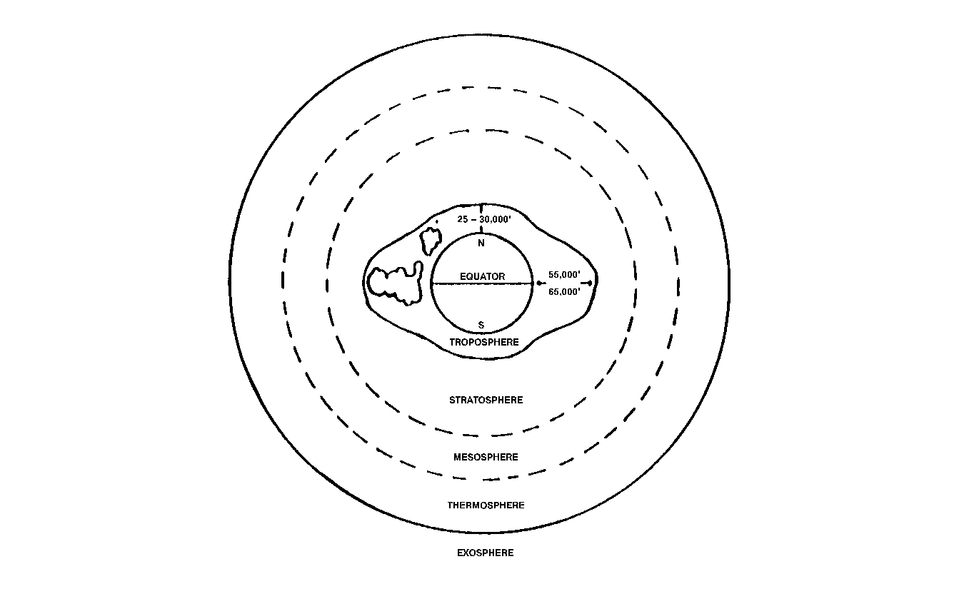
Figure 8-1 Divisions of the Atmosphere
10. The MESOSPHERE is characterized by a marked increase in temperature. At a height of about 150 000 feet, the temperature reaches 10°C. The rise in temperature is due to the presence of a layer of ozone (you know… the ozone layer everybody is talking about!) which absorbs more of the sun's radiation. In the top layer of the mesosphere, the temperature again drops rapidly reaching a level of about -100°C at 250 000 feet above the Earth.

11. Temperature again begins to rise in the THERMOSPHERE and increases for an indefinite distance into Space, rising as high as 3 000°C at 400 miles. This does not mean that a space ship, if it were cruising at this height, would experience a temperature of 3 000°C by contact with the atmosphere. The temperature in these rarefied layers is based on the kinetic theory of gasses. The only heat the space ship would experience would be what it would receive from the radiation of the sun. The spectacular auroras form in the upper regions of the thermosphere.

12. Since air becomes gradually thinner with increasing altitude, the upper limit of the atmosphere is, for all practical purposes, difficult to define. Now that man has invaded the cosmic realm of outer space, just where exactly does SPACE actually begin? At the altitude of 90 to 100 miles, on is entering the realm of satellites. Aerodynamic lift is no longer a requirement. This altitude is accepted by some authorities as the boundary of outer space. Ninety miles up is recognized as the limit of national sovereignty.

MOISTURE IN THE ATMOSPHERE

13. Water vapour is one of the most important constituents of the atmosphere from the standpoint of weather. Its behavior is important to a pilot because it can become visible as clouds, fog, or precipitation.

14. The moisture in the atmosphere originates mainly from evaporation from the oceans and lakes and from the moisture given off by vegetation. While the amount of moisture remains greatest near these sources, it is mixed throughout the lower 20 000 to 40 000 feet of the atmosphere. It is only within this layer that clouds and precipitation occur.

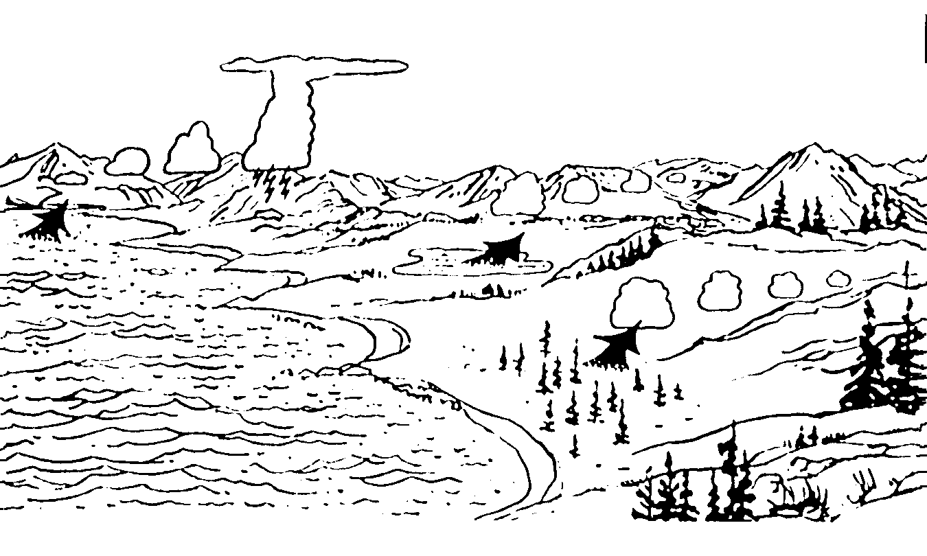
Figure 8-2 Source of Atmospheric Moisture

15. Under certain atmospheric conditions, water vapour can change to a visible form, turning into water droplets or ice crystals. Most weather results because of this characteristic of water. When water is cooled, it changes into water droplets. This process is called condensation. If the temperature is below freezing when the condensation occurs, the water vapour changes directly into ice crystals without the visible water droplet stage. When this change takes place without the vapour first becoming water, the process is known as sublimation. Both condensation and sublimation can result in the formation of fog and clouds, which are composed of water droplets and /or ice crystals.

16. The process of converting water vapour into water droplets or ice crystals can be reversed. When heated, both ice crystals and water droplets return to water vapour. This process is called evaporation. Ice crystals can also turn into water vapour under certain atmospheric conditions. This process is known as sublimation. Accordingly, fog and clouds may evaporate and disappear when they are heated.

17. The moisture content of the air or, in other words, the amount of water vapour present, plays an important role in the determination of weather. If the air is low in moisture content, it means the air is very dry and consequently, little cloud cover can develop. If the air is low in moisture content, it means the air is very dry and, consequently, little cloud cover can develop. If air has a high moisture content, fog and cloud are quite often present. The maximum amount of water vapour that the air can hold depends on the temperature of the air. The higher temperature, the more moisture it can hold.

SECTION 3

CLOUDS

1. Clouds are an indication of what is happening in the atmosphere. The location and type of clouds are evidence of such weather phenomena as frosts, turbulence and thunderstorms.

CLASSIFICATION OF CLOUDS

2. Clouds are classified into four families: high clouds, medium clouds, low clouds and clouds of vertical development. Each of the first three families is subdivided according to whether the clouds billow up in towers (cumulus type) or lie flat in horizontal sheets (stratus type). In addition to these subdivisions, the term Nimbus is added to the names of clouds that normally produce precipitation. Broken or fragmented clouds are identified by the prefix Fracto. Alto is latin word for high; however, clouds that use this prefix in their name are actually found in the middle altitudes of the atmosphere.

Group | High Clouds base 20 000 feet  To 40 000 feet | Middle Clouds base 6 500 feet to 20 000 feet | Low Clouds base surface to 6 500 feet | Clouds of Vertical development base 1 600 feet up
Type | Cirrus (CI)  Cirrostratus (CS)  Cirrocumulus (CC) | Altostratus (AS)  Altocumulus (AC)  Altocumulus (ACC)  Castellanus | Stratus (ST)  Nimbostratus (NS)  Stratocumulus (SC)  Stratus  Fractus (SC)  Cumulus  Fractus (CF) | Cumulus (CU)  Towering  Cumulus (TCU)  Cumulonimbus(CB)

Figure 8-3 Classification of Clouds

HIGH CLOUDS

3. The high clouds are composed of ice crystals and are usually based above 20 000 feet. They are classified as:

a. Cirrus. This cloud appeard as white curly streaks across the sky.

b. Cirrostratus. Unlike cirrus clouds, this cloud appears as a whitish veil through which the sun and moon can be seen, often surrounded by a halo.

c. Cirrocumulus. This is a somewhat rare cloud. It appears as a white sheet with a pebbly pattern.

MIDDLE CLOUDS

4. The middle clouds are based between 6 500 and 20 000 feet. They may be collections of water droplets, ice crystals, or of both. They are classified as:

a. Altostratus. This is a layer cloud with no definite pattern, such as rolls or waves, on its surface. It is steely or bluish in colour and, as seen from a particular place, may cover the entire sky. Sometimes the sun or moon can be seen dimly through it, but it causes no halos.

b. Altocumulus. This is a layer or series of patches of rather flattened round masses of clouds. The cloudlets may be arranged in groups, lines, or waves and are sometimes so close that their edges join.

c. Altocumulus Castellanus. This is simlar to the altocumulus but with pronounced turrets building upward. It indicates considerable instability in the cloud layer and the cloud may develop into cumulonimbus.

LOW CLOUDS

5. The low clouds are usually based above 6 500 feet. They are classified as:

a. Stratus. This is a uniform layer of very low cloud that may appear in extensive sheets or irregular patches. It resembles fog, except that it does not rest on the ground, although it may be very close to it. Its undersurface does not show any patern such as waves or ripples. When it is torn by the wind, it appears in fragments referred to as stratus fractus. Drizzle or freezing may fall from it.

b. Nimbostratus. This is the main precipitation cloud: continuous rain, snow, freezing rain, etc, may be encountered when flying in or below it. In appearance, it is an extensive layer, uniformly dark in colour, that may be based from 6 500 feet to near, or at the ground. Nimbostratus is often part of an extensive cloud layer that forms in the over-runnung warm air ahead of a warm front.
c. Stratocumulus. This is a common and easily recognized cloud form. The bottom has a clear cut, wavy or rolled appearance. It often appears as an extensive sheet, but sometimes, there are well-defined breaks between the rolls. Occasionally, heap clouds are embedded in it. By itself, it gives little precipitation, except in very cold weather when it may give snow.

CLOUDS OF VERTICAL DEVELOPMENT

6. The heap clouds may appear as isolated clouds, or they may be embedded in layer clouds. They are classified as:

a. Cumulus. These are fluffy white clouds that form in the top of convection currents. They are a common sight over land during hot summer afternoons. Their edges are hard and clear-cut in appearance, and their tops are rounded. When they appear as ragged or torn fragments, they are called cumulus fractus.

b. Towering Cumulus. The name aptly describes these cumulus clouds that have grown to considerable height, but still have clear-cut rounded tops.

c. Cumulonimbus. When a towering cumulus grows to a great height, perhaps to the troposphere or higher, the top loses its hard, clear-cut appearance and frays out into a widespread, white, fibrous structure, often called an anvil or a thunderhead. The cloud is now a cumulonimbus or thunderstorm cloud. Heavy precipitation in the form of fain or hail showers may be seen pouring out of it. These clouds are very dangerous for aircraft but, unless they are embedded in or obscured by other clouds, the white spreading tops can be recognized from a considerable distance.

CLOUD FORMATION

7. Essentially, clouds are formed by water vapour into water droplets (condensation) or ice crystals (sublimation). This change is brought about by cooling, usually associated with the expansion of rising air. The extent and type of cloud and precipitation produced will depend on the amount of water vapour available, the abundance of condensation nuclei and the stability of the air.

8. The process by which water vapour changes into water droplets is called condensation and occurs when humidity is high. The level at which water vapour condenses and becomes visible is known as the condensation level. This level is, in practice, the base of the clouds. If the cloud forms at ground level, it is called fog rather than cloud.

9. Clouds are formed in two ways:

a. Air, in which vapour is present, is cooled to its saturation point and condensation occurs. The cooling process occurs as warm air comes in contact with a cold surface.

b. Air, without changing temperature, may absorb additional water vapour until its saturation point is reached, with the result that clouds are formed.

SECTION 4

FOG

1. Fog is one of the most common and persistent weather hazards encountered in aviation because it often restricts visibility during take-offs and landings. Fog is composed of small ice crystals or water droplets suspended in the atmosphere. Although these components are so small they cannot be seen by the naked eye, they are so numerous that they severely reduce visibility.

2. Fog is, in fact, a cloud usually stratus, in contact with the ground. It forms when the air is cooled below its dew-point (the temperature to which air must be cooled to cause saturation), or when the dew-point is raised to the air temperature through the addition of water vapour.

3. To form a water drop in the atmosphere (the basis of fog formation), there must be present some nuclei on which the drops may form. Dust, salt, sulphur trioxide, smoke, etc, provide this function. Given a sufficient number of condensation nuclei, the ideal conditions for the formation of fog are high relative humidity, a small temperature dew-point spread (When the spread between the temperature and dew-point is very small, the air is nearly saturated and a slight drop in temperature may cause condensation and the form of fog.) and some cooling process to initiate condensation. Light surface winds set up a mixing action which spreads and increases the thickness of the fog. In very still air, fog is unlikely to form. Instead, dew will collect.

4. Smoke and dust in air over large cities produce the pea soup fogs characteristics of London and some large American cities. Carbon and dust particles cause dark-coloured fogs. Fogs composed of water drops only are white in colour.

5. Fog is usually dissipated by sunlight filtering down through the fog or stratus layer. This results in heating from below.

TYPES OF FOG

6. The names given to various types of fog are based on the way that they are formed. These types are discussed in the following paragraphs. They are:

a. radiation fog;

b. advective fog;

c. upslope fog;

d. steam fog;

e. precipitation-induced fog; and

f. ice fog.

RADIATION FOG

7. Radiation fog is formed on clear nights with light winds. The ground cools, losing heat through radiation. The air in direct contact with the earth's surface is cooled. If the air is moist and the temperature drops below the dew-point, fog forms. The ideal conditions for the formation of radiation fog are a light wind that spreads the cooling effect through the lower levels of the air, clear skies that permit maximum cooling and an abundance of condensation nuclei. This type of fog is commonly called ground fog, since it forms only over land.

8. Radiation fog normally forms at night, but sometimes it thickens or even forms at sunrise as the initial slight heating from the sun causes a weak turbulence. Radiation fog tends to settle into low areas, such as valleys, and it is usually patchy and only a few hundred feet thick. It normally dissipates within a few hours after sunrise as the sun warms the earth and radiation heating causes the temperature to rise.

ADVECTION FOG

9. Advection fog is caused by the drifting of warm damp air over a colder land or sea surface. This type of fog may persist for days and cover a wide area. It occurs most frequently in coastal regions. Widespread fog forms when moist air from a warm region of the ocean moves over cold water. It can persist for lengthy periods since the water surface is not affected by daytime heating.

10. Advection fog may be spread over land if the circulation is from the sea to a colder land surface and will persist until the direction of the wind changes. Although it may dissipate or thin during the day from daytime heating, it will reform at night. The warm sector of a frontal depression is also favourable for the formation of advection fog.

UPSLOPE FOG

11. Upslope fog is caused by the cooling of air due to expansion as it moves up a slope. A light upslope wind is necessary for its formation.

STEAM FOG

12. Steam fog forms when cold air passes over a warm water surface. Evaporation of the water into cold air occurs until the cold air becomes saturated. The excess water vapour condenses as fog. Steam fog occurs over rivers and lakes, especially during the autumn.

PRECIPITATION-INDUCED FOG

13. Precipitation-induced fog is caused by the addition of moisture to the air through evaporation of rain or drizzle. This type of fog is associated mostly with warm fronts and is sometimes known as frontal fog. The rain falling from the warm air evaporates and saturates the cooler air below.

ICE FOG

14. Ice fog forms in moist air during extremely cold calm conditions. The tiny ice crystals composing it are formed by sublimation and are often called needles. Ice fog is caused by the addition of water vapour to the air through fuel combustion. The very cold air cannot hold any additional water vapour and the excess sublimates into visible ice crystals. Ice fog may appear suddenly when an aircraft engine is started.

SECTION 5

PRECIPITATION

1. In the preceding paragraphs, we learned that clouds are formed by water vapour changing into water droplets or ice crystals. This change is brought about by cooling, usually associated wit the expansion of rising air. The strength and the extent of rising currents are controlled partly by the stability of the air. Once a cloud has formed, other developments within it may cause precipitation.

FORMS OF PRECIPITATION

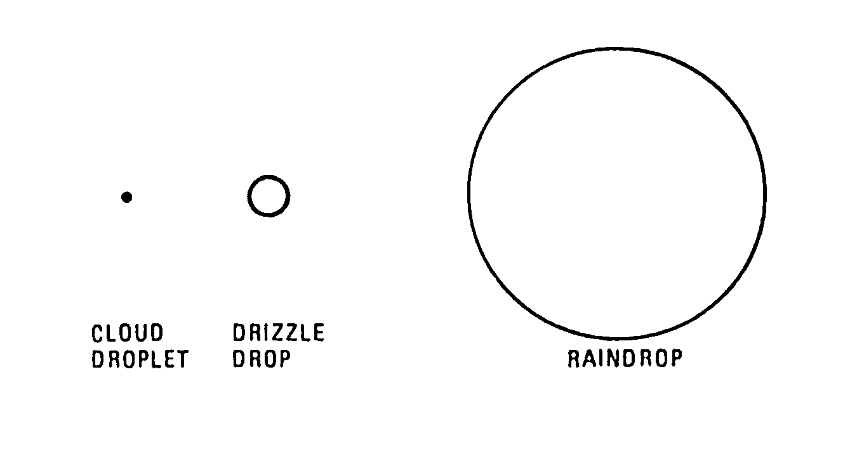
2. Precipitation appears in many forms, such as snow, rain, drizzle or frozen raindrops known as ice pellets. It may be showery or steady. Precipitation occurs when water droplets, visible as a cloud, grow sufficiently in size and weight to fall due to gravity. In clouds with temperatures above freezing, vertical air currents cause the droplets to move about. As a result, they collide with other drops and gradually grow in size, gaining momentum until they fall through the air as rain, A single raindrop must grow enormously in order for precipitation to take place. The average raindrop is about one million times larger than a cloud water droplet!

Figure 8-4 Relative Side of Cloud Droplets, Drizzle Drops and Raindrops

3. In stable clouds such as stratus, there is very little vertical motion, not even enough to sustain small water droplets. The water droplets frequently escape and drift slowly to earth. This form of precipitation is called drizzle.

4. A second mechanism which causes precipitation requires that ice crystals and water droplets exist side-by-side in a cloud at a temperature below freezing. The ice crystals grow at the expense of the water droplets. The droplets tend to evaporate and the resulting water vapour sublimates on the ice crystals. The ice crystals grow in size and weight. They are sustained in the cloud until they grow large enough that their terminal velocity exceeds the updraught velocity in the cloud. If the temperature below the region of formation is above freezing, the crystals will melt, coalesce with other rain drops and fall to earth as rain. If the temperatures are cold all the way to the ground, the ice crystals will aggregate into snow flakes. In Canada, heavy rainfall usually occurs as a result of a combination of sublimation on ice crystal and coalescence.

DRIZZLE

5. Precipitation in the form of very small drops of water which appear to float is called drizzle. At temperatures at or below the freezing level, drizzle freezes on impact with objects and is known as freezing drizzle.

RAIN

6. Precipitation in the form of large water droplets is called rain. Freezing rain is composed of supercooled water droplets that freeze immediately on striking an object which is itself at a temperature below freezing.

SNOW PELLETS (Soft Hailstones)

7. If the region lying below the supercooled region of cloud is not of great depth, a hailstone does not acquire a hard, transparent covering and arrives at the ground as a soft, white ice pellet. It is then known as a snow pellet or soft hailstone.

SNOW

8. In the formation of snow, the invisible water vapour in the air sublimates directly into ice crystals, without passing through an intermediate water stage. Snowflakes are formed of an agglomeration of ice crystals and are usually hexagonal or star-shaped. Snow grains are tiny snow crystals that have acquired a coating of rime. Snow grains and snowflakes fall from non-turbulent clouds.

ICE PRISMS

9. Ice prisms are tiny ice crystals in the form of needles. They may fall from clouds or from a cloudless sky. They exist in stable air masses and at very low temperatures.

ICE PELLETS

10. Ice pellets are formed by the freezing of raindrops. They are hard transparent globular grains of ice about the size of raindrops. They generally rebound when striking the ground.

SECTION 6

TEMPERATURE

1. Temperature, like moisture, in an important weather determinant. Changes in temperature within the lower levels of the atmosphere produce significant changes of state which in turn produce clearness or cloudiness.

SOLAR AND TERRESTIAL RADIATION

2. All heat comes from the sun by radiation. Direct radiation from the sun passes almost unhindered through the lower part of the atmosphere and is absorbed by the earth's surface. The earth, in turn, re-radiates the heat in a form that can be absorbed by the air. For example, some of the outgoing radiation from the earth's surface is absorbed by carbon dioxide and water vapour present in the troposphere. The amount of heating that this creates decreases with altitude as the radiation and re-radiates it back to earth and out to space. As a result, the outgoing radiation balances the incoming radiation from the sun so that the earth's average temperature remains nearly constant.

3. Some of the outgoing terrestrial radiation is absorbed by the lower levels of the atmosphere. The rest passes out into space. The lower levels of the atmosphere are therefore not heated directly by the sun. The sun heats the earth and the earth heats the atmosphere. This fact is of the greatest importance in understanding weather. The atmosphere is heated from below and not from above.

a. Diurnal Variation. During the day, solar radiation exceeds terrestrial radiation and the surface of the earth becomes warmer. At night, solar radiation ceases but terrestrial radiation continues and cools the surface. Warming and cooling of the atmosphere occur as a result of this diurnal imbalance.

b. Seasonal Variation. Because the axis of the earth is tilted relative to the plane of its orbit, the angle at which solar radiation strikes the earth varies from season to season. The northern hemisphere receives more solar energy in June, July and August and is therefore warmer and receives less in December, January and February and is therefore cooler.

c. Latitude. The sun is more directly overhead in equatorial regions than at higher latitudes. The tropics consequently receive the most radiant energy and are warmer than the polar regions, where the slanting rays of the sun deliver less energy over a given area.

d. Topography. Land surfaces absorb more solar radiation than do water surfaces and radiate it more readily. Land surfaces therefore warm up more rapidly during the day and cool more rapidly at night. All land surfaces do not, however, absorb radiation at a uniform rate. There is great variation in radiation absorbtion by varying types of land surface. Wet soil, such as is found in swamps and marches, in almost as effective as water in suppressing temperature changes. Heavy vegitation acts as an insulation against heat transfer. The greatest temperature changes occur over arid, barren surfaces such as deserts and rocky plains. Some of solar radiation is reflected directly back out to space by the earth's surface and is not absorbed at all. Some of this reflection is due to the angle at which the radiation strikes the surface, but the principal cause of reflection is the type of surface. A snow surface, for example, can reflect 90 per cent of the radiation.

e. Clouds greatly affect temperature. A layer of clouds will reflect a high percentage of the incoming solar radiation back out to space, drastically reducing the amount of energy reaching the earth to warm it. On a cloudy night, the clouds absorb the outgoing terrestrial radiation and radiate a considerable part of it back to earth, hindering the escape of heat.
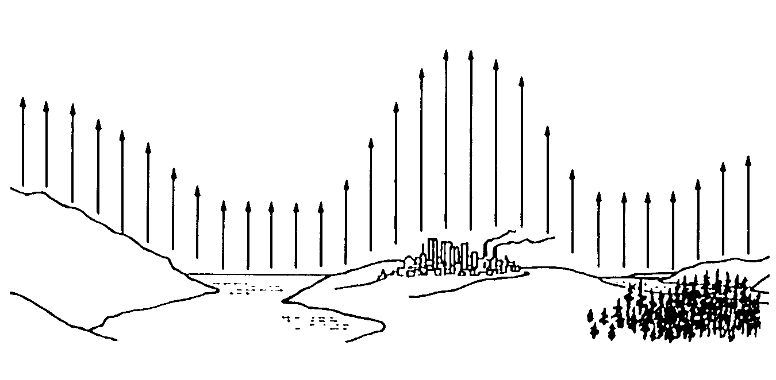
Figure 8-5 The Atmosphere is Heated From Below
PO 417
N
A
V
I
G
A
T
I
O
N

CHAPTER 9

PERFORMANCE OBJECTIVE 417

NAVIGATION

SECTION 1

INTRODUCTION

1. Last year, you learned that the three main points to determine when talking about air navigation are:

a. the correct heading to direct the aircraft to the desired direction;

b. the position of the aircraft at any time; and

c. the time at which the aricraft will reach any particular position.

2. As you remember, we told you that the sky is divided into airspace corridors acting like highways with different altitudes. Pilots have to respect these corridors and therefore are not totally free to take any route they want anytime they want. Such a behaviour would increase the danger of collision.

3. As is the case with someone preparing a hiking trip, a pilot preparing for a voyage must possess the ability to read a chart, measure the distance to be discovered, determine the plane's speed and the time needed to arrive at destination.

SECTION 2

AERONAUTICAL CHARTS

1. As the earth is a sphere, its surface cannot be represented on a flat plane. Some convenient representation of the portion of the earth over which the flight path of an aircraft will pass is necessary to measure the direction and distance between the starting and the destination point of the flight, and to determine the position of the aircraft in relation to the pilot or navigator.

2. A map is a small-scale flat-surface representation of some portion of the earth's surface. Usually a representation which is designed for plotting navigational information is termed as chart, although the term map and chart are often used interchangeably.

3. The only way of reproducing a true and undistorted picture of the earth's surface is to do so on the surface of a figure similar to the earth, this is, on a sphere. In other words, the only perfect maps in existence today are in the form of spheres, such as the common globes that may be seen in any classroom. Globes are obviously too cumbersome for a pilot's compartment. For practical purposes, maps are prepared on flat surfaces, but you must understand that no flat map can represent all or even a part of the earth's surface exactly in every detail.
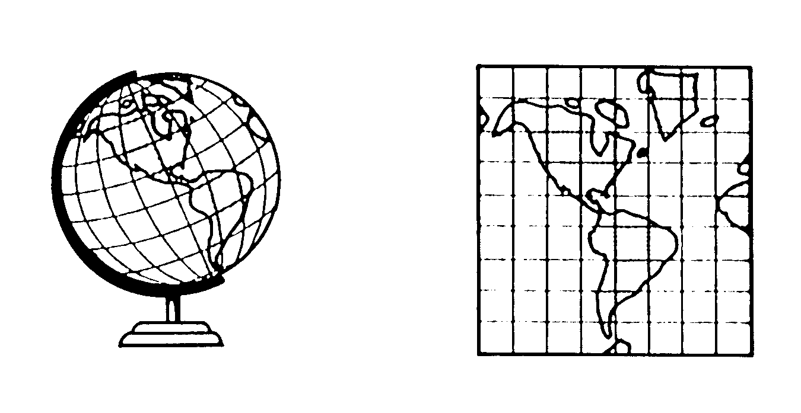
Figure 9-1 Globe Versus Map
4. Since the surface of the earth cannot be accurately projected onto a map, a map must show the portion of the earth's surface it represents with some distortion.

5. There are four basic elements in map construction. These are:

a. areas;

b. shapes;

c. bearing; and

d. distances.

6. According to the particular purpose of a map, one or more of these elements is preserved as nearly correctly as possible, with consequent unavoidable distortion in the remaining elements. The mathematical bases on which maps are constructed are termed projections.

7. There are two principal types of chart projections used in air navigation charts: the Lambert Conformal Conic Projection and the Transverse Mercator Projection.

THE LAMBERT CONFORMAL CONIC PROJECTION

8. The basic idea upon which the Lambert Conic Projection was developed supposes a cone is superimposed over the surface of a sphere. If the cone were opened and unrolled, the meridians and parallels would appear as shown in Figure 9-2.

9. On this type of map, the angles between meridians and parallels are the same on the map as they are on the ground. The term conformal refers to this characteristic. Scale must be the same along both meridians and parallels.

THE MERCATOR PROJECTION

10. The principle on which the Mercator Projection is based is that of a cylinder which has its points of tangency at the Equator. Its approximate form may be visualized by imagining a light at the centre of a globe that casts a shadow of the meridians and parallels on a cylinder of infinite length enclosing it. As you can see at Figure 9-3, the shadows of the more northerly parallels of latitude are wider apart on the cylinder than they actually are on the sphere.

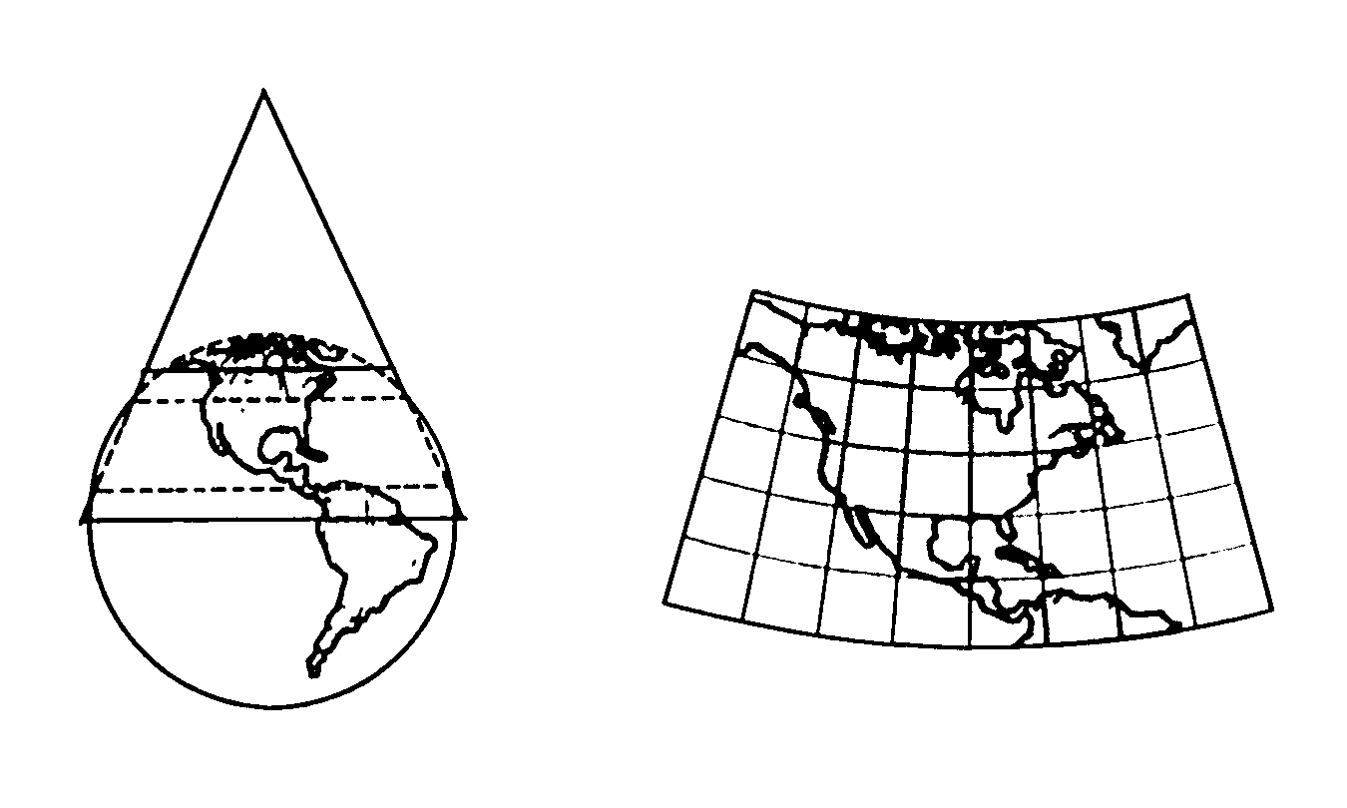
Figure 9-2 Lambert Conformal Conic Projection and Development

11. The shadows of the meridians on the cylinder are straight and parallel lines to infinity, whereas on the sphere they converge to meet in a point at the Poles. It is, in other words, as though the Meridians were stretched apart at the Poles to the same distance they are apart at the Equator. This causes extreme exaggeration of longitude in northerly areas. The Mercator Projection is relatively precise in depiction of distances in the equatorial regions. However, distortion, as has been stated, becomes more pronounced with distance from the Equator.

12. To overcome this problem, the Mercator technique can be applied by rotating the cylinder 90 degrees so that the point of tangency is a meridian of longitude rather than the Equator. In this case, the chart is accurate along the selected meridian. Such a projection is called a Transverse Mercator Projection (see Figure 9-4).

13. The Transverse Mercator Projection, because of its method of production, is quite accurate in depicting scale, especially on charts covering a relatively small geographical area. Depending on the area to be depicted, any one of the 360 meridians of longitude can be selected as the point of tangency for the chart projection.

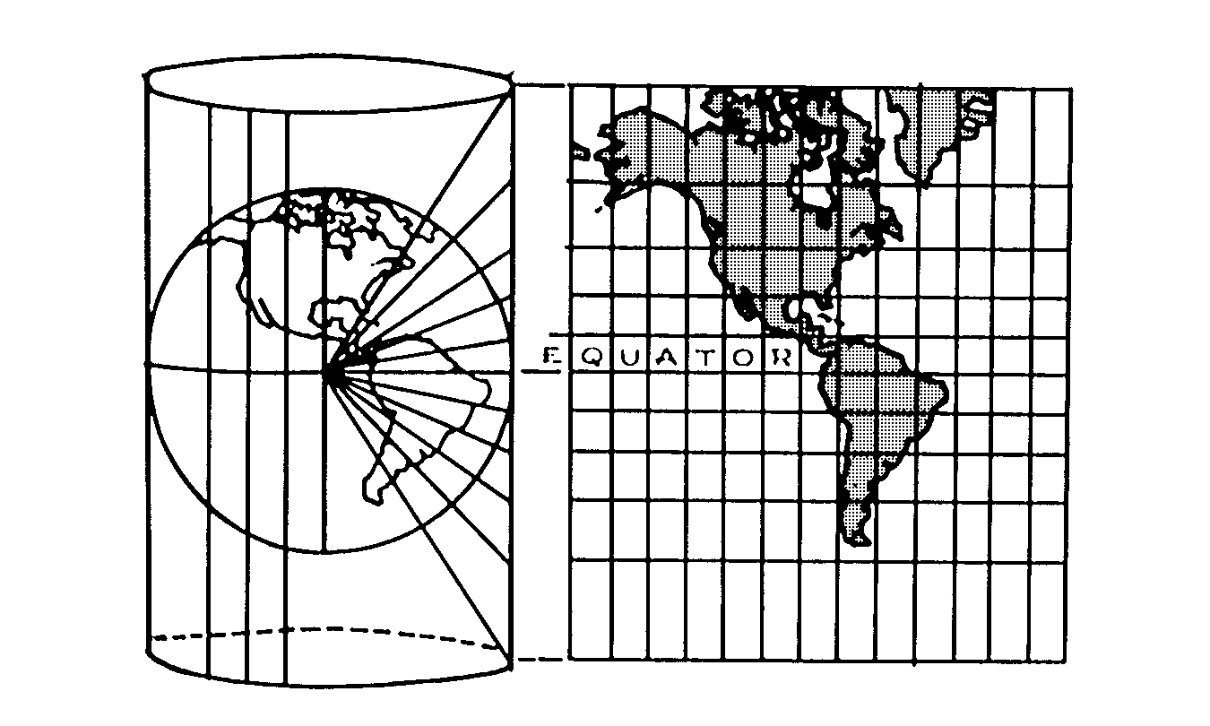
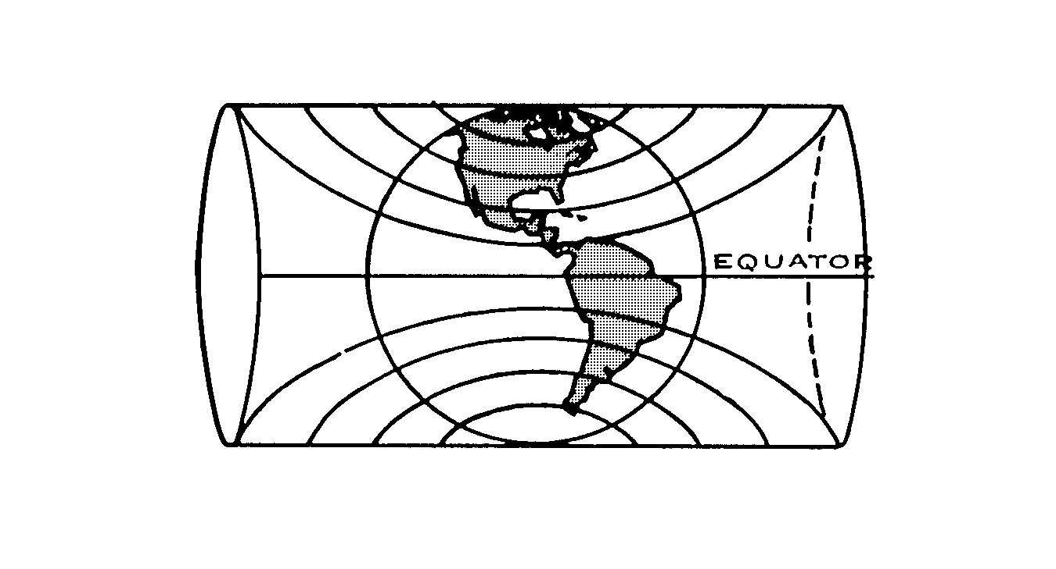
Figure 9-3 Mercator Projection and Development

Figure 9-4 Transverse Mercator Projection

TYPES OF AERONAUTICAL CHARTS

14. Canadian Pilotage Charts (CPC) are designed primarily for visual navigation and are most useful during flights at lower altitudes and at slower speeds. Each chart depicts a portion of Canada and is identified by the name of the principal landmarks on the chart. The Smithers-Fort St. James Chart, for example, derives its name form the two communities that are positioned near the western and eastern edges of the chart, which covers a substantial portion of the interior of British Columbia. CPCs are based on the Transverse Mercator Projection and conform to the characteristics of that projection.

15. VFR Navigation Charts (VNC) are a new series of charts that will eventually replace the Canadian Pilotage Charts. They depict more extensive geographical areas. Each of the new VFR Navigation Charts replaces four of the CPC series. The chart is printed on both sides, with the northern half of the area to be depicted on one side and the southern half on the reverse. Each chart is identified by the name of a principal landmark (eg, Toronto, Montreal, Vancouver). VFR Navigation Charts are based on the Lambert Conformal Projection and conform to the characteristics of that projection.

16. World Aeronautical Charts (WAC) are designed for visual navigation and are most useful during flight at the higher altitudes and at greater speeds. Each chart depicts a sizeable portion of the geographical area of Canada. Nineteen charts cover the whole country. Each chart is identified by a letter and a number. For example, E 17 covers the area from Thunder Bay west to Regina, and from the 48th Parallel north to Thompson, Manitoba. As is the case with VFR charts, it is printed on both sides. The title of the chart and other aeronautical information is printed on two sides of a white side border on one edge of the map.

17. Radio Navigation Charts provide information for radio navigation over designated airways systems. Enroute Low Altitude Charts (LE) are intended for use up to but not including 18 000 feet. Enroute High altitude Charts (HE) are intended for use at 18 000 feet and above. Terminal Area Charts depict aeronautical radio navigation information in congested areas at a larger scale and are intended for use form the surface up to 18 000 feet. Enroute charts do not portray any cities, towns, or topographical features, but depict all radio navigation aids, including airways, beacons, reporting points, communication frequencies, etc. Each chart contains two separate map sheets printed back-top-back. A table of symbols and a list of all radio communication facilities available within the area covered by the charts is printed on the front of the sheet.

SECTION 3

BASIC CHART INFORMATION

1. Map Scale. The scale of a map is the ratio of a given distance on the map to the actual distance that it represents on the earth.

Scale = Map distance
Earth distance

There are several methods of expressing scale. They are:

a. Representative Fraction. Perhaps the most common method of expressing map scale is by representative fraction. A representative fraction expresses the ration of a unit of length of the map to a corresponding number of similar units on the earth. For example, a representative fraction of 1:500 000 means that one inch on the map is equal to 500 000 inches on the earth.

b. Statement of Words. Another method of expressing scale is by a simple statement in words such as "one in a million", which means that one unit on the map is equivalent of one million similar units on the earth. Other examples of scales expressed as statements in words are:

(1) Six-Inch Map. This means that six inches on the map represent one mile on the earth.

(2) One-Half-Inch Map. Here one-half inch on the map represents one mile on the earth.

(3) Eight-Mile Map. This statement means that eight miles on the earth are represented by one inch on the map.

c. Graduated Scale. Almost every map used in air navigation is provided with a graduated scale, even though one of the above-noted methods of expressing scale is also used on the map. A graduated scale is simply a line drawn on some convenient part of the map and graduated to show the length of one mile on the map. An example of a graduated scale is shown in Figure 9-5.

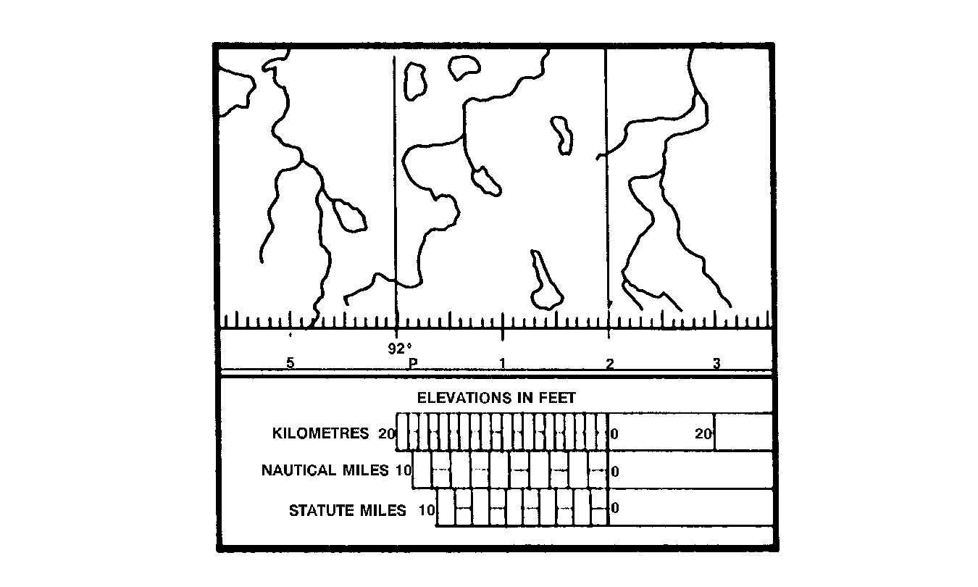
Figure 9-5 Graduated Scale Line

2. Relief on Maps. The term relief is used to describe the method of representing changes in elevation of the earth's surface on a flat plane or map. Some of the methods used for showing relief are listed below:

a. Contour Lines. These join points of equal height above sea level (see Figure 9-6).

b. Layer Tinting. This is used between contour lines.

c. Spot Heights. These show the height above sea level of isolated obstructions and hill tops. The greatest height on any one sheet of some map is shown in a box.

- Hachures. These are lines showing abrupt slopes. Hachures are usually used only on Mercator Plotting Charts (see Figure 9-6).

e. Shading. This shows abrupt slopes.

3. Isogonic Lines. Isogonic lines (lines joining places of equal magnetic variation) are depicted by dashed lines. The degree of variation is printed at regular intervals along the line.

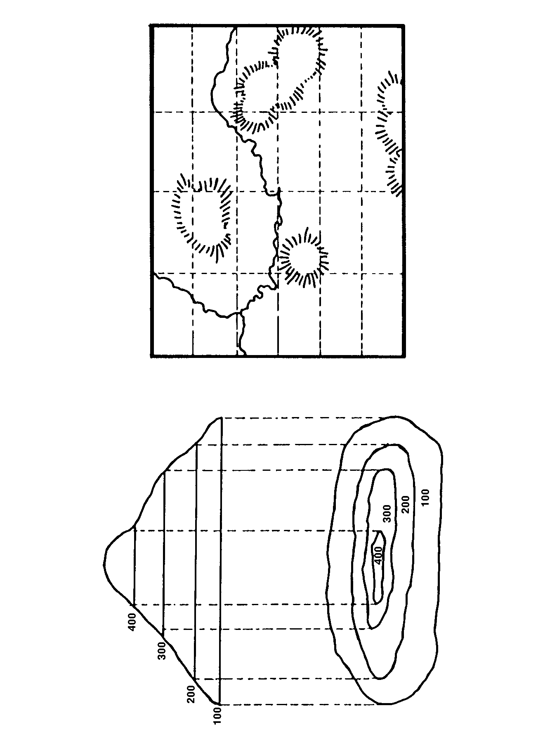
Figure 9-6 Contour Lines and Hachures
4. Latitude and Longitude. A grid-like pattern of meridians and parallels is depicted on aeronautical charts. The meridians are graduated in minutes of latitude, and the parallels in minutes of longitude. This makes it possible for latitude and longitude to be measured on the chart. In addition, the subdivided meridians provide a scale of nautical miles, since a minute of latitude may be considered as a nautical mile.

5. Communities, Roads and Railways. Yellow squares represent towns and small villages. Hamlets are represented by small circles. A city is depicted by a yellow area outlined in black that corresponds to the actual shape and size of the community. Highways are indicated by red or brown lines, double-lane highways by double lines. Railways are shown as black lines.

6. Aerodromes. Small airports are sown by a circle as depicted in Figure 9-7. Large airports (those with hard surface runways) are depicted at their location on the chart by a diagram of the landing areas. For airports with a control tower, a schematic depiction of the airport is repeated on the white border of Canadian Pilotage Charts.

7. Restricted Areas. Areas over which flight is restricted are marked on aeronautical charts and information about them is printed on the chart. These include Alert, Danger, Restricted, Warning and Prohibited Areas, and Military Climb Corridors.

8. Compass Rose. A circle overprinted on a chart divided into 360°, from which directions may be measured, is called a compass rose. The compass rose is oriented on the chart on the Magnetic North. It has a diameter of approximately 30 nautical miles on Canadian Pilotage and VFR Navigation Charts (1:500 000).

9. Aeronautical Information. The date of issue of a particular chart is always included with the information printed with the title of the chart. A legend of aeronautical information explaining the symbols and data appearing on the chart is always printed somewhere on the sheet. The legend includes topographical symbols, as well as information on aerodromes, radio frequencies, airways and control.

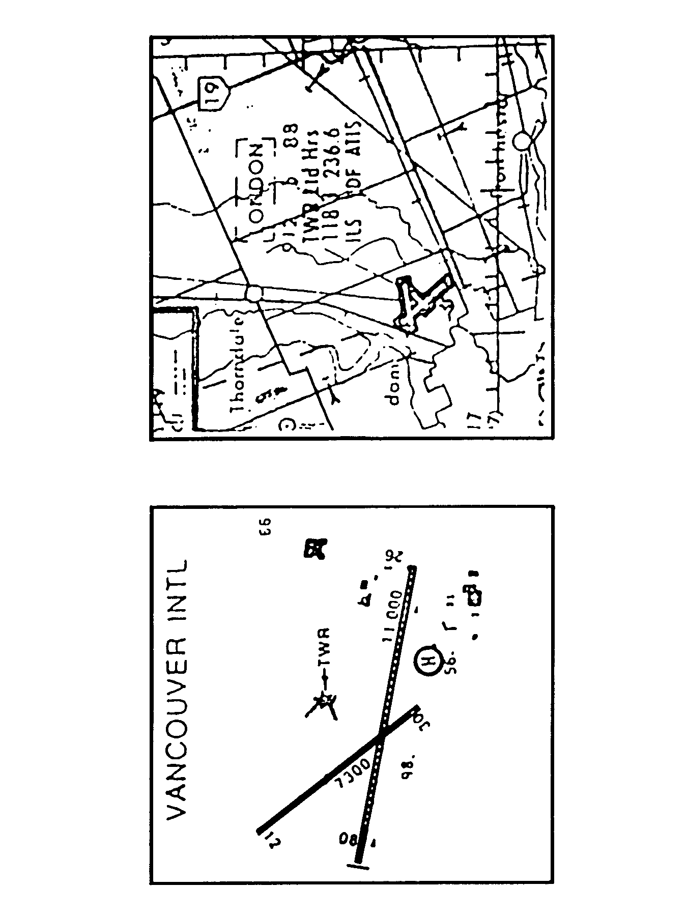
Figure 9-7 Aerodromes

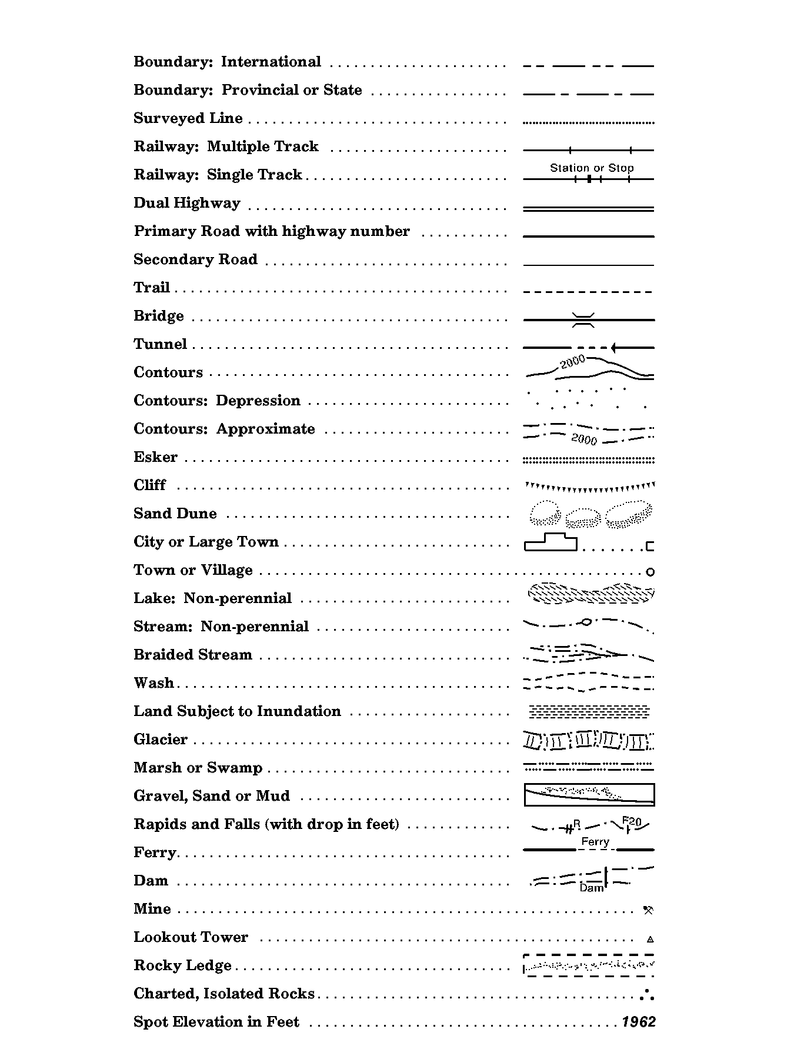
Figure 9-8 Conventional Topographical Symbols

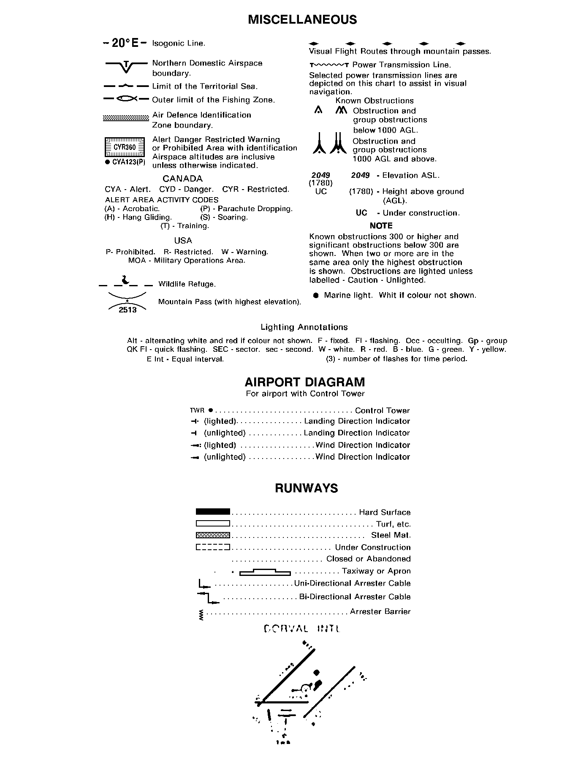
Figure 9-9 Aeronautical Symbols

SECTION 4

NAVIGATION PLOTTING AND PLOTTING EQUIPMENT

1. Plotting is the process of recording on a map or chart information about the intended or actual progress of an aircraft's flight.

2. In planning a flight, the pilot plots the departure point, the aircraft's intended track, intermediate points, destination and the distance between each point. Once the flight, pinpoints or other fixing information, and new required tracks and distances are plotted.

INSTRUMENTS

3. Plotting a flight requires measuring distances, angles and directions. Pilots use specially designed instruments to plot their flights.

a. Navigation dividers are used primarily to mesure distances on a chart. They are opened or closed by holding one leg of the dividers against the palm of the hand and moving the other leg with the first two fingers. Most navigational dividers have a tension screw which permits an adjustment to be made to prevent the legs of the dividers from becoming too stiff or too loose. Additionally, small set screws are usually provided; they permit the points that form the dividers' ends to be adjusted to make them equal in length.

When dividers are used to measure the distance represented by a line drawn on a chart, the points of the dividers are separated or set to span the line. The dividers are then placed against the graduated scale of the chart where the spanned distance is read of in miles. By reversing the procedure, lines can be drawn on the chart to represent any desired distance, ie, the dividers are set to span the desired distance on the graduated scale, and then used to mark off the line to the length set on the dividers.

Frequently, the chart distances to be measured or marked off exceed the maximum span of the dividers. In such cases, the dividers are set to span convenient distances, preferably a divisor of the total distance. The total distance is then measured or laid off in steps, resetting the dividers for the last step if the remaining distance falls short of the distance initially set on the dividers.

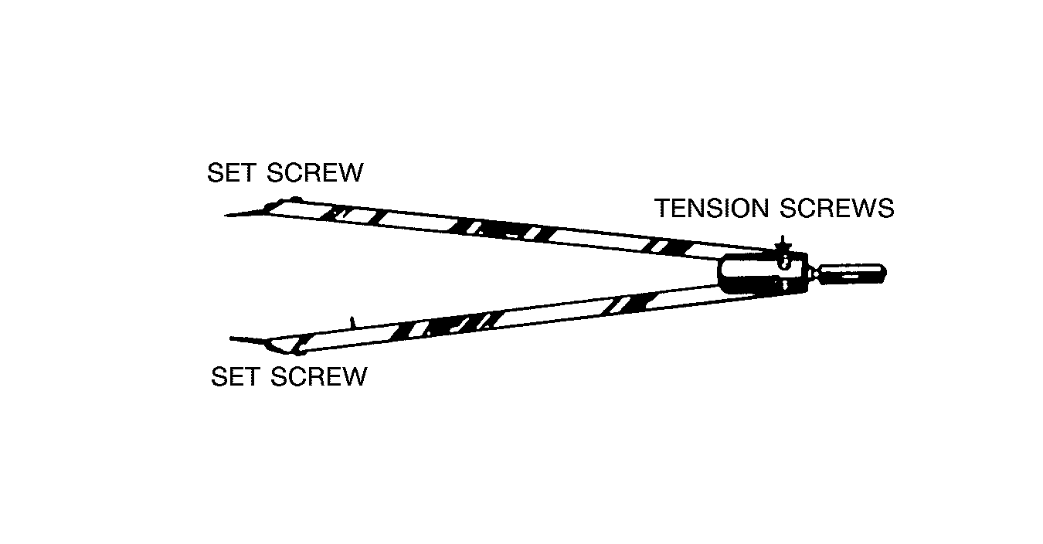
Figure 9-10 Navigational Dividers

When distances are being measured or marked off on a chart, the chart should be kept flat and smooth between the points of the dividers. A wrinkle may introduce an error of several miles. In marking off a distance, too much pressure on the dividers tends to spread the points, which could introduce an error in the distance. A position on the chart may be identified by pricking the chart lightly with one point of the dividers.

b. The Douglas Protractor is an instrument designed primarily for measuring angles. It is useful in performing a variety of other tasks as well.

The instrument shown in Figure 9-11 consists of a five-inch square of transparent material with a small hole in the centre. The undersurface of the protractor has a glossy finish and the upper face a matt finish to receive pencil markings. The edge of the square is marked off in degrees and labelled at 10-degree intervals on two scales, the outer one clockwise, and the inner one, in italics, counterclockwise. The remainder of the surface is marked off by a series of lines parallel to the edges and one-half inch apart. The left side of the protractor, distinguished by the printed Douglas Combined Protractor and Parallel Rule, is termed the ruling edge.

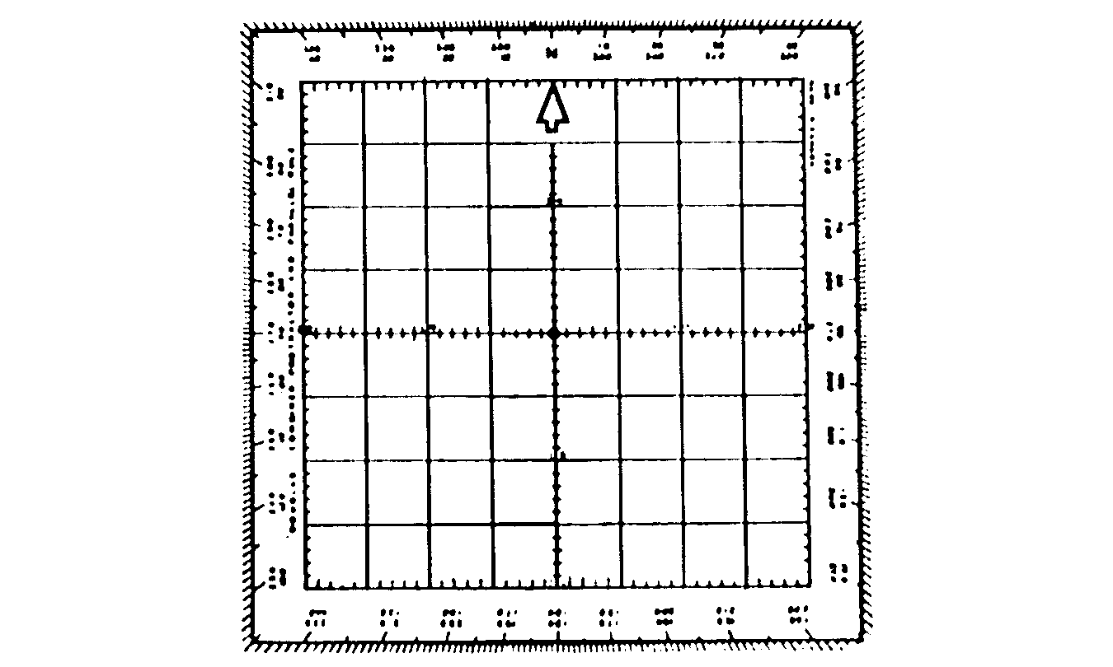
Figure 9-11 Douglas Protractor

In addition to a protractor, a pilot will require a ruler to measure distances. A mileage scale is printed on every aeronautical chart and it is simple matter to measure the distance from the airport of departure to the destination and lay this distance off against the chart scale to determine the mileage.

c. The Navigation Plotter (see Figure 9-12) is of great assistance in plotting and planning flights. It combines a protractor and a straightedge in one device, and also incorporates a mileage scale for both 1:500 000 and 1:1000 000 charts. The plotter is made of clear plastic so that details of the chart can be seen through it. The direction of a track is determined by using the protractor portion of the plotter. It is numbered from 0° to 180° on the outside scale and from 190° to 360° on the inside scale. The outside scale is used for easterly tracks and the inside scale for westerly tracks.

To use the plotter, place the hole in the centre of the plotter over an intersection of the track line and one of the longitude lines on the chart. A point somewhere near the midpoint of the track is best chosen to obtain greater accuracy. Place the pencil point through the hole and rotate the plotter until the top edge of the straightedge is aligned with the track line.

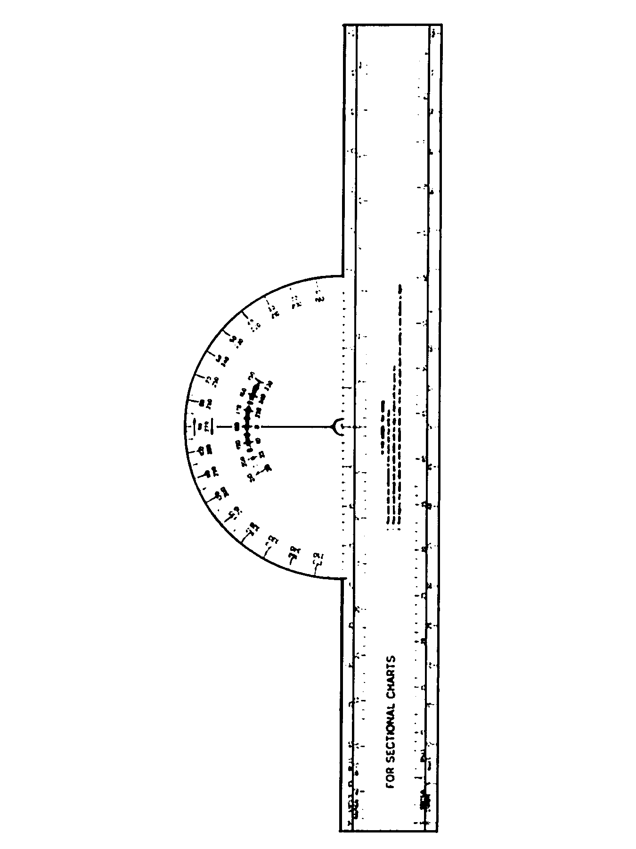
Figure 9-12 Navigation Plotter
Read the true track heading where the longitude line of the chart intersects the scales. In using the straightedge to determine the distance from the airport of departure to the destination, be sure to use the correct side of the straightedge for the type of chart in use. The mileage scale on one side of the straightedge is 1:500 000 for Canadian Pilotage Charts and is marked off in both statute and nautical miles. The reverse side of the straightedge has a scale of 1:1000 000 for World Aeronautical Charts and is also marked off in both statute and nautical miles.

PLOTTING A DIRECTION

4. As shown in Figure 9-13, the protractor is positioned on the chart in such a way that the centre hole of the protractor falls on the point at which the directed line is to originate, and the north point of the protractor points towards true north. The protractor is thus aligned with the local meridian through the point of origin. Next, a pencil mark is made on the chart opposite the desired direction on the outer scale of the protractor. The protractor is then removed and one of its edges used as a guide to draw a straight line from the point of origin in the direction of the pencil mark to any desired length.

READING OFF A DIRECTION

5. As illustrated in Figure 9-13, the protractor is positioned on the chart with the centre hole on that point on the line at which true direction is to be measured with the north point of the protractor pointing to true north. The true direction of the line at the selected point is read off the outer scale where the line, extended if necessary, cuts the edge of the protractor.

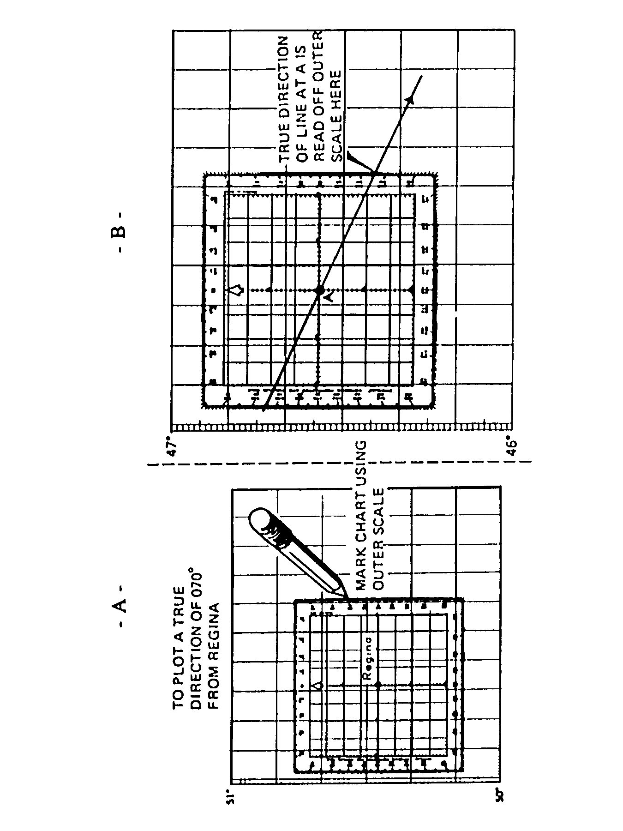
Figure 9-13 A – Protractor Aligned with Local Meridian
B – Reading Off Direction

SECTION 5

NAVIGATION TERMINOLOGY

Closing Angle. This is the angle between the old required track and the new required track necessary to arrive at the destination (see Figure 9-14).

Compass North. This is the direction in which a particular compass needle lies when influenced by both the earth's magnetic field and local magnetic influences (deviation) in the airplane. The actual reading on a compass at any time is the angle between Compass North and the direction the airplane is heading.

Drift. A wind blowing from either the starboard or port side of an airplane will cause the airplane to drift away from its intended track. In order to maintain one's intended track, it is necessary to turn the plane slightly into the wind to compensate for the force acting laterally upon it. Drift (or drift angle) is the angle between the heading flown and the track-made-good over the ground. In other words, it is the angle at which the pilot heads the airplane across the track to keep the wind from blowing him off the track. It is expressed in degrees either port or starboard (see Figure 9-15).
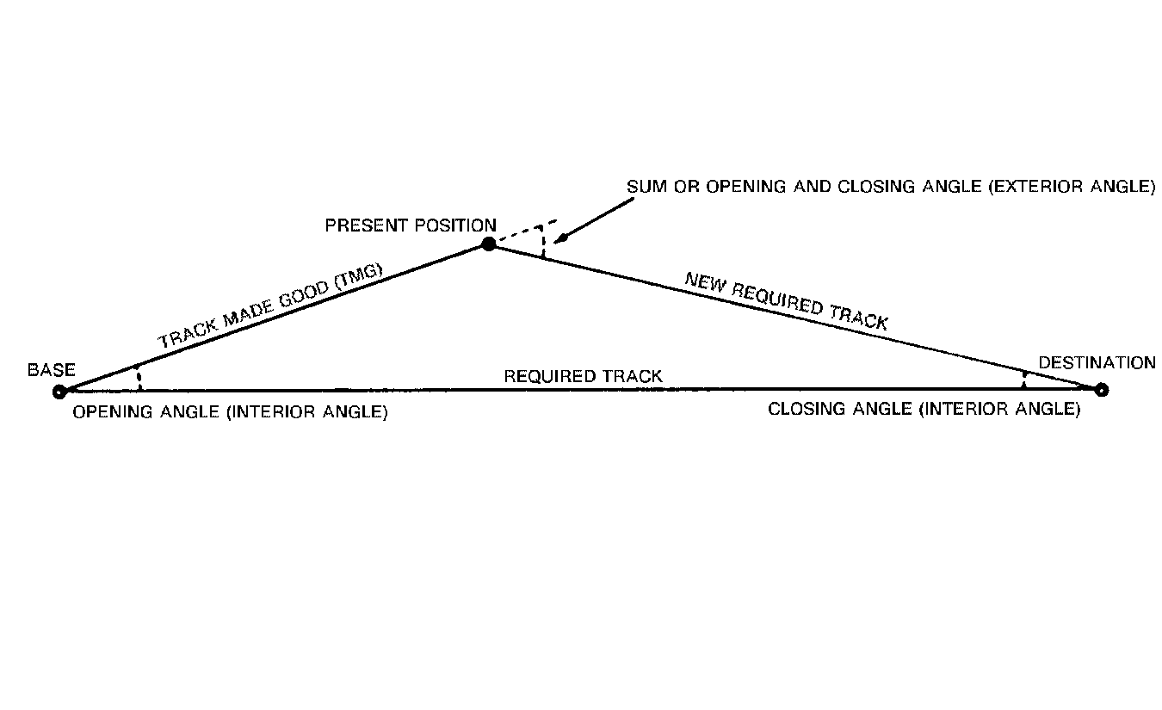

Figure 9-14 Opening and Closing Angles

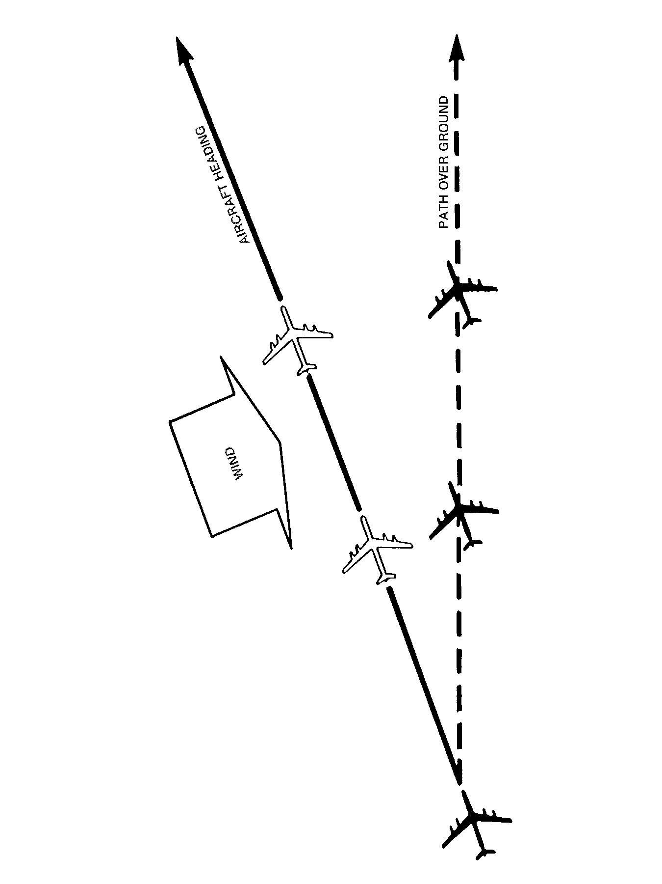
Figure 9-15 Effect of Drift
Groundspeed is the speed of the airplane relative to the air. It is affected by the wind. If there is no wind at all, true airspeed and groundspeed will be the same. If, however, an airplane is flying in an air mass that is moving in the same direction, the airplane will have a tailwind that will help its progress over the ground, with the result that its groundspeed will be in excess of the true airspeed. Conversely, a headwind will impede the progress of the airplane over the ground with the result that the groundspeed will be slower than the true airspeed.

The heading of an airplane is the angle between the longitudinal axis of the airplane at any moment and a meridian. In other words, it is the direction the nose of the airplane is pointing, measured from an imaginary line running north and south. If the heading is measured from the true meridian, it is referred to as a true heading, if from a magnetic meridian, as a magnetic heading. If it is measured from the direction of a compass needle, it is referred to as a compass heading. The angle is measured clockwise through 360°.

Indicated airspeed is the airplane's speed as indicated by the airspeed indicator.

A magnetic meridian is the direction in which a compass needle lies when influenced only by the earth's magnetic field. In actual practice, magnetic meridians are not shown on maps but are found by adding or subtracting the variation at any particular place to or from the true meridian.

Opening Angle. This is the angle between the required track and the track-made-good (see Figure 9-14).

The track (intended) is the direction an airplane intends to travel over the ground. The intended track may be represented by a straight line drawn on a map. Its direction is the angle between this line and a meridian measured clockwise through 360°. As in the case of headings, tracks are named true, magnetic or compass with reference to the meridian from which they are measured (see Figure 9-16).

The required track is the proposed path of the airplane over the ground (see Figure 9-14).

The track-made-good is the actual path travelled by the airplane over the ground. Like the intended track, it may be represented by a line drawn on a map and, provided it is a reasonably straight line, its direction measured from the true or magnetic meridian or compass north (see Figure 9-14).

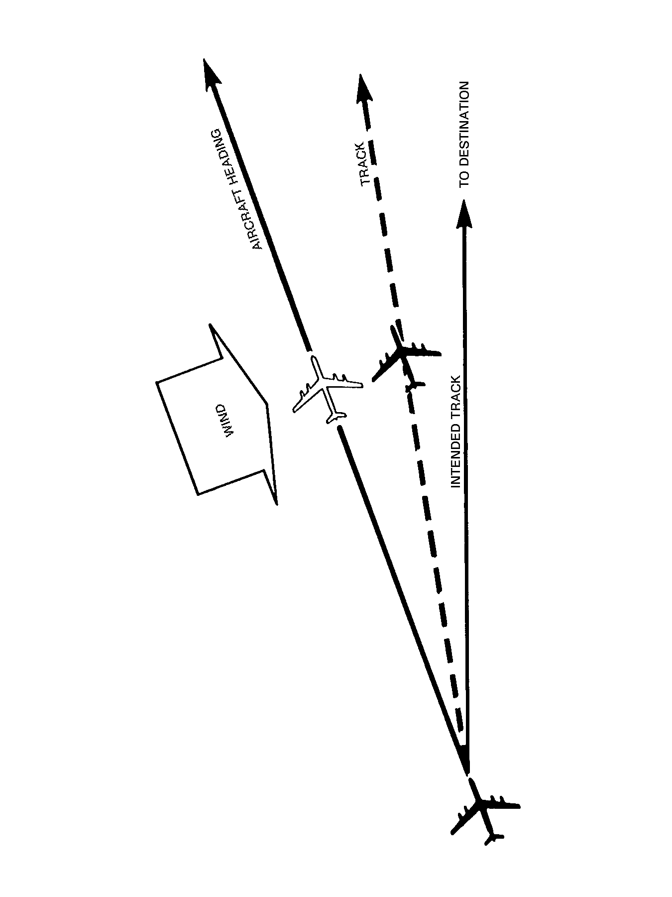
Figure 9-16 Heading, Track and Intended Track
Track Error. This is the angle between the required track and the track-made-good, measured in degrees either left or right of the required track.

True Airspeed. This is the speed of the airplane relative to the air. It is the indicated airspeed corrected for the airspeed indicator error due to density and temperature.

Wind is defined as air in motion, especially a mass of air having a common direction or motion. Wind moves horizontally. A movement of air moving vertically is called a current.

UNITS OF DISTANCE AND SPEED

A statute mile is a distance of 5 280 feet.
A nautical mile (6 080 feet) is the average length of one minute of latitude.
A kilometre is a distance of 1 000 meters.
A knot is a speed of one nautical mile per hour.

CONVERSIONS

66 Nautical Miles = 76 Statute Miles = 122 kilometers
To convert knots to mph., multiply by 1.15.
To convert mph. to knots, divide mph. by 1.15.
To convert kilometres per hour to knots, multiply by .54.
To convert km/h. to mph., multiply by .62.

HOURS AND MINUTES

To convert minutes to hours, divide by 60 (60 min. = 1 hour)
To convert hours to minutes, multiply by 60, eg, .75 hrs equals .75 × 60 = 45 minutes

TIME AND FLIGHT

To find the time in flight, divide the distance by the groundspeed, eg, the time to fly 120 nautical miles at a groundspeed of 80 knots is 120 divided by 80 = 1.5 hours (.5 hrs × 60 = 30 minutes).

DISTANCES

To find the distance flown in a given time, multiply groundspeed by time, eg, the distance flown in 1 hour 45 minutes at a groundspeed of 120 knots is 120 × 1.75 = 210 nautical miles.

GROUNDSPEED

To find the groundspeed, divide the distance flown by the time, eg, an airplane flies 270 n. miles in 3 hours. The groundspeed is 270 divided by 3 = 90 knots.

THE ONE-IN-SIXTY RULE

An error in the track of one degree will cause an error in position of about one mile in a distance of 60 miles.

A pilot on a cross-country flight who has got off track will be able to estimate the divergence in miles quite easily, but it is very difficult to know how many degrees it is necessary to alter the heading by compass to correct the error.

Suppose an airplane is two miles off track after travelling 30 miles. The error in the track will be roughly 4°. Therefore the correction to the compass heading will be 4° to correct the error. This will put the airplane on a track parallel to the required track but 2 miles from it. Suppose the plane is 60 miles from its destination. An additional 2° correction to heading will gradually close the track. Therefore, a total correction of 6° will bring the airplane in to its destination.

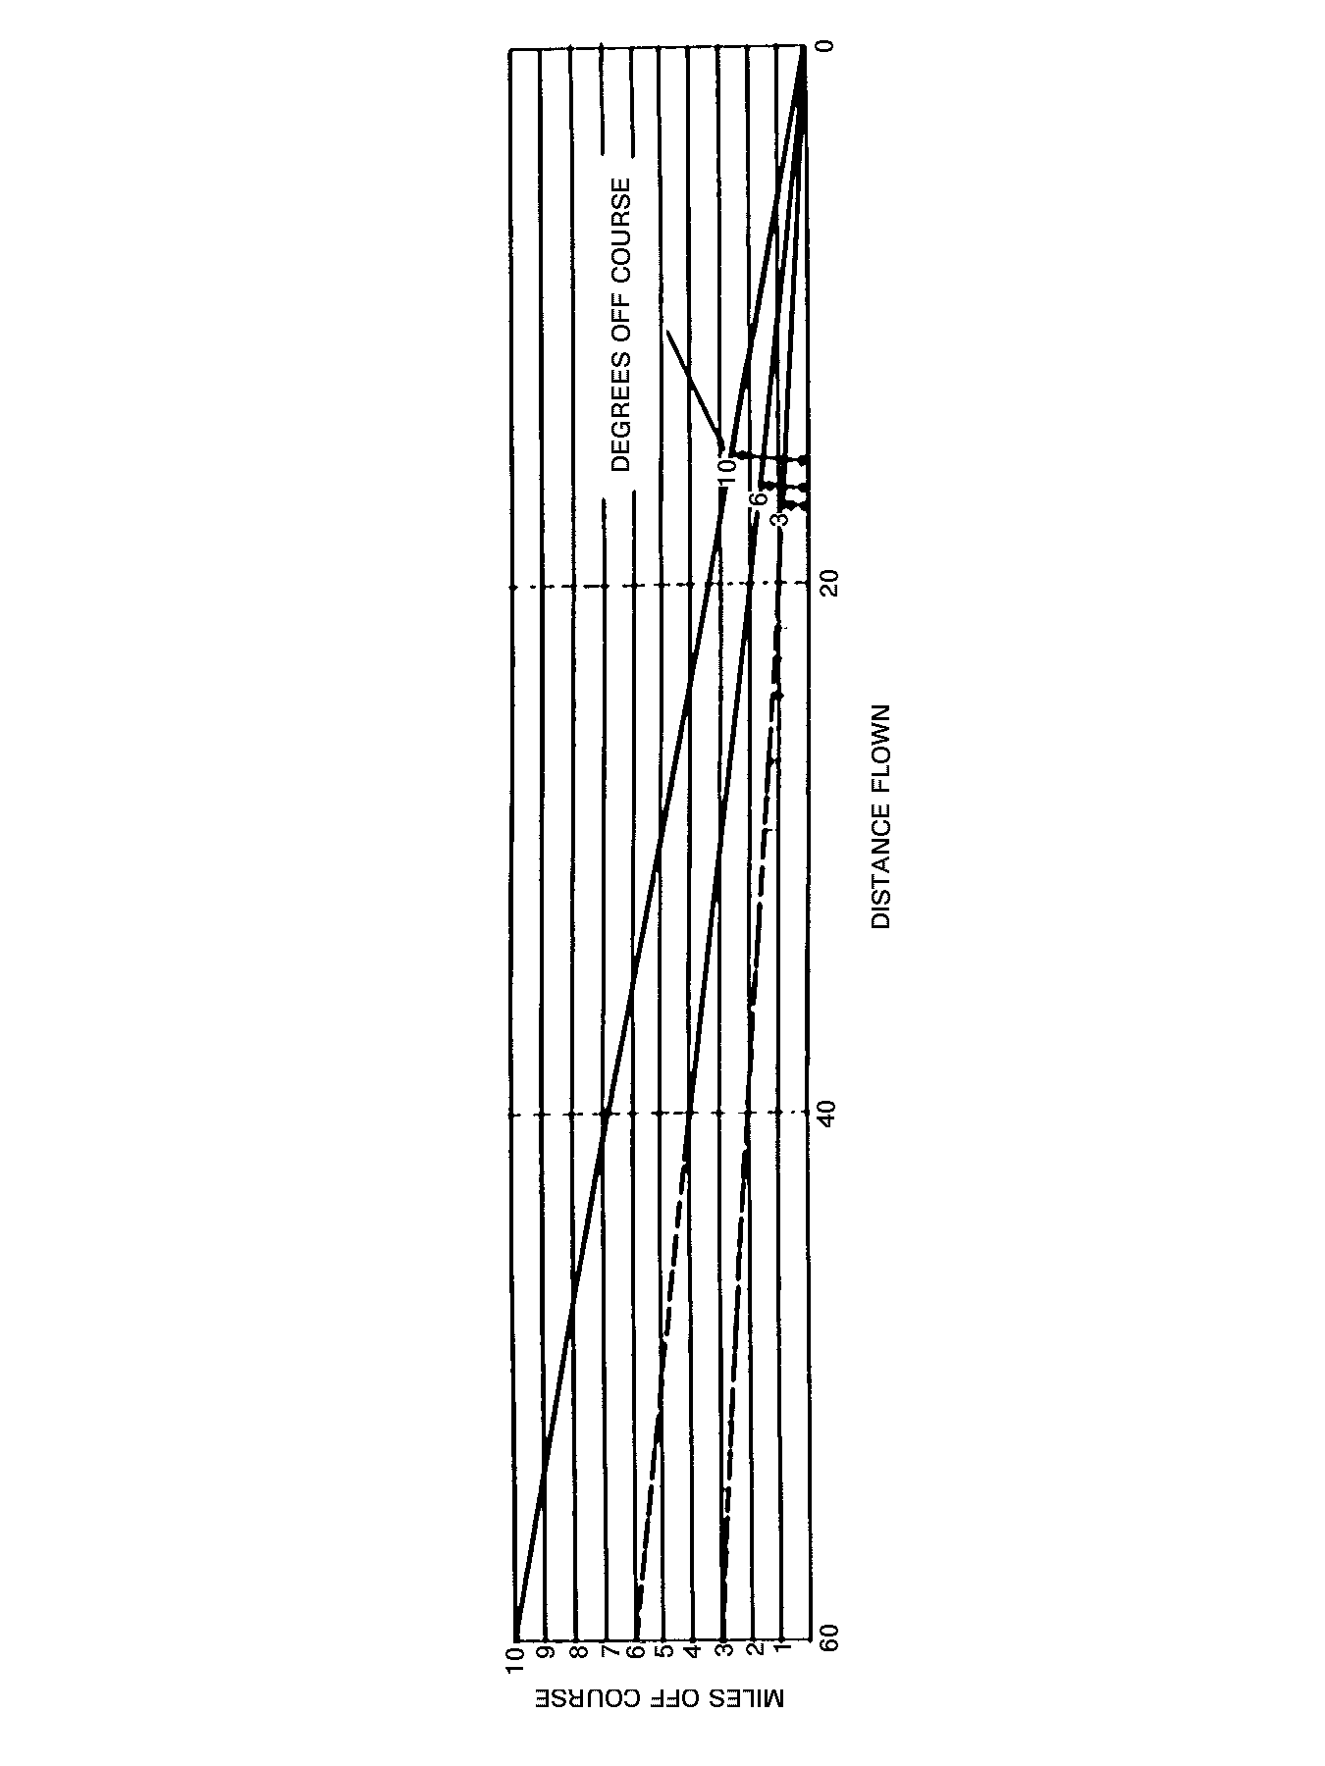
Figure 9-17 The One-in-Sixty Rule

SECTION 6

CONCLUSION

1. A pilot has to take into consideration more factors than those you just learned, while plotting a flight plan. Wind direction, altitude, magnetic winds, bad weather, and fuel consumption are only a few of them. Air navigation requires resolving a variety of problems involving interrelated factors.

2. You may be asked to plot a simple flight plan. Don't worry! You have the basic knowledge required to do it. Using a chart, dividers, a Douglas protractor and a ruler:

a. identify the co-ordinates for the departure point;

b. identify the aircraft's intended track;

c. identify the co-ordinates for the destination;

d. determine the distance to be covered by the plane; and

e. the duration of the flight.

PO 419
A
I
R
C
R
E
W

S
U
R
V
I
V
A
L

CHAPTER 10

PERFORMANCE OBJECTIVE 419

AIRCREW SURVIVAL

INTRODUCTION

1. Among the various responsibilities you may be asked to fulfil within the next training year, YOU could be asked to participate in the selection of a site for your squadron bivouac during the aircrew survival exercise.

2. A bivouac is defined as a temporary encampment without tents, but a bivvy is an abbreviation of bivouac and means a small tent (concise Oxford Dictionary). It may seem rather easy to select a good site for an exercise, but certain rules have to be followed in order to avoid surprises. Always remember that the cadets' safety must remain the prime factor in choosing one site over another.

SELECTION OF A BIVOUAC SITE

3. In selecting a site, you should look for:

a. well-drained ground;

b. safe surroundings;

c. an absence of poison ivy, poison oak and poison sumach, etc; and

d. pure water.

4. Well-Drained Ground. The idea is to get high and dry. Pick a spot where light breezes blow and where water will drain off quickly. If you can get gravelly soil covered with tough grass, it is even better for drainage. Keep away from lush vegetation (marsh) and clay soil (which collects puddles and mud when it rains). It would also be wise to chose to install your tent on top of a hill so that, when it rains, you will not be flooded!

5. Safe Surroundings. Tall grass and swamp areas are havens for mosquitoes, heavy underbrush provides cover for black flies and the water's edge harbours midges. Select your site away from such areas. As you search for a site, look carefully for birds' nests or animals' dens. Animals such as skunks, foxes and marmots may react unpredictably if they feel threatened by the presence of many human beings. Even if animals are not all equally dangerous, it is important that you remain vigilant.

6. Dangerous Plants. Check your bivouac site for poison ivy, poison oak and poison sumach. Take a good look around to see if you can find various types of edible berries but, most importantly, identify the spots where younger cadets could find non-edible plants (look for venomous mushrooms which can be deadly...).

7. Pure Water. Select a camping site that is next to a swift-running stream or well. Once again, ensure that the source of water can be used by cadets. If you are staying for a couple of days and are planning to use the water source to do your laundry or perform your personal ablutions, ensure that the spot chosen won't affect the source of drinking water. Contary to popular belief, the quality of water has nothing to do with its transparency. It is quite possible for a source of clear water to be infected with bacteria or parasites which could affect your health. Take a couple of seconds and contact the site authorities before making any decision.

ELEMENTS OF A BIVOUAC

8. The following elements should be included in the set-up of a bivouac:

a. latrine;

b. tent lines;

c. fire point;

d. quarter-master (QM);

e. access road;

f. petroleum, oil, lubricants (POL);

g. kitchen;

h. safety vehicle; and

j. first aid tent.

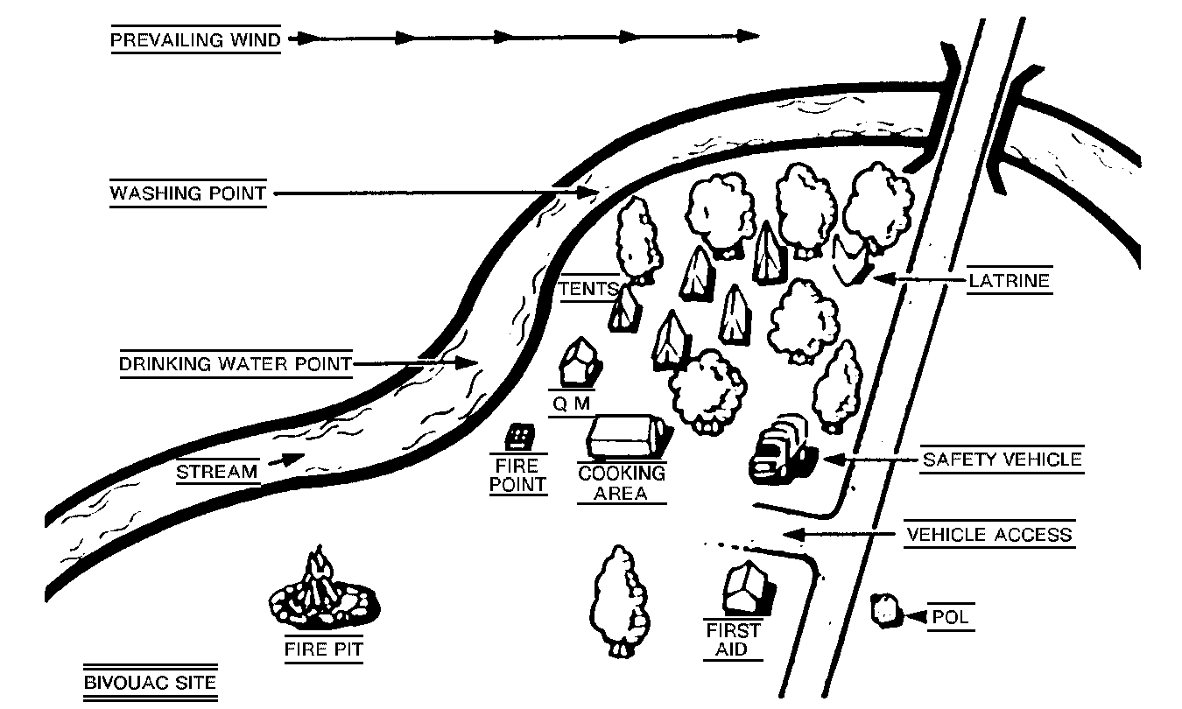
Figure 10-1 Set-up of the Bivouac

9. Latrine. If at all possible, before making a latrine, make use of an outhouse that might already be available. Many campgrounds have chemical toilets or portable models that you can use too. The general rule of thumb is to use toilets that are already provided for your use before starting to dig: it is far more environmentally sound. And whatever you do, don't make the back of your tent the most convenient place to go to the washroom! If you must build a latrine, here is how to build a cross-support type:

a. Decide on a location for the latrine which should be downwind and at least 100 metres away from your bivouac site.

b. A clear path to the latrine should be marked, using mine tape or a row of stones to line the route so that you can find it at night.

c. Dig a hole in the ground about a metre in depth and leave the dirt you dig out in a pile next to the hole (leave shovel there too!).

d. Use two trees or pound two stakes into the ground on either side of the hole.

e. Make a comfortable cross-support on which to sit (make sure that it will not break!).
f. Lash the cross-support to the stakes or tree trunks and make sure that the seat is at the right height so that your smallest cadets can touch the ground with their feet when sitting.

g. Construct a shelter around the latrine to shield it from prying eyes by using ponchos or something similar.

h. Make up a sign that says OCCUPIED, hang it on a post and put a roll of toilet paper within easy reach of the latrine

j. Remember to shovel in a bit of dirt when you have finished in order to prevent attracting flies. When you leave your campsite, do not forget to fill in the rest of the hole and mark it with a small sign, or cover it up with dead braches or brush.

10. If you set up separate latrines for both sexes, everyone will feel more comfortable about going to the washroom. Don't forget to cover up your toilet paper against the rain, otherwise you may find a soggy roll of paper when you need it most!

11. The flies that visit your latrine because you did not shovel in a layer of dirt might also drop in for supper! By adding disinfectant balls or powder to a latrine you kill the useful bacterial that break down waste and then the latrine will really start to smell. If your latrine does start to smell, fill in the hole, burn the cross support and dig another hole.

12. Tents. Tents are usually divided in two groups, one for the boys and one for the girls. If it gets too cold at night, it is recommended that you regroup the tents in a circle around the camp fire. This way, heat will be distributed equally to all the tents.

13. Fire Point. Extinguishers, water buckets, shovels and any additional tools likely to be used in case of emergency, must be kept handy. It is recommended to put them in a central point, away from the POL.

14. Access Road/Safety Vehicle. An access road for all vehicles, and more specifically for the safety vehicle, must be planned. You must ensure that the access to this road is kept clear at all times.

15. POL. The storage area for petrol, oil and lubricants must be located at a reasonable distance from the camp site. This way you will avoid a possible disaster that could be caused by the explosion of a leak. The access to this area should also be limited to a few persons.

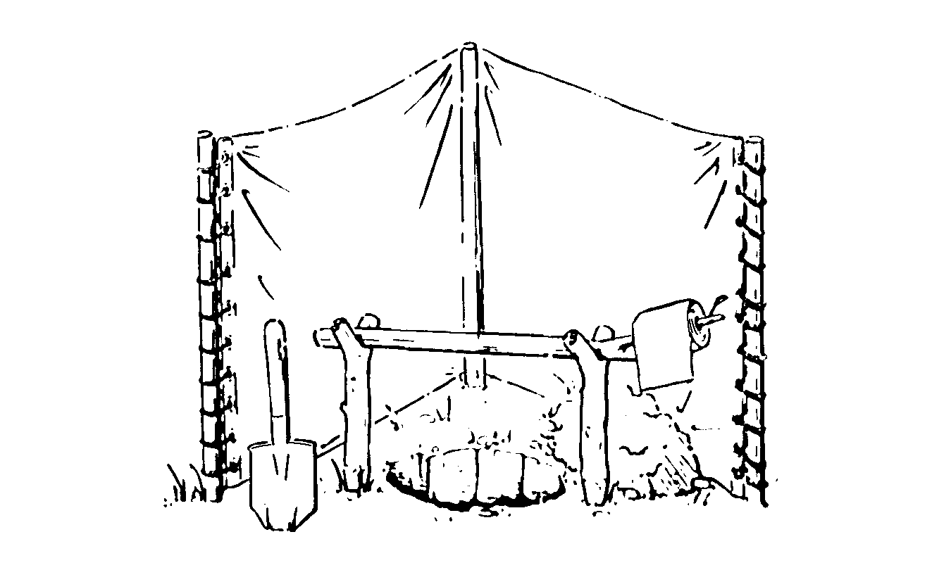
Figure 10-2 Latrines

16. Safety Vehicle. The safety vehicle should be located near the first aid tent and the access road if possible. This vehicle must be in a good running condition and must not be used for any purposes other than emergencies.

17. First Aid Tent. The first aid tent must be equipped with at least one stretcher, a well-furnished first aid kit and any additional equipment likely to help when treating minor injuries. It is important to ensure that one competent person is on duty all the time in case of emergency.

YOUR CONTRIBUTION TO THE SURVIVAL EXERCISE

18. The successful result of an activity, such as the survival weekend, relies on the ability to work together demonstrated by every individual involved in the organization. You will be asked to perform a series of small tasks which, at first sight, may not seem too important. To peel potatoes, find kindling wood or wash dishes may seem less important when compared with building a shelter, being in charge of the first aid tent or acting as fire-picket at night. To understand the real importance of a small task, you must see it as part of a larger ensemble.

19. Senior cadets, such as yourself, are responsible for providing the best possible support to younger cadets. It is therefore essential for you to ensure that young cadets are well supervised in their efforts and that they can perform in ideal conditions. It is as important for a younger cadet
to know that meals will be ready on time and that a campfire will be lit, as it is for them to benefit from a good night's sleep or first aid treatments when required. Small tasks are often perceived as having a minor impact when isolated from the major activity. You will, however, make a huge contribution to the overall success of the survival weekend by performing your tasks diligently.

20. A survival weekend, such as the one you will be asked to participate in, is the perfect setting to test the squadron esprit de corps, especially as it pertains to the older and more experienced cadets. Younger cadets will learn to put more energy into the accomplishment of their tasks if they see you do it too. The dynamism you demonstrate while performing small tasks will certainly be a good indicator of your ability to work as member of a team.

PO 420
T
R
A
I
N
I
N
G

S
U
P
P
O
R
T

CHAPTER 11

PERFORMANCE OBJECTIVE 420

TRAINING SUPPORT

INTRODUCTION

1. For almost four years now, you have gained plenty of experience while serving with your squadron and in summer camps. You have acquired many qualifications and a lot of knowledge, something which is of great value. This is why your officers trust you and are giving you additional responsibilities.

2. From the day you joined the air cadets movement, older and more experienced cadets, as well as officers, have been taking good care of you and have been teaching you air cadets fundamentals and the basic knowledge you require to become qualified. Now has come the time to return the favour and do exactly the same thing for the younger cadets of your squadron. Now is the time to apply the SERVE part of the air cadet motto.

3. Most of you already have some sort of responsibility within your own flight or with an optional group such as the squadron band, responsibilities that came with the rank you are wearing. You are aware, then, that young cadets require a great deal of attention. They need to be guided, supported and encouraged. This is why leadership is part of your formation as an air cadet.

4. The best air cadet squadrons are those which count on responsible and efficient NCOs. Your officers alone cannot teach all the mandatory subjects included in the training programme, nor can they plan and supervise all the activities in which your squadron is involved.

5. The officers should be able to count on you and your experience to take charge of different tasks directly related to training. Only if you are involved, dynamic and show initiative can your cadets benefit from a much-needed supervision. The cadet movement is among the very few which provide such a complete formation for its older members so they can take care of the younger ones.

6. In addition to having to complete your Level 4 training, you will be asked, starting this year, to fulfil a series of duties directly related to the training of your squadron. You will be assessed, taking into consideration the efficiency by which you handle what is asked of you. You should take advantage of the situation to show your officers and senior cadets what you are made of. Show them they were right to trust you to start with and also that you are ready for more responsibilities.

7. The way you handle the tasks given to you this year will greatly influence your officers' decision when the time comes to decide what you can, or should do next year in Level. 5.

EVALUATION REPORT

8. In the following pages, you will find many copies of the evaluation report used to keep track of what you are asked to do in PO 420. They also contain a part where your supervisor will write your evaluation. You must use one report sheet for each task you are asked to perform for this PO.

9. Write your name, the date, the task description and the time you spent performing the task. You must give this report to your supervisor whole responsibilities include writing comments and compiling the total time spent (all tasks combined).

10. Never hesitate to ask your supervisor any questions you may have if you need additional information to complete your task. Take notes and make sure that your task has been successfully completed. Any task, even the smallest, deserves to be well executed. You must always remember that everything you do has a direct impact on other cadets' training. You must therefore constantly show efficiency and professionalism.

Something to Think About...

The only people who never fail are those who never try.

– Chase

Don't make excuses make good.

It takes less time to do a thing right
than it does to explain why you did it wrong.

– Henry Longfellow

There are two ways of meeting difficulties:
you alter the difficulties
or you modify yourself meeting them.

– Phillis Bottome

PO 420 TRAINING SUPPORT
EVALUATION REPORT – LEVEL 4

______________________
CADET'S NAME: Date:
______________________
Assigned task:
__________________________________________________

______________________

Time spend: Total time:
(actual task) (addition)
Supervisor's comments: Pass/Fail

Signature:

Instructions:

a. One task per evaluation report.

b. The evaluation will be done using the following criteria:
– completion of the task;
– use of a plan (if required);
– delegation/supervision (if required);
– compliance with instructions;
– adaptation capability, initiative; and
– dynamism and enthusiasm.

c. The cadet must report to his/her supervisor upon completion of each task.

d. The supervisor must sign the cadet's evaluation report and provide feedback upon completion of each task.

PO 420 TRAINING SUPPORT
EVALUATION REPORT – LEVEL 4

______________________
CADET'S NAME: Date:
______________________
Assigned task:
__________________________________________________

______________________

Time spend: Total time:
(actual task) (addition)
Supervisor's comments: Pass/Fail

Signature:

Instructions:

a. One task per evaluation report.

b. The evaluation will be done using the following criteria:
– completion of the task;
– use of a plan (if required);
– delegation/supervision (if required);
– compliance with instructions;
– adaptation capability, initiative; and
– dynamism and enthusiasm.

c. The cadet must report to his/her supervisor upon completion of each task.

d. The supervisor must sign the cadet's evaluation report and provide feedback upon completion of each task.

PO 420 TRAINING SUPPORT
EVALUATION REPORT – LEVEL 4

______________________
CADET'S NAME: Date:
______________________
Assigned task:
__________________________________________________

______________________

Time spend: Total time:
(actual task) (addition)
Supervisor's comments: Pass/Fail

Signature:

Instructions:

a. One task per evaluation report.

b. The evaluation will be done using the following criteria:
– completion of the task;
– use of a plan (if required);
– delegation/supervision (if required);
– compliance with instructions;
– adaptation capability, initiative; and
– dynamism and enthusiasm.

c. The cadet must report to his/her supervisor upon completion of each task.

d. The supervisor must sign the cadet's evaluation report and provide feedback upon completion of each task.

PO 420 TRAINING SUPPORT
EVALUATION REPORT – LEVEL 4

______________________
CADET'S NAME: Date:
______________________
Assigned task:
__________________________________________________

______________________

Time spend: Total time:
(actual task) (addition)
Supervisor's comments: Pass/Fail

Signature:

Instructions:

a. One task per evaluation report.

b. The evaluation will be done using the following criteria:
– completion of the task;
– use of a plan (if required);
– delegation/supervision (if required);
– compliance with instructions;
– adaptation capability, initiative; and
– dynamism and enthusiasm.

c. The cadet must report to his/her supervisor upon completion of each task.

d. The supervisor must sign the cadet's evaluation report and provide feedback upon completion of each task.

PO 420 TRAINING SUPPORT
EVALUATION REPORT – LEVEL 4

______________________
CADET'S NAME: Date:
______________________
Assigned task:
__________________________________________________

______________________

Time spend: Total time:
(actual task) (addition)
Supervisor's comments: Pass/Fail

Signature:

Instructions:

a. One task per evaluation report.

b. The evaluation will be done using the following criteria:
– completion of the task;
– use of a plan (if required);
– delegation/supervision (if required);
– compliance with instructions;
– adaptation capability, initiative; and
– dynamism and enthusiasm.

c. The cadet must report to his/her supervisor upon completion of each task.

d. The supervisor must sign the cadet's evaluation report and provide feedback upon completion of each task.

PO 420 TRAINING SUPPORT
EVALUATION REPORT – LEVEL 4

______________________
CADET'S NAME: Date:
______________________
Assigned task:
__________________________________________________

______________________

Time spend: Total time:
(actual task) (addition)
Supervisor's comments: Pass/Fail

Signature:

Instructions:

a. One task per evaluation report.

b. The evaluation will be done using the following criteria:
– completion of the task;
– use of a plan (if required);
– delegation/supervision (if required);
– compliance with instructions;
– adaptation capability, initiative; and
– dynamism and enthusiasm.

c. The cadet must report to his/her supervisor upon completion of each task.

d. The supervisor must sign the cadet's evaluation report and provide feedback upon completion of each task.

PO 420 TRAINING SUPPORT
EVALUATION REPORT – LEVEL 4

______________________
CADET'S NAME: Date:
______________________
Assigned task:
__________________________________________________

______________________

Time spend: Total time:
(actual task) (addition)
Supervisor's comments: Pass/Fail

Signature:

Instructions:

a. One task per evaluation report.

b. The evaluation will be done using the following criteria:
– completion of the task;
– use of a plan (if required);
– delegation/supervision (if required);
– compliance with instructions;
– adaptation capability, initiative; and
– dynamism and enthusiasm.

c. The cadet must report to his/her supervisor upon completion of each task.

d. The supervisor must sign the cadet's evaluation report and provide feedback upon completion of each task.

