PO 417

N
A
V
I
G
A
T
I
O
N

CHAPTER 10

PERFORMANCE OBJECTIVE 417

NAVIGATION

SECTION 1

INTRODUCTION

1. The Earth on which we live is a ball, or sphere, technically an oblate spheroid. Not knowing any better, the human race has for centuries lived on the outside of the sphere − enduring heat and cold, clouds and rain, snow and sleet, fog, mist and mortal uncertainty. Cities of the future may be located underground in a world of perfectly regulated conditions of heat, light and fresh air.

2. Meanwhile, we must make the best of our world, such as it is. Humans are restless souls, and travel and curiosity have always been two of their most cultivated and persevering habits. To make it possible to move about on this great terrestrial sphere then, they must have some master plan to enable them to define position, direction and distance.

SECTION 2

TYPES OF NAVIGATION

3. There are several methods of navigation used by pilots to find their way from place to place on this Earth of ours:

a. Pilotage. Pilotage is navigation by reference to landmarks such as mountains, cities and rivers.

b. Dead Reckoning. Navigation by use of predetermined vectors of wind and true airspeed and precalculated heading, ground-speed and estimated time of arrival

c. Radio Navigation. Navigation by use of radio aids, that is, navigation signals broadcast by radio stations on the ground or from satellites.
d. Celestial Navigation. Navigation by measuring angles to heavenly bodies (sun, moon and stars) to determine position on the Earth.

e. Inertial Navigation. Navigation by self-contained airborne gyroscopic equipment or electronic computers that provide a continuous display of position.

4. Most pilots use these various methods of navigation in combination. The use of pilotage by itself is limited by visibility (you have to be able to see the landmarks) and by familiarity with the area over which the flight is being conducted. Therefore, pilotage in combination with dead reckoning is a more effective method of navigation.

SECTION 3

NAVIGATION PROCEDURES FOR A FLIGHT

5. In pilot navigation, thorough pre-flight preparation is required to reduce much of the navigational work in the cockpit. This allows the pilot to focus attention on flying the aircraft and communicating with the air traffic control facilities. Plotting in flight is reduced to a minimum. The pilot must have a well prepared log form and map, and must study the route carefully.

6. As opposed to general beliefs, pilots only have a limited choice of routes to follow while in the air. They cannot suddenly decide to fly in a straight line to the airport or spin around at any altitude they wish, just as a car driver also has a limited choice of routes to go from one city to another. A driver would not drive across a field or face the highway traffic in the opposite direction to save some time!

7. The air space is divided in corridors you can compare to a major highway with many levels. It is regulated for safety reasons. Would you believe that in Canada and the USA there are currently 200 000 registered aircraft and there may be as many as 10 000 airborne at any one time!

8. Pre-flight preparation entails a number of essential steps that must be completed before take-off. These are listed as follows:

a. selection of route;
b. analysis of weather;

c. preparation of map or chart;

d. preparation of flight logs;

e. reviews of Notices to Airmen (NOTAMs); and

f. completion of the flight plan.

9. Navigation in the atmosphere deals with movement in three dimensions as distinct from the two-dimensional movement of surface vehicles. Although aircraft fly above, and not on, the surface of the Earth, their movement is invariably expressed as motion relative to the surface of the Earth. As a first step in the study of navigation, then, consideration must be given to the form of the Earth.

SECTION 4

EARTH

SHAPE OF THE EARTH

10. For the purpose of navigation, the Earth is assumed to be a perfect sphere. However, spinning through space and centrifugal force have caused it to become flattened slightly at the poles and bulged at the equator just as if you were applying pressure to either side of a beach ball.

ROTATION OF THE EARTH

11. The Earth makes one rotation each day about an imaginary line called the "spin axis". The two points at which the spin axis terminates on the surface of the Earth are called the "poles". EAST is defined as the direction in which the Earth is rotating; while WEST is the direction opposite to east (Figure 10-1). The North Pole lies to the left of an observer facing east and the South Pole lies to the right.

LATITUDE AND LONGITUDE

Figure 10-1 Rotation Axis

12. As a well-planned modern city is an orderly gridwork of intersecting streets and avenues, so ancient masterminds have divided the surface of our sphere into a geometrical pattern of intersecting circles called the Graticule. Those running north and south are meridians of longitude (Figure 10-2). Those running east and west are parallels of latitude.

13. There are two lines by which grid references are calculated: the Equator (Figure 10-2), a great circle on the surface of the Earth lying equidistant from the Poles, and the Prime Meridian, which is the meridian passing through Greenwich, England.

14. Longitude is measured from 0 to 180 degrees east and west of the Prime Meridian. The Prime Meridian is numbered 0. The meridian on the opposite side of the Earth to the Prime Meridian is the 180th and is called the International Date Line. Here the time changes a day. Longitude is measured in degrees (°), minutes (') and seconds ("). There are 60 minutes in a degree and 60 seconds in a minute.

15. Latitude is measured from 0 to 90 degrees north or south of the Equator, which is numbered 0 degrees. Latitude is also expressed in degrees, minutes and seconds.

Figure 10-2 Equator, Meridians and Parallels of Latitude

EARTH'S MAGNETISM

16. The Earth is a magnet and like any other magnet has a North and a South Magnetic Pole. Lines of force flow between these two poles creating a magnetic field that surrounds the Earth. A compass needle will be influenced by the earth's magnetic field and will lie parallel to one of the magnetic lines of force with its north seeking pole pointing to magnetic North. The magnetic line in which the compass needle lies is called the Magnetic Meridian.

VARIATION

Figure 10-3 Earth's Magnetism

17. The angle between the true meridian and the magnetic meridian in which the compass needle lies is called the Magnetic Variation. Since the Magnetic North Pole is not stationary, but moving in a somewhat erratic circle, obviously the variation is not constant at any one place, but changes slowly from year to year. This is called the annual change. This has to be taken into consideration when using old maps.

18. It can, therefore, be seen that if the Magnetic Pole lies west of the True Pole from a given point, the compass needle will point west of True North Hence, the magnetic meridian will lie west of the true meridian.

ISOGONIC LINES

19. The direction of the Earth's magnetic field is measured, periodically, over most of the Earth's surface. The results of such a survey are plotted on a chart. Lines are drawn on the chart joining places having the same variation and these lines are called ISOGONIC or ISOGONAL LINES. Isogonal lines are not straight lines but bend and twist due to the influence on the magnetic field of local magnetic bodies below the Earth's surface.
20. The isogonal lines are numbered east and west according to whether the compass variation is to the east or west of True North.

AGONIC LINES

21. In each hemisphere there will be places where the North Pole and the North Magnetic Pole will be in transit, that is, where they will lie in the same straight line. These places will, therefore, have no magnetic variation. Lines drawn through places of "no variation" are called AGONIC LINES. Like the isogonic lines, they twist and curve due to the local attraction of magnetic bodies in the Earth.

SECTION 5

GEOGRAPHICAL CO-ORDINATES

22. The location of cities, towns, airports, etc, may be designated by their geographical co-ordinates, that is, the intersection of the lines of latitude and longitude marking their position on a map. It is exactly like locating a specific place in your town. As an example, the arena in your city may he located at the intersection of Royal and Notre-Dame Streets, the city itself being located on a map at the intersection of the 75th Meridian West and the 40th Parallel North.

23. When a position is being recorded by the latitude and longitude method, the latitude co-ordinate, by convention, is written first and is followed by the longitude co-ordinate. The latitude and longitude of Winnipeg, Manitoba will be written as 4954N 9714W, meaning Winnipeg is 49 degrees 54 minutes north of the equator and 97 degrees 14 minutes west of the prime meridian.

DETERMINE THE DIRECTION

24. The term "direction" can be defined as "the path pursued by a moving body" or "the point to which one moves or at which one looks". The direction to a certain destination can be maintained with ease when the destination is visible from the point of departure. On most navigation trips, however, direction must be obtained from a map and the aircraft heading must be in the proper direction throughout the trip. Direction, then, is an essential part of navigation, and there must be a method of expressing it.

DIRECTION EXPRESSED AS AN ANGLE

Figure 10-4 Measuring the Latitude and the Longitude

25. While planning their flights, pilots draw a line between the departure point and the expected arrival point. They then calculate the angle this line makes with a north line passing through the point (Figure 10-5). The angle is always measured clockwise from the particular chosen datum and using the compass rose (Figure 10-5). The direction of the datum itself is referred to as the magnetic north direction (eg, 48 degrees north, 270 degrees north, etc)

26. Navigation uses the meridian as a reference line, or datum, because it is a north-south line. By convention, direction is measured clock-wise from north to the nearest degree and is expressed as a three-figure group. North is given the symbol 000 (for clarity, it is expressed verbally as "360") and therefore, east, which is 90 degrees from north, is 090 and west is 270 etc. The resulting circle of direction is known as the compass rose. It replaces the usual cardinal and intermediate points because the number of named directions is small and their names are too cumbersome for use in navigation.

TRUE DIRECTION
Figure 10-5 Direction Expressed as an Angle

27. The geographical North Pole, known as true north, is the reference point for measurement of true direction. The direction of true north never changes; all maps and charts use true north as a datum. Unfortunately, there is no convenient method of measuring true north directly and continuously; therefore, in navigation, true direction must be derived from magnetic direction.
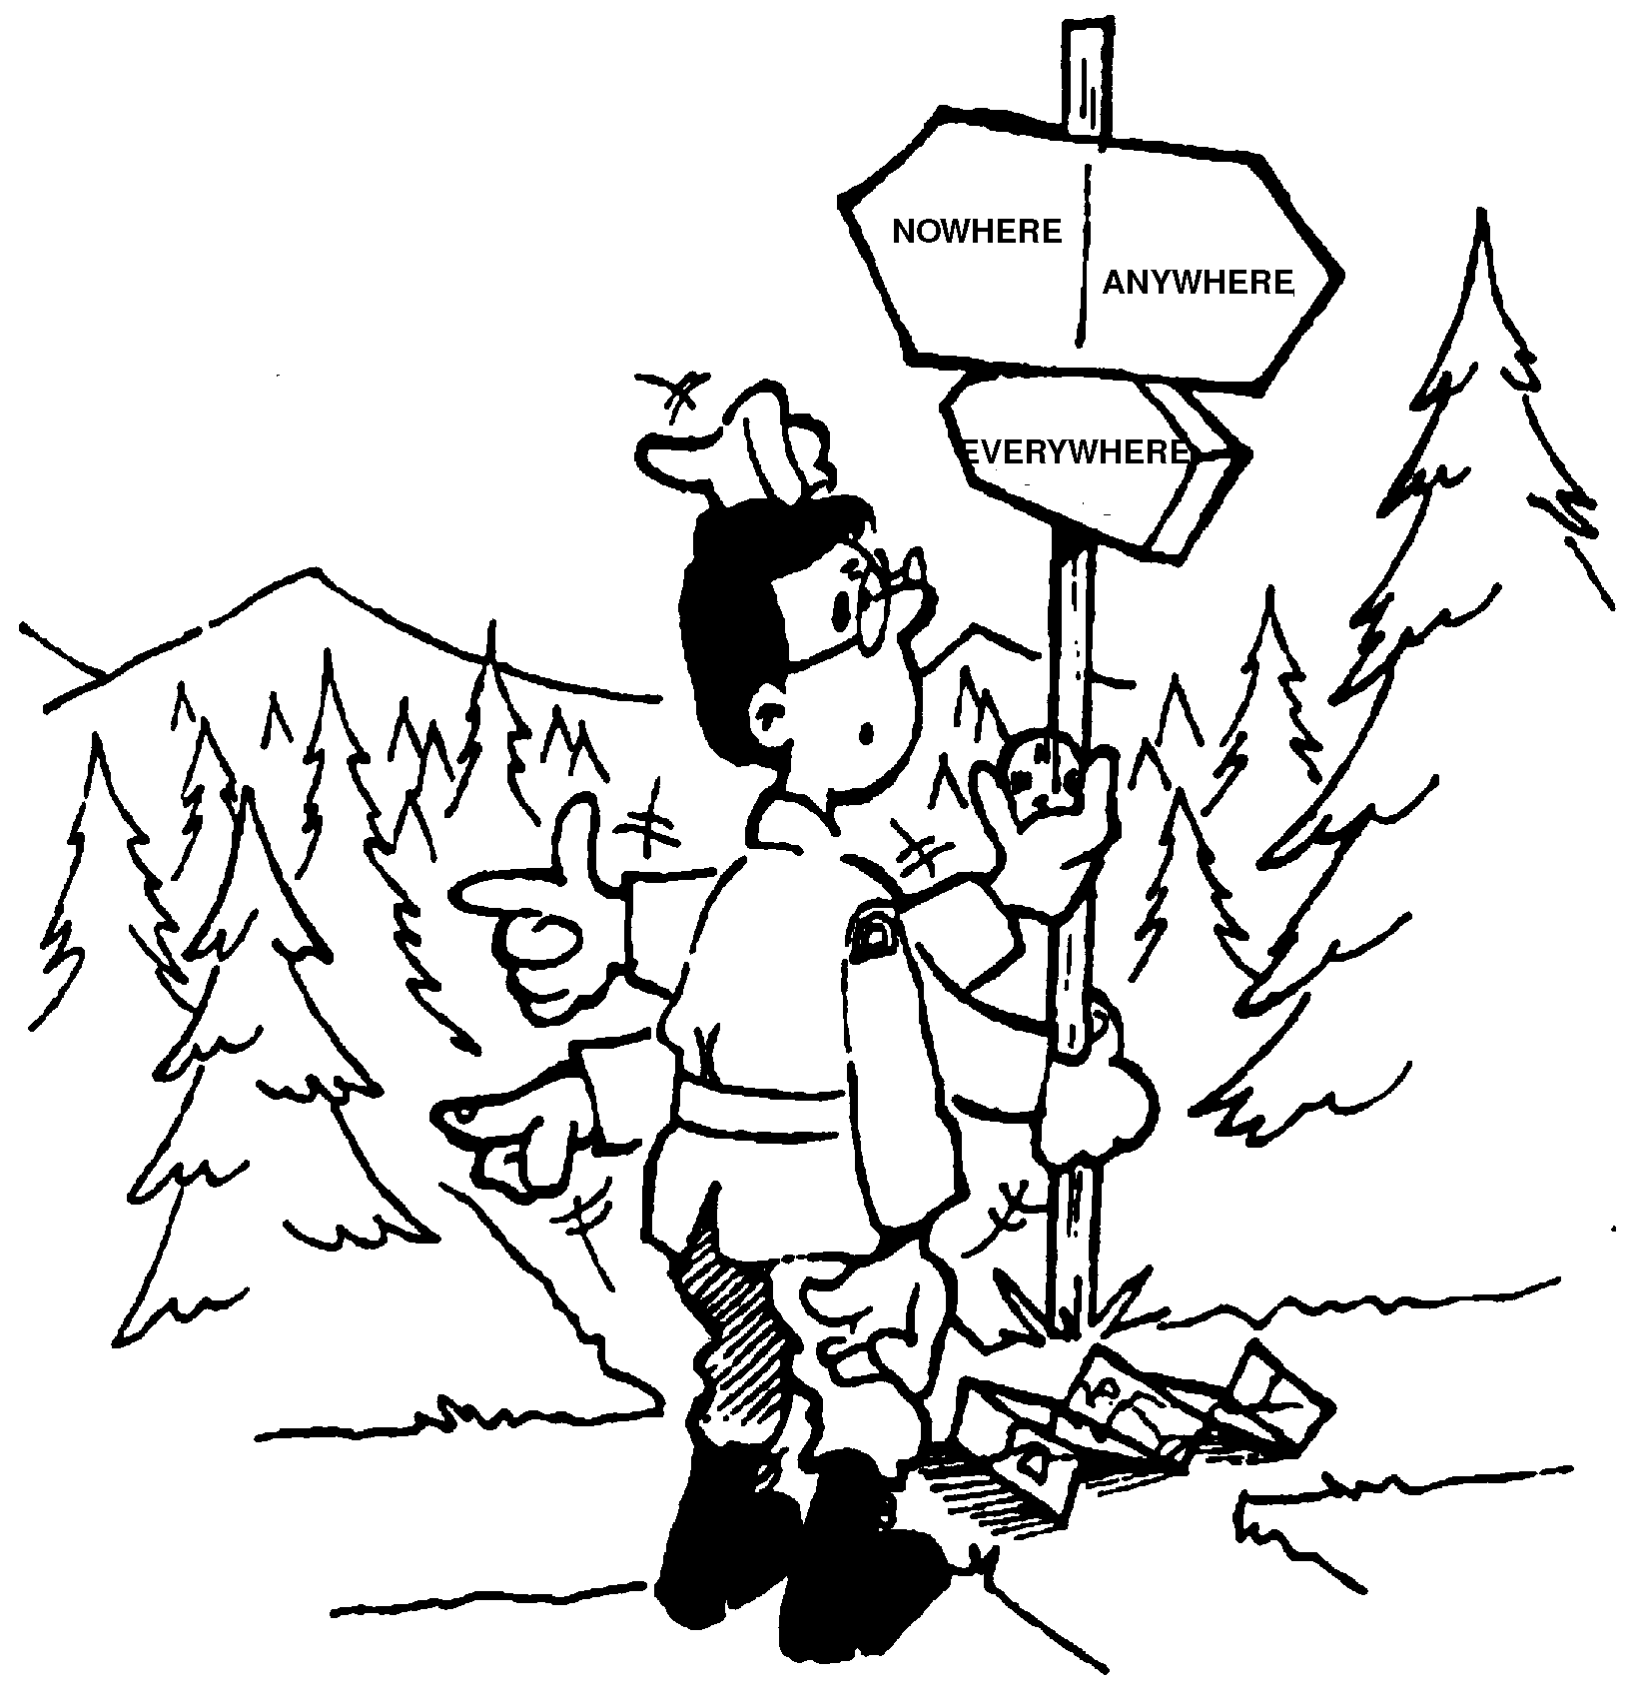

SECTION 6

CONCLUSION

28. Pilots must be able to do more than identify their position and calculate the direction while flying. They also have to calculate the speed, the amount of fuel and the duration of the flight. They must be able to read aeronautical maps using a navigation compass, a protractor, the engine instruments, etc. Flying a plane demands more than just being able to read a map. It is a question of safety. While in the air, pilots are too busy flying the plane to take care of the preparation.

29. This chapter has discussed the basic elements of air navigation, primarily from the pilot's point of view. However, whether one deals with pilot type navigation or the more conventional long-range type of navigation, such as that carried out by a professional navigator, there are three main points to be determined:

a. the correct heading to direct the aircraft to the desired destination;
b. the position of the aircraft at any time; and

c. the time at which the aircraft will reach any particular position.
30. Are you interested in learning more about flying? Why don't you join your squadron flying club? Ask the flying instructor, other cadets or the training officer about pilot's training. Maybe you will be among the lucky cadets who will be wearing wings and flying a plane soon, who knows?

SOMETHING TO THINK ABOUT...

Life is either a daring adventure or nothing

Helen Keller

Seeing's believing, but feeling's the truth.

Thomas Fuller MD

