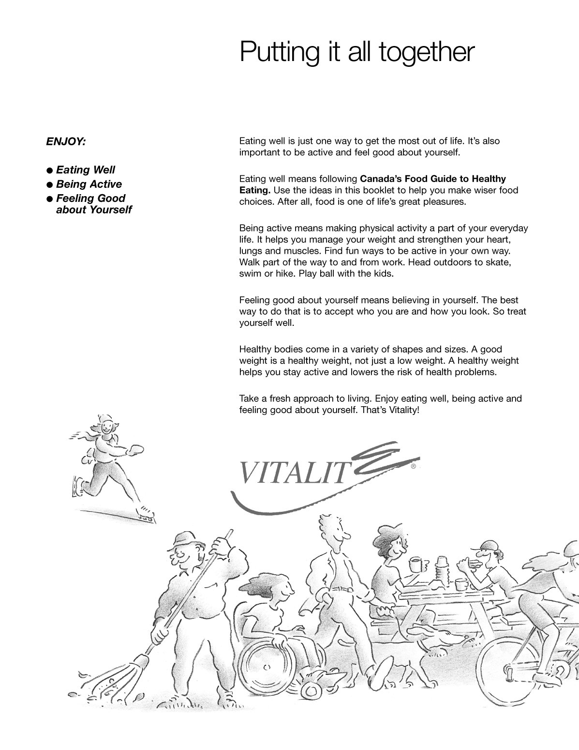
Figure 6-1 (Sheet 11 of 12) Canada's Food Guide

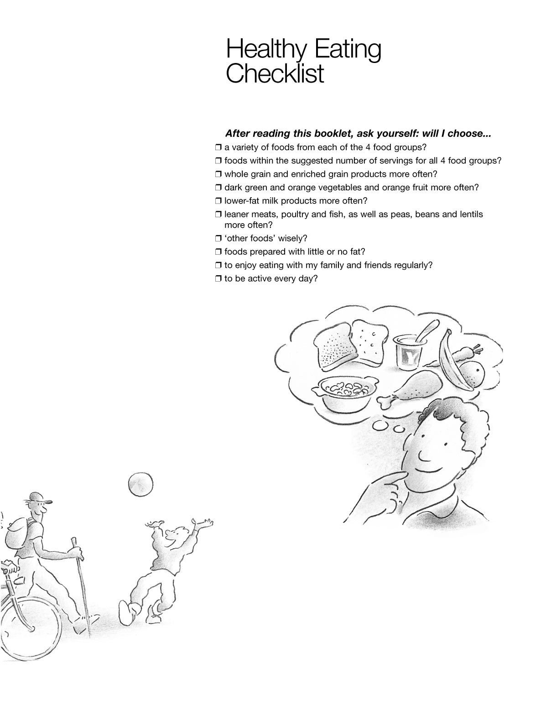
Figure 6-1 (Sheet 12 of 12) Canada's Food Guide

Figure 6-2 Fire Extinguisher Use

Figure 6-3 Classes of Fires

