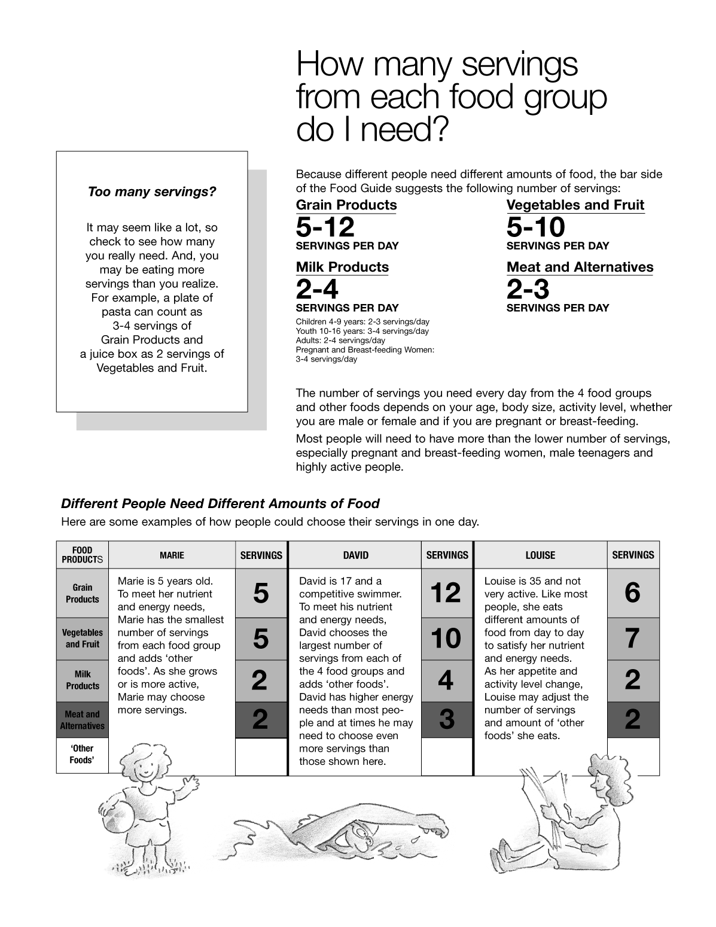
Figure 6-1 (Sheet 7 of 12) Canada's Food Guide

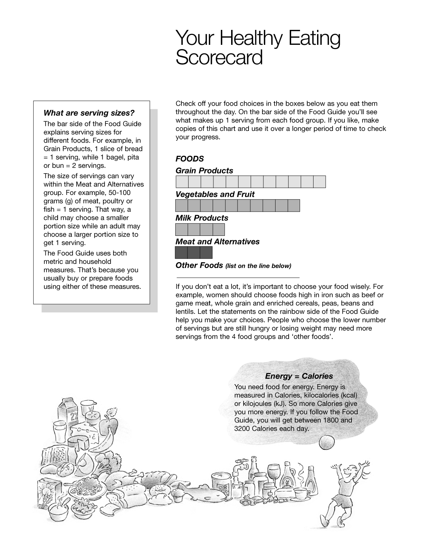
Figure 6-1 (Sheet 8 of 12) Canada's Food Guide

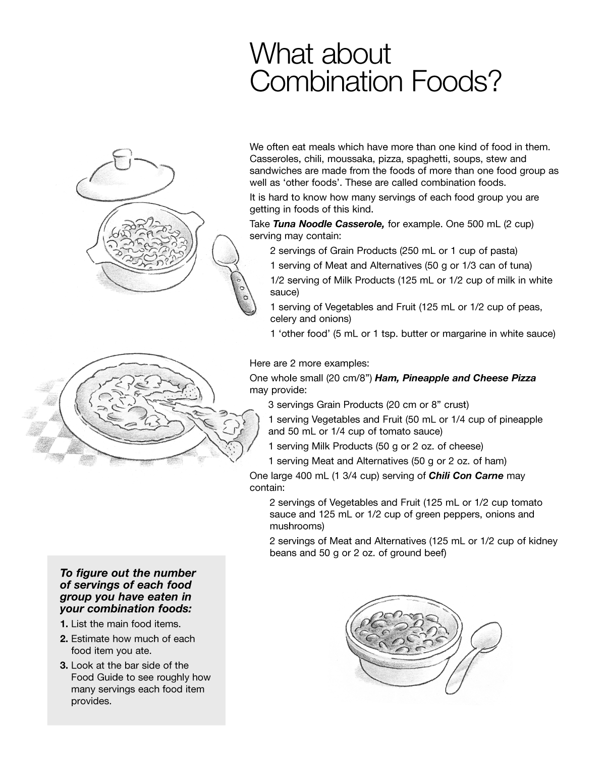
Figure 6-1 (Sheet 9 of 12) Canada's Food Guide

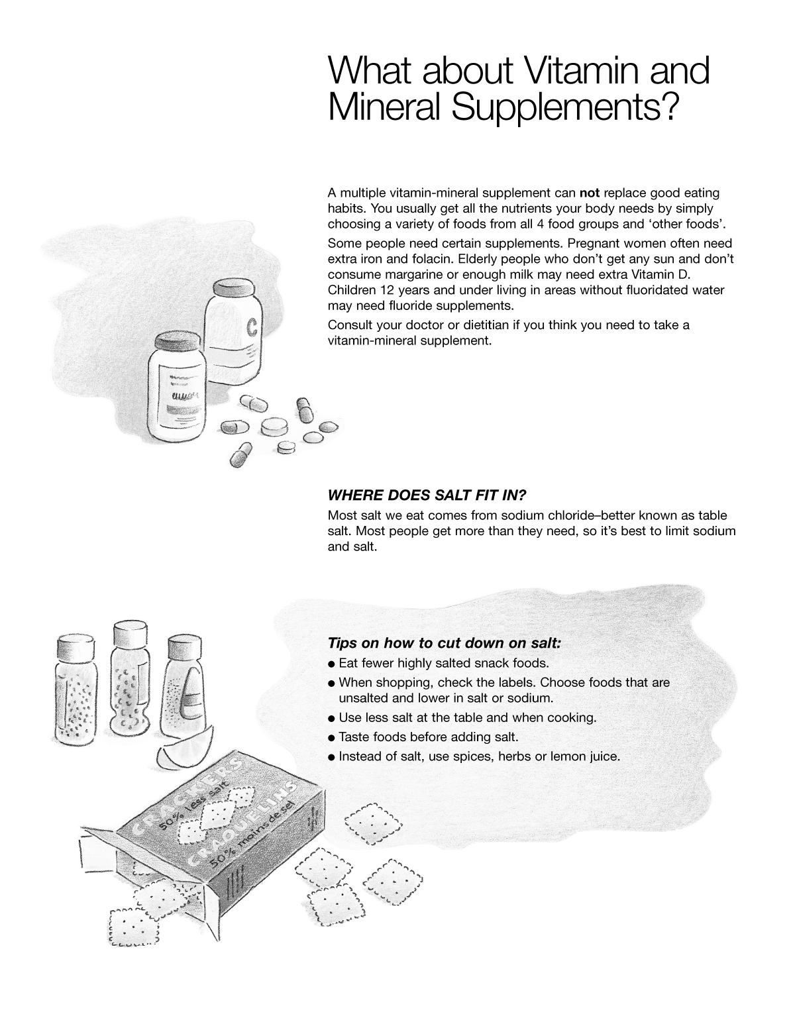
Figure 6-1 (Sheet 10 of 12) Canada's Food Guide

