416
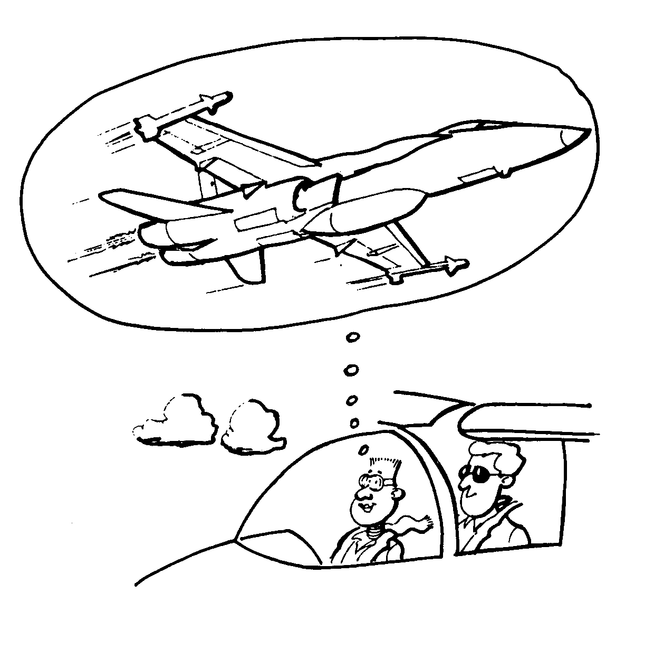
P
R
O
P
U
L
S
I
O
N

CHAPTER 9

PERFORMANCE OBJECTIVE 416

PROPULSION

INTRODUCTION

1. No aircraft can fly without the help of an engine. Cessnas and F18s use different types of engines. Even gliders need to be towed into the air by something with engine power.

2. In this chapter you will learn about some of the basic aircraft engines and how they work.

TYPES OF AIRCRAFT ENGINES

3. Most of the small aircraft you see at the local airport are powered by internal combustion engines. These engines are designed to turn propellers in front of, or sometimes behind, a plane.

4. Internal combustion engines have cylinders and pistons inside them. When the engine is running the cylinders fill with a mixture of gasoline and air. The mixture expands and then burns, which forces the pistons up and down. This reaction happens very quickly − thousands of times per minute. The up and down movement of the pistons is called reciprocating. The movement of the pistons provides power to turn the aircraft propellers.

5. Propellers are not flat but are curved like airfoils. They behave in the same way, with the blades striking the air and developing thrust in the way a wing develops lift.

6. Other types of aircraft are powered by jet engines. Modern fighter planes such as the CF-18 and airliners such as the Boeing 747 use types of jet engines. Some jet aircraft have only one engine, while larger planes can have as many as eight.
7. In the jet engine, air is drawn into the intake and compressed, with a resulting rise in pressure. Fuel is added and burned in a combustion chamber. This produces a high speed, hot gas. It flows through a turbine, which uses just enough energy from the gas to power the compressor. The rest of the energy provides thrust in the form of hot gases being blown out the back in a steady stream.

8. There is one more kind of engine, which is a combination of the first two. The turbo prop engine has propellers that when driven by a jet engine develop much more thrust at take off. This type of engine is ideal for heavy load carriers like the Hercules.

FOUR STROKE ENGINE

9. To understand how an engine works you must first know what parts make up an engine. The cylinders in an internal combustion engine have many other parts in addition to pistons.

10. Each cylinder has two valves on top. One valve opens and closes to let the mixture of gasoline and air through into the cylinder. Once this is done and the mixture is burnt, the other valve opens to release the exhaust.

11. The gasoline/air mixture is ignited by a spark plug. Most aircraft have two in every cylinder. In the cylinder you will also find the piston. The piston is driven up and down by the burning air mixture.

12. The piston is attached by a connecting rod to the crank shaft. As the piston drives up and down, the connecting rod rotates around the crankshaft, turning it. This forces the propeller to turn.

TYPES OF INTERNAL COMBUSTION ENGINES

13. The horizontally opposed engine is most commonly used in general aviation planes. This engine has two banks of cylinders lying flat, directly opposite each other, and working on the same crankshaft. There may be four, six or eight cylinders. The advantage of this motor type is its flat or pancake shape which generates less drag.

Figure 9-1 Basic Components of the Four Stroke Engine
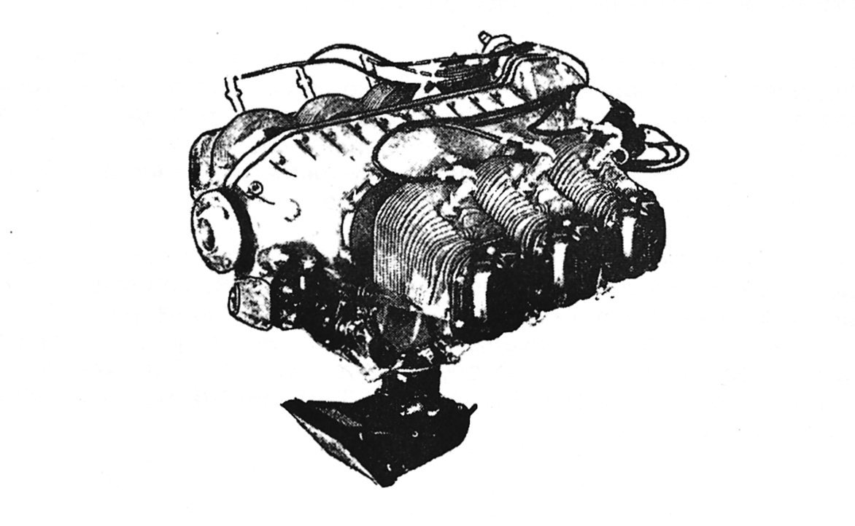

Figure 9-2 Horizontally Opposed Engine
14. Many larger, older aircraft have radial engines. In this arrangement the cylinders are arranged in a circle in the front of the engine with the top ends of the cylinders pointed outwards. The crankshaft runs through the middle of the cylinders to the front of the aircraft. Radial engines have many cylinders. For example, a Second World War fighter with a radial engine had 13 cylinders.

15. Some other old aircraft have in-line engines. This was the first type of aircraft engine used in great numbers. In an in-line engine the cylinders are lined up in a row from the front of the engine to the back, with the tops pointed up. The crankshaft runs under the cylinders to the front of the aircraft.

HOW THE FOUR STROKE ENGINE WORKS

16. In the engine the parts of the cylinder work together in a cycle to turn the aircraft's propeller. In most aircraft engines, this is the four stroke cycle.

17. In the first stroke the intake valve opens to let the gasoline/air mixture into the cylinder, and the piston moves down to draw the mixture in. The exhaust valve is closed during this stage. This is called the intake stroke.

18. In the second stroke both valves are closed while the piston moves up to compress the gasoline/air mixture. This is called the compression stroke.

19. In the third stroke both valves remain closed while the spark plug ignites the gas. which burns and expands and forces the piston down again. This is called the power stroke.

20. In the fourth stroke the intake valve is closed while the exhaust valve opens to let the burnt gases out. The piston moves up again to force the gases out. This is called the exhaust stroke.

21. The whole process repeats itself causing the crankshaft to turn the propeller on the aircraft.

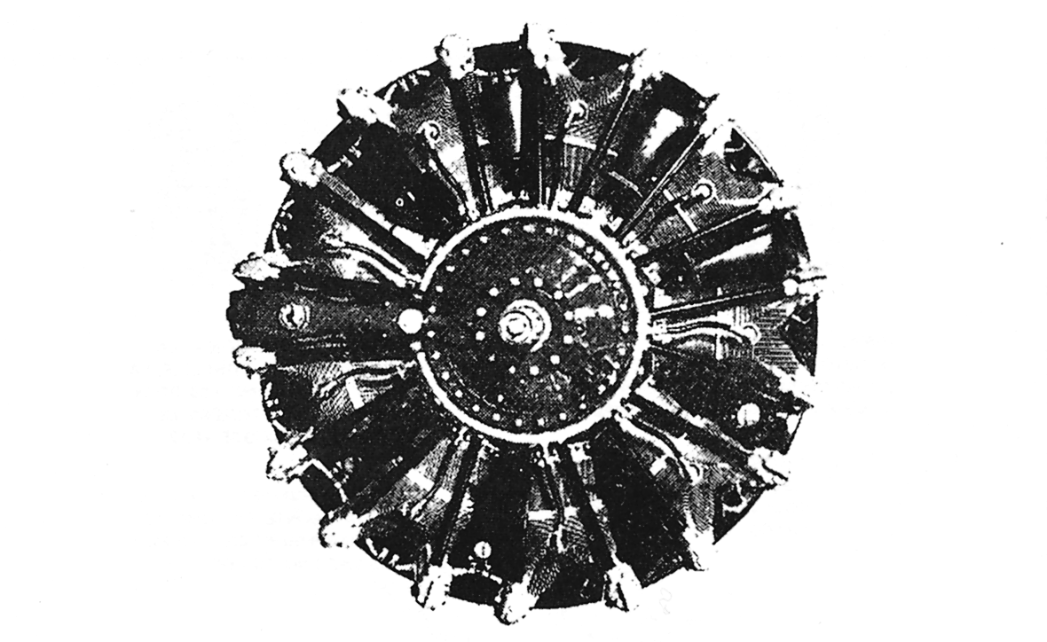

Figure 9-3 Radial Engine
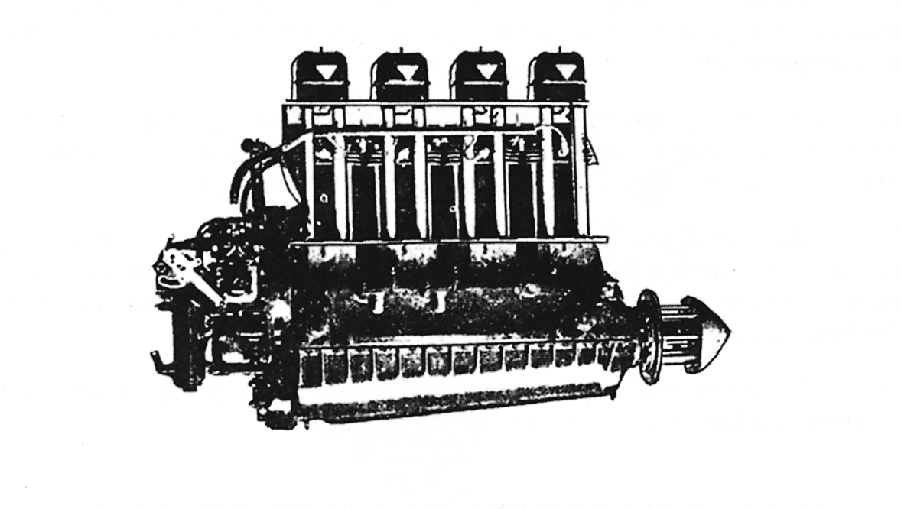

Figure 9-4 In-line Engine

Figure 9-5 Four Stroke Cycle
THE FUNCTIONS OF OIL

22. Oil plays an important role in the functioning of an aircraft engine and many other engines. In fact, oil fulfils four important functions:

a. Oil cools the engine by drawing heat away from hot engine parts as it flows by.

b. Oil helps seal parts of the engine by creating a barrier between parts so that air and other gases cannot get through. This is especially important in the cylinder, so the gasoline/air mixture does not escape.

c. Oil lubricates the engine, creating a smooth surface between parts that rub together, such as the piston when it moves up and down.

d. Oil flushes the engine. This means the oil carries away dirt and debris from the engine as it flows through.

23. The mystery can be removed from how a car operates or how a plane flies if you learn the basics of how an engine operates. This information can be useful if your car breaks down, or your father needs the lawn-mower fixed.

