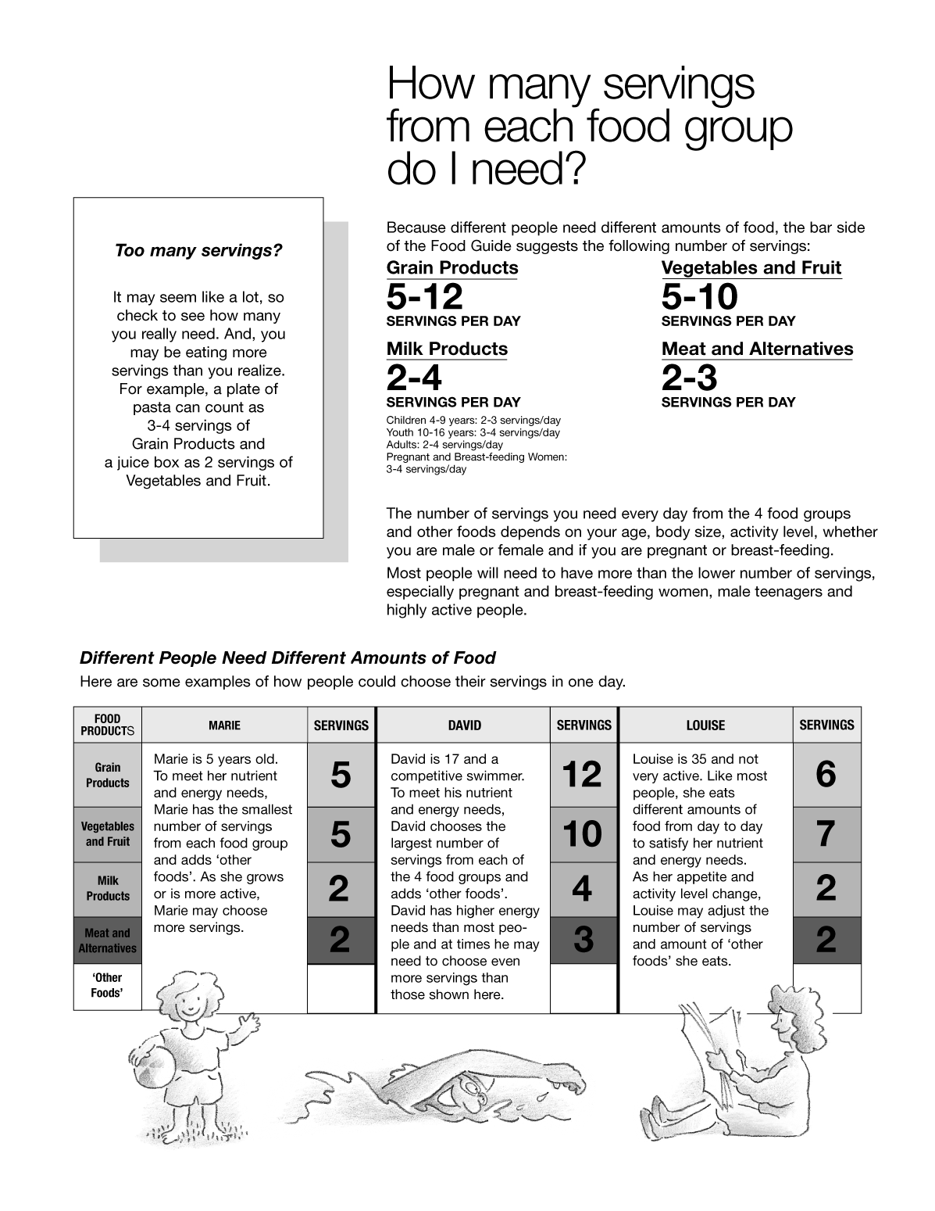
Figure 5-1(Sheet 7 of 12) Canada's Food Guide
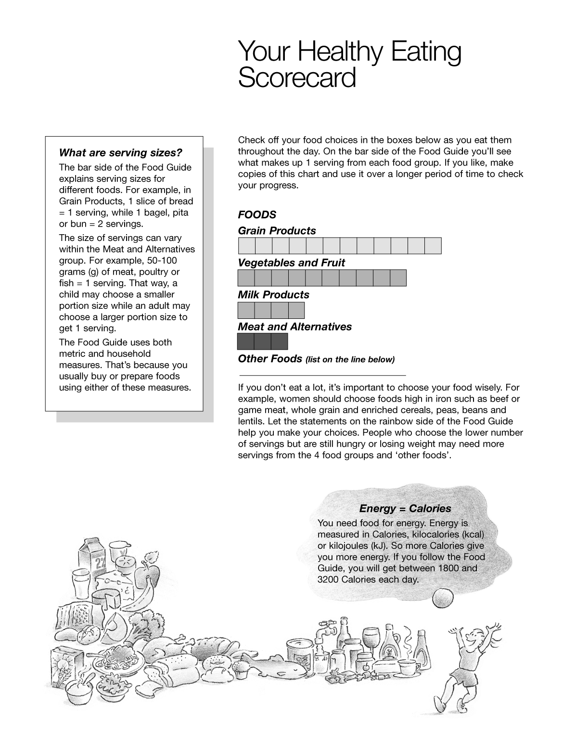
Figure 5-1(Sheet 8 of 12) Canada's Food Guide
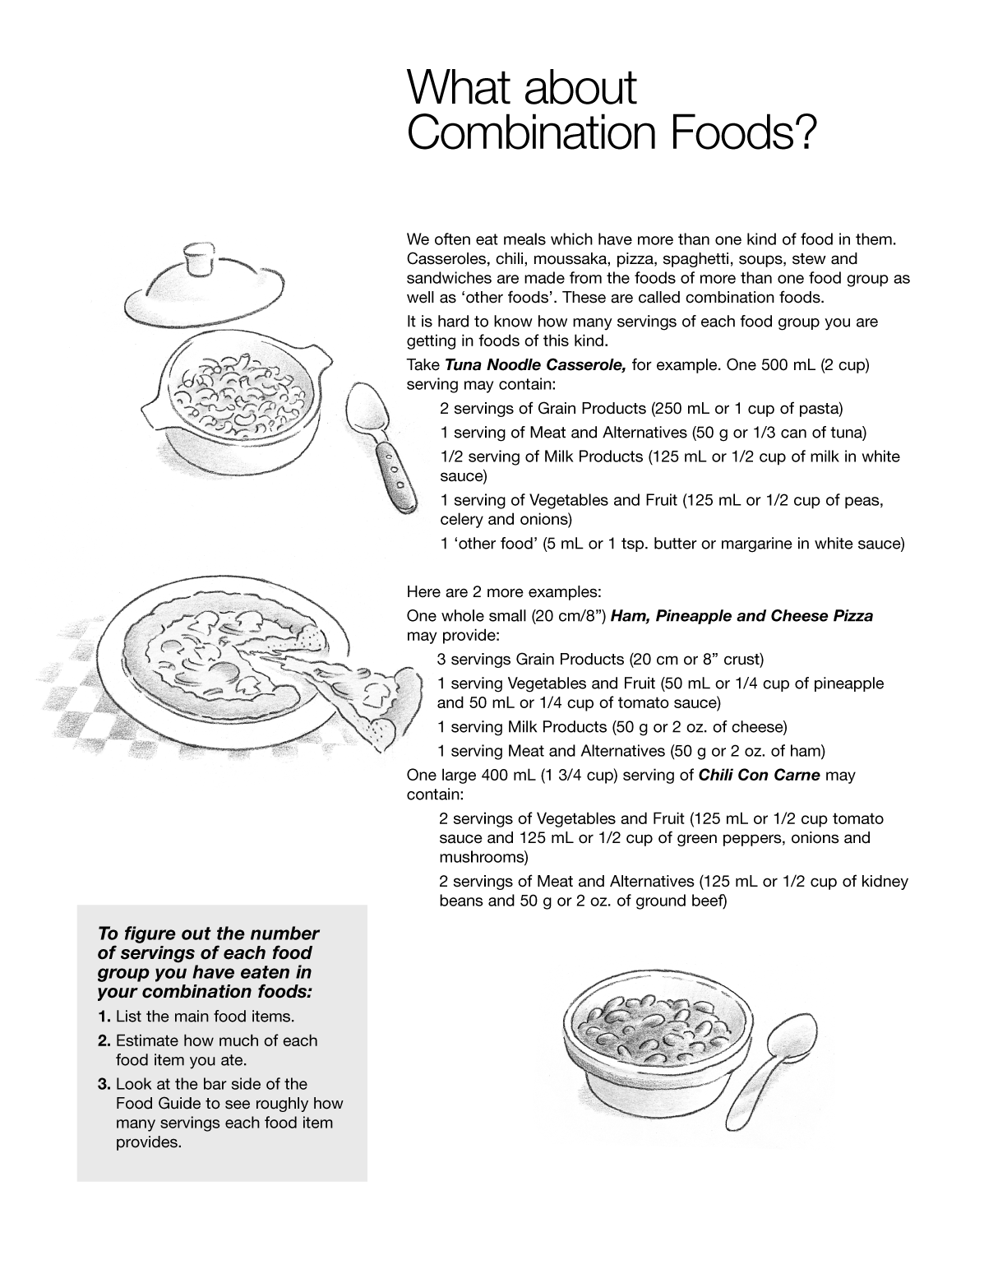
Figure 5-1(Sheet 9 of 12) Canada's Food Guide

