A-CR-CCP-267/PH-001

ROYAL CANADIAN AIR CADETS

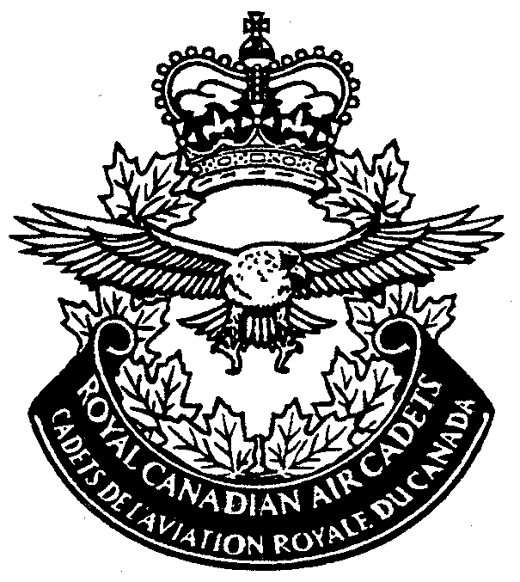

COURSE TRAINING PLAN
SQUADRON TRAINING
LEVEL TWO

Issued on Authority of the Chief of the Defence Staff
Publiée avec l'autorisation du Chef d'état-major de la Défense


A-CR-CCP-267/PH-001

COURSE TRAINING PLAN

ROYAL CANADIAN AIR CADETS

PROFICIENCY LEVEL TWO

(This publication supersedes A-CR-CCP-267/PH-001 dated 1997-01-15)

Issued on Authority of the Chief of the Defence Staff

OPI: D Cdts 1998-07-01

LIST OF EFFECTIVE PAGES

Insert latest changed pages, dispose of superseded pages in accordance with applicable orders.

NOTE

The portion of the text affected by the latest change is indicated by a black vertical line in the margin of the page. Changes to illustrations are indicated by miniature pointing hands or black vertical lines.

Dates of issue for original and changed pages are:

Original 0 1994-04-22  Ch 1 1997-01-15  Ch 2 1998-07-01  Ch 3 | Ch 4  Ch 5  Ch 6  Ch 7

Zero in Change No. Column indicates an original page. The use of the letter E or F indicates the change is in English or French only. Total number of pages in this publication is 114 consisting of the following:

Page No. Change No.  Title 1  A 1  B/C 0  i/ii 0  iii/iv 0  v, vi 0  1-1, 1-2 0  1A-1/1A-2 1  1B-1/1B-2 0  2-1, 2-2 0  3-1 to 3-4 0  3A-1, 3A-2 0  3B-1/3B-2 0  3C-1/3C-2 0  3D-1/3D-2 0  3E-1/3E-2 0  3F-1/3F-2 0  3G-1, 3G-2 0  4-1/4-2 0  4-3 to 4-9/4-10 0  4-11/4-12 0  4-13 to 4-15/4-16 0  4-17/4-18 0  4-19/4-20 0  4-21/4-22 0  4-23/4-24 0  4-25/4-26 0  4-27/4-28 0  4-29 to 4-31/4-32 0  4-33/4-34 0 | Page No. Change No.  4-35/4-36 0  4-37/4-38 0  4-39/4-40 0  4-41/4-42 0  4-43 to 4-47/4-48 0  4-49/4-50 0  4-51 to 4-53/4-54 0  4-55 to 4-57/4-58 0  4-59/4-60 0  4-61/4-62 0  4-63/4-64 0  4-65 to 4-69/4-70 0  4-71 to 4-73/4-74 0  4-75/4-76 0  4-77 to 4-79/4-80 0  4-81/4-82 0  4-83 to 4-85/4-86 0  4-87/4-88 0  4-89/4-90 0  4-91/4-92 0  4-93/4-94 0  4-95/4-96 0  4-97/4-98 0  4-99/4-100 0  4-101 to 4-103/4-104 0  4-105/4-106 0  4-107/4-108 0  4-109 to 4-115/4-116 0  4-117/4-118 0  4-119/4-120 0

LIST OF EFFECTIVE PAGES (Cont)

Page No. Change No.  4-121 to 4-123/4-124 0  4-125/4-126 0  4-127 to 4-129/4-130 0 | Page No. Change No.  4-131/4-132 0  4-133/4-134 0  4-135/4-136 0

FOREWORD

1. Course Training Plan (CTP) for Royal Canadian Air Cadets Level Two training is issued on authority of the Chief of Defence Staff and is based on the Course Training Standard (CTS), A-CR-CCP-265/PT-001.

2. This publication is effective upon receipt and supersedes A-CR-CCP-267/PH-001 dated 1997-01-15.

3. Suggestions for changes shall be forwarded through normal channels to National Defence Headquarters (NDHQ), Attention: Director Air Cadets.

PREFACE

1. This CTP was developed by a team of cadet training development officers working for the Director Cadets in collaboration with Region Headquarters, Area Cadet Officers (Air) and squadron officers from each region.

2. This publication is for the use of air cadet squadron training officers and their staffs in planning and conducting the mandatory support squadron training programme.

3. This CTP is an integral part of a performance-oriented system of training. It is the third document in the squadron programme and identifies Enabling Objectives (EOs) within the Performance Objectives (POs). Each EO defines in precise terms what skill the individual trainee must demonstrate to achieve the final PO.

4. A more detailed explanation of the Canadian Forces Individual Training System and how it applies to cadets can be found in the training management guide, A-CR-CCP-272/PF-001 (under development).
CONTENTS

PAGE

CHAPTER 1 – GENERAL 1-1

Outline of Training 1-1
Conduct of Training 1-2
Use of CTP 1-2

Annex A – Course Summary 1A-1/1A-2

Annex B – Suggested Course Timetable 1B-1/1B-2

CHAPTER 2 – COURSE MANAGEMENT DETAILS 2-1

Aim 2-1
Critical Requirements 2-1

CHAPTER 3 – ASSESSMENT OF CADETS 3-1

General 3-1
Specific Assessment Guidelines 3-1
Grading 3-2
Re-testing 3-3
Progress Monitoring 3-3
Unsatisfactory Course Progress 3-3
Course Reporting 3-4

Annex A – PO 401 Drill Assessment Form 3A-1

Table of Conversion 3A-2

Annex B – PO 403 Uniform Inspection Form 3B-1/3B-2

Annex C – PO 405 Air Cadet Fitness Programme – Test Record Chart 3C-1/3C-2

Annex D – PO 410 Effective Speaking Marking Guide 3D-1/3D-2

Annex E – PO 414 Principles of Flight 3E-1/3E-2

Annex F – PO 416 Propulsion 3F-1/3F-2

Annex G – DND 1964 – Cadet Information Sheet 3G-1

CHAPTER 4 – PERFORMANCE OBJECTIVE 4-1/4-2

401 Drill 4-1/4-2
402 Drill Instruction – not allocated for Level Two 4-23/4-24
403 General Cadet Knowledge 4-25/4-26
404 Citizenship 4-41/4-42
405 Physical Fitness 4-53/4-54
406 Sensible Living 4-57/4-58

CONTENTS (Cont)
PAGE

407 First Aid – not allocated 4-61/4-62
408 Leadership 4-63/4-64
409 Instructional Techniques – not allocated for Level Two 4-73/4-74
410 Effective Speaking 4-75/4-76
411 Aircraft Identification – not allocated for Level Two 4-87/4-88
412 Aeronautical Facilities – not allocated for Level Two 4-89/4-90
413 Meteorology – not allocated for Level Two 4-91/4-92
414 Principles of Flight 4-93/4-94
415 Airframe Structures – not allocated for Level Two 4-105/4-106
416 Propulsion 4-107/4-108
417 Navigation – not allocated for Level Two 4-117/4-118
418 Radio Communications 4-119/4-120
419 Aircrew Survival 4-125/4-126
420 Training Duties – not allocated for Level Two 4-133/4-134
421 Range – not allocated for Level Two 4-135/4-136

CHAPTER 1

GENERAL

OUTLINE OF TRAINING

1. Description of Need. The Air Cadet Mandatory and Mandatory Support Programmes include training in leadership, citizenship, physical fitness and aviation subjects. A need exists to build on training received in Level One and to provide some more opportunities for cadets to gain experience and knowledge by performing the duties of an air cadet.

2. Scope. The following subject areas will be covered:

a. Drill – PO 401.

b. General Cadet Knowledge – PO 403.

c. Citizenship – PO 404.

d. Physical Fitness – PO 405.

e. Sensible Living – PO 406.

f. Leadership – PO 408.

g. Effective Speaking – PO 410.

h. Principles of Flight – PO 414.

j. Propulsion – PO 416.

k. Radio Communications – PO 418.

m. Aircrew Survival – PO 419.

3. Programme Design. This programme is designed to be completed during mandatory and mandatory support training time. Mandatory training is training conducted to achieve POs outlined in the CTS. It takes place over 25 training sessions. Mandatory support training is training conducted outside regular training sessions and assists in achieving the objectives of mandatory training.

4. Local headquarters training for Level Two is based on:

a. 30 training sessions (one per week) consisting of:

(1) 25 sessions dedicated to Proficiency Level Two, and

(2) five sessions used at the squadron commander’s direction; and

b. eight mandatory support training days allocated as follows:

(1) one day – gliding familiarization flying,

(2) two days – bush weekend exercise,

(3) two days – citizenship,

(4) two days – sports, and

(5) one day – annual inspection.

5. Suggested Course Timetable. Annex B of this chapter contains a suggested timetable for completion of this course.

CONDUCT OF TRAINING

6. Method of Achieving Objectives. The cadets shall be taught through the following methods:

a. Lecture Method. A formal or semi-formal discourse in which the instructor presents a series of events, facts or principles, or explores a problem or explains relationships.

b. Discussion Method. A method in which group discussion techniques are used to reach instructional objectives.

c. Demonstration Method. A method of instruction where the instructor, by actually performing an operation or doing a job, shows the student what to do, how to do it and through explanations, brings out why, where and when it is done.

d. Performance Method. A method in which the student is required to perform, under controlled conditions, the operations, skill or movement being taught.

e. Study Assignment Method. A method in which the instructor assigns readings in books, periodicals, manuals or handouts; requires the completion of a project or research paper; or prescribes problems and exercises for the practice of a skill.

7. As the majority of the POs are skilled-related and hands-on, an experimental learning approach is essential.

USE OF CTP

8. This CTP shall be used by all Royal Canadian Air Cadet squadrons as the primary authority covering the organization and conduct of Proficiency Level Two training.

COURSE SUMMARY

LEVEL TWO

PERFORMANCE OBJECTIVES  LEVEL TWO | MANDATORY  TRAINING  PERIODS | MANDATORY  SUPPORT  TRAINING
- Drill  403 General Cadet Knowledge  404 Citizenship  405 Physical Fitness  406 Sensible Living  408 Leadership  410 Effective Speaking  414 Principles of Flight  416 Propulsion  418 Radio Communications  419 Aircrew Survival  Commanding Officer’s (CO’s) Periods  Total | 16  11  5  1  3  6  9  6  5  2  3  67  23  90 | one day – annual inspection  two activities (two days)  two activities (two days)  one gliding familiarization day for PO's  414, 416 inclusive. (See note below).  one weekend exercise (two days)  8 Mandatory Support Training Days
Note: If the squadron is not serviced by a gliding site, contact the Regional HQ/RCA Ops O for an alternate, but equivalent activity.

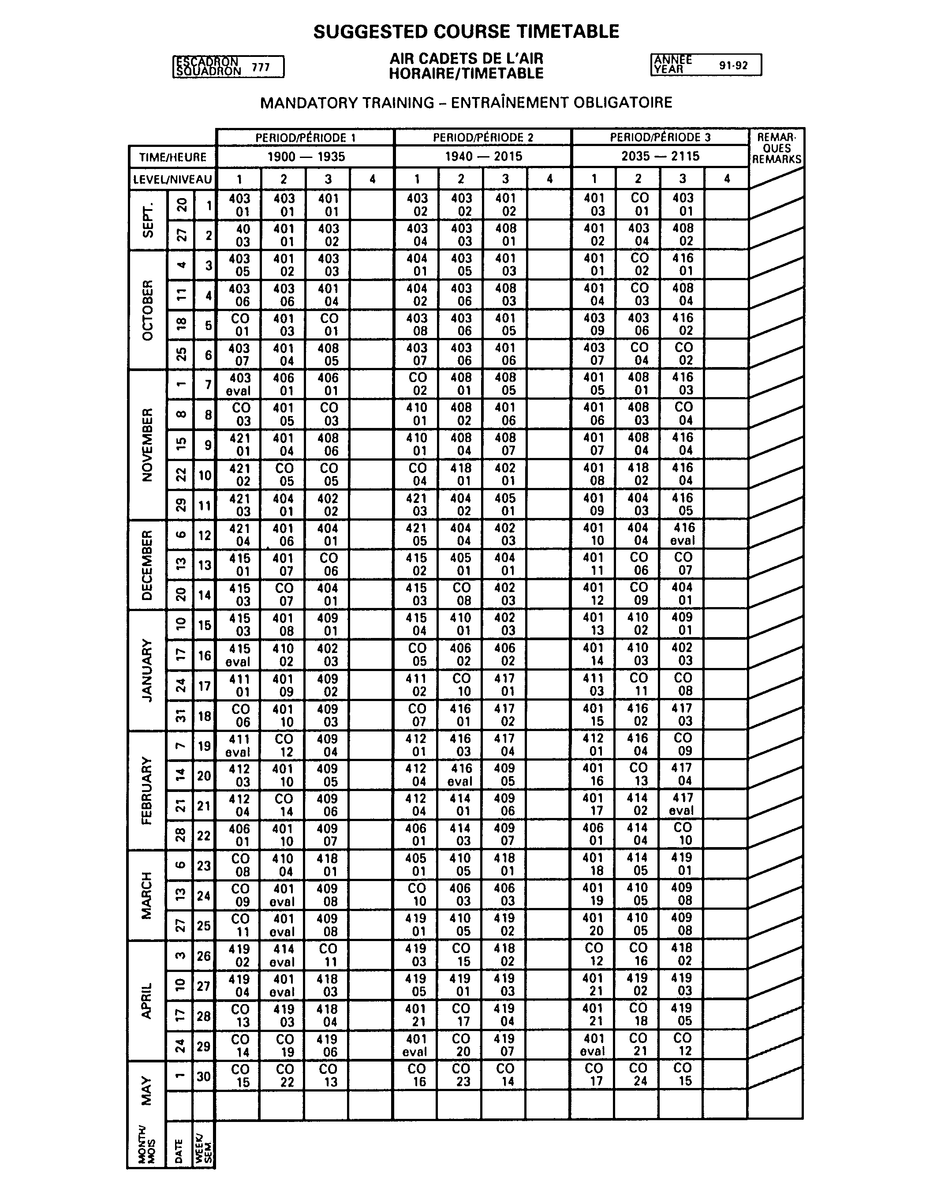
CHAPTER 2

COURSE MANAGEMENT DETAILS

AIM

1. The aim of the Proficiency Level Two course is to train a cadet to perform the duties of a Level Two cadet as detailed in Air Cadet Specifications.

CRITICAL REQUIREMENTS

2. Course Duration. The duration of this course is 25 training sessions plus the following exercises during mandatory support training time:

a. 1 September to 30 June – one familiarization flying day (gliding, Canadian Force (CF) or other), and one weekend exercise;

b. 1 September to 31 December – two 1-day exercises; and

c. 1 January to 30 June – two 1-day exercises.

3. In addition, five training sessions may be allocated at the discretion of the squadron commanding officer CO.

4. In summary, the course is composed of the following:

a. 30 training sessions (one per week) –

(1) 25 sessions dedicated to Proficiency Level Two, and

(2) five sessions used at the squadron commander’s discretion; and

b. eight mandatory support training days.

5. Instructor Allocation. The following are required:

a. Training officer.

b. Officer instructor – course training officer.

c. Level IV qualified cadet instructors.

6. Course Capacity. The course capacity will be dependent on the resources available at each squadron. As well, enrolment will remain in accordance with the squadron’s designated quota.

7. Facility Requirements. Squadrons should seek access to the following facilities in order to conduct this course:

a. area to conduct drill instruction;

b. classroom space;

c. a range; and

d. area to conduct sports activities.

8. Equipment and Personnel Support. During the course, there is one aircrew survival exercise designed to allow a Level Two cadets to apply knowledge of survival in the field. The training support requirements are as follows:

a. Transportation Bus, panel vans (as available);

b. sleeping bags;

c. two radios;

d. tents suitable for command posts and accommodations;

e. fresh or dry rations (as available); and

f. Additional Equipment as Available axes, shovels, rope, lanterns and coleman stoves.

9. Citizenship Training. Practical citizenship training must be conducted at the squadron. A cadet must participate in a minimum of two activities over the training year. One of those two must be an activity related to preserving the environment. These activities are to be conducted during mandatory support training time and are counted as the designated exercises detailed in paragraph 2, Critical Requirements and Chapter 1, paragraph 4b. Practical citizenship activities may include, but are not limited to the following:

a. Community. The following apply:

(1) The Terry Fox Run;

(2) Legion Poppy Day;

(3) Remembrance Day Parade;

(4) Christmas Seal Campaign;

(5) Santa Claus Parade;

(6) hospital volunteer;

(7) senior citizen home visits;

(8) city dedication ceremonies; and

(9) assistance with civic events.

b. Environment. The following apply:

(1) community garbage clean-up projects;

(2) assisting members of the community return recycables;

(3) park maintenance; and

(4) any local initiative towards preserving the environment.

CHAPTER 3

ASSESSMENT OF CADETS

GENERAL

1. Course Assessment. A pass/fail assessment of each cadet will be based on:

a. successfully meeting the standards of the POs as stated in Chapter 4 of this CTP; and

b. the cadet’s overall behaviour.

2. PO Assessment. Completion of POs will be evaluated by:

a. Performance Checks (PCs); and

b. Tests of Supporting Knowledge (TSKs).

3. PCs. All POs will be assessed using PCs. POs not able to be assessed practically shall be evaluated by a TSK. These tests can be oral or written, although it is recommended they be oral. The pass mark is 60 per cent.

SPECIFIC ASSESSMENT GUIDELINES

4. PO 401. At the end of all training a practical test for PO 401 will be administered. Attached in Annex A of this chapter is the checklist of drill movements to be completed and the assessment guide.

5. PO 403. To pass PO 403 the cadet must complete all the EOs in this PO. The cadet's standard of dress and deportment will be a reflection of the individual's pride in and loyalty to the Royal Canadian Air Cadets. Dress and deportment must be monitored for the duration of the course and poor behaviour in this regard should be reflected in the comments section on the Cadet Academic Record (Annex G). If uniform is to be assessed for inter-flight competition purposes, use the evaluation form in Annex B of this chapter.

6. PO 404. In order to meet the standard in PO 404 the cadet must participate in a minimum of two citizenship events over the duration of the course. One of those two must be an activity related to preserving the environment, for example, helping people deliver recycables, garbage clean-up of parks or local areas, tree planting, etc. There are many local programmes to which cadets can contribute.

7. PO 405. Air Cadet Fitness Programme (ACFP) testing will be conducted once a year to determine the cadets' level of physical fitness. Cadets must participate in one team sports activity with the squadron during the training year. Regardless of previous certification, cadets should complete ACFP testing. Participation in the ACFP testing helps to satisfy one of the aims of the cadet sports programme: promoting working together and encouraging others.

8. PO 406. There is no evaluation for this PO, although attendance of lectures is required.

9. PO 408. There will be no evaluation for this PO as the contents serve merely to introduce the cadet to the ideas of leadership.

10. PO 410. The cadet must deliver a three-minute prepared speech ensuring effective communication of ideas by speaking clearly and displaying proper dress and deportment. An evaluation form is enclosed in Annex D for completion of this PO. The cadet must speak on any subject; the impromptu speech at EO 410.02 serves as preparation for the three-minute prepared speeches.

11. PO 414. Cadets must respond to oral questions on the contents of PO 414. They should use a model to illustrate their answers. Answers do not have to be detailed but cadets must respond correctly to questions on Bernoulli's Principle. The questions are contained in Annex E of this chapter.

12. PO 416. The cadet must respond correctly to oral questions on this PO. Answers do not have to be detailed. The questions are contained in Annex F of this chapter.

13. PO 418. The cadet will use radio voice procedure to correctly recite the phonetic alphabet and numbers.

14. PO 419. The cadet will participate in a weekend survival exercise. Attendance is the minimum requirement for this PO.

GRADING

15. POs 403, 404, 405, 406, 408, 414, 416, 418 and 419 will not be graded. They will be assessed as pass/fail only. POs 401 and 410 will be graded.

16. Level Two Grading. Grades are defined as:

a. A – Above Standard Performance. The following apply:

(1) received a grade of 80 per cent or greater in POs 401 and 410;

(2) obtained a pass on nine of nine remaining Level Two POs; and

(3) enthusiastically approached all tasks, helped others achieve POs and participated actively in all aspects of squadron life.

b. B – Standard Performance. The following apply:

(1) received a grade of 60 per cent or greater in POs 401 and 410;

(2) obtained a minimum of eight remaining Level Two POs; and

(3) approached all tasks enthusiastically.

c. C – Minimum Performance. The following apply:

(1) received a minimum grade of 60 per cent or greater in POs 401 and 410;

(2) obtained a minimum of six of nine remaining Level Two POs; and

(3) displayed inappropriate behaviour at some time during the course.

d. F – Fail. The following apply:

(1) the cadet did not receive a minimum of 60 per cent on POs 401 and 410;

(2) the cadet received a Fail on a minimum of five of nine remaining Level Two POs; and

(3) the cadet failed to present a minimum standard of deportment and behaviour expected of Level Two cadets.
RE-TESTING

17. A cadet who fails a PC or TSK will be permitted a supplemental attempt to pass. Failure of a supplemental attempt constitutes failure of that PO (see paragraphs 25 to 28 for further details). If, in the judgement of the CO, unusual circumstances exist, a further attempt may be granted. The details shall be recorded on the cadet's file.

PROGRESS MONITORING

18. Continuous monitoring of a cadets' progress is required at the squadron in order to provide the following:

a. early warning of a cadets' difficulties; and

b. feedback on the effectiveness of training.

19. Mechanisms used for this purpose include the following:

a. cadet interviews; and

b. enabling checks.

20. Cadet's Progress File. Progress files will be used to record observations on a cadets' performance. The course training officer will ensure that forms are included to record:

a. completion of and attendance at essential training activities required by POs/EOs;

b. accumulated performance results for each PO;

c. observations on performance for each assessment element;

d. observations on behaviour; and

e. counselling forms.

21. Cadets experiencing difficulty in any area of performance are to be counselled with regard to the nature of their shortcomings. Corrective action will be suggested.

22. Cadet Interviews. Cadet interviews will be carried out by the course training officer. There will be a minimum of one interview per training year.

23. Any areas of weakness will be identified during these interviews.

24. Enabling Checks. Short quizzes based on training received during the course should be conducted regularly. These quizzes can act as early warnings of training deficiencies and should reduce the number of re-tests.

UNSATISFACTORY COURSE PROGRESS

25. Unsatisfactory course progress is indicated by:

a. failure of a PO; and/or

b. inappropriate behaviour.

26. All PO failures will be submitted to the CO of the squadron for consideration. The CO will review:

a. the seriousness of the failure;

b. performance on related POs;

c. indications of any earlier trouble and action taken;

d. overall course performance; and

e. feasibility of a re-test.

27. The CO or training officer will make a recommendation for either a re-test or failure.

28. In addressing inappropriate behaviour on the part of a cadet, COs should follow normal counselling procedures.

COURSE REPORTING

29. Academic records will be prepared on each cadet. Enclosed in Annex G is the Cadet Academic Record where a cadet's success or failure in a course will be recorded.

30. The Cadet Academic Record will indicate a "Pass" or "Fail".

31. The Academic Record will contain a narrative description of the cadet's performance on the course including specific details regarding:

a. any POs in which the cadet demonstrated exceptional ability; and

b. any POs in which the cadet had difficulty.

32. The narrative may contain:

a. general comments on overall conduct;

b. a descriptive narrative on –

(1) any exceptional conduct, or

(2) any inappropriate conduct resulting in counselling action; and

c. any recommendations for future courses/employment.

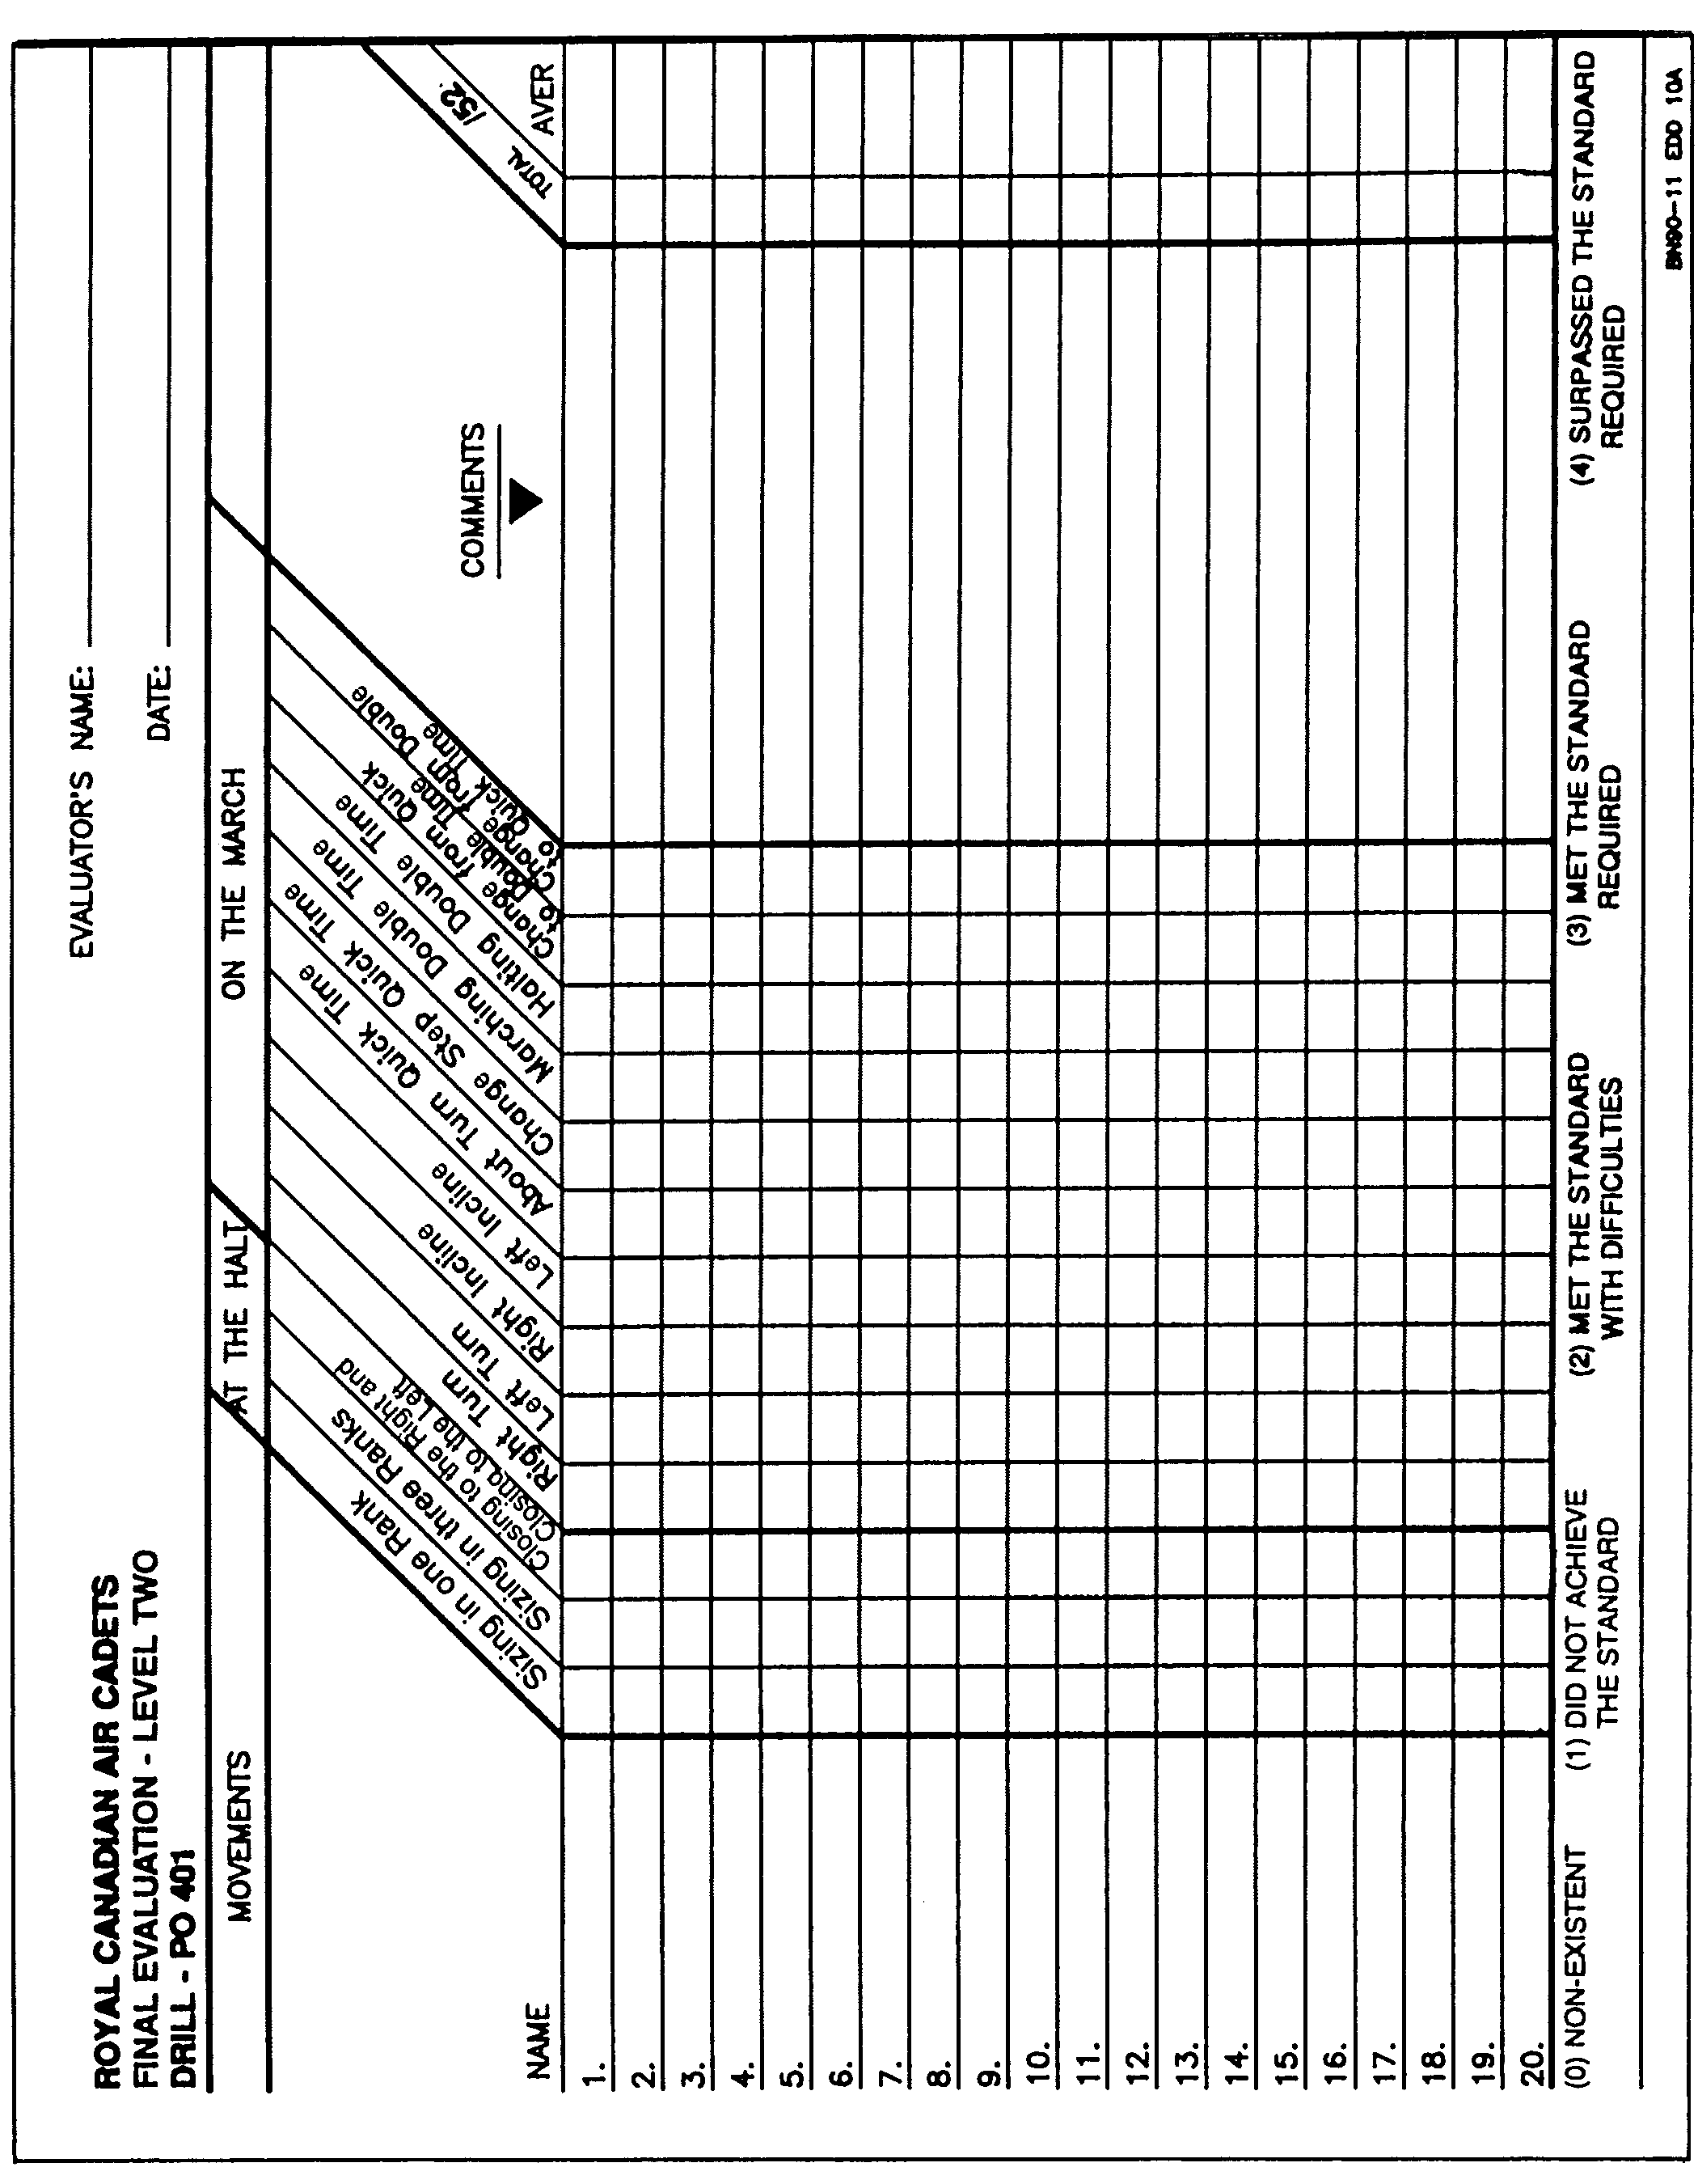
TABLE OF CONVERSION

 | /52 | % | /52 | % | /52 | % | /52 | %
 | 1 | 1 | 15 | 29 | 29 | 56 | 43 | 83
 | 2 | 4 | 16 | 31 | 30 | 58 | 44 | 84
 | 3 | 6 | 17 | 33 | 31 | 60 | 45 | 86
 | 4 | 8 | 18 | 35 | 32 | 61 | 46 | 88
 | 5 | 10 | 19 | 36 | 33 | 63 | 47 | 90
 | 6 | 11 | 20 | 38 | 34 | 65 | 48 | 92
 | 7 | 13 | 21 | 40 | 35 | 67 | 49 | 94
 | 8 | 15 | 22 | 42 | 36 | 69 | 50 | 96
 | 9 | 17 | 23 | 44 | 37 | 71 | 51 | 98
 | 10 | 19 | 24 | 46 | 38 | 73 | 52 | 100
 | 11 | 21 | 25 | 48 | 39 | 75
 | 12 | 23 | 26 | 50 | 40 | 77
 | 13 | 25 | 27 | 52 | 41 | 79
 | 14 | 27 | 28 | 54 | 42 | 81

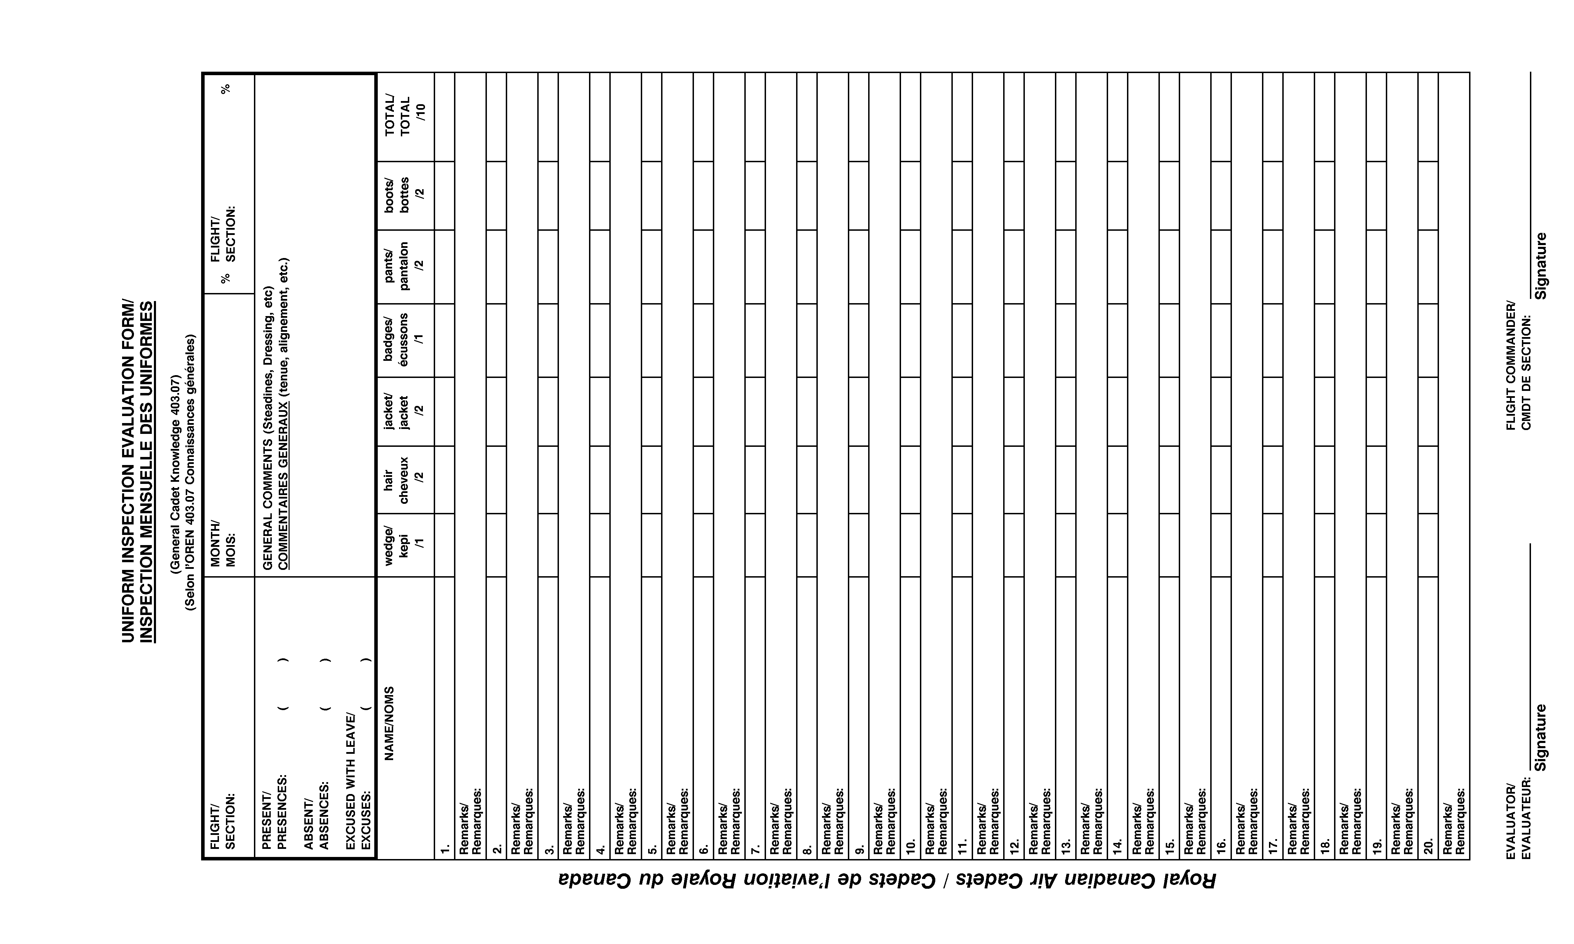
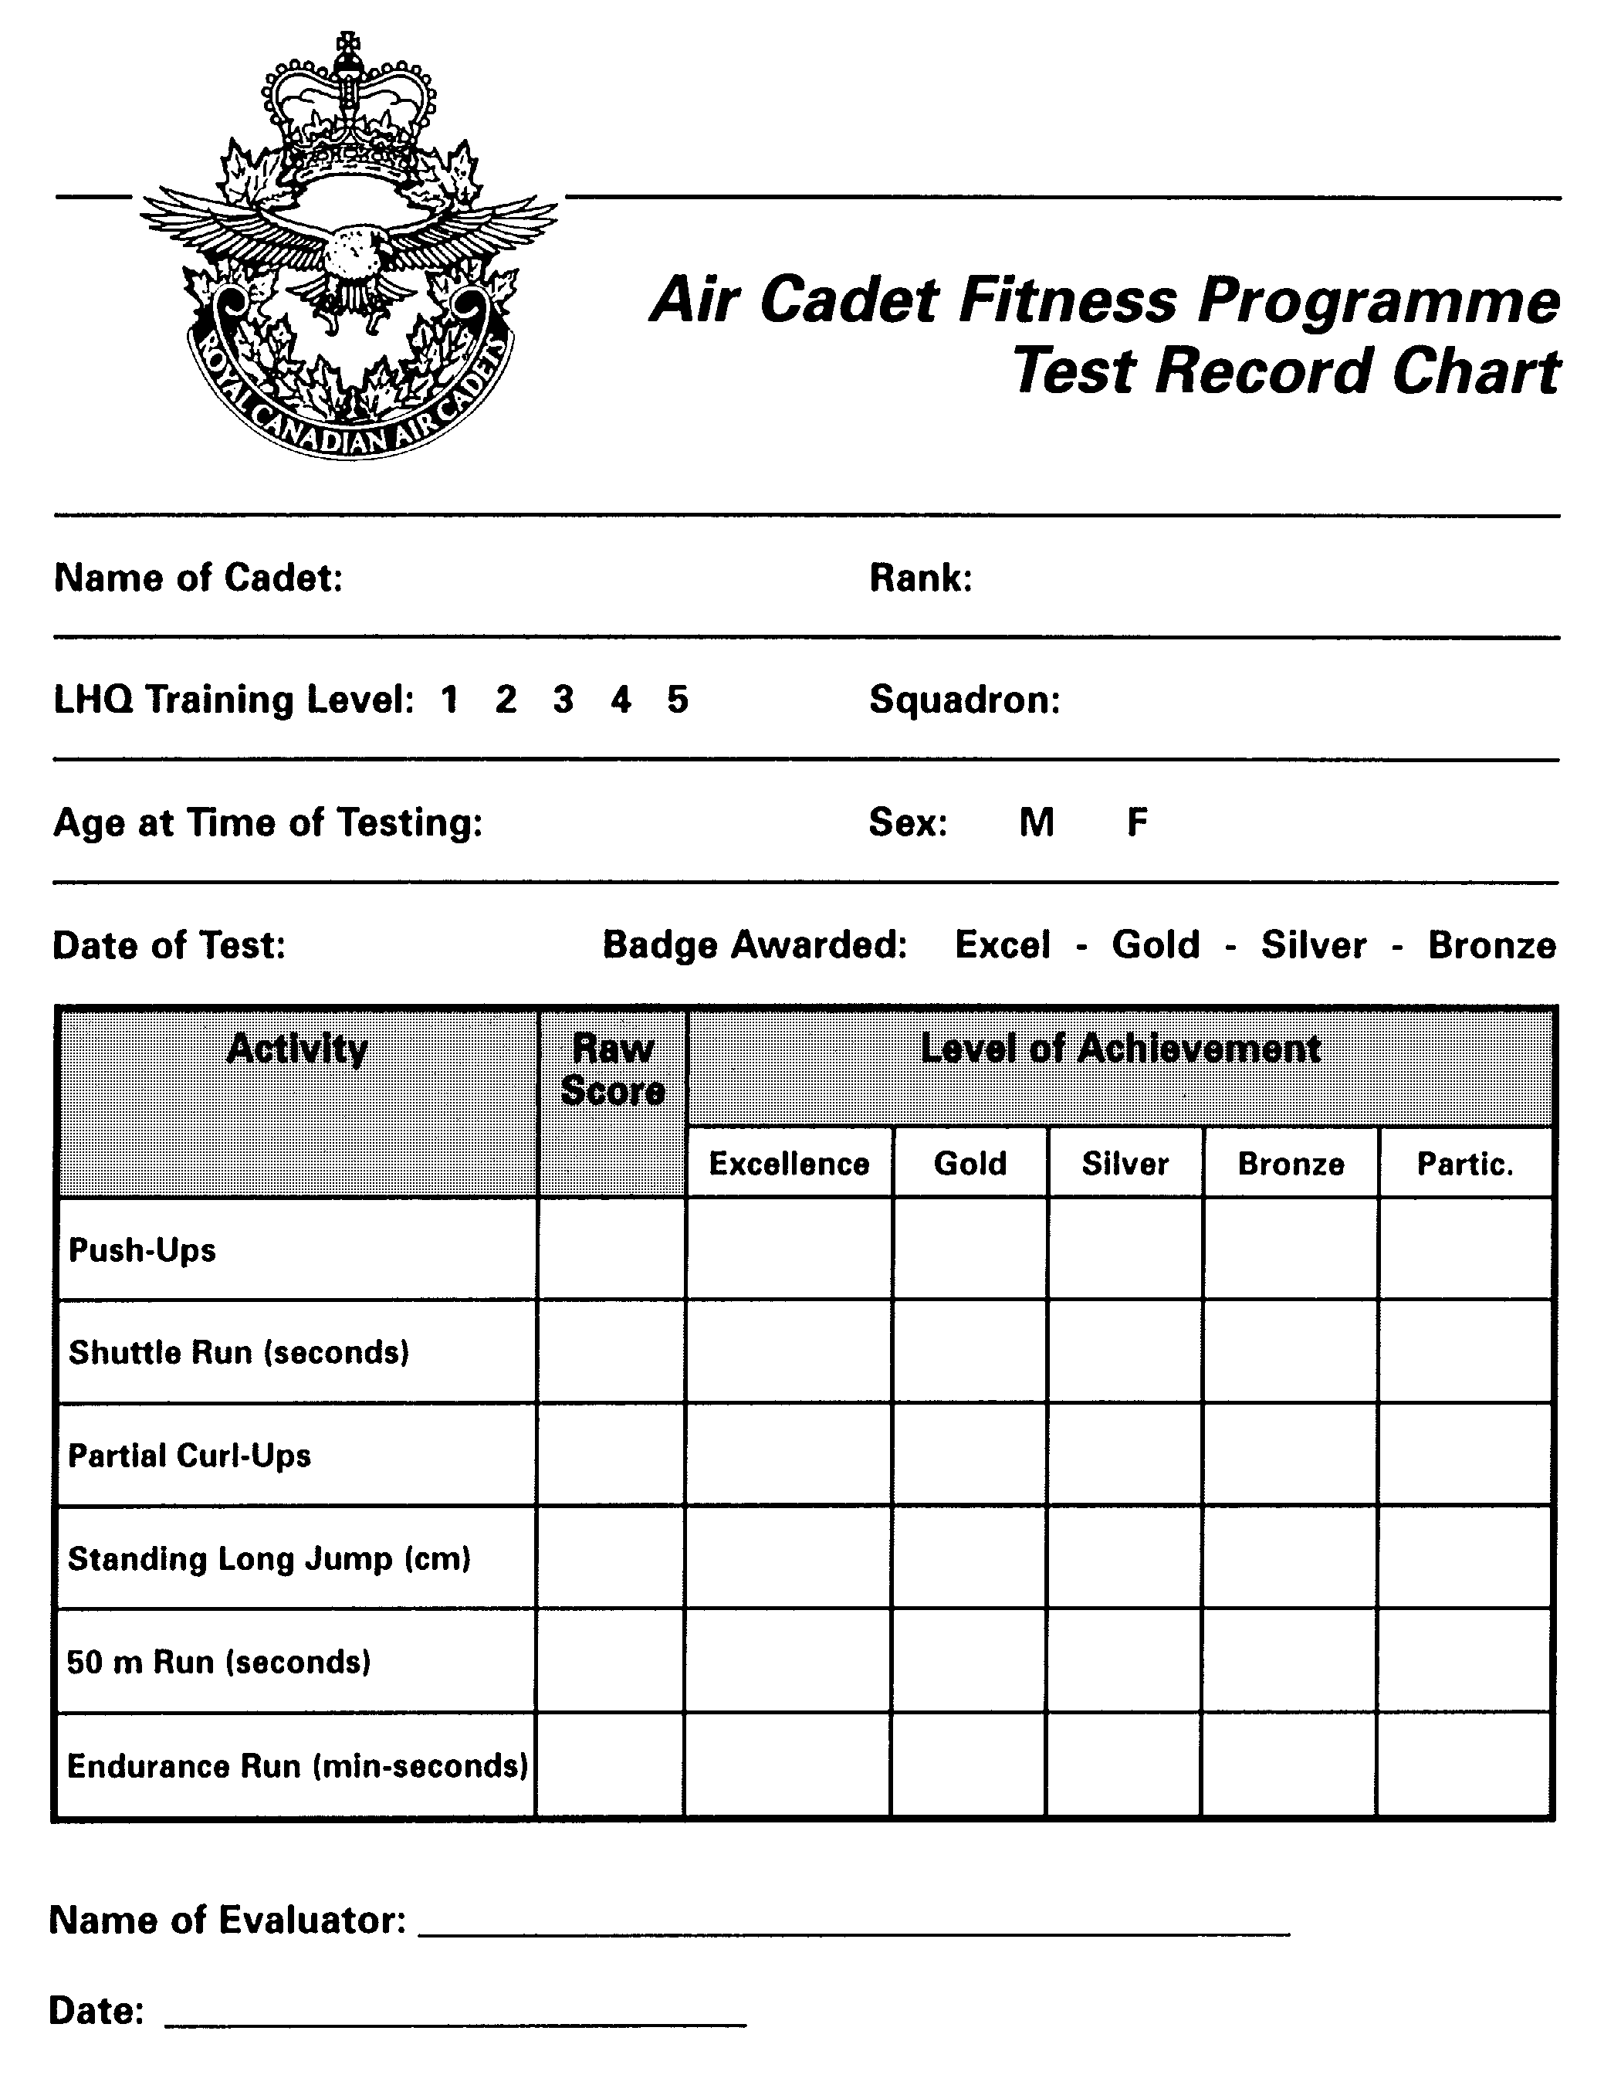
ROYAL CANADIAN AIR CADETS
PO 410 – EFFECTIVE SPEAKING
EVALUATION – LEVEL 2

Cadets name:
1. ONE-MINUTE IMPROMPTU PRESENTATION (EO 410.02)

Main ideas /3 Voice /3
Development /2 Appearance /2
Conclusion /3 Attitude /2

Total /15

Comments ____________________________________________________________________

Date: Evaluator:

2. THREE-MINUTE PREPARED PRESENTATION (PO 410.05)

Introduction /2 Voice /3
Development /3 Appearance /2
Conclusion /3 Attitude /3
Coherence /2 Visual aid(s) /2

Total /20

Comments ____________________________________________________________________

Date: Evaluator:

PO 414 – PRINCIPLES OF FLIGHT
ORAL QUESTIONS

Instructions: Cadets are to respond correctly to questions using a model or diagram to illustrate their answer. Questions may be divided among cadets to accommodate large numbers, or cadets may be divided into teams.

Testing Aids: model aircraft and/or pictures of aircraft.

1. List the four forces that act on an aircraft in flight and show how they do so.

2. Illustrate and explain how lift is created by clearly identifying where the areas of high pressure and low pressure are as air passes over the wing of an aircraft.

3. State why the shape of an airfoil is important.

4. State and give examples of types of drag.

5. State and show the lateral axis of the aircraft.

6. State which flight control procedures roll. Around which axis does a plane roll?

7. Which flight control procedures pitch? Demonstrate an aircraft pitching with the model.

8. When an aircraft pitches, along which axis is the movement? Point it out on the model.

9. When an aircraft yaws, along which axis is the movement? Point it out.

10. Which flight control produces yawing? Demonstrate an aircraft yawing with the model.

PO 416 – PROPULSION
ORAL QUESTIONS

Instructions: Cadets are to respond correctly to questions using a model or diagram to illustrate their answer. Questions may be divided among cadets to accommodate large numbers of cadets or cadets may be divided into teams.

Testing Aids: model aircraft and/or pictures of aircraft.

1. State the three types of engines.

2. Which one is used most commonly on small aircraft engines?

3. How are propellers shaped and why?

4. Identify the following components and explain their function:

– intake valve

– exhaust valve

– spark plug

– piston

– cylinders

– connecting rod

– crank shaft

5. How does the turbo prop engine work and what is its main advantage?

6. Name the three different types of internal combustion engines.

7. Explain the four strokes of the four-stroke engine. Identify which components move during each stroke and the action that occurs.

8. List a function of oil and explain its purpose in an engine.

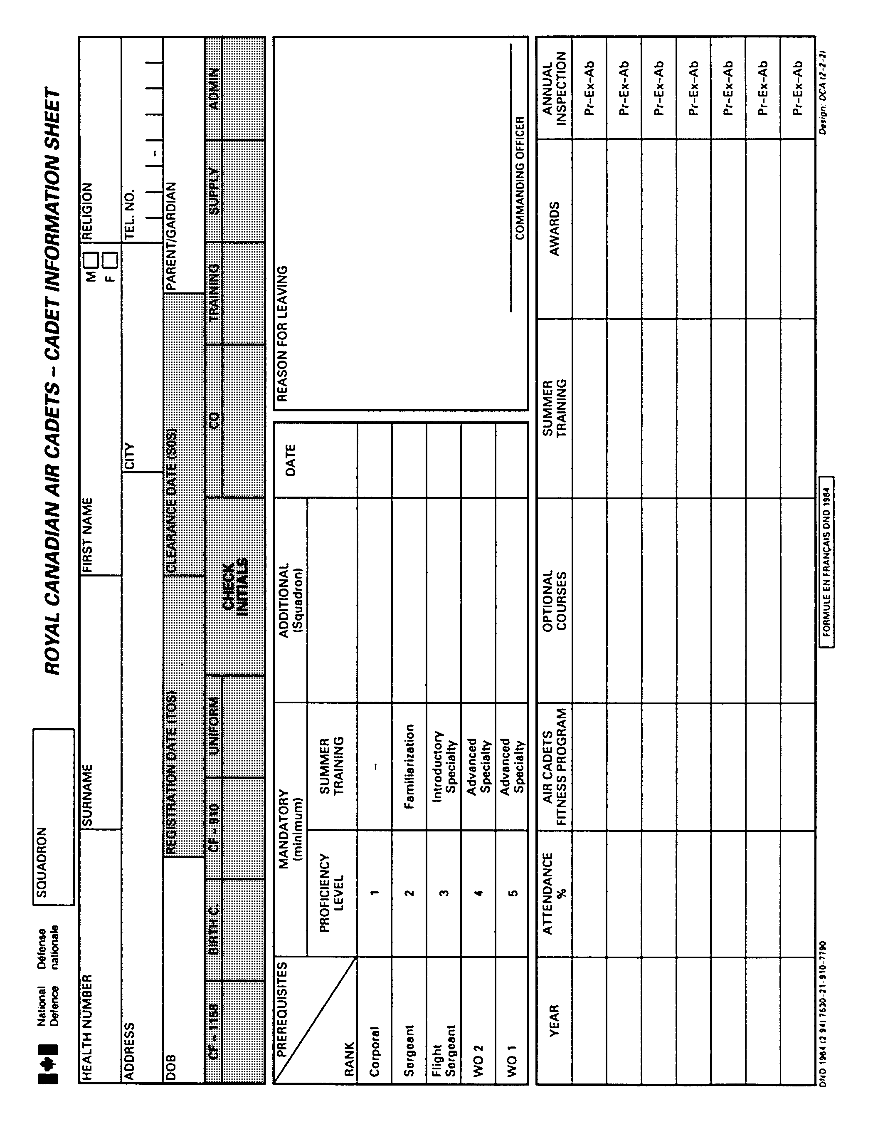
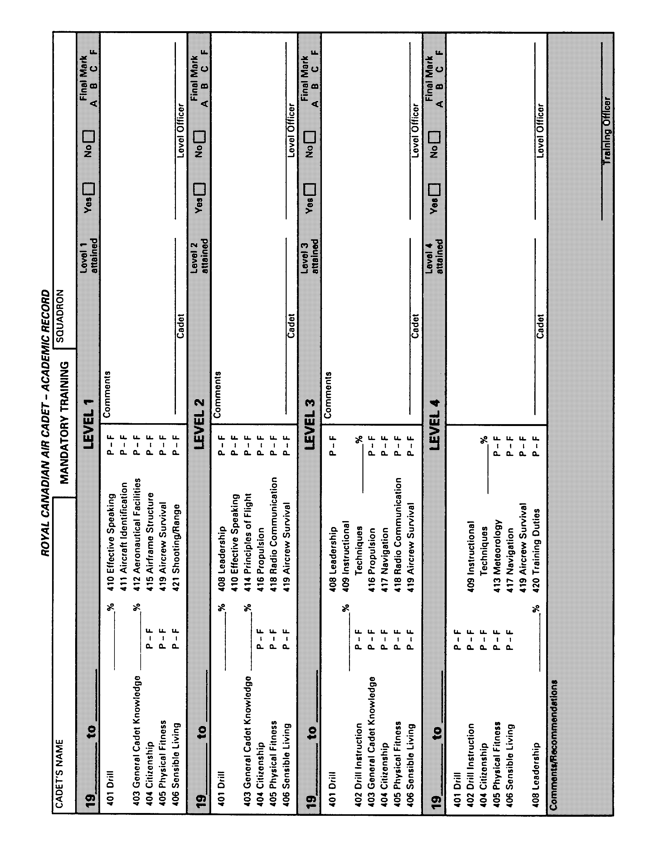

CHAPTER 4: LESSON SPECIFICATIONS PO
COURSE TITLE: LEVEL TWO TRAINING SUMMARY

CTS: A-CR-CCP-265/PC-001
401 DRILL
PERFORMANCE – Execute foot drill at the halt and on the march.

A. CTP TRAINING

EO | PERFORMANCE STATEMENTS | NUMBER OF PERIODS
01  02  03  04  05  06  07  08  09  10 | Execute foot drill movements at the halt and on the march (Review/Practise).  Execute sizing in one, two and three ranks.  Execute left (right) turns and left (right) inclines on the march in quick time.  Execute the about turn on the march in quick time.  Execute foot drill on the march (Review/Practise).  Execute marching and halting in double time, changing from double time to quick time and changing from quick time to double time.  Execute foot drill movements on the march (Review/Practise).  Execute the change step on the march in quick time.  Execute the movements required for closing to the left or right.  Execute foot drill movements at the halt and on the march.  Testing | 2  1  1  1  1  1  1  1  1  3  3
TOTAL 16

B. MANDATORY SUPPORT TRAINING

CTS: A-CR-CCP-265/PC-001
STANDARD – The cadet must take part in the squadron's annual inspection.
CHAPTER 4: LESSON SPECIFICATIONS

COURSE TITLE: LEVEL TWO CTS NUMBER: A-CR-CCP-265/PC-001
EO AND TEACHING POINTS | TRAINING DETAILS
DRILL: 401.01 | 5. TIME – Two 35-minute periods.
1. PERFORMANCE – Execute foot drill movements at the halt and on the march.  2. CONDITIONS:  a. Given – words of command; and  b. Denied – assistance.  3. STANDARD – The cadet will execute the following drill movements in accordance with references:  a. formation of a squad;  b. position of attention;  c. position of stand-at-ease;  d. stand easy;  e. stand-at-ease from attention;  f. attention from stand-at-ease;  g. stand easy from stand-at-ease;  h. open and close order march;  j. paces forward and to the rear;  k. left (right) and about turns at the halt;  m. marching, halting in quick time;  n. wheeling;  p. stepping out and stepping short; | 6. METHOD/APPROACH:  a. Review;  b. Practise/repeat; and  c. Individual correction.
7. SUBSTANTIATION:

a. Drill teaches air cadets obedience, steadiness and self-reliance, makes them alert and gives them a smart bearing. Well taught and executed drill develops the individual pride and esprit de corps necessary for the foundation of successful training.

b. Squad formations are essential to maintain control and ensure uniformity throughout training.
8. REFERENCES:

a. A-PD-201-000/PT-000, Canadian Forces Manual of Drill and Ceremonial; and

b. Level Two Handbook.
 | 9. TRAINING AIDS – NA. | 10. LEARNING AIDS – NA.
 | 11. TEST DETAILS – NA.
12. REMARKS:

a. These two lessons are designed to review all movements taught in Proficiency Level One.

b. Be sure to correct basic skills.

CHAPTER 4: LESSON SPECIFICATIONS

COURSE TITLE: LEVEL TWO CTS NUMBER: A-CR-CCP-265/PC-001
DRILL: 401.01 (cont)
q. mark time, forward and halt in quick time;

r. saluting with the hand at the halt;

s. saluting with the hand on the march; and

t. paying compliments with the squad on the march.

4. TEACHING POINTS – Review explanations of movements if necessary.

CHAPTER 4: LESSON SPECIFICATIONS

COURSE TITLE: LEVEL TWO CTS NUMBER: A-CR-CCP-265/PC-001
EO AND TEACHING POINTS | TRAINING DETAILS
DRILL: 401.02 | 5. TIME – One 35-minute period.
1. PERFORMANCE – Execute sizing in one, two and three ranks.  2. CONDITIONS:  a. Given – words of command; and  b. Denied – assistance.  3. STANDARD – The cadet will:  a. Execute sizing in single rank in accordance with references by:  (1) executing a right turn;  (2) observing the standard pause;  (3) sizing in relation to others in the squad, at shoulder to shoulder dressing;  (4) numbering;  (5) stepping one pace forward if an odd number, or stepping one pace backward if an even number;  (6) executing a right turn if an odd number or a left turn if an even number; and  (7) stepping off in quick time, reforming threes and assuming the new position.  b. Execute sizing in three ranks in accordance with references by:  (1) executing a right turn; | 6. METHOD/APPROACH:  a. Demonstrate/explain/execute/repeat; and  b. Individual correction.
 | 7. SUBSTANTIATION – Sizing is executed to make the squad look more uniform and to allot designated positions in the squad.
8. REFERENCES:

a. A-PD-201-000/PT-000, Canadian Forces Manual of Drill and Ceremonial, Articles 227, 229 and 230; and

b. Level Two Handbook.
 | 9. TRAINING AIDS – Assistant instructor. | 10. LEARNING AIDS – Diagram of movements.
 | 11. TEST DETAILS – Each cadet will be checked independently and will be required to execute a drill movement as ordered.
12. REMARKS:

a. Sizing in two ranks does not have to be taught unless the squad regularly forms up in two ranks. Otherwise, mention to the cadets that it is an option available in sizing a squad.

b. Be sure to check the details in the reference for this lesson.

CHAPTER 4: LESSON SPECIFICATIONS

COURSE TITLE: LEVEL TWO CTS NUMBER: A-CR-CCP-265/PC-001
DRILL: 401.02 (cont)
(2) observing the standard pause;

(3) sizing in relation to others in the squad;

(4) executing an open order march;

(5) numbering;

(6) taking a step backward if an even number;

(7) executing a right turn if an odd number, or a left turn if an even number; and

(8) stepping off in quick time and reforming threes, assuming the new position.

4. TEACHING POINTS – When sizing in a single rank, to reform in three ranks:

a. number one remains the right-hand person of the front rank;

b. number three becomes the right-hand person of the centre rank; and

c. number five becomes the right-hand person of the rear rank.

CHAPTER 4: LESSON SPECIFICATIONS

COURSE TITLE: LEVEL TWO CTS NUMBER: A-CR-CCP-265/PC-001
EO AND TEACHING POINTS | TRAINING DETAILS
DRILL: 401.03 | 5. TIME – One 35-minute period.
1. PERFORMANCE – Execute left (right) turns and left (right) inclines on the march.  2. CONDITIONS:  a. Given – words of command; and  b. Denied – assistance.  3. STANDARD – The cadet will:  a. Execute a left turn on the march in accordance with references by:  (1) bending the right knee and turning 90 degrees to the left;  (2) pivoting on the left foot;  (3) keeping the body steady;  (4) taking a 15-inch check pace; and  (5) continuing to march in quick time.  b. Execute a right turn on the march in accordance with references by:  (1) bending the left knee and turning 90 degrees to the right;  (2) pivoting on the right foot and the heel of the left foot;  (3) keeping the body steady;  (4) taking a 15-inch check pace; and | 6. METHOD/APPROACH:  a. Demonstrate/explain/execute/repeat; and  b. Individual correction.
 | 7. SUBSTANTIATION – Turns on the march are executed to change direction on the march.
8. REFERENCES:

a. A-PD-201-000/PT-000, Canadian Forces Manual of Drill and Ceremonial, Article 314; and

b. Level Two Handbook.
 | 9. TRAINING AIDS – Assistant instructor. | 10. LEARNING AIDS – NA.
 | 11. TEST DETAILS – Each cadet will be checked independently and will be required to execute a drill movement as ordered.
12. REMARKS:

a. Stress basic skills, posture, etc.

b. Movements should be taught by numbers.

CHAPTER 4: LESSON SPECIFICATIONS

COURSE TITLE: LEVEL TWO CTS NUMBER: A-CR-CCP-265/PC-001
DRILL: 401.03 (cont)
(5) continuing to march in quick time.

4. TEACHING POINTS:

a. The incline is executed using the same movements.

b. Cadence for turns is the same as that for quick time – 120 paces per minute.

c. See standard for the exact steps involved in this movement.

CHAPTER 4: LESSON SPECIFICATIONS

COURSE TITLE: LEVEL TWO CTS NUMBER: A-CR-CCP-265/PC-001
EO AND TEACHING POINTS | TRAINING DETAILS
DRILL: 401.04 | 5. TIME – One 35-minute period.
1. PERFORMANCE – Execute the about turn on the march in quick time.  2. CONDITIONS:  a. Given – words of command; and  b. Denied – assistance.  3. STANDARD – The cadet will execute an about turn on the march in accordance with references by:  a. taking a 15-inch check pace;  b. pivoting on the sole of the right foot to turn 90 degrees to the right;  c. pivoting on the sole of the right foot again to turn 90 degrees to the right;  d. keeping arms at the sides as for the position of attention; and  e. stepping off in quick time with the left foot, swinging the arms.  4. TEACHING POINTS:  a. Timing is essential.  b. When a blank file of one cadet exists in a squad, the blank file cadet shall commence to step short on the cautionary word of command, "RETIRE", and execute the about turn with the new leading rank on the executive word, "TURN". | 6. METHOD/APPROACH:  a. Demonstrate/explain/execute/repeat; and  b. Individual correction.
 | 7. SUBSTANTIATION – Turns are executed to change direction on the march.
8. REFERENCES:

a. A-PD-201-000/PT-000, Canadian Forces Manual of Drill and Ceremonial, Article 316; and

b. Level Two Handbook.

 | 9. TRAINING AIDS – NA. | 10. LEARNING AIDS – NA.
 | 11. TEST DETAILS – Each cadet will be checked independently and will be required to adopt a drill position as ordered.
12. REMARKS:

a. Stress basic skills, posture, etc.

b. Movement should be taught by numbers.

CHAPTER 4: LESSON SPECIFICATIONS

COURSE TITLE: LEVEL TWO CTS NUMBER: A-CR-CCP-265/PC-001
EO AND TEACHING POINTS | TRAINING DETAILS
DRILL: 401.05 | 5. TIME – One 35-minute period.
1. PERFORMANCE – Execute foot drill on the march.  2. CONDITIONS:  a. Given – words of command; and  b. Denied – assistance.  3. STANDARD – The cadet will execute the following drill movements in accordance with references:  a. sizing in one, two and three ranks;  b. left (right) turns and left (right) inclines on the march; and  c. about turns on the march.  4. TEACHING POINTS – Review explanations of movements if necessary. | 6. METHOD/APPROACH:  a. Review;  b. Practise/repeat; and  c. Individual correction.
 | 7. SUBSTANTIATION – NA.
8. REFERENCES:

a. A-PD-201-000/PT-000, Canadian Forces Manual of Drill and Ceremonial, Articles 227, 229, 230, 314 and 316; and

b. Level Two Handbook.

 | 9. TRAINING AIDS – NA. | 10. LEARNING AIDS – NA.
 | 11. TEST DETAILS – NA.
12. REMARKS:

a. This lesson is designed to review all movements taught in 401.01 to 401.04.

b. Be sure to correct all errors in basic skills.

CHAPTER 4: LESSON SPECIFICATIONS

COURSE TITLE: LEVEL TWO CTS NUMBER: A-CR-CCP-265/PC-001
EO AND TEACHING POINTS | TRAINING DETAILS
DRILL: 401.06 | 5. TIME – One 35-minute period.
1. PERFORMANCE – Execute the following drill movements:  a. marching and halting in double time;  b. changing from double time to quick time; and  c. changing from quick time to double time.  2. CONDITIONS:  a. Given – words of command; and  b. Denied – assistance.  3. STANDARD – The cadet will execute the drill movements required for marching in double time in accordance with references by:  a. stepping off on the balls of the feet with easy swinging strides;  b. inclining the body slightly forward;  c. bending the arms at the elbows;  d. keeping the hands closed;  e. maintaining dressing by the directing flank;  f. halting when the left foot is forward and on the ground and completing two check paces before assuming the position of attention;  g. changing to quick time by:  (1) shortening the pace to 30-inches, and | 6. METHOD/APPROACH:  a. Demonstrate/explain/execute/repeat; and  b. Individual correction.
 | 7. SUBSTANTIATION – Double time is normally executed when in sports or survival gear. It provides a faster means of arriving at a designated area and promotes physical fitness.
8. REFERENCES:

a. A-PD-201-000/PT-000, Canadian Forces Manual of Drill and Ceremonial, Articles 303, 318 and 319; and

b. Level Two Handbook.

 | 9. TRAINING AIDS – Assistant instructor. | 10. LEARNING AIDS – NA.
 | 11. TEST DETAILS – Each cadet will be checked independently and will be required to execute a drill movement as ordered.
 | 12. REMARKS – NA.

CHAPTER 4: LESSON SPECIFICATIONS

COURSE TITLE: LEVEL TWO CTS NUMBER: A-CR-CCP-265/PC-001
DRILL: 401.06 (cont)
(2) completing four more paces in double time and then breaking into quick time; and

h. changing back into double time by stepping off in double time with the left foot when the command is given.

4. TEACHING POINTS:

a. It is normal to change to quick time before ordering the halt from double time.

b. Dressing is very important. It is usually difficult for cadets to maintain dressing in double time. Stress that double time is generally used wearing sports gear. However, a knowledge of it is important.

CHAPTER 4: LESSON SPECIFICATIONS

COURSE TITLE: LEVEL TWO CTS NUMBER: A-CR-CCP-265/PC-001
EO AND TEACHING POINTS | TRAINING DETAILS
DRILL: 401.07 | 5. TIME – One 35-minute period.
1. PERFORMANCE – Execute foot drill movements on the march.  2. CONDITIONS:  a. Given – words of command; and  b. Denied – assistance.  3. STANDARD – The cadet will execute the following drill movements in accordance with references:  a. sizing in one, two and three ranks;  b. left (right) turns and left (right) inclines on the march;  c. about turns on the march;  d. marching and halting in double time; and  e. changing to (from) double time from (to) quick time.  4. TEACHING POINTS – Review explanation of movements if necessary. | 6. METHOD/APPROACH:  a. Review;  b. Practise/repeat; and  c. Individual correction.
 | 7. SUBSTANTIATION – NA.
8. REFERENCES:

a. A-PD-201-000/PT-000, Canadian Forces Manual of Drill and Ceremonial, Articles 227, 229, 230, 303, 314, 316, 318 and 319; and

b. Level Two Handbook.

 | 9. TRAINING AIDS – NA. | 10. LEARNING AIDS – NA.
 | 11. TEST DETAILS – NA.
12. REMARKS:

a. This lesson is designed to review all movements taught in 401.01 to 401.07;

b. Be sure to correct all errors in basic skills.

CHAPTER 4: LESSON SPECIFICATIONS

COURSE TITLE: LEVELTWO CTS NUMBER: A-CR-CCP-265/PC-001
EO AND TEACHING POINTS | TRAINING DETAILS
DRILL: 401.08 | 5. TIME – One 35-minute period.
1. PERFORMANCE – Execute the change step on the march in quick time.  2. CONDITIONS:  a. Given – words of command; and  b. Denied – assistance.  3. STANDARD – The cadet will execute the change step on the march in quick time in accordance with references by:  a. completing a 15-inch check pace;  b. forcing the weight forward on the left foot;  c. bending the right knee in double time and placing it smartly beside the left foot;  d. cutting the arms to the sides; and  e. shooting the left foot forward in a 15-inch check place as the right foot hits the ground.  4. TEACHING POINTS – The timing is counted as left, right, left in double time. | 6. METHOD/APPROACH:  a. Demonstrate/explain/execute/repeat; and  b. Individual correction.
 | 7. SUBSTANTIATION – The change step is executed when someone is out of step with the squad. It ensure uniformity of step.
8. REFERENCES:

a. A-PD-201-000/PT-000, Canadian Forces Manual of Drill and Ceremonial, Article 308; and

b. Level Two Handbook.

 | 9. TRAINING AIDS – Assistant instructors. | 10. LEARNING AIDS – NA.
 | 11. TEST DETAILS – Each cadet will be checked independently and required to execute a drill movement as ordered.
12. REMARKS:

a. This class should be taught by numbers.

b. As many assistant instructors as possible should be used because cadets usually find this movement difficult to execute.

CHAPTER 4: LESSON SPECIFICATIONS

COURSE TITLE: LEVEL TWO CTS NUMBER: A-CR-CCP-265/PC-001
EO AND TEACHING POINTS | TRAINING DETAILS
DRILL: 401.09 | 5. TIME – One 35-minute period.
1. PERFORMANCE – Execute the movements required for closing to the left or right.  2. CONDITIONS:  a. Given – words of commands; and  b. Denied – assistance.  3. STANDARD – The cadet will execute closing to the left or right in accordance with references by:  a. bending the left (right) knee and carrying the foot to the left (right) and placing it smartly on the ground with the insides of the heels 10 inches apart;  b. keeping arms at the sides;  c. balancing the weight of the body; and  d. bending the knee of the other leg and carrying the foot to the left (right) and placing it smartly by the foot that moved first.  4. TEACHING POINTS – Paces left (right close march shall not be ordered when the distance required to move exceeds eight paces. When the distance is greater, the squad shall be turned and marched the required distance. | 6. METHOD/APPROACH:  a. Demonstration/explain/execute/repeat; and  b. Individual correction.
 | 7. SUBSTANTIATION – Closing to the left or right is executed to move a squad a distance no greater than eight paces.
8. REFERENCES:

a. A-PD-201-000/PT-000, Canadian Forces Manual of Drill and Ceremonial; Article 215; and

b. Level Two Handbook.
 | 9. TRAINING AIDS – Assistant Instructor. | 10. LEARNING AIDS – NA.
 | 11. TEST DETAILS – Each cadet will be checked independently and required to execute a drill movement as ordered.
 | 12. REMARKS – Check basic skills.

CHAPTER 4: LESSON SPECIFICATIONS

COURSE TITLE: LEVEL TWO CTS NUMBER: A-CR-CCP-265/PC-001
EO AND TEACHING POINTS | TRAINING DETAILS
DRILL: 401.10 | 5. TIME – Three 35-minute periods.
1. PERFORMANCE – Execute foot drill movements at the halt and on the march.  2. CONDITIONS:  a. Given – words of command and;  b. Denied – assistance.  3. STANDARD – The cadet will execute the following drill movements in accordance with references:  a. sizing in one, two and three ranks;  b. closing to the left or right;  c. left (right) turns and inclines on the march;  d. about turn on the march;  e. changing step on the march in quick time;  f. marching, halting in double time; and  g. changing to (from) double time from (to) quick time.  4. TEACHING POINTS – Review explanations of movements if necessary. | 6. METHOD/APPROACH:  a. Review;  b. Practise/repeat; and  c. Individual correction.
 | 7. SUBSTANTIATION – NA.
8. REFERENCES:

a. A-PD-201-000/PT-000, Canadian Forces Manual of Drill and Ceremonial, Articles 215, 227, 229, 230, 303, 308, 314, 316, 318 and 319; and

b. Level Two Handbook.

 | 9. TRAINING AIDS – NA. | 10. LEARNING AIDS – NA.
 | 11. TEST DETAILS – NA.
12. REMARKS:

a. This lesson is designed as a review of movements taught in 401.01 to 401.10; and

b. Be sure to correct errors in basic skills.

PO 402

(Not allocated)

CHAPTER 4: LESSON SPECIFICATIONS PO
COURSE TITLE: LEVEL TWO TRAINING SUMMARY

CTS: A-CR-CCP-265/PC-001
403 GENERAL CADET KNOWLEDGE
PERFORMANCE – Demonstrate pride in and loyalty to the squadron and the Royal Canadian Air Cadets.

CTP TRAINING

EO | PERFORMANCE STATEMENTS | NUMBER OF PERIODS
01  02  03  04  05  06 | Discuss the requirements for Proficiency Level Two.  Discuss the cadet responsibilities of the Department of National Defence (DND) and the Air Cadet League.  Identify the rank insignia of the Royal Canadian Sea Cadets.  Identify the rank insignia of the Royal Canadian Army Cadets.  Discuss the summer training options available through Air cadets.  Participate in a trivia game about Canadian aviation history. | 1  1  1  1  1  5
TOTAL 10

CHAPTER 4: LESSON SPECIFICATIONS

COURSE TITLE: LEVEL TWO CTS NUMBER: A-CR-CCP-265/PC-001
EO AND TEACHING POINTS | TRAINING DETAILS
GENERAL CADET KNOWLEDGE: 403.01 | 5. TIME – One 35-minute period.
1. PERFORMANCE – Discuss the requirements for Proficiency Level Two.  2. CONDITIONS:  a. Given – an outline of courses; and  b. Denied – NA.  3. STANDARD – The cadet will discuss the requirements for Proficiency Level Two by:  a. identifying the courses that must be completed; and  b. identifying the eligibility requirements for summer camps upon completion of Level Two.  4. TEACHING POINTS:  a. Content of Level Two.  b. Recommendation for rank upon completion.  c. Optional activities throughout the year. | 6. METHOD/APPROACH – Lecture/discussion.
 | 7. SUBSTANTIATION – Cadets should know what training options are available so that they can plan a future in the organization.
 | 8. REFERENCES – Level Two Handbook.
 | 9. TRAINING AIDS – Level Two Handbook. | 10. LEARNING AIDS – NA.
 | 11. TEST DETAILS – NA.
12. REMARKS:

a. Give a brief introduction to the training options available in Level Three.

b. Encourage cadets to ask questions so they have a good understanding of the training year to come.

CHAPTER 4: LESSON SPECIFICATIONS

COURSE TITLE: LEVEL TWO CTS NUMBER: A-CR-CCP-265/PC-001
EO AND TEACHING POINTS | TRAINING DETAILS
GENERAL CADET KNOWLEDGE: 403.02 | 5. TIME – One 35-minute period.
1. PERFORMANCE – Discuss the cadet responsibilities of:  a. DND; and  b. the Air Cadet League of Canada.  2. CONDITIONS:  a. Given – NA;  b. Denied – NA.  3. STANDARD – The cadet will:  a. discuss the role of the DND in the Air Cadet organization;  b. identify the Director of Cadets;  c. discuss the role of the National Air Cadet League of Canada;  d. discuss the role of the provincial branch of the Air Cadet League;  e. discuss the role of the local branch of the Air Cadet League; and  f. identify the president of the national, provincial and local branches of the Air Cadet League. | 6. METHOD/APPROACH – Lecture/discussions.
 | 7. SUBSTANTIATION – Knowledge of DND and the Air Cadet League helps the cadet understand more about the organization.
8. REFERENCES:

a. Level Two Handbook; and

b. Air Cadet League Handbook.

 | 9. TRAINING AIDS – A chart of the channels of communication between the Air Cadet League and DND. | 10. LEARNING AIDS – A handout.
 | 11. TEST DETAILS – The cadet will respond to questioning on the subject matter. A trivia game is sufficient to test this material.
12. REMARKS:

a. This class is designed to be informative. A lot of detail is not necessary.

b. Encourage discussion.

CHAPTER 4: LESSON SPECIFICATIONS

COURSE TITLE: LEVEL TWO CTS NUMBER: A-CR-CCP-265/PC-001
GENERAL CADET KNOWLEDGE: 403.03 (cont)
4. TEACHING POINTS:

a. Responsibilities of DND:

(1) supply items (ie, uniforms);

(2) transportation as authorized;

(3) facilities for summer camps; and

(4) officers for Annual Inspections.

b. Responsibilities of National Air Cadet League:

(1) working with DND on Air Cadet issues;

(2) providing and supervising local sponsors;

(3) providing training accommodations not provided by DND; and

(4) arranging some recreational programs.

c. The provincial level supervises the activities of all Air Cadet units in their respective areas.

d. Responsibilities of the local level:

(1) forms the backbone of the league;

(2) finances squadrons;

(3) ensures squadrons are properly managed;

(4) ensures squadrons have a meeting place;

(5) assists in fund raising; and

CHAPTER 4: LESSON SPECIFICATIONS

COURSE TITLE: LEVEL TWO CTS NUMBER: A-CR-CCP-265/PC-001
GENERAL CADET KNOWLEDGE: 403.02 (cont)
(6) identifies examples of community groups such as:

(a) Rotary Clubs,

(b) Lions,

(c) Air Force Association,

(d) Legions, and

(e) Kiwanis.

CHAPTER 4: LESSON SPECIFICATIONS

COURSE TITLE: LEVEL TWO CTS NUMBER: A-CR-CCP-265/PC-001
EO AND TEACHING POINTS | TRAINING DETAILS
GENERAL CADET KNOWLEDGE: 403.03 | 5. TIME – One 35-minute period.
1. PERFORMANCE – Identify the rank insignia of the Royal Canadian Sea Cadets.  2. CONDITIONS:  a. Given – rank badges of the sea cadets; and  b. Denied – NA.  3. STANDARD – The cadet will correctly identify the rank structure of the Royal Canadian Sea Cadets.  4. TEACHING POINTS:  a. Able Cadet;  b. Leading Cadet;  c. Cadet Qualified Petty Officer Second Class;  d. Cadet Petty Officer Second Class;  e. Cadet Qualified Petty Officer First Class;  f. Cadet Petty Officer First Class;  g. Cadet Chief Petty Officer Second Class; and  h. Cadet Chief Petty Officer First Class. | 6. METHOD/APPROACH – Lecture/demonstration/discussion.
 | 7. SUBSTANTIATION – Cadets will be attending tri-service functions and should be able to identify sea and army cadet ranks. This is a measure of respect and reflects well on air cadets.
8. REFERENCES:

a. Level Two Handbook; and

b. A-CR-CCP-990/PT-001, Dress Regulations for Royal Canadian Sea, Army and Air Cadets.

 | 9. TRAINING AIDS – Rank badges of the Royal Canadian Sea Cadets. | 10. LEARNING AIDS – Rank badges of the Royal Canadian Sea Cadets.
 | 11. TEST DETAILS – Each cadet should be capable of identifying the ranks of Royal Canadian Sea Cadets.
 | 12. REMARKS – If possible, invite a neighbouring member of a sea cadet corps to instruct this class. It will make the class more interesting for the cadets.

CHAPTER 4: LESSON SPECIFICATIONS

COURSE TITLE: LEVEL TWO CTS NUMBER: A-CR-CCP-265/PC-001
EO AND TEACHING POINTS | TRAINING DETAILS
GENERAL CADET KNOWLEDGE: 403.04 | 5. TIME – One 35-minute period.
1. PERFORMANCE – Identify the rank insignia of the Royal Canadian Army Cadets.  2. CONDITIONS:  a. Given – rank badges of the Army Cadets; and  b. Denied – NA.  3. STANDARD – The cadet will correctly identify the rank structure of the Royal Canadian Army Cadets.  4. TEACHING POINTS:  a. Lance Corporal;  b. Corporal;  c. Master Corporal;  d. Sergeant;  e. Warrant Officer;  f. Master Warrant Officer; and  g. Chief Warrant Officer. | 6. METHOD/APPROACH – Lecture/demonstration/discussion.
 | 7. SUBSTANTIATION – Cadets will be attending tri-service functions and should be able to identify sea and army cadet ranks. This is a measure of respect and reflects well on air cadets.
8. REFERENCES:

a. Level Two Handbook; and

b. A-CR-CCP-990/PT-001, Dress Regulations for Royal Canadian Sea, Army and Air Cadets.

 | 9. TRAINING AIDS – Rank badges of the Royal Canadian Army Cadets. | 10. LEARNING AIDS – Rank badges of the Royal Canadian Army Cadets.
 | 11. TEST DETAILS – Each cadet should be capable of visually identifying the ranks of the Royal Canadian Army Cadets.
 | 12. REMARKS – If possible, invite a neighbouring member of an army cadet corps to instruct this class.

CHAPTER 4: LESSON SPECIFICATIONS

COURSE TITLE: LEVEL TWO CTS NUMBER: A-CR-CCP-265/PC-001
EO AND TEACHING POINTS | TRAINING DETAILS
GENERAL CADET KNOWLEDGE: 403.05 | 5. TIME – One 35-minute period.
1. PERFORMANCE – Discuss the summer training options available through the Air Cadets.  2. CONDITIONS:  a. Given – NA.  b. Denied – NA.  3. STANDARD – The cadet will discuss the summer training options available through the Air Cadets by:  a. identifying the eligibility requirements for summer camps upon completion of Level Two; and  b. identifying the eligibility requirements for summer camps upon completion of Level Three and above.  4. TEACHING POINTS:  a. Identify the summer camps available.  b. Identify the aims of summer camp courses.  c. Talk about what to expect at summer camp, such as routine, staffing and activities.  d. List the items to be brought to camp. | 6. METHOD/APPROACH:  a. Lecture; and  b. Discussion.
 | 7. SUBSTANTIATION – Cadets should know what camp options are available to them so that they can plan to attend.
 | 8. REFERENCES – Level Two Handbook.
 | 9. TRAINING AIDS – NA. | 10. LEARNING AIDS:  a. Information on summer camps; and  b. List of items to be brought to camp.
 | 11. TEST DETAILS – Cadets will be required to respond orally to questioning on the subject matter.
 | 12. REMARKS – Conduct the class as a discussion session during which cadets will be informed of camp requirements.

CHAPTER 4: LESSON SPECIFICATIONS

COURSE TITLE: LEVEL TWO CTS NUMBER: A-CR-CCP-265/PC-001
EO AND TEACHING POINTS | TRAINING DETAILS
GENERAL CADET KNOWLEDGE: 403.06 | 5. TIME – Five periods of 35 minutes.
1. PERFORMANCE – Participate in a trivia game about Canadian aviation history.  2. CONDITIONS – Given:  a. Canadian aviation trivia game; and  b. Level Two Handbook chapter on aviation history.  3. STANDARD – The cadet must correctly answer three trivia questions during the course of the game.  4. TEACHING POINTS – All teaching points are found on the reverse side of the trivia cards. These facts are to be read aloud to the cadets as the game is played. | 6. METHOD/APPROACH – A-CR-CCP-267/PH-001, Trivia Game.
 | 7. SUBSTANTIATION – Cadets should have some knowledge of the origins of the cadet organization, the Royal Canadian Air Force, and contributions by Canadians in the field of aviation. Knowledge in this area stimulates an interest in aviation and develops pride in and loyalty to Royal Canadian Air Cadets.
 | 8. REFERENCES – Level Two Handbook.
 | 9. TRAINING AIDS – Aviation Trivia Game. | 10. LEARNING AIDS – Aviation Trivia Game.
 | 11. TEST DETAILS – The cadets must respond correctly to three questions. They can have as many chances as they wish.
12. REMARKS:

a. The instructor must have a good understanding of how the game operates and how best to divide the group into teams.

b. The instructor must be prepared to read the answer on the back of the card to the class so that it is informative and all participants learn aviation facts.

c. This is an excellent game to play on the bus while waiting for gliding/familiarization flights.

CHAPTER 4: LESSON SPECIFICATIONS PO
COURSE TITLE: LEVEL TWO TRAINING SUMMARY

CTS: A-CR-CCP-265/PC-001
404 CITIZENSHIP
PERFORMANCE – Participate in squadron activities within the community, province and country.

A. CTP TRAINING

EO | PERFORMANCE STATEMENTS | NUMBER OF PERIODS
01  02  03  04 | Describe the three types of government.  Describe the structure of the Canadian government.  Discuss the purposes of existing community groups.  Identify ways to preserve the environment. | 1  1  1  2
TOTAL 5

B. MANDATORY SUPPORT TRAINING

CTS: A-CR-CCP-265/PC-001

STANDARDS – The cadet will participate in squadron activities within the community, province and country by assisting with a minimum of two squadron-supported community activities. One of those two must be an activity related to preserving the environment.

CHAPTER 4: LESSON SPECIFICATIONS

COURSE TITLE: LEVEL TWO CTS NUMBER: A-CR-CCP-265/PC-001
EO AND TEACHING POINTS | TRAINING DETAILS
CITIZENSHIP: 404.01 | 5. TIME – One 35-minute period.
1. PERFORMANCE – Describe the three types of government.  2. CONDITIONS:  a. Given – NA; and  b. Denied – assistance.  3. STANDARD – The cadet will describe the three different types of government by responding to questions on:  a. the autocratic type of government;  b. the democratic form of government; and  c. the oligarchy.  4. TEACHING POINTS:  a. Autocratic Government. The following apply:  (1) direction is in the form of command; and  (2) the government is controlled by one government, usually an absolute monarchy or a dictatorship.  b. Democratic/Participatory. The following apply:  (1) country governed by the people who elect members to run the country;  (2) the leader employs the resources of the people; and  (3) two-way communication is predominant. | 6. METHOD/APPROACH:  a. Lecture; and  b. Discussion.
7. SUBSTANTIATION:

a. A knowledge of the different forms of government provides a better understanding of how the Canadian system works.

b. It promotes the attributes of good citizenship.
 | 8. REFERENCES – Level Two Handbook.
 | 9. TRAINING AIDS:  a. The Charter of Rights and Freedoms; and  b. Charts outlining the different approaches. | 10. LEARNING AIDS – Discussion.
 | 11. TEST DETAILS – Each cadet will be required to respond to questions on the subject matter.
 | 12. REMARKS – Do not go into a lot of detail on the subject matter.

CHAPTER 4: LESSON SPECIFICATIONS
COURSE TITLE: LEVEL TWO CTS NUMBER: A-CR-CCP-265/PC-001
CITIZENSHIP: 404.01 (cont)
c. Oligarchy. Power is in the hands of a few.

d. Canada is a democratic country. There is a Charter of Rights and Freedoms to ensure the following freedoms:

(1) freedom of speech;

(2) freedom of the press;

(3) freedom of assembly and association;

(4) freedom of religion;

(5) equality before the law; and

(6) the right to life, liberty, security and enjoyment of property.

CHAPTER 4: LESSON SPECIFICATIONS

COURSE TITLE: LEVEL TWO CTS NUMBER: A-CR-CCP-265/PC-001
EO AND TEACHING POINTS | TRAINING DETAILS
CITIZENSHIP: 404.02 | 5. TIME – One 35-minute period.
1. PERFORMANCE – Describe the structure of the Canadian Government.  2. CONDITIONS:  a. Given – NA; and  b. Denied – assistance.  3. STANDARD – The cadet will describe the structure of the Canadian Government by responding to questions on:  a. the Federal System. The following apply:  (1) provincial governments – 10 provinces, two territories; and  (2) federal government based in Ottawa, Ontario.  b. the three branches of the Federal Government and the Queen's representative:  (1) the Executive Branch;  (2) the Legislative Branch; and  (3) the Judicial Branch.  4. TEACHING POINTS:  a. The Provincial and Territorial Governments are responsible for:  (1) education;  (2) child welfare; | 6. METHOD/APPROACH:  a. Lecture; and  b. Discussions.
7. SUBSTANTIATION:

a. A knowledge of the different branches of the Canadian Government provides a better understanding of how the Canadian system works.

b. A good citizen supports the democratic process by becoming an active participant.

 | 8. REFERENCES – Level Two Handbook.
 | 9. TRAINING AIDS – A diagram of the structure and responsibilities. | 10. LEARNING AIDS:  a. Discussion; and  b. A handout on the structure of government.
 | 11. TEST DETAILS – Each cadet will be required to respond to questioning on the subject matter.
 | 12. REMARKS – Avoid too much detail.

CHAPTER 4: LESSON SPECIFICATIONS
COURSE TITLE: LEVEL TWO CTS NUMBER: A-CR-CCP-265/PC-001
CITIZENSHIP: 404.02 (cont)
(3) highways; and

(4) health care.

b. The Federal Government is responsible for:

(1) citizenship;

(2) foreign policy;

(3) postal services; and

(4) currency.

c. The Executive Branch of the Federal Government includes:

(1) the Prime Minister;

(2) the Cabinet; and

(3) the Public Service.

d. The Legislative Branch of the Federal Government is the law-making branch and consists of:

(1) the Senate; and

(2) the House of Commons.

e. The Judicial Branch of the Federal Government is the law enforcement branch, and consists of:

(1) the RCMP;

(2) provincial police forces;

CHAPTER 4: LESSON SPECIFICATIONS
COURSE TITLE: LEVEL TWO CTS NUMBER: A-CR-CCP-265/PC-001
CITIZENSHIP: 404.02 (cont)
(3) municipal police;

(4) the Supreme Court of Canada;

(5) provincial courts; and

(6) Magistrate Courts.

CHAPTER 4: LESSON SPECIFICATIONS

COURSE TITLE: LEVEL TWO CTS NUMBER: A-CR-CCP-265/PC-001
EO AND TEACHING POINTS | TRAINING DETAILS
CITIZENSHIP: 404.03 | 5. TIME – One 35-minute period.
1. PERFORMANCE – Discuss the purposes of existing community groups.  2. CONDITIONS:  a. Given – NA; and  b. Denied – assistance.  3. STANDARD – The cadet will discuss the progress of existing community groups by responding to questions on those groups that are present in the cadet's home town.  4. TEACHING POINTS – Community groups and their purpose:  a. Lions Club;  b. Rotary Club;  c. Kinsmen;  d. Royal Canadian Legion; and  e. Royal Canadian Air Force Association, etc. | 6. METHOD/APPROACH:  a. Lecture; and  b. Discussion.
7. SUBSTANTIATION:

a. A knowledge of existing community groups provides a knowledge of community services available.

b. A knowledge of such groups encourages cadets to support and become involved in their community.

 | 8. REFERENCES – Level Two Handbook.
 | 9. TRAINING AIDS:  a. Handouts on the different organizations; and  b. Their different uniforms. | 10. LEARNING AIDS – Discussion.
 | 11. TEST DETAILS – Each cadet will be required to respond to oral questions on the subject matter.
12. REMARKS:

a. It will be the instructor's responsibility to get information on existing community groups.

b. Indicate that many of these community groups support air cadet squadrons.

c. Use local examples and local references.

CHAPTER 4: LESSON SPECIFICATIONS

COURSE TITLE: LEVEL TWO CTS NUMBER: A-CR-CCP-265/PC-001
EO AND TEACHING POINTS | TRAINING DETAILS
CITIZENSHIP: 404.04 | 5. TIME – Two 35-minute periods.
1. PERFORMANCE – Identify ways to preserve the environment.  2. CONDITIONS:  a. Given – NA; and  b. Denied – assistance.  3. STANDARD – The cadet will correctly identify 10 ways to contribute to preserving the environment.  4. TEACHING POINTS:  a. Household items that can be recycled by the province/city/municipality:  (1) papers;  (2) glass;  (3) cans;  (4) cardboard;  (5) plastics; and  (6) bags.  b. How can recycling be organized at:  (1) cadets;  (2) home; and  (3) school. | 6. METHOD/APPROACH:  a. Lecture;  b. Discussion; and  c. Group activity.
 | 7. SUBSTANTIATION – Preserving the environment is a concern of every citizen. Cadets must be able to identify ways in which they can actively participate in recycling programmes and activities which help the environment.
 | 8. REFERENCES – Level Two Handbook.
 | 9. TRAINING AIDS – Local pamphlets on recycling. | 10. LEARNING AIDS – NA.
 | 11. TEST DETAILS – The cadet must identify (orally or in written form) 10 ways to contribute to saving the Earth. Specific local references to recycling should be included.
12. REMARKS:

a. The instructor should collect local information on recycling programmes.

b. The cadets should form groups and identify 50 ways to save the Earth. Each group could identify 10.

c. Local newspaper articles can reflect many environmental "hot spots" that may be used to illustrate the importance of our concern for the environment around us.

CHAPTER 4: LESSON SPECIFICATIONS
COURSE TITLE: LEVEL TWO CTS NUMBER: A-CR-CCP-265/PC-001
CITIZENSHIP: 404.04 (cont)
c. Fifty ways to save the Earth (group activity).

d. Encourage cadets to actively participate in preserving the environment.

CHAPTER 4: LESSON SPECIFICATIONS PO
COURSE TITLE: LEVEL TWO TRAINING SUMMARY

CTS: A-CR-CCP-265/PC-001
405 PHYSICAL FITNESS
PERFORMANCE – Participate in one team sports activity at the squadron and the ACFP.

A. CTP TRAINING

EO | PERFORMANCE STATEMENTS | NUMBER OF PERIODS
01 | Participate in a discussion on the cadet sports programme | 1

TOTAL 1

B. MANDATORY SUPPORT TRAINING

CTS: A-CR-CCP-265/PC-001

STANDARD – The cadet will participate in:

a. ACFP in accordance with specified references; and

b. a minimum of one team sports activity in the training year.

CHAPTER 4: LESSON SPECIFICATIONS

COURSE TITLE: LEVEL TWO CTS NUMBER: A-CR-CCP-265/PC-001
EO AND TEACHING POINTS | TRAINING DETAILS
PHYSICAL FITNESS: 405.01 | 5. TIME – One 35-minute period.
1. PERFORMANCE – Participate in a discussion on the cadet sports programme.  2. CONDITIONS:  a. Given:  (1) appropriate personal equipment and clothing; and  (2) equipment as required.  b. Denied – assistance.  3. STANDARD – The cadet will participate in a discussion on the cadet sports programme by discussing:  a. importance of fitness;  b. importance of stretching and how to lead stretching exercises;  c. the standards for the cadets sports programme; and  d. organizing team sports.  4. TEACHING POINTS:  a. Stretching techniques for:  (1) legs;  (2) arms;  (3) neck; and  (4) torso. | 6. METHOD/APPROACH – Cadet participation/discussion.
 | 7. SUBSTANTIATION – It is important for a cadet to participate in stretching exercises before sports events to reduce the risk of injury.
 | 8. REFERENCES – NA.
 | 9. TRAINING AIDS:  a. Demonstrations; and  b. Charts. | 10. LEARNING AIDS:  a. Sports events; and  b. Stretching exercises.
 | 11. TEST DETAILS – NA.
 | 12. REMARKS – Stress importance of stretching exercises.

CHAPTER 4: LESSON SPECIFICATIONS
COURSE TITLE: LEVEL TWO CTS NUMBER: A-CR-CCP-265/PC-001
PHYSICAL FITNESS: 405.01 (cont)
b. Importance of consuming water before participating in sports events.

c. Cool down.

d. Explain the standard – cadets must participate in one sports event, and they have a responsibility to encourage others to participate.

e. Explain what ACFP is and when it will be conducted.

CHAPTER 4: LESSON SPECIFICATIONS PO
COURSE TITLE: LEVEL TWO TRAINING SUMMARY

CTS: A-CR-CCP-265/PC-001
406 SENSIBLE LIVING
PERFORMANCE – Pursue a healthy and safe lifestyle.

CTP TRAINING SESSIONS

EO | PERFORMANCE STATEMENTS | NUMBER OF PERIODS
01 | Pursue a healthy and safe lifestyle (Guest Lecturers). | 3

TOTAL 3

CHAPTER 4: LESSON SPECIFICATIONS

COURSE TITLE: LEVEL TWO CTS NUMBER: A-CR-CCP-265/PC-001
EO AND TEACHING POINTS | TRAINING DETAILS
SENSIBLE LIVING: 406.01 | 5. TIME – Three 35-minute periods.
1. PERFORMANCE – Pursue a healthy and safe lifestyle.  2. CONDITIONS:  a. Given – a situation where cadets may apply knowledge; and  b. Denied – assistance.  3. STANDARD – The cadet will pursue a healthy and safe lifestyle by:  a. practising the principles of personal hygiene and nutrition;  b. observing the rules and regulations of fire prevention;  c. complying with cadet regulations on the use of drugs;  d. discussing the provisions of the young Protection Services; and  e. identifying the dangers of health by the illicit or indiscriminate use of drugs and the effects of smoking.  4. TEACHING POINTS:  a. principles of personal hygiene and nutrition;  b. rules and regulations of fire prevention and fire safety; and  c. cadet regulations on the use of drugs. | 6. METHOD/APPROACH – Guest lecturers.
 | 7. SUBSTANTIATION – It is important for cadets to know the principles of pursuing a healthy and safe lifestyle so that they can apply them.
 | 8. REFERENCES – As provided by guest lecturers.
 | 9. TRAINING AIDS – Guest lecturers. | 10. LEARNING AIDS:  a. Lecture; and  b. Handouts.
 | 11. TEST DETAILS – No test is administered.
12. REMARKS:

a. These classes should be conducted by guest lecturers.

b. If none are available then the class should be conducted by an officer.

c. The course is intended to be informational only, not moralistic.

d. Cover rules and regulations only. Do not tell the cadets how to live their lives.

PO 407

(Not allocated)

CHAPTER 4: LESSON SPECIFICATIONS PO
COURSE TITLE: LEVEL TWO TRAINING SUMMARY

CTS: A-CR-CCP-265/PC-001
408 LEADERSHIP
PERFORMANCE – Lead subordinates.

CTP TRAINING

EO | PERFORMANCE STATEMENTS | NUMBER OF PERIODS
01  02  03  04 | Identify the principles of leadership.  Identify the qualities of a leader.  Discuss the role of self-confidence, self-discipline and the leader.  Discuss the responsibilities and duties of a junior non-commissioned officer (NCO). | 2  1  1  2

TOTAL 6

CHAPTER 4: LESSON SPECIFICATIONS

COURSE TITLE: LEVEL TWO CTS NUMBER: A-CR-CCP-265/PC-001
EO AND TEACHING POINTS | TRAINING DETAILS
LEADERSHIP: 408.01 | 5. TIME – Two 35-minute classes.
1. PERFORMANCE – Discuss the principles of leadership.  2. CONDITIONS:  a. Given – NA; and  b. Denied – references.  3. STANDARD – Cadets will correctly identify 10 of the principles of leadership and explain how they can apply them when completing duties at the squadron.  4. TEACHING POINTS:  a. Review definitions of leadership; and  b. Principles of leadership –  (1) lead by setting a good personal example,  (2) know your cadets and look after their welfare,  (3) develop the qualities of leadership in your cadets,  (4) make sound and timely decisions,  (5) train your cadets to work as a team,  (6) communicate your ideas and thoughts clearly,  (7) keep your cadets informed of all events,  (8) take good personal initiatives, | 6. METHOD/APPROACH – Lecture/discussion.
 | 7. SUBSTANTIATION – Level Two cadets will be placed in positions of responsibility on occasion. Knowledge of the principles of leadership will help the cadets complete their duties.
 | 8. REFERENCES – Level Two Handbook.
 | 9. TRAINING AIDS – NA. | 10. LEARNING AIDS – NA.
 | 11. TEST DETAILS – Verbal confirmation. In EO 410.02 the cadet will be asked to deliver a one-minute impromptu speech on the information covered in PO 408. Topics are listed in EO 410.02.
12. REMARKS:

a. Relate all the principles of leadership to the cadet's experience. Give concrete examples.

b. Instructors are reminded to stress the most important principle: head by example.

CHAPTER 4: LESSON SPECIFICATIONS
COURSE TITLE: LEVEL TWO CTS NUMBER: A-CR-CCP-265/PC-001
LEADERSHIP: 408.01 (cont)
(9) know what your strengths and weaknesses are and improve yourself, and

(10) treat your cadets as you would like to be treated yourself.

CHAPTER 4: LESSON SPECIFICATIONS

COURSE TITLE: LEVEL TWO CTS NUMBER: A-CR-CCP-265/PC-001
EO AND TEACHING POINTS | TRAINING DETAILS
LEADERSHIP: 408.02 | 5. TIME – One 35-minute period.
1. PERFORMANCE – Discuss the qualities of a leader.  2. CONDITIONS:  a. Given – NA; and  b. Denied – references.  3. STANDARD – The cadet will discuss the qualities of a leader by correctly identifying all qualities and providing an example of how possessing those qualities will assist cadets in completing their tasks.  4. TEACHING POINTS:  a. Qualities. The following apply:  (1) honesty;  (2) sense of responsibility;  (3) confidence;  (4) enthusiasm;  (5) dependability;  (6) patience;  (7) decisiveness;  (8) determination;  (9) loyalty; and  (10) courage. | 6. METHOD/APPROACH – Lecture/discussion.
 | 7. SUBSTANTIATION – NA.
 | 8. REFERENCES – Level Two Handbook.
 | 9. TRAINING AIDS – NA. | 10. LEARNING AIDS – NA.
 | 11. TEST DETAILS – Verbal confirmation.
 | 12. REMARKS – Place the emphasis of instruction on the true qualities of a leader.

CHAPTER 4: LESSON SPECIFICATIONS
COURSE TITLE: LEVEL TWO CTS NUMBER: A-CR-CCP-265/PC-001
LEADERSHIP: 408.02 (cont)
b. Qualities that people mistakenly believe leaders must have:

(1) physical stature;

(2) toughness;

(3) a drinking habit;

(4) a tendency to make quick decisions;

(5) aloofness;

(6) genius;

(7) independence; and

(8) human qualities.

CHAPTER 4: LESSON SPECIFICATIONS

COURSE TITLE: LEVEL TWO CTS NUMBER: A-CR-CCP-265/PC-001
EO AND TEACHING POINTS | TRAINING DETAILS
LEADERSHIP: 408.03 | 5. TIME – One 35-minute period.
1. PERFORMANCE – Discuss the role of confidence in leadership.  2. CONDITIONS:  a. Given – NA; and  b. Denied – references.  3. STANDARD – The cadet will correctly identify what a leader should have confidence in.  4. TEACHING POINTS – Leaders must have confidence in:  a. aim  b. superiors;  c. associates;  d. subordinates; and  e. themselves. | 6. METHOD/APPROACH – Lecture/discussion.
 | 7. SUBSTANTIATION – Cadets must understand how essential confidence is to be an effective leader.
 | 8. REFERENCES – Level Two Handbook.
 | 9. TRAINING AIDS – NA. | 10. LEARNING AIDS – NA.
 | 11. TEST DETAILS – NA.
 | 12. REMARKS – NA.

CHAPTER 4: LESSON SPECIFICATIONS

COURSE TITLE: LEVEL TWO CTS NUMBER: A-CR-CCP-265/PC-001
EO AND TEACHING POINTS | TRAINING DETAILS
LEADERSHIP: 408.04 | 5. TIME – Two 35-minute periods.
1. PERFORMANCE – Discuss the duties and responsibilities of a junior NCO.  2. CONDITIONS:  a. Given – a situation where knowledge of the subject matter can be applied; and  b. Denied – assistance.  3. STANDARD – The cadet will participate in a discussion on the duties and responsibilities of a junior NCO by responding to questions on the following:  a. the difference between an officer's role and an NCO's;  b. the chain of command;  c. dress and deportment of an NCO;  d. approach to cadets (new recruits);  e. approach to senior NCOs; and  f. duty rosters.  4. TEACHING POINTS:  a. the officer/NCO relationship (as outlined in the Level Two Handbook);  b. identify the chain of command at the NCO level;  c. dress and deportment of NCOs – lead by example;  d. approach to cadets – FIRM, FAIR, FRIENDLY; | 6. METHOD/APPROACH – Guided discussion.
 | 7. SUBSTANTIATION – Level Two cadets will assume some NCO duties. A discussion about those duties and responsibilities will help cadets know how to approach their tasks.
 | 8. REFERENCES – Level Two Handbook.
 | 9. TRAINING AIDS – NA. | 10. LEARNING AIDS – NA.
 | 11. TEST DETAILS – Cadets will be checked independently to ensure they are carrying out duties as assigned.
12. REMARKS:

a. These classes should be conducted as discussions.

b. Duties for junior NCOs will vary by squadron.

c. Use this opportunity to explain this to the cadets.

d. Encourage the cadets to use the self-evaluation forms at the end of the leadership chapter of the handbook.

e. Stress the equal importance of each part of Firm, Fair and Friendly.

CHAPTER 4: LESSON SPECIFICATIONS
COURSE TITLE: LEVEL TWO CTS NUMBER: A-CR-CCP-265/PC-001
LEADERSHIP: 408.04 (cont)
e. approach to senior cadets – respectful even if you don't agree; and

f. identify duties of the duty NCOs and where duty schedule is posted.

PO 409

(Not allocated)

CHAPTER 4: LESSON SPECIFICATIONS PO
COURSE TITLE: LEVEL TWO TRAINING SUMMARY

CTS: A-CR-CCP-265/PC-001
410 EFFECTIVE SPEAKING
PERFORMANCE – Deliver speeches.

CTP TRAINING

EO | PERFORMANCE STATEMENTS | NUMBER OF PERIODS
01  02  03  04  05 | Identify the guidelines for delivering an impromptu speech.  Deliver a one-minute impromptu speech.  Identify the characteristics that affect the human voice.  Prepare a three-minute speech.  Deliver a three-minute prepared speech. | 1  2  1  1  4

TOTAL 9

CHAPTER 4: LESSON SPECIFICATIONS

COURSE TITLE: LEVEL TWO CTS NUMBER: A-CR-CCP-265/PC-001
EO AND TEACHING POINTS | TRAINING DETAILS
EFFECTIVE SPEAKING: 410.01 | 5. TIME – One 35-minute period.
1. PERFORMANCE – Identify the guidelines for delivering an impromptu speech.  2. CONDITIONS:  a. Given – a topic; and  b. Denied – assistance and references.  3. STANDARD – The cadet will correctly identify the following guidelines for delivering an impromptu speech:  a. grasping first thought;  b. logically compiling the introduction, main ideas and body;  c. delivering an effective conclusion;  d. using reasoning and imagination; and  e. speaking clearly and displaying proper dress and deportment.  4. TEACHING POINTS:  a. the four guidelines for giving an impromptu speech:  (1) grasp first thought;  (2) compile introduction, main ideas and body;  (3) choose a conclusion; and  (4) use reasoning and imagination. | 6. METHOD/APPROACH – Lecture.
 | 7. SUBSTANTIATION – A knowledge of impromptu speaking guidelines ensures the effective communication of ideas, and develops the ability to respond to questioning clearly and coherently.
 | 8. REFERENCES – Level Two Handbook.
 | 9. TRAINING AIDS – NA. | 10. LEARNING AIDS – A one-minute impromptu speech.
11. TEST DETAILS:

a. Each cadet will be required to respond to questions on the subject matter.

b. A practical test will be conducted during the next class.

 | 12. REMARKS – Remind cadets that during the next class they will each have to deliver a one-minute impromptu speech on a given topic.

CHAPTER 4: LESSON SPECIFICATIONS
COURSE TITLE: LEVEL TWO CTS NUMBER: A-CR-CCP-265/PC-001
EFFECTIVE SPEAKING: 410.01 (cont)
b. The key is not to think too hard.

c. Deportment. The following apply:

(1) well pressed uniform;

(2) polished boots; and

(3) neat hair.

d. Voice techniques – mannerisms.

CHAPTER 4: LESSON SPECIFICATIONS

COURSE TITLE: LEVEL TWO CTS NUMBER: A-CR-CCP-265/PC-001
EO AND TEACHING POINTS | TRAINING DETAILS
EFFECTIVE SPEAKING: 410.02 | 5. TIME – Two 35-minute periods.
1. PERFORMANCE – Deliver a one-minute impromptu speech.  2. CONDITIONS:  a. Given – a topic; and  b. Denied – assistance and references.  3. STANDARD – The cadet will deliver a one-minute impromptu speech by:  a. ensuring effective communication of ideas;  b. grasping the first thought;  c. logically compiling introduction, ideas and body;  d. using reasoning and imagination; and  e. delivering an effective conclusion.  4. TEACHING POINTS – Contained within remarks. | 6. METHOD/APPROACH – Cadet speeches.
 | 7. SUBSTANTIATION – Delivering impromptu speeches helps develop logical thinking and effective communication techniques.
 | 8. REFERENCES – Level Two Handbook.
 | 9. TRAINING AIDS – NA. | 10. LEARNING AIDS – NA.
 | 11. TEST DETAILS – Each cadet will be required to deliver a one-minute impromptu speech on a topic supplied by the instructor. The topics cover material from POs 408, 410.01 and 410.02.
 | 12. REMARKS – The instructor must provide feedback to the cadets on their speech delivery.

CHAPTER 4: LESSON SPECIFICATIONS

COURSE TITLE: LEVEL TWO CTS NUMBER: A-CR-CCP-265/PC-001
EO AND TEACHING POINTS | TRAINING DETAILS
EFFECTIVE SPEAKING: 410.03 | 5. TIME – One 35-minute period.
1. PERFORMANCE – Identify the characteristics that affect the human voice.  2. CONDITIONS:  a. Given –NA; and  b. Denied – assistance.  3. STANDARD – The cadet will correctly identify the characteristics that affect the human voice.  4. TEACHING POINTS:  a. Characteristics of the human voice include the following:  (1) Tone. The overall impression of an uttered sound.  (2) Range. Vary the range of your words to avoid becoming monotone.  (3) Pitch. Keep your voice low to project it better.  (4) Volume. Vary it to create interest.  (5) Inflection. Stress main words or topics more so than other parts of the speech.  b. One of the best methods to analyze the voice is to use a tape recorder. This way you can quickly correct your errors. | 6. METHOD/APPROACH – Lecture.
 | 7. SUBSTANTIATION – A knowledge of what an instructor has to say will help cadets prepare speeches and develop effective communication techniques.
 | 8. REFERENCES – Level Two Handbook.
 | 9. TRAINING AIDS – NA. | 10. LEARNING AIDS – A speech.
11. TEST DETAILS:

a. Each cadet will be required to respond to questions on the subject matter.

b. Each cadet will be required to deliver a three-minute prepared speech during 410.05.

12. REMARKS:

a. Have the cadets submit their topics during the next class.

b. Cadets should practise using their voices, so they learn how their range, tone, pitch, etc, can vary.

CHAPTER 4: LESSON SPECIFICATIONS

COURSE TITLE: LEVEL TWO CTS NUMBER: A-CR-CCP-265/PC-001
EO AND TEACHING POINTS | TRAINING DETAILS
EFFECTIVE SPEAKING: 410.04 | 5. TIME – One 35-minute period.
1. PERFORMANCE – Prepare a three-minute speech.  2. CONDITIONS:  a. Given – NA; and  b. Denied – assistance.  3. STANDARD – The cadet will prepare a three-minute speech by correctly following the guidelines for preparing a speech.  4. TEACHING POINTS:  a. Select and limit the subject. It should relate to your own experiences or knowledge.  b. Determine the purpose of the speech:  (1) to entertain;  (2) to inform; and  (3) to persuade.  c. Analyse the members of the audience and the occasion. Know something about their social and educational levels.  d. Gather the data:  (1) list main points; and  (2) under these, list minor supporting ideas. | 6. METHOD/APPROACH – Lecture.
 | 7. SUBSTANTIATION – Knowing the guidelines for preparing a speech will help cadets effectively plan and present their topics.
 | 8. REFERENCES – Level Two Handbook.
 | 9. TRAINING AIDS – A chart outlining the logical progression of planning steps. | 10. LEARNING AIDS – A speech.
11. TEST DETAILS:

a. Each cadet will be required to respond to questions on the subject matter.

b. Each cadet will be required to present a three-minute prepared speech during 410.06 to 410.09.

 | 12. REMARKS – Each cadet should have a topic.

CHAPTER 4: LESSON SPECIFICATIONS
COURSE TITLE: LEVEL TWO CTS NUMBER: A-CR-CCP-265/PC-001
EFFECTIVE SPEAKING: 410.04 (cont)
e. Outline the material. This ensures unity and coherence. It is also a working guide.

f. Organize and develop the speech into the introduction, body and conclusion.

g. Plan the visual aids. These gain and hold interest as well as help clarify what you are saying.

h. Practise aloud. Rehearse in front of family or friends.

CHAPTER 4: LESSON SPECIFICATIONS

COURSE TITLE: LEVEL TWO CTS NUMBER: A-CR-CCP-265/PC-001
EO AND TEACHING POINTS | TRAINING DETAILS
EFFECTIVE SPEAKING: 410.05 | 5. TIME – Four 35-minute periods
1. PERFORMANCE – Deliver a three-minute prepared speech.  2. CONDITIONS:  a. Given:  (1) training aids as required; and  (2) references.  b. Denied – assistance.  3. STANDARD – The cadet will deliver a three-minute prepared speech ensuring effective communication of ideas by speaking clearly and displaying proper dress and deportment.  4. TEACHING POINTS – NA. | 6. METHOD/APPROACH – Cadet speeches.
 | 7. SUBSTANTIATION – NA.
 | 8. REFERENCES – Level Two Handbook.
 | 9. TRAINING AIDS – NA. | 10. LEARNING AIDS – NA.
 | 11. TEST DETAILS – Cadets will each be given a short assessment after their speeches.
 | 12. REMARKS – NA.

PO 411

(Not allocated)
PO 412

(Not allocated)
PO 413

(Not allocated)

CHAPTER 4: LESSON SPECIFICATIONS PO
COURSE TITLE: LEVEL TWO TRAINING SUMMARY

CTS: A-CR-CCP-265/PC-001
414 PRINCIPLES OF FLIGHT
PERFORMANCE – Discuss the principles that affect flight.

CTP TRAINING

EO | PERFORMANCE STATEMENTS | NUMBER OF PERIODS
01  02  03  04  05 | Identify the four forces that act on an aircraft in flight.  Explain the production of lift.  Explain types of drag.  Explain aircraft axis movement.  Explain aircraft control surfaces.  Testing | 1  1  1  1  1  1

TOTAL 6

CHAPTER 4: LESSON SPECIFICATIONS

COURSE TITLE: LEVEL TWO CTS NUMBER: A-CR-CCP-265/PC-001
EO AND TEACHING POINTS | TRAINING DETAILS
PRINCIPLES OF FLIGHT: 414.01 | 5. TIME – One 35-minute period.
1. PERFORMANCE – Identify the four forces that act on an aircraft in flight.  2. CONDITIONS:  a. Given:  (1) model; and  (2) diagrams.  b. Denied – NA.  3. STANDARD – The cadet will correctly identify the four forces that act on an aircraft in flight, including:  a. lift;  b. weight;  c. thrust; and  d. drag.  4. TEACHING POINTS:  a. Lift. Force that holds aircraft in air.  b. Weight:  (1) effect of gravity; and  (2) works through centre of gravity.  c. Thrust. Forward motion.  d. Drag. Caused by friction. | 6. METHOD/APPROACH – Lecture.
 | 7. SUBSTANTIATION – It is necessary to have a basic understanding of the four forces before focusing on any one of the forces.
8. REFERENCES:

a. Level Two Handbook; and

b. From the Ground Up.

 | 9. TRAINING AIDS – Model. | 10. LEARNING AIDS – Model.
 | 11. TEST DETAILS – The cadets will not be formally checked on this EO. Questions should be asked throughout the class.
 | 12. REMARKS – Lift and drag will be explained in further detail in subsequent EOs.

CHAPTER 4: LESSON SPECIFICATIONS

COURSE TITLE: LEVEL TWO CTS NUMBER: A-CR-CCP-265/PC-001
EO AND TEACHING POINTS | TRAINING DETAILS
PRINCIPLES OF FLIGHT: 414.02 | 5. TIME – One 35-minute period.
1. PERFORMANCE – Explain the production of lift.  2. CONDITIONS:  a. Given:  (1) diagrams; and  (2) model.  b. Denied – NA.  3. STANDARD – The cadet will correctly explain how lift is produced, indicating on a model or an acceptable diagram. Explanation to include:  a. air over top of wing faster speed than underneath;  b. difference in pressures creates lift.  4. TEACHING POINTS – Bernoulli Principle and lift:  a. Air is a fluid.  b. When the speed of a fluid is increased, the pressure is decreased (energy in a system remains the same).  c. Air over the top of the wing has increased speed and decreased pressure.  d. Air under the wing has relatively lower speed and relatively higher pressure. | 6. METHOD/APPROACH – Lecture.
 | 7. SUBSTANTIATION – Fear of flying is often a result of lacking an understanding of how an aircraft is held aloft. Often this fear can be overcome.
8. REFERENCES:

a. Level Two Handbook; and

b. From the Ground Up.

 | 9. TRAINING AIDS:  a. Model; and  b. diagram. | 10. LEARNING AIDS – Model.
 | 11. TEST DETAILS – The cadets will be checked individually and will be required to respond to oral questions.
12. REMARKS:

a. Complex physics should not be introduced.

b. The concept of the production of lift can be instructed at a basic level, while still allowing the cadets to have an understanding of how lift is produced.

CHAPTER 4: LESSON SPECIFICATIONS

COURSE TITLE: LEVEL TWO CTS NUMBER: A-CR-CCP-265/PC-001
EO AND TEACHING POINTS | TRAINING DETAILS
PRINCIPLES OF FLIGHT: 414.03 | 5. TIME – One 35-minute period.
1. PERFORMANCE – Explain types of drag.  2. CONDITIONS:  a. Given:  (1) reference; and  (2) instruction.  b. Denied – NA.  3. STANDARD – The cadet will correctly explain from memory the types of drag, including:  a. parasite drag; and  b. induced drag.  4. TEACHING POINTS:  a. Parasite drag:  (1) form drag; and  (2) skin friction.  b. Inducted drag. | 6. METHOD/APPROACH – Lecture.
 | 7. SUBSTANTIATION – Drag has a major effect on an aircraft. A major consideration in aircraft design is the elimination of drag.
 | 8. REFERENCES – Level Two Handbook.
 | 9. TRAINING AIDS – Model. | 10. LEARNING AIDS – Model.
 | 11. TEST DETAILS – The cadets will be checked individually and will be required to respond to both written and oral questions.
 | 12. REMARKS – It is most important for the cadets to understand that parasite drag is caused by those parts of the aircraft that do not produce lift, while induced drag is a result of those parts of the aircraft that do produce lift.

CHAPTER 4: LESSON SPECIFICATIONS

COURSE TITLE: LEVEL TWO CTS NUMBER: A-CR-CCP-265/PC-001
EO AND TEACHING POINTS | TRAINING DETAILS
PRINCIPLES OF FLIGHT: 414.04 | 5. TIME – One 35-minute period.
1. PERFORMANCE – Explain aircraft axis movement.  2. CONDITIONS:  a. Given:  (1) diagrams; and  (2) charts.  b. Denied – NA.  3. STANDARD – The cadets will correctly explain from memory the movements of an aircraft about its axes, including:  a. longitudinal;  b. lateral;  c. vertical; and  d. air.  4. TEACHING POINTS:  a. Aircraft axes:  (1) longitudinal;  (2) lateral; and  (3) vertical.  b. Aircraft movements:  (1) rolling; | 6. METHOD/APPROACH – Lecture.
 | 7. SUBSTANTIATION – An understanding of an aircraft's movements about its axes will broaden the cadets' knowledge of principles of flight.
 | 8. REFERENCES – Level Two Handbook.
 | 9. TRAINING AIDS – OHP. | 10. LEARNING AIDS – NA.
 | 11. TEST DETAILS – The cadets will be checked individually and will be required to respond to both oral and written questions.
 | 12. REMARKS – NA.

CHAPTER 4: LESSON SPECIFICATIONS
COURSE TITLE: LEVEL TWO CTS NUMBER: A-CR-CCP-265/PC-001
PRINCIPLES OF FLIGHT: 414.04 (cont)
(2) pitching; and

(3) yawing.

CHAPTER 4: LESSON SPECIFICATIONS

COURSE TITLE: LEVEL TWO CTS NUMBER: A-CR-CCP-265/PC-001
EO AND TEACHING POINTS | TRAINING DETAILS
PRINCIPLES OF FLIGHT: 414.05 | 5. TIME – One 35-minute period.
1. PERFORMANCE – Explain aircraft control surfaces.  2. CONDITIONS:  a. Given – model; and  b. Denied – NA.  3. STANDARD – The cadet will correctly explain, using a model or reasonable diagram, how the control surfaces of the aircraft operate, including:  a. rudder;  b. aileron; and  c. elevator.  4. TEACHING POINTS:  a. Rudder –  (1) controls yaw; and  (2) is controlled by rudder pedals.  b. Aileron –  (1) produces roll; and  (2) is controlled from control column.  c. Elevator –  (1) produces pitch; and  (2) is controlled from control column. | 6. METHOD/APPROACH:  a. Lecture; and  b. Demonstration.
 | 7. SUBSTANTIATION – With the cadets' understanding of lift and movement they can now understand how each control surface moves the aircraft.
8. REFERENCES:

a. Level Two Handbook; and

b. From the Ground Up.

 | 9. TRAINING AIDS:  a. Model; and  b. OHP. | 10. LEARNING AIDS – Model.
 | 11. TEST DETAILS – The cadets will be checked individually and will be required to explain the function of each control surface.
 | 12. REMARKS – At this point the cadets should have an understanding of how (in general terms) each control moves, what movement it produces and how the movement is produced.

PO 415

(Not allocated)

CHAPTER 4: LESSON SPECIFICATIONS PO
COURSE TITLE: LEVEL TWO TRAINING SUMMARY

CTS: A-CR-CCP-265/PC-001
416 PROPULSION
PERFORMANCE – Discuss the propulsion system of an aircraft.

CTP TRAINING

EO | PERFORMANCE STATEMENTS | NUMBER OF PERIODS
01  02  03  04 | Identify types of engines.  Identify the components of an internal combustion engine.  Explain the four stroke cycle.  Explain the functions of oil.  Testing | 1  1  1  1  1

TOTAL 5

CHAPTER 4: LESSON SPECIFICATIONS

COURSE TITLE: LEVEL TWO CTS NUMBER: A-CR-CCP-265/PC-001
EO AND TEACHING POINTS | TRAINING DETAILS
PROPULSION: 416.01 | 5. TIME – One 35-minute period.
1. PERFORMANCE – Identify types of engines.  2. CONDITIONS:  a. Given:  (1) model; and  (2) diagrams/charts.  b. Denied – NA.  3. STANDARD – The cadet will correctly identify, from a diagram, the following engines:  a. jet engine; and  b. internal combustion.  4. TEACHING POINTS:  a. Engine types –  (1) internal combustion:  (a) cylinders/pistons, and  (b) reciprocating or back-and-forth movement;  (2) jet; and  (3) turbo prop, which couples jet with a shaft and is often used to drive a propeller (turbo prop). | 6. METHOD/APPROACH – Lecture.
 | 7. SUBSTANTIATION – Thrust, one of the four forces that act on an aircraft, is usually produced by an engine. The four forces will be learned in PO 414.
8. REFERENCES:

a. Level Two Handbook; and

b. From the Ground Up.

 | 9. TRAINING AIDS:  a. Model; and  b. Diagrams. | 10. LEARNING AIDS – Model.
 | 11. TEST DETAILS – The cadets will be checked independently and will be required to respond to questions during class.
12. REMARKS:

a. During this class the cadets should only be made aware that there are two basic types of aircraft engines (internal combustion and jet) and that turbines are affixed to jet engines for various reasons. When a turbine is part of a jet engine for the purpose of driving a propeller, it is referred to as a turbo prop engine.

b. The parts of an engine should not be part of this EO.

CHAPTER 4: LESSON SPECIFICATIONS
COURSE TITLE: LEVEL TWO CTS NUMBER: A-CR-CCP-265/PC-001
PROPULSION: 416.01 (cont)
e. Examples –

(1) internal combustion – most small single engine aircraft;

(2) jet – F-18, F-15, F-14, etc; and

(3) turbo prop – Aurora, Dash 8, Hercules.

CHAPTER 4: LESSON SPECIFICATIONS

COURSE TITLE: LEVEL TWO CTS NUMBER: A-CR-CCP-265/PC-001
EO AND TEACHING POINTS | TRAINING DETAILS
PROPULSION: 416.02 | 5. TIME – One 35-minute period.
1. PERFORMANCE – Identify the components of an internal combustion engine.  2. CONDITIONS:  a. Given:  (1) models; and  (2) diagrams.  b. Denied – NA.  3. STANDARD – The cadet will identify, using a diagram or model, the components of an internal combustion engine, including:  a. intake valve;  b. exhaust valve;  c. spark plug;  d. piston;  e. cylinder;  f. connecting rod; and  g. crank shaft.  4. TEACHING POINTS:  a. Parts of an internal combustion engine (see Standard previously mentioned). | 6. METHOD/APPROACH – Lecture.
 | 7. SUBSTANTIATION – In order to understand the four stroke cycle (next EO), it is important for cadets to know the basic components of the internal combustion engine.
8. REFERENCES:

a. Level Two Handbook; and

b. From the Ground Up.

 | 9. TRAINING AIDS:  a. Models; and  b. Diagrams. | 10. LEARNING AIDS – Models.
 | 11. TEST DETAILS – The cadets will be checked independently and will be required to respond to questions in the class and in the handbook.
 | 12. REMARKS – During this EO the cadets should learn the names of the parts of the internal combustion engine but not the interaction of each part in terms of the four stroke cycle.

CHAPTER 4: LESSON SPECIFICATIONS
COURSE TITLE: LEVEL TWO CTS NUMBER: A-CR-CCP-265/PC-001
PROPULSION: 416.02 (cont)
b. Cylinder configurations:

(1) horizontally opposed;

(2) radial; and

(3) in-line.

CHAPTER 4: LESSON SPECIFICATIONS

COURSE TITLE: LEVEL TWO CTS NUMBER: A-CR-CCP-265/PC-001
EO AND TEACHING POINTS | TRAINING DETAILS
PROPULSION: 416.03 | 5. TIME – One 35-minute period.
1. PERFORMANCE – Explain the four stroke cycle.  2. CONDITIONS:  a. Given:  (1) model; and  (2) diagram.  b. Denied – NA.  3. STANDARD – The cadet will correctly explain the four strokes of the four stroke engine, including:  a. which components move during the four stroke cycle; and  b. the action that occurs during the four stroke cycle process.  4. TEACHING POINTS:  a. Intake stroke:  (1) intake valve open;  (2) exhaust valve closed; and  (3) piston moves down.  b. Compression stroke:  (1) intake valve closed;  (2) exhaust valve closed; and | 6. METHOD/APPROACH – Lecture.
 | 7. SUBSTANTIATION – The four stroke cycle is the basic principle behind the power production of the reciprocating engine.
8. REFERENCES:

a. Level Two Handbook; and

b. From the Ground Up.

 | 9. TRAINING AIDS:  a. Model; and  b. Diagram. | 10. LEARNING AIDS – Model.
 | 11. TEST DETAILS – The cadets will be checked individually and will be required to respond to questions.
 | 12. REMARKS – NA.

CHAPTER 4: LESSON SPECIFICATIONS
COURSE TITLE: LEVEL TWO CTS NUMBER: A-CR-CCP-265/PC-001
PROPULSION: 416.03 (cont)
(3) piston moves up.

c. Combustion (power) stroke:

(1) intake valve closed;

(2) exhaust valve closed;

(3) piston moves down; and

(4) spark plug fires.

d. Exhaust stroke:

(1) intake valve closed;

(2) exhaust valve open; and

(3) piston moves up.

CHAPTER 4: LESSON SPECIFICATIONS

COURSE TITLE: LEVEL TWO CTS NUMBER: A-CR-CCP-265/PC-001
EO AND TEACHING POINTS | TRAINING DETAILS
PROPULSION: 416.04 | 5. TIME – One 35-minute period.
1. PERFORMANCE – Explain the functions of oil.  2. CONDITIONS:  a. Given:  (1) references; and  (2) assistance.  b. Denied – NA.  3. STANDARD – The cadet will correctly explain from memory the functions of oil in an engine.  4. TEACHING POINTS – Functions of oil:  a. cooling;  b. sealing;  c. lubrication; and  d. flushing. | 6. METHOD/APPROACH – Lecture.
 | 7. SUBSTANTIATION – The importance of oil in an engine is described in this class. This knowledge is useful not only when dealing with aircraft, but also with automobiles, lawnmowers, etc.
8. REFERENCES:

a. Level Two Handbook; and

b. From the Ground Up.

 | 9. TRAINING AIDS – OHP. | 10. LEARNING AIDS – NA.
 | 11. TEST DETAILS – Cadets will be checked individually and will be required to respond to questions.
 | 12. REMARKS – Such topics as viscosity, carbon content, and oil additives are too complex to introduce at this time and should be avoided.

PO 417

(Not allocated)

CHAPTER 4: LESSON SPECIFICATIONS PO
COURSE TITLE: LEVEL TWO TRAINING SUMMARY

CTS: A-CR-CCP-265/PC-001
418 RADIO COMMUNICATIONS
PERFORMANCE – Use radio voice procedure.

CTP TRAINING

EO | PERFORMANCE STATEMENTS | NUMBER OF PERIODS
01 | Use radio voice procedure to recite the phonetic alphabet and numbers. | 1

TOTAL 2

CHAPTER 4: LESSON SPECIFICATIONS

COURSE TITLE: LEVEL TWO CTS NUMBER: A-CR-CCP-265/PC-001
EO AND TEACHING POINTS | TRAINING DETAILS
RADIO COMMUNICATIONS: 418.01 | 5. TIME – Two 35-minute periods.
1. PERFORMANCE – Use radio voice procedure to recite the phonetic alphabet and numbers.  2. CONDITIONS:  a. Given – NA; and  b. Denied – assistance and references.  3. STANDARD – The cadet will correctly recite from memory, using radio voice procedure, the following:  a. the phonetic alphabet; and  b. numbers as they are spoken over the air.  4. TEACHING POINTS:  a. The phonetic alphabet:  A – Alpha  B – Bravo  C – Charlie  D – Delta  E – Echo  F – Foxtrot  G – Golf  H – Hotel  I – India | 6. METHOD/APPROACH – Lecture.
 | 7. SUBSTANTIATION – Knowledge of proper voice procedures allows a cadet to correctly use radio equipment either on flying scholarship training or aircrew survival training.
 | 8. REFERENCES – Level Two Handbook.
 | 9. TRAINING AIDS – A chart depicting the different pronunciations. | 10. LEARNING AIDS – A handout.
 | 11. TEST DETAILS – Each cadet will be required to recite the phonetic alphabet and the numbers.
 | 12. REMARKS – This class is relatively straight-forward and should therefore be made fun. Divide the class into teams and have them read aircraft identification numbers using correct radio voice procedures.

CHAPTER 4: LESSON SPECIFICATIONS
COURSE TITLE: LEVEL TWO CTS NUMBER: A-CR-CCP-265/PC-001
RADIO COMMUNICATIONS: 418.01 (cont)
J – Juliet

K – Kilo

L – Lima

M – Mike

N – November

O – Oscar

P – Papa

Q – Quebec

R – Romeo

S – Sierra

T – Tango

U – Uniform

V – Victor

W – Whiskey

X – X-Ray

Y – Yankee

Z – Zulu

b. Numbers –

1 – Wun

2 – Too

CHAPTER 4: LESSON SPECIFICATIONS
COURSE TITLE: LEVEL TWO CTS NUMBER: A-CR-CCP-265/PC-001
RADIO COMMUNICATIONS: 418.01 (cont)
3 – Three

4 – Fower

5 – Fife

6 – Six

7 – Seven

8 – Ate

9 – Niner

0 – Zero

CHAPTER 4: LESSON SPECIFICATIONS PO
COURSE TITLE: LEVEL TWO TRAINING SUMMARY

CTS: A-CR-CCP-265/PC-001
419 AIRCREW SURVIVAL
PERFORMANCE – Participate in an aircrew survival exercise.

A. CTP TRAINING

EO | PERFORMANCE STATEMENTS | NUMBER OF PERIODS
01  02  03 | Describe different types of survival shelters.  Describe proper hiking and trekking techniques.  Describe the steps involved in building a common rabbit snare. | 1  1  1

TOTAL 3

B. MANDATORY SUPPORT TRAINING

1. The cadet must participate in a minimum of one weekend survival bush exercise. At this time the cadet will be provided with the opportunity to practically apply knowledge required in 419.01, 02 and 03.
CHAPTER 4: LESSON SPECIFICATIONS

COURSE TITLE: LEVEL TWO CTS NUMBER: A-CR-CCP-265/PC-001
EO AND TEACHING POINTS | TRAINING DETAILS
AIRCREW SURVIVAL: 419.01 | 5. TIME – One 35-minute period. Time allotted during mandatory support training exercises to build survival shelters.
1. PERFORMANCE – Describe different types of survival shelters.

2. CONDITIONS:

a. Given – a situation where a knowledge of the subject matter would apply; and

b. Denied – NA.

3. STANDARD – The cadet will correctly describe the construction of a lean-to, including:

a. the pole framework;

b. small opening; and

c. identification of different natural shelters, including:

(1) caves, and

(2) tree shelters.

4. TEACHING POINTS:

a. The lean-to –

(1) a pole framework covered with evergreen boughs, heavy grasses, split wood or stabs of bark;

(2) low mouth; and

(3) opening no greater than the width of a sleeping bag.

b. Natural shelters –

(1) caves;

 | 6. METHOD/APPROACH – Lecture.
 | 7. SUBSTANTIATION – A knowledge of the different types of survival shelters is important to cadets. They will be able to look after themselves and others should a situation ever require survival techniques.
8. REFERENCES:

a. Level Two Handbook; and

b. B-GA-217-000/PT-001, Down But Not Out, Chapter 5.
 | 9. TRAINING AIDS:  a. Diagrams; and  b. prepared models of shelters. | 10. LEARNING AIDS – A weekend exercise to build such shelters.
11. TEST DETAILS:

a. Each cadet will be required to answer questions on the subject matter.

b. Each cadet will be required to help construct a lean-to on a survival weekend.

 | 12. REMARKS – The practical test of this PO will be conducted during mandatory support training.

CHAPTER 4: LESSON SPECIFICATIONS
COURSE TITLE: LEVEL TWO CTS NUMBER: A-CR-CCP-265/PC-001
AIRCREW SURVIVAL: 419.01 (cont)
(2) base of large, overhanging rocks;

(3) a fallen tree in a secure position; and

(4) base of a large tree with thick, low branches.

CHAPTER 4: LESSON SPECIFICATIONS

COURSE TITLE: LEVEL TWO CTS NUMBER: A-CR-CCP-265/PC-001
EO AND TEACHING POINTS | TRAINING DETAILS
AIRCREW SURVIVAL: 419.02 | 5. TIME – One 35-minute period. Time allotted during mandatory support to participate in a hike.
1. PERFORMANCE – Describe proper hiking and trekking techniques.

2. CONDITIONS:

a. Given – NA.

b. Denied – NA.

3. STANDARD – The cadet will correctly describe proper hiking and trekking techniques by:

a. identifying the importance of proper footwear;

b. describing uphill walking techniques; and

c. describing downhill walking techniques.

4. TEACHING POINTS:

a. Types of hiking boots:

(1) light weight; and

(2) heavy weight.

b. The need for ankle support.

c. Uphill Walking Techniques. Make sure the whole foot comes in contact with the ground.

d. Downhill Walking Techniques. Do not lock the knee.

6. METHOD/APPROACH:

a. Lecture; and

b. Demonstration.
 | 7. SUBSTANTIATION – It is important to know the proper hiking and trekking techniques to avoid injury.
 | 8. REFERENCES – Level Two Handbook.
 | 9. TRAINING AIDS – NA. | 10. LEARNING AIDS – NA.
 | 11. TEST DETAILS – Cadets will be required to answer questions on the subject matter.
12. REMARKS:

a. Encourage cadets to share their hiking experiences.

b. Cadets will be required to participate on a hike organized by the squadron.

c. Be sure cadets know the importance of wearing proper footwear.

d. Emphasize the importance of this knowledge for cadets participating in Duke of Edinburgh expeditions.

CHAPTER 4: LESSON SPECIFICATIONS

COURSE TITLE: LEVEL TWO CTS NUMBER: A-CR-CCP-265/PC-001
EO AND TEACHING POINTS | TRAINING DETAILS
AIRCREW SURVIVAL: 419.03 | 5. TIME – One 35-minute period. Time allotted during mandatory support training survival exercise.
1. PERFORMANCE – Describe the steps involved in building a common rabbit snare.

2. CONDITIONS:

a. Given – snare wire or string; and

b. Denied – assistance.

3. STANDARD – The cadet will correctly describe how to build a common rabbit snare, including:

a. watching for and identifying rabbit runways (trails);

b. making a loop 4-1/2 in. diameter (a little larger than a fist); and

c. placing it 3-in. above the ground along the rabbit runway.

4. TEACHING POINTS:

a. How to identify a rabbit runway (trail):

(1) usually beaten down grass and twigs;

(2) droppings; and

(3) holes.

b. Size of snare and placement.

c. Other methods of acquiring food:

(1) hunting; and

(2) fishing.

 | 6. METHOD/APPROACH – Demonstration.
 | 7. SUBSTANTIATION – Despite all the careful preparation for an outing, the possibility of getting lost does exist. Therefore it is important to know how to procure food to ensure survival.
8. REFERENCES:

a. Level Two Handbook; and

b. B-GA-217-000/PT-001, Down But Not Out.

 | 9. TRAINING AIDS – NA. | 10. LEARNING AIDS – NA.
 | 11. TEST DETAILS – Each cadet should assist in building a snare, trap or net on a weekend.
 | 12. REMARKS – NA.

PO 420

(Not allocated)
PO 421

(Not allocated)

