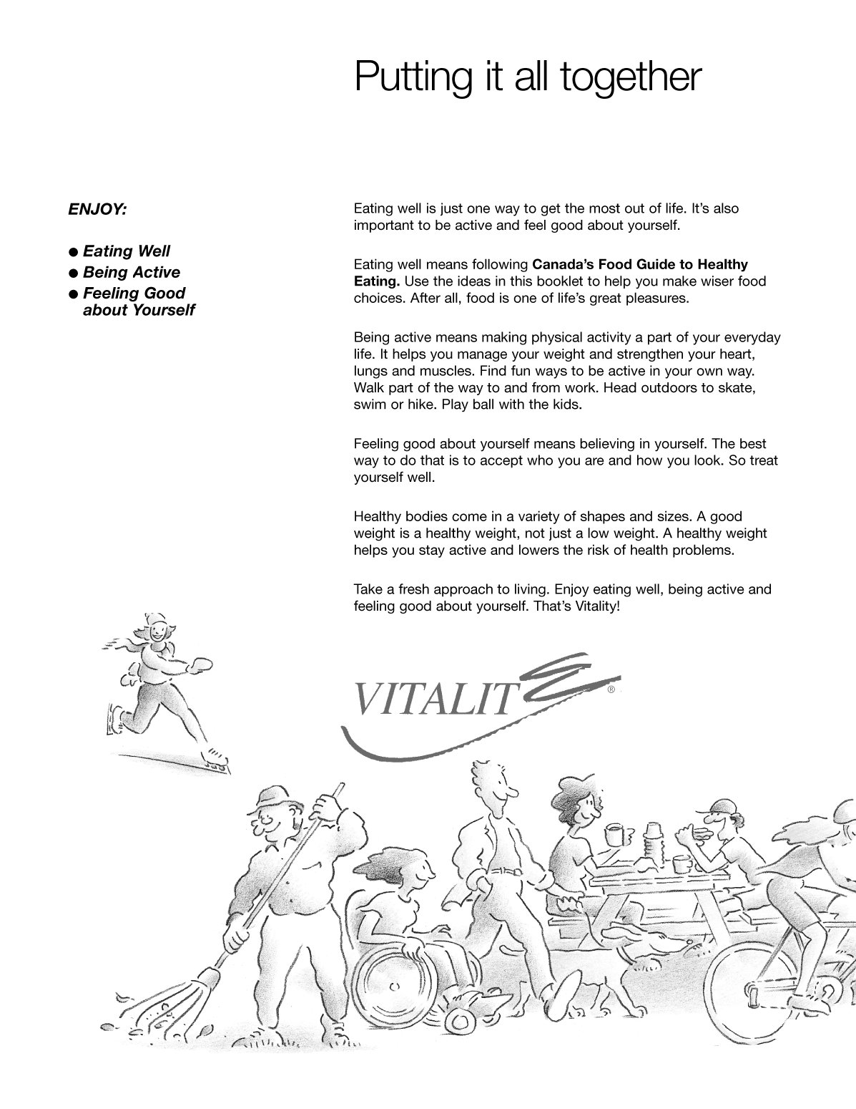
Figure 5-1 (Sheet 11 of 12) Canada's Food Guide

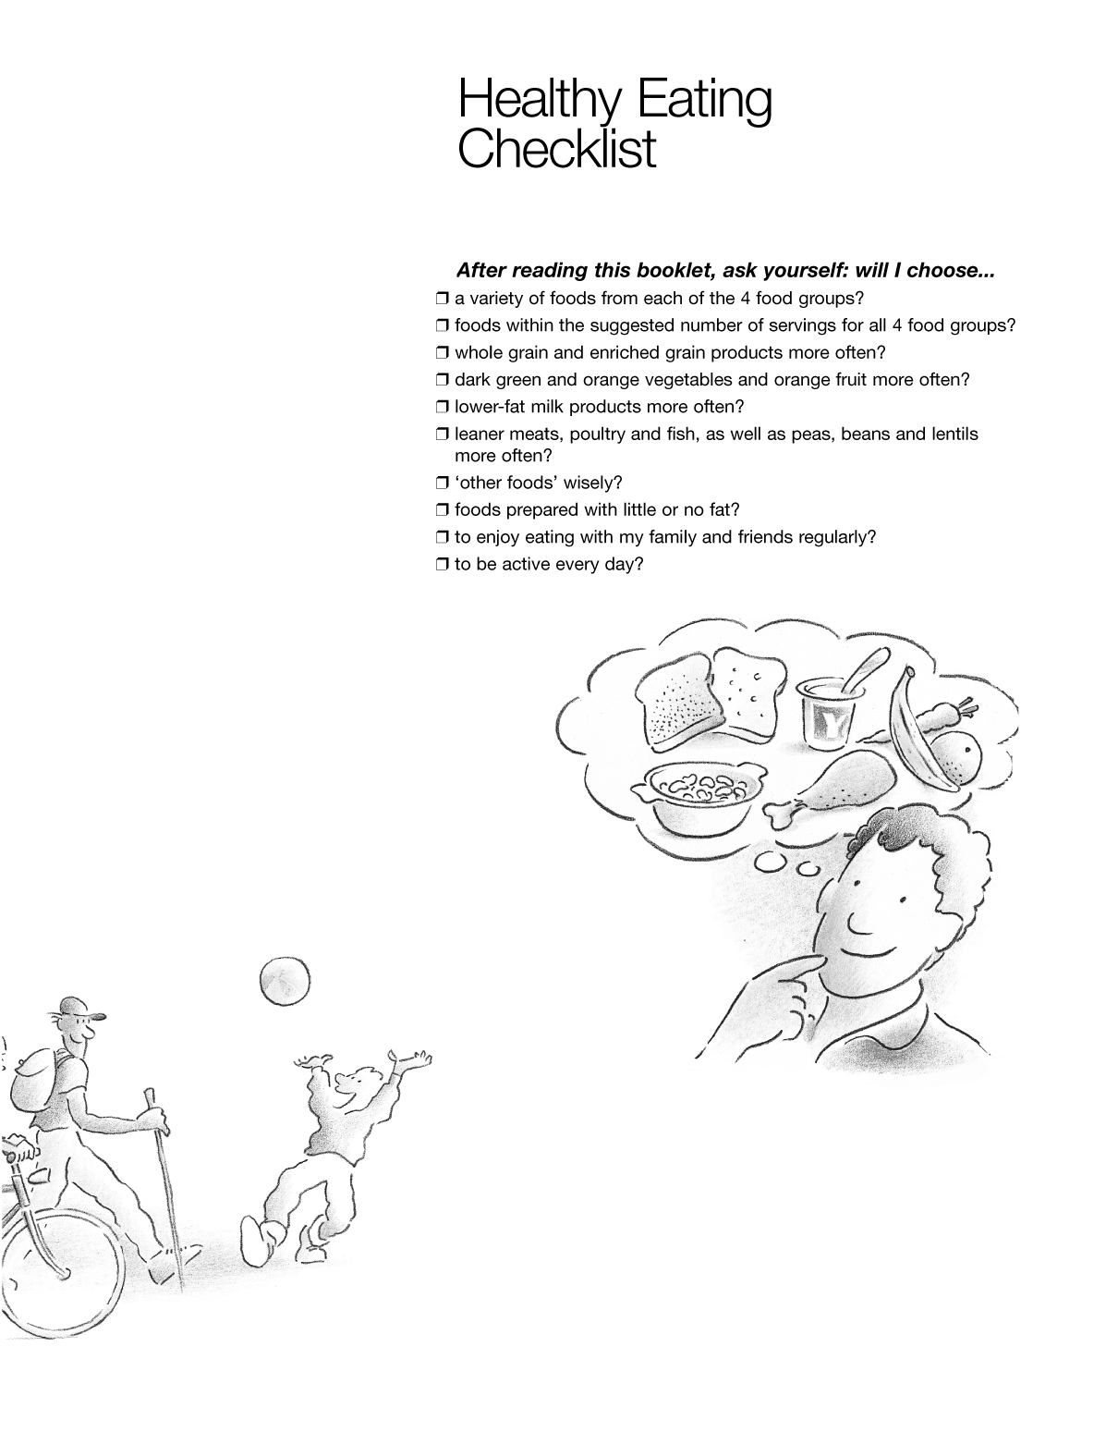
Figure 5-1 (Sheet 12 of 12) Canada's Food Guide

Figure 5-2Fire Extinguisher Use

Figure 5-3Classes of Fires

