406

S
E
N
S
I
B
L
E
L
I
V
I
N
G

CHAPTER 5

PERFORMANCE OBJECTIVE 406

SENSIBLE LIVING

GENERAL

1. What is sensible living? After you have completed this unit, you will have a little better understanding of just what it means to live sensibly.

2. You will complete this unit throughout the year. There will likely be several specialists invited to the squadron to talk to you about fire safety, hygiene and nutrition, drugs, alcohol and smoking. Although there is no formal test on this unit, you will have to attend the guest lecturers' presentations to complete your second year training.

NUTRITION

3. Figure 5-1 illustrates Canada's Food Guide. If you follow the guidelines set out in Canada's Food Guide, you can set up a good nutritional basis for a healthy life.

FIRE PREVENTION AND SAFETY

4. Figures 5-2 and 5-3 illustrate and explain the use of fire extinguishers. Your local fire department can provide you or your squadron with many pamphlets that contain useful information on fire prevention and safety.
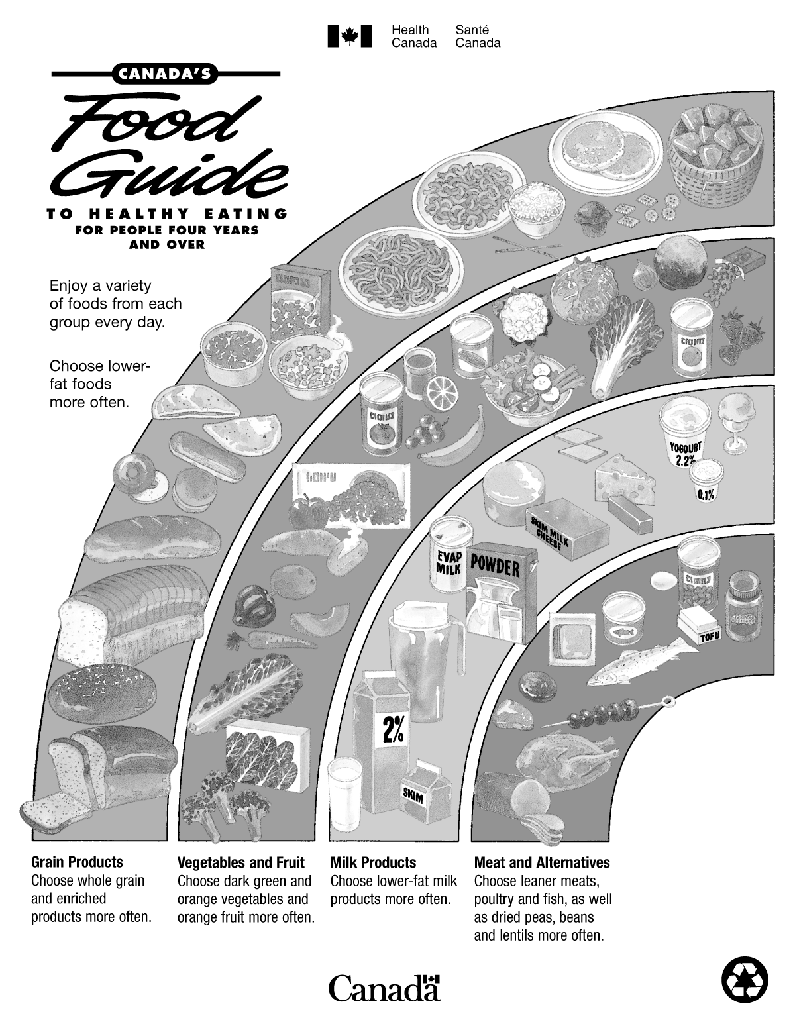
Figure 5-1 (Sheet 1 of 12) Canada's Food Guide
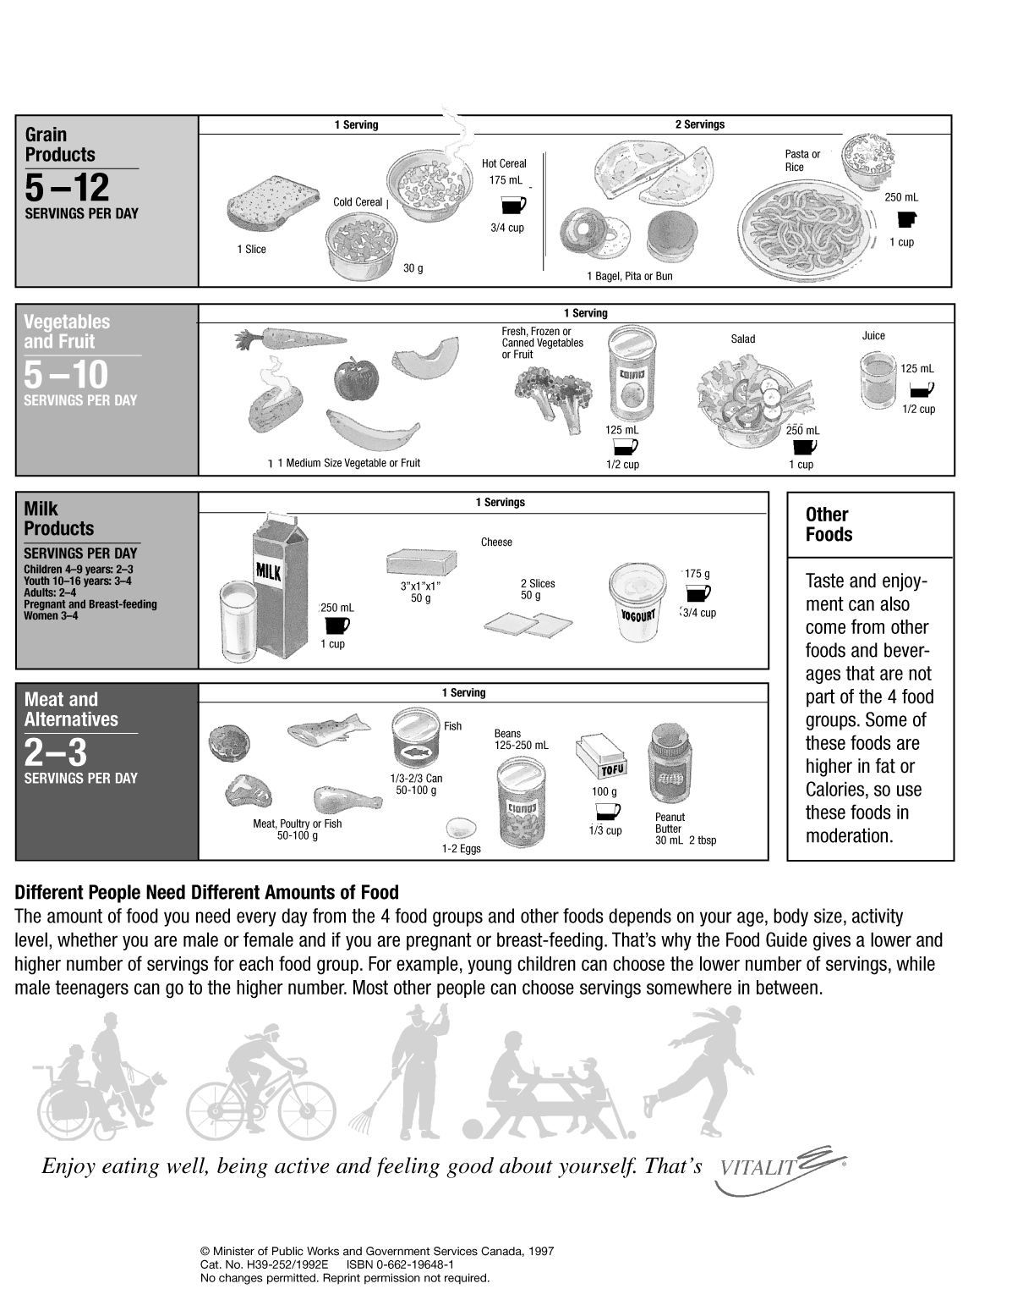
Figure 5-1 (Sheet 2 of 12) Canada's Food Guide
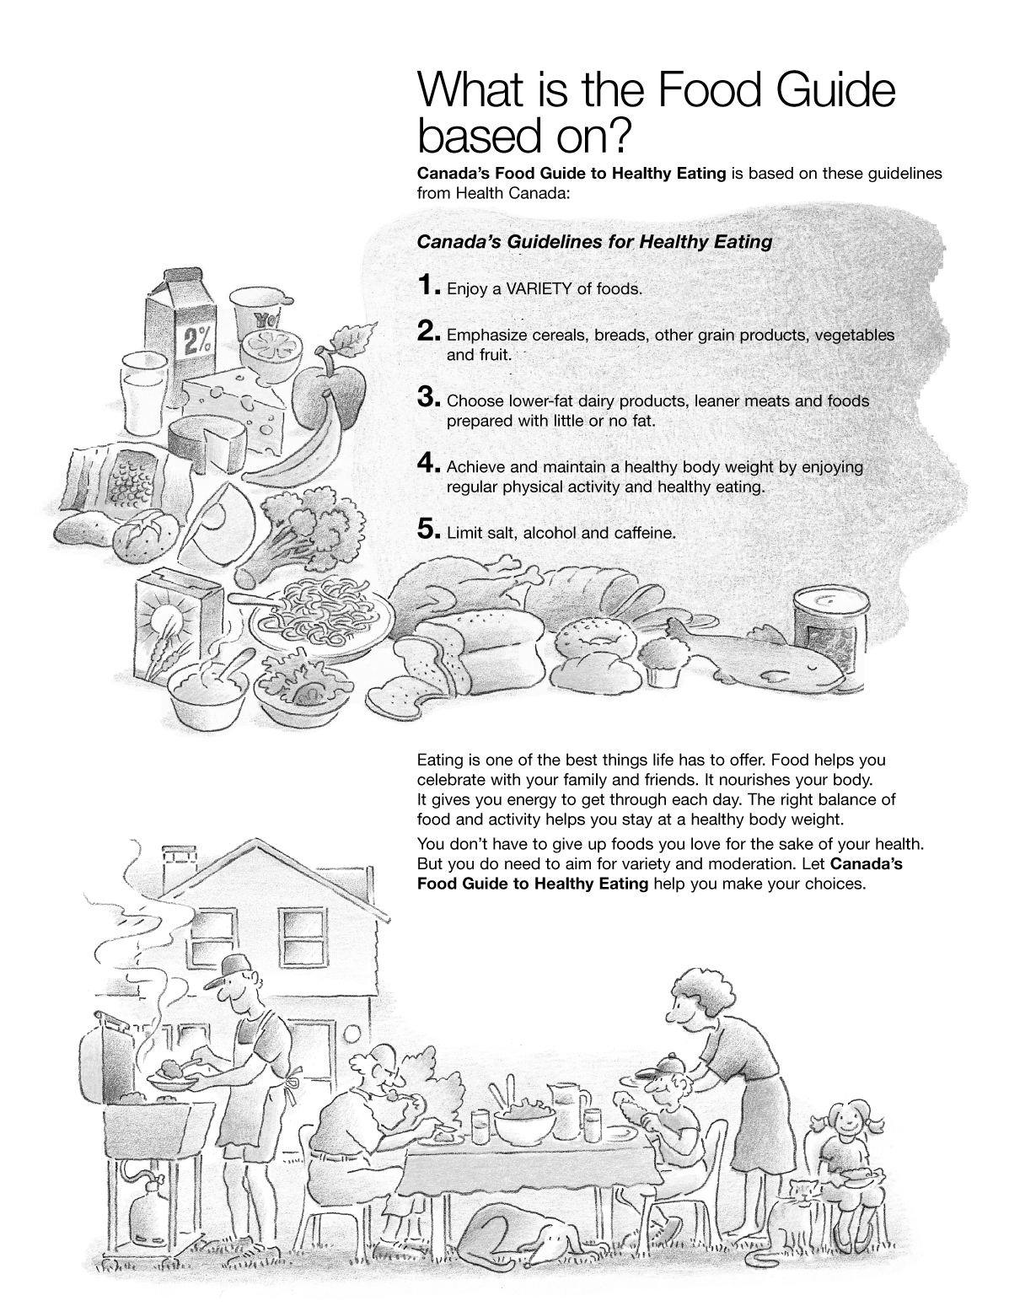
Figure 5-1 (Sheet 3 of 12) Canada's Food Guide
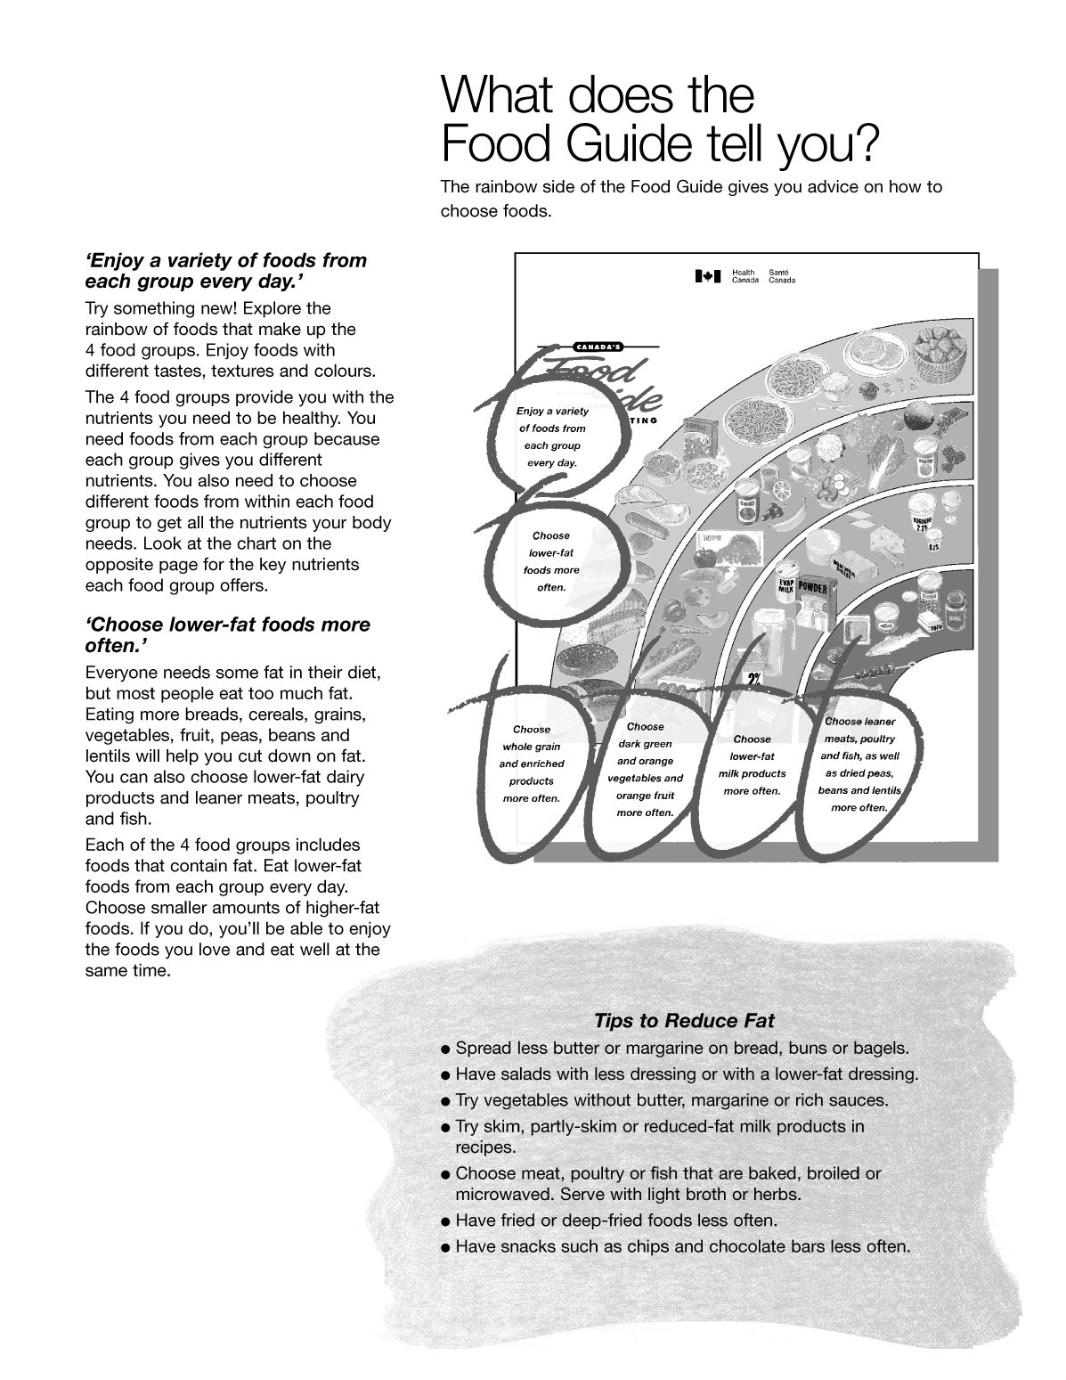
Figure 5-1 (Sheet 4 of 12) Canada's Food Guide
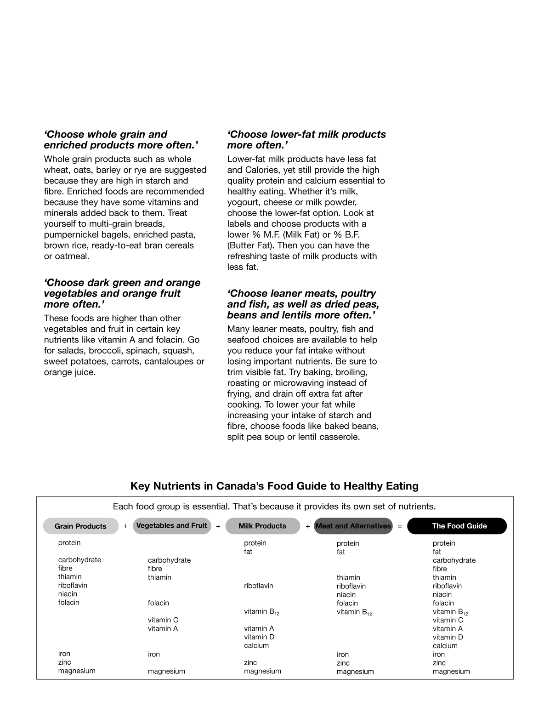
Figure 5-1 (Sheet 5 of 12) Canada's Food Guide
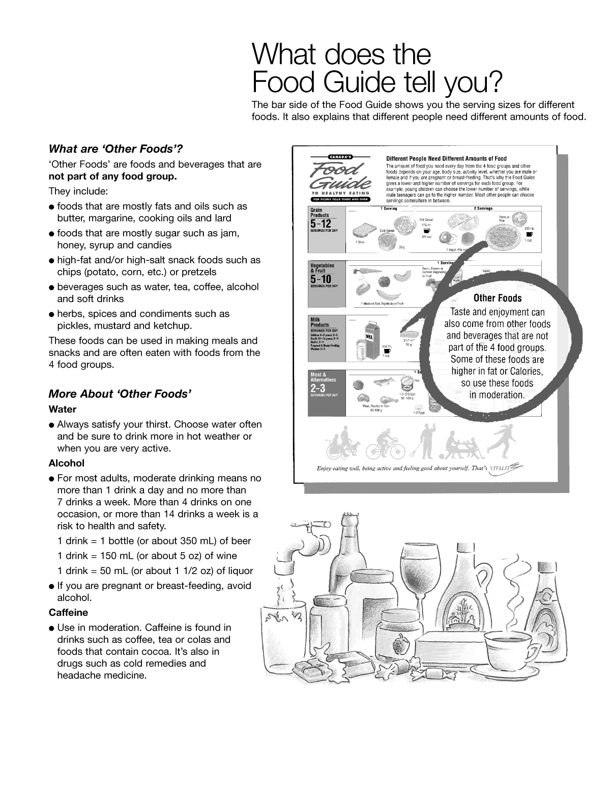
Figure 5-1 (Sheet 6 of 12) Canada's Food Guide

