401

D
R
I
L
L

CHAPTER 1

PERFORMANCE OBJECTIVE 401

DRILL

SECTION 1

GENERAL

1. The History of Drill.Military drill originally developed for moving infantry during battle. Troops might have to face to a different flank to meet a new attack; to form into a compact square to repel cavalry; or to extend into a two-man line to deliver maximum fire-power on the enemy. Troops had to perform these movements rapidly and efficiently if they wanted to stay alive. If the troops practised these movements beforehand on the parade square, they could perform them reasonably well in the stress, noise and confusion of the battlefield. This practice made the troops much more effective in the field. As a result, drill developed. In the process of teaching drill, however, it was seen that other benefits were gained. Drill was also an excellent way of developing physical coordination, teamwork, and team spirit in the soldiers.

2. The Need for Drill.The need for drill as a part of actual warfare has long since disappeared. Drill's second value however, remains as important as ever, especially in a cadet squadron. There is no better way of developing sharpness and team spirit (esprit de corps) − both important elements of the cadet world.

3. Drill Can Be Fun.Amazingly, drill can be FUN. At first, you may feel awkward or uncoordinated. Don't worry, these are common feelings for a cadet who is just beginning to learn drill. Gradually, as you get the hang of it, you will begin to feel a sense of satisfaction in getting it just right. As you work with the rest of your squad to accomplish something that can only be done as a team, you will begin to feel a sense of pride, in yourself and your squadron.

4. Good drill, when it is closely supervised and when the highest precision is demanded, is an exercise in obedience and alertness. It sets the standard for the individual and the squadron, and builds a sense of confidence between the commander and the cadet.

5. Drill Movements. The various drill movements you will learn during your first year appear in this chapter. This information is based on A-PD-201-000/PT-000, Canadian Forces Manual of Drill and Ceremonial. If drill interests you and you would like to learn more about it, there may be a copy of A-PD-201-000/PT-000 at your squadron.

6. The information in this chapter is to be used as a reference only. Don't worry about reading it before you learn the drill in each section. If you have questions about your drill classes, be sure to ask your instructor. If you still have questions, or if you want to refresh your memory at home, you should turn to this chapter for help.

SECTION 2

SQUAD DRILL AT THE HALT

THE STANDARD PAUSE

7. Some drill movements require a standard pause to be observed. This means that while performing a drill movement you will hold your position for a precise period of time without moving. This pause allows you to perform movements precisely. The standard pause is calculated from the quick march cadence (which is .60 paces per minute). It is equivalent to two paces or 1.5 seconds. You will learn to recognize the length of the
standard pause by listening to the beat of the base drum or your instructors as they call out the time.

FORMATION OF A SQUAD

8. Soon after arrival at the squadron, new cadets will learn how to form a squad. These formations are essential to maintain control and to ensure uniformity throughout training.

9. On the command, "FORM UP IN SINGLE (TWO) (THREE) RANK(S) − MOVE", you will do the following:

a. assume the position of attention;

b. observe the standard pause (1.5 seconds);

c. step off with the left foot, march forward towards the instructor; and

d. the first cadet who approaches the instructor will halt three paces directly in front of the instructor and the remainder will cover that cadet from front to rear and/or fall in on the cadet's left at arm's length intervals.

POSITION OF ATTENTION

10. The position of attention is one of readiness in expectation of a word of command. Exactness in this position is important as the position is adopted by officers and cadets when addressing a superior.

11. The position of attention is as follows:

a. heels together and in line;

b. feet turned out to form an angle of 30 degrees;

c. body balanced and the weight evenly distributed on both feet;

d. shoulders level, square to the front;
e. arms hanging as straight as their natural bend will allow, with elbows and wrists touching the body;

Figure 1-1Formation of a Squad

f. wrists straight, the back of the hand held outwards;

g. the fingers aligned, touching the palm of the hand, thumbs placed on the side of the forefinger at the middle joint with the thumbs and back of the fingers touching the thighs lightly and the thumbs in line with the seam of the trousers; and

h. head held erect, neck touching the back of the collar, eyes straight to the front.

12. NO part of your body shall be strained when in the position of attention. Straining your body will only make you more uncomfortable; try to relax, while maintaining the position of attention. Muscles should not be tense, merely held in position.
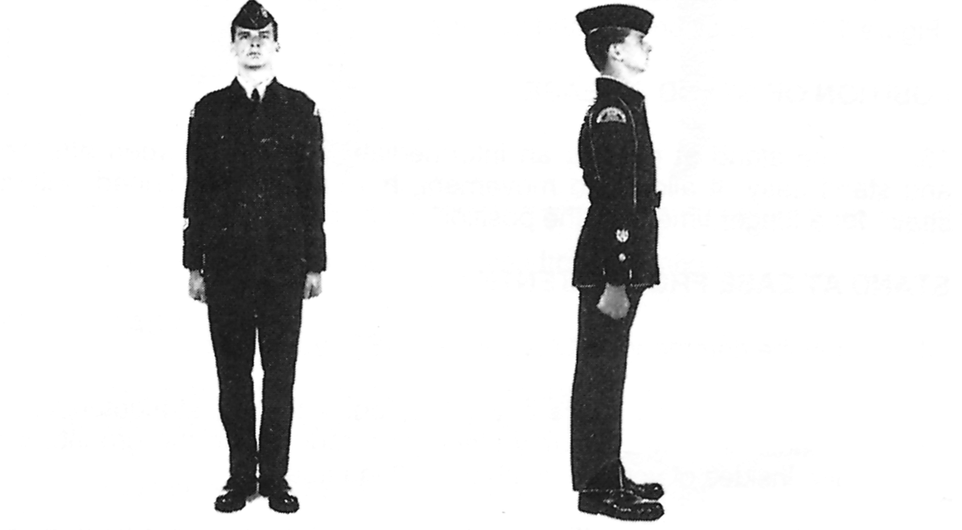

Figure 1-2Position of Attention
POSITION OF STAND AT EASE
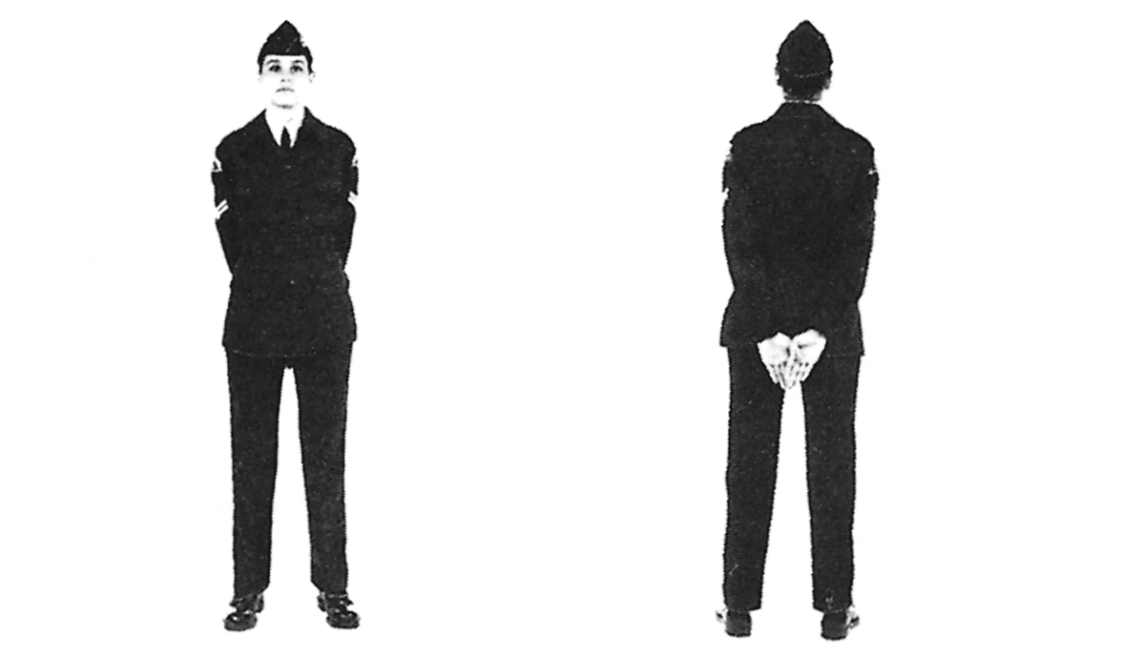

Figure 1-3Position of Stand at Ease

13. The stand at ease is an intermediate position between attention and stand easy. It allows no movement, but can be maintained, without strain, for a longer time than the position of attention.

STAND AT EASE FROM ATTENTION

14. On the command "STAND AT − EASE" you shall:

a. bend your left knee, carry your left foot to the left, straightening it in double time, and smartly place your foot flat on the ground, with the insides of your heels 25 cm (10 in.) apart;

b. at the same time, with a quick motion, bring your arms behind your back, stretched to their full extent, and place the back of your right hand in the palm of your left, with thumbs crossed right over left, the fingers together and extended; and
c. balance your body with your weight evenly distributed on both feet.

15. You will notice the term "bend the left (right) knee" is used throughout this chapter and in the drill chapters of the other manuals. The term means to bend your knee so your foot will hang at its natural angle with the toe pointed downwards 15 cm (6 in.) off the ground and directly underneath the knee.
STAND EASY
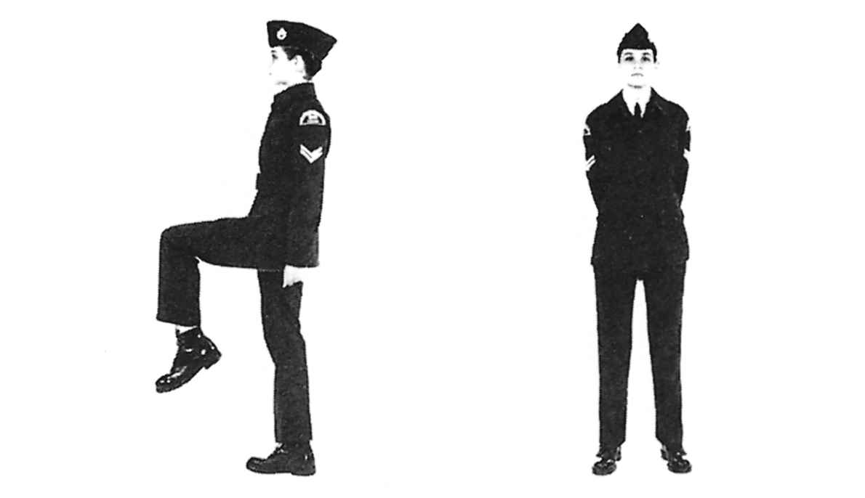

Figure 1-4 Position of Stand at Ease from Attention

16. The position of stand easy is ordered when it is time for the squad to relax This command is only given when the squad is in the position of

17. On the command, "STAND − EASY", you shall:

a. close your hands and bring your arms to the position of attention;
b. observe a standard pause; and

c. relax.

18. When standing easy, you may adjust clothing and equipment but you shall not move your feet or talk.
STAND AT EASE FROM STAND EASY
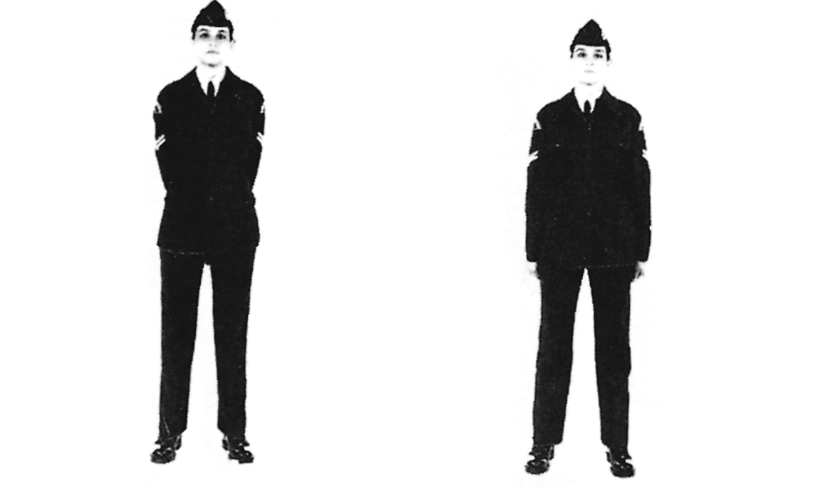

Figure 1-5Position of Stand Easy

19. On the command, "SQUAD", you shall assume the position of stand at ease.

ATTENTION FROM STAND AT EASE

20. On the command, "ATTEN − TION", you will:

a. bend your left knee and straighten your left leg in double time, placing your left foot smartly beside the right, in the position of attention, toe touching first, followed by the heel, and with heels aligned; and

b. at the same time, with a quick motion, bring your arms and hands to the position of attention.

SALUTING WITH THE HAND AT THE HALT

21. The salute is given with the right hand. When a cadet is unable to salute, due to the carrying of articles, compliments will be paid by turning the head and eyes to the left or right or standing to attention, as appropriate.

22. The salute is performed in two movements − up and down. On the command, "TO THE FRONT − SALUTE", you shall:

a. bend your right elbow and open the palm of your right hand; and

b. force your right hand by its shortest route to the outside edge of the eyebrow so that:

(1) the palm of the hand is facing down;

(2) the thumb and fingers are fully extended and close together;

(3) the tip of the second finger is just touching the outside of your right eyebrow;

(4) the hand, wrist and forearm are in a straight line;

(5) the elbow is in line with the shoulders; and

(6) the upper arm is parallel to the ground.

23. These steps complete the upward movement of the salute. The salute is held for the standard pause. The downward movement is then executed by bringing your hand sharply to the position of attention by the
shortest route, without slapping the thigh. The hand is closed after the forearm is lowered below the shoulder level.
24. At times it is desirable to salute to the left or right. When you are given the command "TO THE RIGHT (or LEFT) − SALUTE", the salute shall be executed as explained for the Salute to the Front, except that:
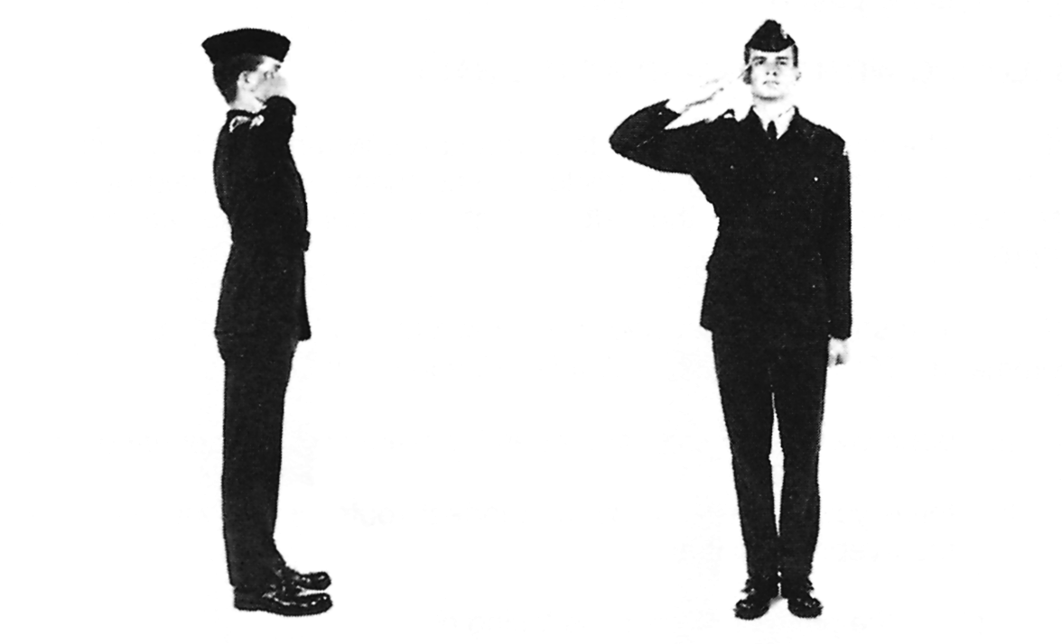

Figure 1-6Saluting With the Hand to the Front

a. your head and eyes shall be turned smartly to the right (left) as far as possible without straining;

b. when saluting to the left, your right hand, wrist, and arm are brought further over to the left, to the correct position in line with the outside edge of the right eyebrow; and

c. when saluting to the right, your arm is moved to the rear. The tip of the second finger remains in line with the outside edge of the right eyebrow.

25. When the salute is lowered, after observing the standard pause, your hand is brought sharply to the position of attention, at the same time your head and eyes are turned smartly to the front.
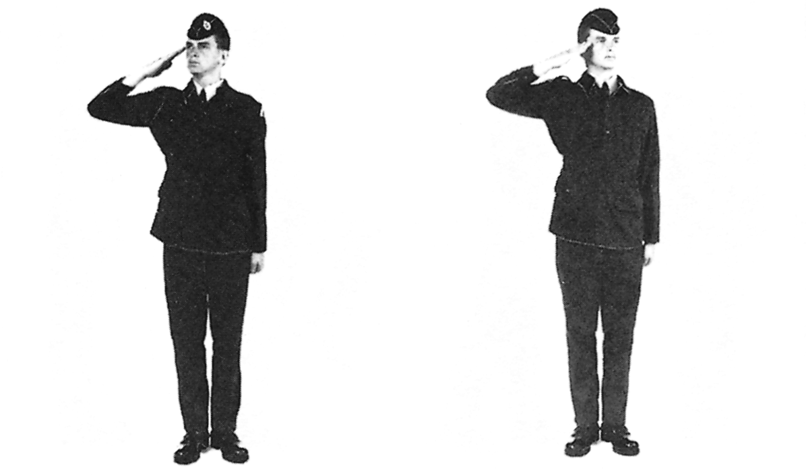

Figure 1-7Saluting With the Hand to the Right and Left

TURNING AND INCLINING AT THE HALT

26. Turns and inclines are performed to change direction: right or left turns by 90 degrees; about turn 180 degrees; and right and left inclines 45 degrees.

27. On the command, "RIGHT − TURN", you shall keep both knees braced, arms at your sides, maintain your body upright, and turn 90 degrees to the right by pivoting on the right heel and left toe. On the completion of this part of the movement, the weight of your body is placed on the right foot, and your left leg is braced with the heel off the ground. To perform the second part of the movement you bend your left knee, straighten it in double time, and smartly place your left foot by your right
to assume the position of attention. The standard pause is observed between the two parts of the movement.
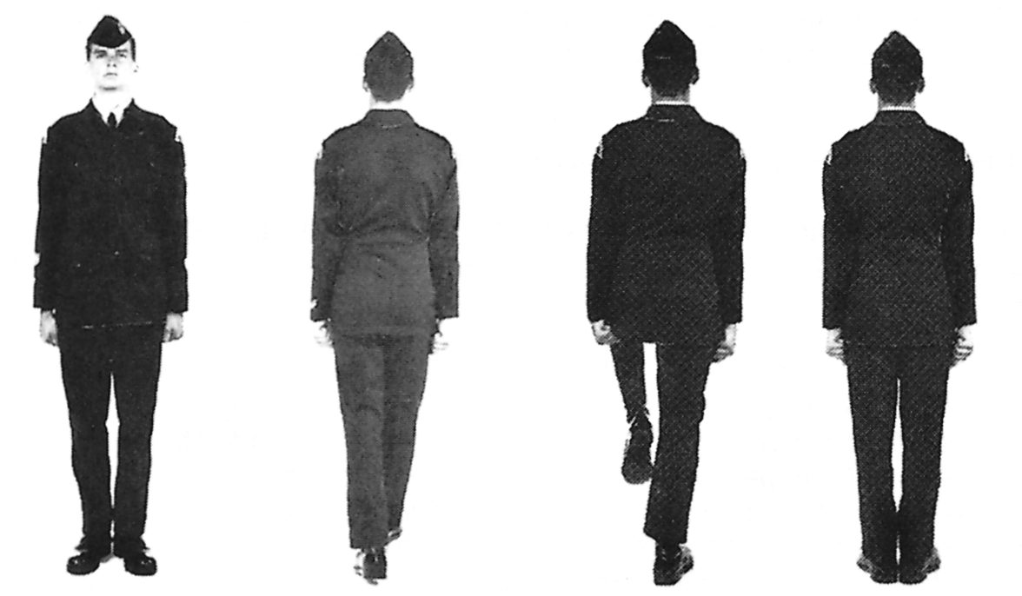

Figure 1-9About Turn
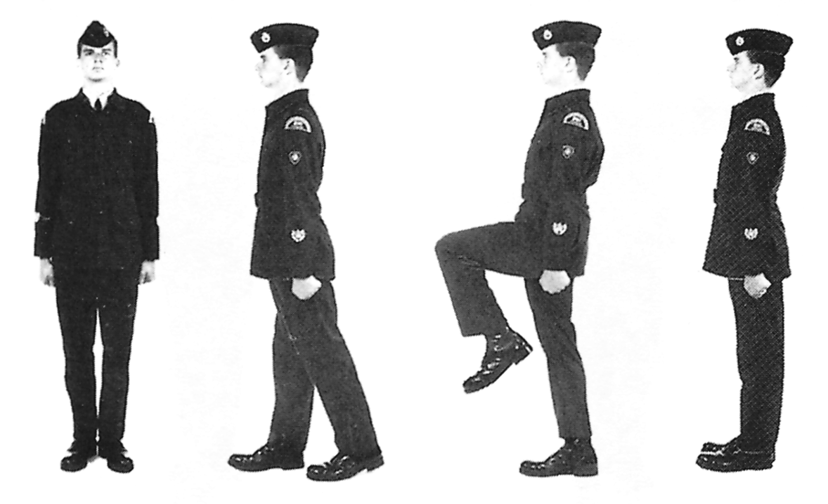

Figure 1-8Right Turn

28. On the command, "ABOUT TURN", the drill as described for the right turn is followed except that the pivot to the right is made through 180 degrees. Balance is maintained by bracing your legs and locking the thighs.

29. On the command, "RIGHT IN − CLINE", the drill as described in turning to the right is followed but the turn is only made through 45 degrees.

30. On the command, "LEFT − TURN", the drill as described for the right turn is followed except that the details of moving your feet and direction are reversed.

31. On the command, "LEFT IN − CLINE", the drill as described in turning to the left is followed but the turn is only made through 45 degrees.

DRESSING A SQUAD

32. A squad is dressed so that it looks sharp and well ordered. Dressing ensures that there is proper spacing between members from front to rear and side to side. Two orders are used to accomplish the dressing of a squad. The first is "RIGHT DRESS", which is done in three movements, with the standard pause between each movement. The second command IS "EYES FRONT", which is one step.

33. On the command, "RIGHT − DRESS":

a. the right-hand cadet of the front rank stands fast;

b. the remainder take a 40 cm (15 in.) pace forward by shooting the left foot forward, bending the right knee, and adopting the position of attention;
c. standard pause;

d. the right file of cadets stands fast;

e. the remainder turn head and eyes to the right as far as possible without straining;

f. at the same time, members of the front rank, except the righthand cadet, shoot their right arms to their full extent behind the shoulder of the cadet on the right. The hand is closed as in the position of attention, with the back of the hand facing up, and the arm parallel to the ground;

g. standard pause;

h. the right-hand cadet of the front rank stands fast; and

j. the remainder take up correct alignment, distance and covering by taking short quick paces until the remainder are in the correct position. Movement starts with the left foot.

34. As a guide to taking up correct alignment, each cadet in the squad, except the right-hand cadet, moves to a position from which the lower portion of the face of the second cadet to the right can just be seen. Correct covering is taken up by glancing to the front without moving the head. The interval is correct when the closed hand is touching the left shoulder of the cadet on the right.

35. On the command, "EYES − FRONT", you shall snap your head and eyes to the front and cut the right arm smartly to the position of attention, without slapping the thigh.

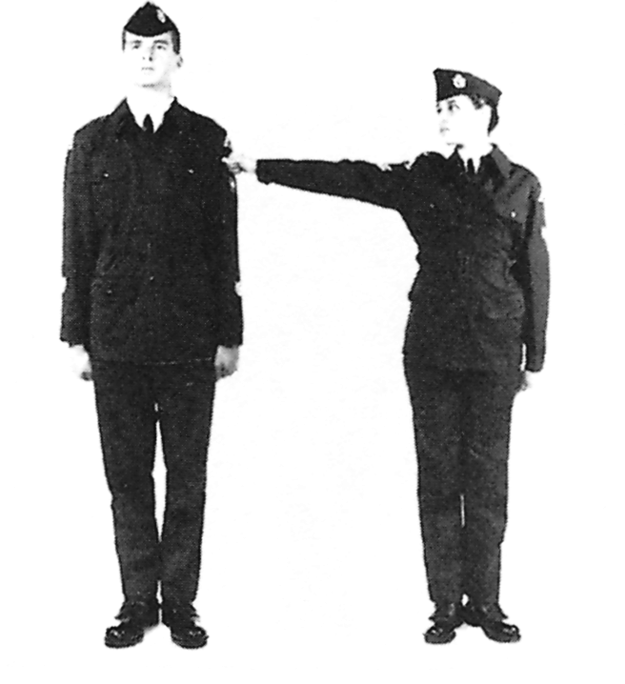

Figure 1-10 Dressing a Squad − Arm's Length

36. On the command, "SHOULDER DRESSING, RIGHT − DRESS", dressing is carried out as for the Right Dress, except the arms are not raised and dressing is taken up without arm's length interval.

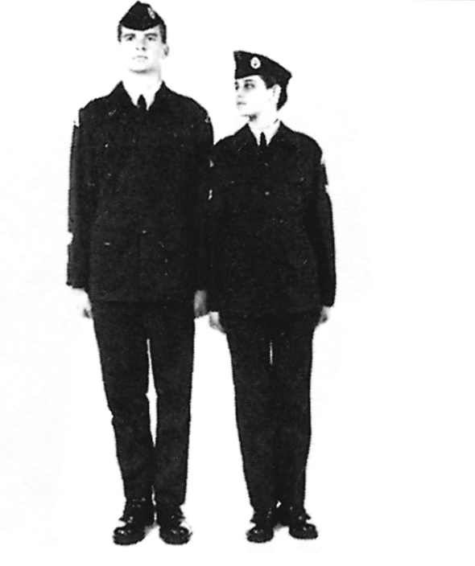

Figure 1-11 Dressing a Squad − Shoulder Dressing

37. On the command, "ELBOW DRESSING, RIGHT − DRESS", dressing is carried out as for Right Dress except:

a. the right hand is placed on the hip;

b. the fingers are closed, pointed down and extended forward;.

c. the thumbs are to the rear;

d. the elbow is straight out to the side; and

e. the point of the elbow is touching the cadet on the right.

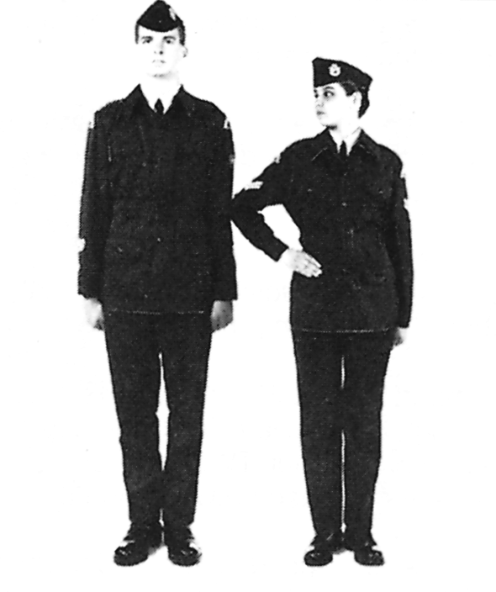

Figure 1-12 Dressing a Squad − Elbow Dressing

38. At times a squad may be commanded to dress to the left. In such cases the same drill is followed as for right dress, except the head and eyes are turned left and the left arm is raised. The left-hand cadet stands fast.

CALLING THE ROLL

39. On the command, "ATTENTION/ANSWER TO YOUR NAME/STAND AT − EASE" you shall stand at ease. When your name is called, you shall come to attention and answer in one of the following ways:

a. "Sir" or "Ma'am" if the person calling the roll is an officer, or warrant officer;

b. "Flight Sergeant," "Sergeant" or "Corporal" if the person calling the roll is a flight sergeant, sergeant or corporal; or

c. "Present" if the person calling the roll is below the rank of corporal.

40. When the roll is supervised by a person senior in rank to the person calling the roll, you shall answer to your name with the correct response for the rank of the supervisor.

41. You shall stand at ease after answering to your name, remembering to observe the standard pause between movements.

NUMBERING

42. Numbering is used to designate individuals in the squad and determine the number of cadets on parade.

43. On the command, "SQUAD − NUMBER", the front rank only shall number off from the right to the left. The right-hand cadet shall call out ONE, the next cadet shall call out TWO and so on. The head and eyes shall remain still. There is no pause between numbers.

44. Cadets in the centre and rear ranks determine their numbers by taking the number of the front rank cadet they are behind.

45. When an error in numbering occurs, the command, "AS YOU WERE", followed by the last correct number is called out. The cadet so designated repeats the number and the drill of numbering continues. The command, "AS YOU WERE, SQUAD NUMBER", may be ordered and the squad will renumber from the beginning.

PROVING

46. Proving may be used by members of the squad to identify themselves. You should learn to prove so that the instructor will know when you need to ask a question.

47. On the command, "NUMBERS , , , PROVE", the cadets so designated raise their left forearm parallel to the ground, keeping their left elbow close to the body and the hand closed as for the position of attention.

48. On the command, "ATTENTION", the cadets who proved will adopt the position of attention.
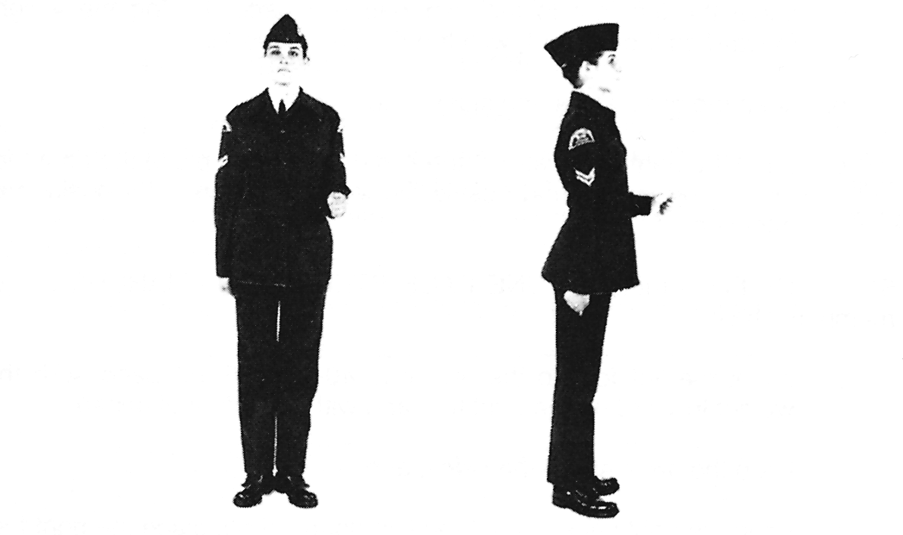

Figure 1-13Proving

PACES FORWARD AND TO THE REAR

49. When taking paces forward and backward:

a. the cadence shall be in quick time; and

b. the arms shall be kept still at the sides

50. On the command, "ONE PACE FORWARD − MARCH", squad members shall:
a. shoot the left foot to the rear one half pace, forcing the weight forward on the left foot, with the right heel raised;

b. keep the arms still at the sides; and

c. bend the right knee, straighten it in double time, place the right foot smartly on the ground beside the left and assume the position of attention.

51. On the command, "ONE PACE STEP BACK − MARCH", squad members shall:

a. shoot the left foot to the rear one 40 cm (15 in.) pace, with the weight forward on the right foot and with the left heel raised;

b. keep the arms still at the sides; and

c. bend the right knee, straighten it in double time, place the right foot smartly on the ground beside the left and assume the position of attention.

52. The timing for the previously mentioned movements is as follows:

a. for one pace, one-two;

b. for two paces, one, one-two; and

c. for three paces, one, one, one-two.

OPEN ORDER − MARCH

53. To execute the open order the following steps are taken:

a. the front rank shall step forward three 40 cm (15 in.) paces, the rear rank shall step back three 40 cm (15 in.) paces and the centre rank shall stand fast;
b. the cadence shall be in quick time; and

c. the arms shall be kept still at the sides.

54. On the command, "OPEN ORDER − MARCH", the movements will be executed as for three paces forward and to the rear, the final movement being executed by bending the right knee, straightening it in double time and placing the right foot smartly on the ground by the left and assuming the position of attention.

Figure 1-14Open Order − Three Ranks
55. The timing for the movements is counted one, one, one-two.

CLOSE ORDER − MARCH

56. On the command, "CLOSE ORDER − MARCH", the squad shall act in the reverse of the action for the open order.
FALLING OUT OF RANKS

57. The command, "FALL − OUT", shall be used when an individual is called out of the squad.

58. On the command, "FALL − OUT", the cadet named shall come to attention, march to the right of the flank of the squad in front of that cadet's rank, and then proceed in the required direction.

FALLING INDIVIDUALS IN

59. On the command, "FALL − IN", the individual ordered marches to the left flank of the squad and returns to position by marching in rear of the rank, wheeling into the original position, and halting. The individual shall pick up the dressing and remain at attention or stand at ease, as required.

Figure 1-15Falling Out of Ranks

DISMISSING A SQUAD

Figure 1-16Falling Individuals In

60. The command "DISMISS" signifies the end of a parade, period of instruction, etc. The squad shall be in line and at attention when dismissed.

61. On the command, "DIS − MISS", squad members shall:

a. turn right;

b. observe the standard pause;

c. salute, if an officer is on parade;

d. observe the standard pause; and

e. march at attention independently, in quick time, from the place of parade.

CARRYING OF ARTICLES
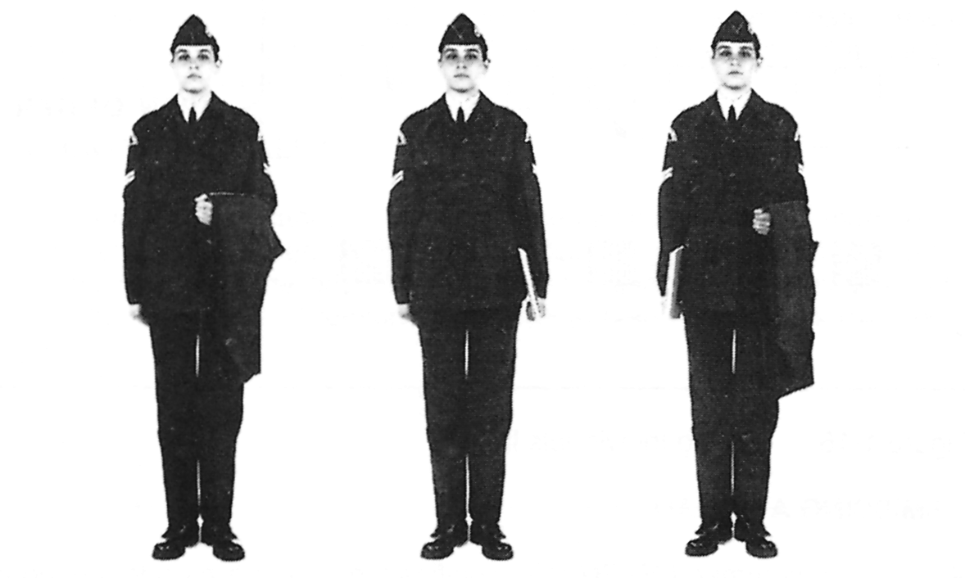

Figure 1-17Carrying of Articles

62. If an article is carried, it shall be carried in the left hand. If an article is carried when marching, the left arm is not swung.
REMOVE HEAD-DRESS

63. The order to remove head-dress may be given when it is customary, eg, at outdoor church parades, during the consecration of a squadron banner or whenever it is desirable to honour a dignitary by giving three cheers .

64. On the command, "REMOVE − HEAD-DRESS", you shall bring your right hand to the front of your wedge by the shortest route, and grasp the front at the centre between the thumb and fingers. The standard pause is then observed. Keeping the bend in the right arm, you will then cut the upper arm to the right side of the body, keep the forearm parallel to the ground and bring the right hand to the centre of the body. Maintaining the
grasp on the front of the wedge, squad members shall hold the wedge above the hand and in the centre of the body.
STAND AT EASE WITH HEAD-DRESS REMOVED
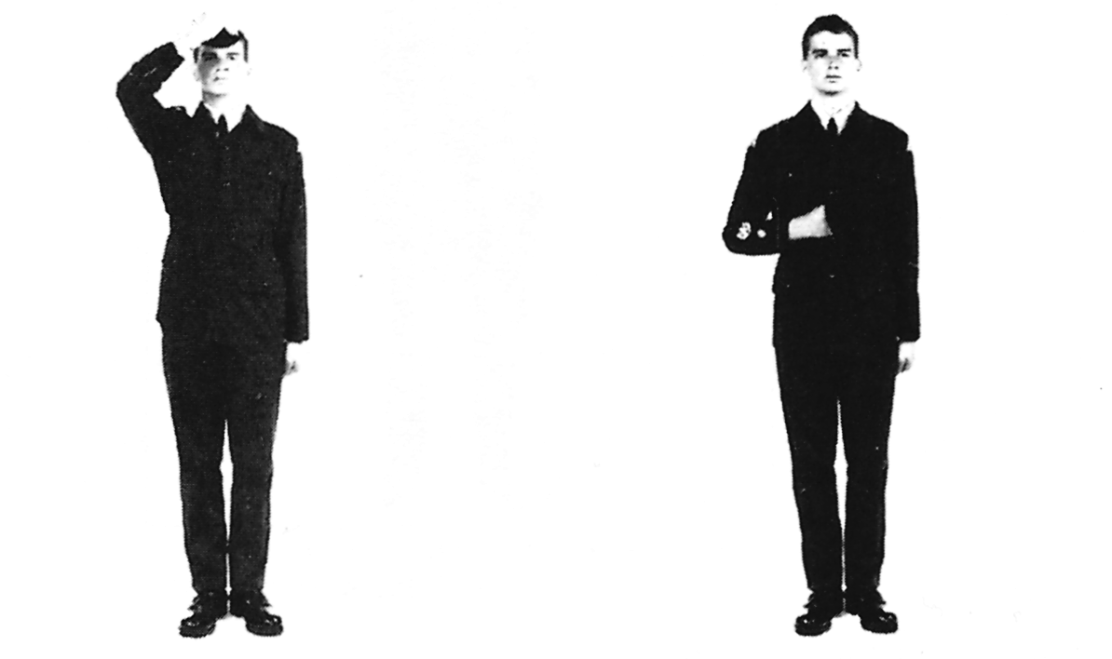

Figure 1-18Remove Head-dress

65. On the command, "STAND AT − EASE" you shall assume the position for standing at ease when carrying articles, except that the right arm and hand will maintain the wedge in the position as detailed for attention.

STAND EASY WITH HEAD-DRESS REMOVED

66. On the command, "STAND − EASY", squad members shall extend the right arm down the side with the wedge held elbow the hand and, after a standard pause, relax.

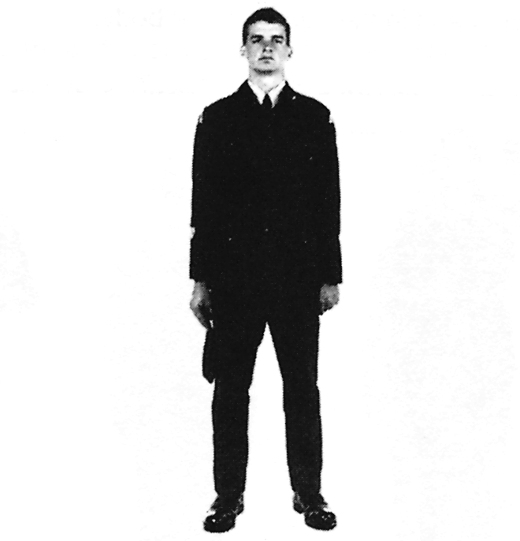

Figure 1-19 Stand Easy with Head-dress Removed

REPLACE HEAD-DRESS

67. On the command, "REPLACE − HEAD-DRESS", you shall replace the wedge with the right hand, observe the standard pause, and return to the position of attention by cutting the right arm to the right side.

SECTION 3

SQUAD DRILL ON THE MARCH

DRILL COMMANDS ON THE MARCH

68. When performing drill movements on the march a drill command to execute the movement will be called as a specific foot hits the floor. It is important to know which foot commands are called on so that you can perform drill precisely as an individual and as a member of a squad. The table that follows indicates which foot the commands are given on for drill movements you are required to perform at the end of Level One training.

DRILL MOVEMENTS | FOOT
HALT FROM THE QUICK MARCH | LEFT
STEPPING OUT AND STEPPING SHORT | LEFT
RETURN TO QUICK MARCH (FROM STEPPING OUT) | RIGHT
MARK TIME | RIGHT
FORWARD | LEFT
SALUTING ON THE MARCH | LEFT
EYES RIGHT AND LEFT | LEFT
FORMING SINGLE FILE ON THE MARCH | RIGHT
RETURN TO THREE RANKS FROM SINGLE FILE | RIGHT

MARCHING AND HALTING IN QUICK TIME

69. When marching, you shall hold your body upright, keep your head and eyes to the front, and be in the position of attention.

70. On the command, "QUICK − MARCH", you shall:

a. shoot your left foot forward in one 40 cm (15 in.) pace, toe up;

b. strike the heel on the ground first and keep the toe pointed directly forward;

c. at the same time, swing your right arm straight forward and your left arm straight to the rear, waist high;

d. continue marching with paces of 80 cm (30 in.) each;

e. bring your legs forward successively in a straight line; and

f. swing your arms forward successively in a straight line from your shoulder, front to rear, with hands closed as in the position of attention.
71. You may be directed to swing your arms breast pocket high, instead of waist high.

72. Prior to the command "QUICK − MARCH", the instructor, or another person giving the command, will usually say "BY THE RIGHT (CENTRE OR LEFT)". This phrase is an instruction for you. When you hear, for example, "BY THE RIGHT" you know that the dressing for the squad is taken from the right-hand rank. In other words, you should glance out of the corner of your eye towards the person on your right to be sure that you are maintaining the proper spacing between ranks.
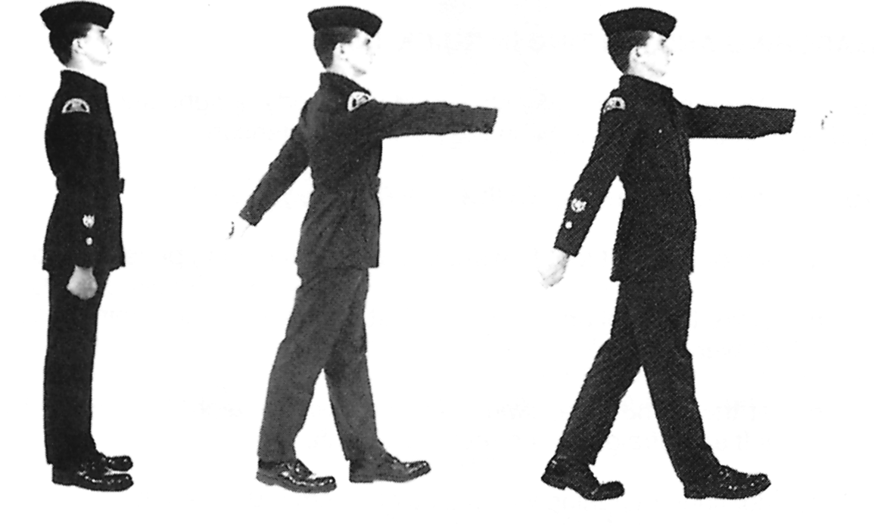

Figure 1-20Marching in Quick Time
73. On the command, "SQUAD − HALT", you shall:

a. check the forward movement by placing your right foot on the ground using the heel as a brake;

b. swing your left arm forward and your right arm to the rear;
c. take one 40 cm (15 in.) pace with your left foot, placing it flat on

d. swing your right arm forward and your left arm to the rear;

e. bend your right knee, straightening it in double time; and

f. at the same time, cut your arms to your sides as quickly as possible and assume the position of attention.

74. The timing for the halt is called as one, one-two.
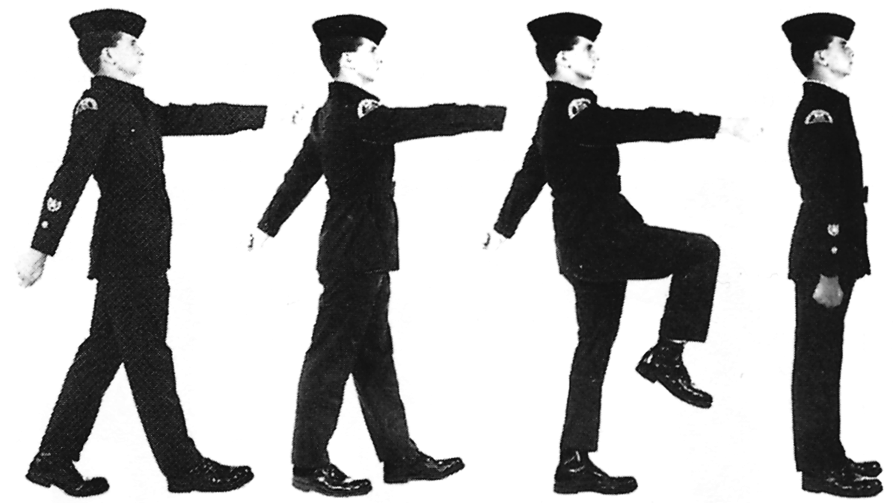

Figure 1-21Halting in Quick Time
MARKING TIME, FORWARD AND HALT IN QUICK TIME

75. Marching in quick time is done at the same cadence as marching in quick time.

76. On the command, "MARK − TIME", you shall:
a. take one 40 cm (15 in.) pace with your left foot, placing the foot flat on the ground;

b. bring your right foot in to the left in a straight-leg manner, not scraping the ground;

c. at the same time, cut your right arm down and your left in from the rear, and assume the position of attention;

d. bend your left knee;

e. place the toe on the ground before the heel as the leg is lowered; and

f. continue to mark time until the command "FOR − WARD" or "HALT" is given.
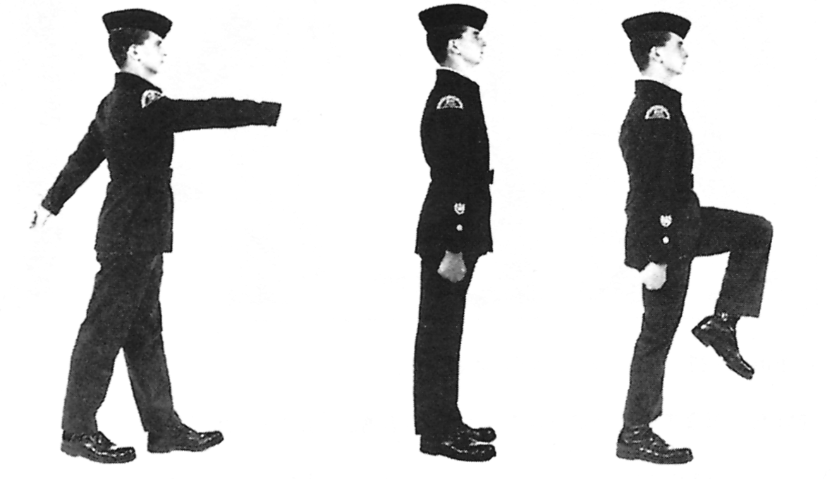

Figure 1-22Marking Time in Quick Time
77. On the command, "FOR − WARD", you shall:

a. straighten your right leg and assume the position of attention;

b. shoot your left foot forward in a 40 cm (15 in.) pace; and

c. continue marching in quick time, swinging your right arm forward and your left arm to the rear.

78. On the command, "SQUAD − HALT", you shall:

a. take a further mark time pace with your right foot;

b. take a further mark time pace with your left foot; and

c. straighten your right leg in double time and assume the position of attention.

79. The timing for the halt is counted one, one-two.

WHEELING

80. Wheeling is the term used for the action of changing direction without using a left or right turn.

81. On the command, "RIGHT − WHEEL", the leading file of three cadets wheels around one quarter of a circle, which changes the cadets' direction by 90 degrees.

82. The inner flank of cadets shall step short, and the outside flank of cadets shall step out, without changing the speed (cadence) of their steps.

83. When the leading file has wheeled 90 degrees, it shall march in the new direction, with the normal length of pace. When the wheel is completed, the direction from which the dressing is taken is indicated by the instructor, or supervisor, ordering "BY THE RIGHT (LEFT)".

84. The remaining files shall act as described in paragraphs 80 and 81.
85. Dressing is maintained by glancing inwards when wheeling and keeping the head to the front.
86. If the squad is ordered to halt or mark time, and only part of the squad has completed the wheel, the squad shall remain in this position unless the command, "REAR FILES − COVER", is ordered. On the command, "REAR FILES − COVER", the files at the rear cover off the files that are facing the new direction.

Figure 1-23Wheeling (to the Right)

87. It may, at times, be desirable to wheel a squad less than 90 degrees. When this is the case, the command, "FOR − WARD", is ordered when the leading file is facing the required direction.

SALUTING ON THE MARCH WITH THE HAND

88. The movement of the salute to the front and to the left or right shall be as described in paragraphs 20 to 24 of this chapter.
89. When cadets salute on the march, they shall commence the salute five paces before reaching an officer; look directly into the officer's eyes by turning their head in the required direction on the commencement of the salute; and complete the salute one pace beyond the officer. This permits the officer to return the salute before the cadet has passed.

90. On the command, "TO THE FRONT (LEFT) (RIGHT) SALUTE", you shall:

a. complete an 80 cm (30 in.) pace with your right foot;

b. swing your left arm forward and your right arm to the rear;

c. complete an 80 cm (30 in.) pace with your left foot;

d. cut your left arm to the side;

e. bring your right arm to the side, executing the salute in one continuous movement. While saluting, the head is turned right (left) as far as possible without straining;

f. complete four 80 cm (30 in.) paces in quick time, ending with your left foot forward;

g. complete an 80 cm (30 in.) pace with your right foot;

h. cut your right arm to the side; and

j. continue marching.
Figure 1-24 Saluting on the March
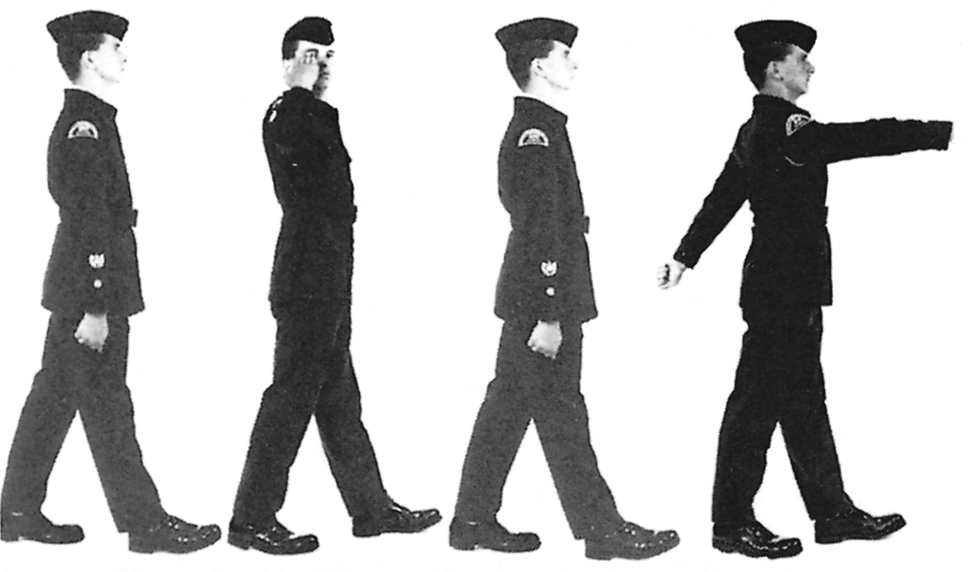

PAYING COMPLIMENTS WITH A SQUAD ON THE MARCH

91. On the command, "EYES − RIGHT (LEFT)", you shall do the following:

a. complete a full pace forward with your right foot and, as your left foot comes forward and strikes the ground, turn your head and eyes to the right (left) as far as possible without straining and look directly into the eyes of the person being saluted;

b. continue swinging your arms; and

c. if you are the leading cadet on the direction flank, you must look to the front to keep direction.

92. On the command, "EYES − FRONT", you shall complete a full pace forward with your right foot and, as your left foot comes forward and strikes the ground, cut your head and eyes smartly to the front.

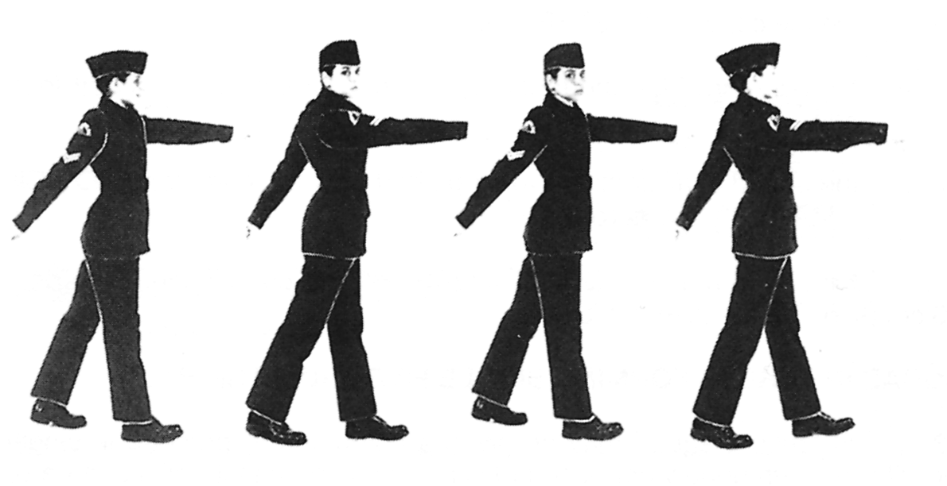

Figure 1-25Eyes Right on the March

STEPPING OUT AND STEPPING SHORT

93. Stepping out is used to increase the distance to be covered without altering the cadence. To decrease the distance to be covered without altering the cadence, stepping short is used.

94. On the command, "STEP − OUT":

a. the pace shall be lengthened by 7.5 cm (3 in.) on the next left foot; and

b. the squad shall continue to step out until the command "QUICK − MARCH", is ordered.

95. On the command, "QUICK − MARCH", the pace is shortened by 7.5 cm (3 In.) on the next left foot.

96. On the command, "STEP − SHORT":

a. the pace shall be shortened by 23 cm (9 in.) on the next left foot; and

b. the squad shall continue to step short until the command, "QUICK − MARCH", is ordered.

97. On the command, "QUICK − MARCH", the pace is lengthened by 23 cm (9 in.) on the next left foot.

SQUAD IN THREES FORMING SINGLE FILE FROM THE HALT

98. At times a squad may be given a command to proceed in single file. This is often done when a squad is moving into an instructional area or into a mess.

99. On the command, "SINGLE FILE FROM THE LEFT (RIGHT), QUICK − MARCH":

a. the flank indicated in the command marches off in single file in quick time; and

b. the remainder marks time. The leading cadets of the other two files execute a left (right) incline and lead off in single file when the file on their left (right) is clear.

SQUAD IN THREES FORMING SINGLE FILE ON THE MARCH

100. On the command, "SINGLE FILE FROM THE LEFT (RIGHT), REMAINDER MARK":

a. the directing flank continues marching forward;

b. the remainder marks time; and

c. the leading cadets of the other two files execute a left (right) incline and lead off in single file when the file on their left (right) is clear.

Figure 1-26Squad in Threes Forming Single File

SQUAD IN SINGLE FILE REFORMING THREES FROM THE HALT

101. On the command, "ON THE RIGHT (LEFT) REFORM THREES, REMAINDER QUICK − MARCH":

a. the rank leading the single file stands fast; and

b. the remainder steps off, reforms three ranks and halts.

SQUAD IN SINGLE FILE REFORMING THREES ON THE MARCH

102. On the command, "ON THE RIGHT (LEFT), REFORM THREES, FRONT RANK MARK − TIME":

a. the rank leading marks time; and

b. the remainder reforms threes and marks time.

103. On the command, "FOR − WARD" or "SQUAD − HALT", the squad acts as ordered.

